BSCMail User Guide

# Introduction

BSCMail is a volunteer-management and scheduling application suitable for use by non-profit and for-profit organizations alike. It is easy to use and customizable to meet virtually any need.

BSCMail is distributed under the GNU General Public License. Please visit <http://www.gnu.org/licenses/> for details.

This guide corresponds to BSCMail version 3.0.

# Tutorial

# Reference

## Main Window

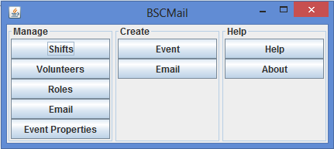

The BSCMail main window is the starting point when the application is launched. There are a number of buttons on the main window, each performing a different function. Note that the buttons are grouped into three columns: **Manage**, **Create**, and **Help**. The buttons perform the following functions.

The **Manage, Shifts** button opens the Manage Shifts window, which allows you to manage volunteer shifts.

The **Manage, Volunteers** button opens the Manage Volunteers window, which allows you to manage the list of volunteers.

The **Manage, Roles** button opens the Manage Roles window, which allows you to define specific volunteer roles.

The **Manage, Email** button opens the Manage Email window, which allows you to define a template for sending scheduling emails.

The **Manage, Event Properties** button opens the Manage Event Properties window, which allows you to define custom properties for your event.

The **Create, Event** button opens the Event Setup window, which allows you to assign volunteers to and write information for a specific event.

The **Create, Email** button opens the Event Email Text window, which displays a custom crafted scheduling message for your event.

The **Help, Help** button opens this user guide.

The **Help, About** button opens a window displaying information about this version of BSCMail.

## Manage Shifts Window

## Manage Volunteers Window

## Manage Roles

## Manage Email Window

## Manage Event Properties Window

## Event Setup Window

## Event Email Text Window

# Data Format