**Appendix**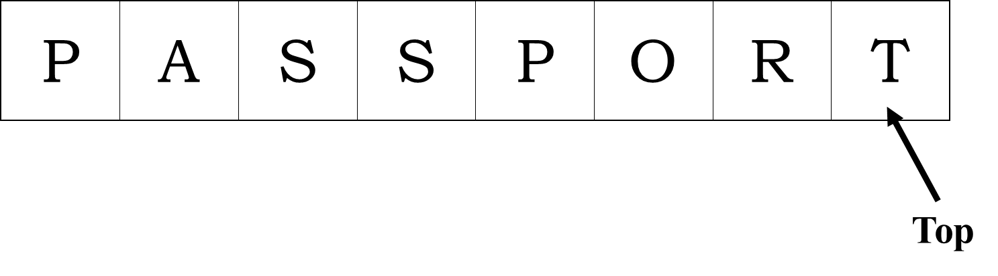

Figure 1 **Stack** Structure of a line of words

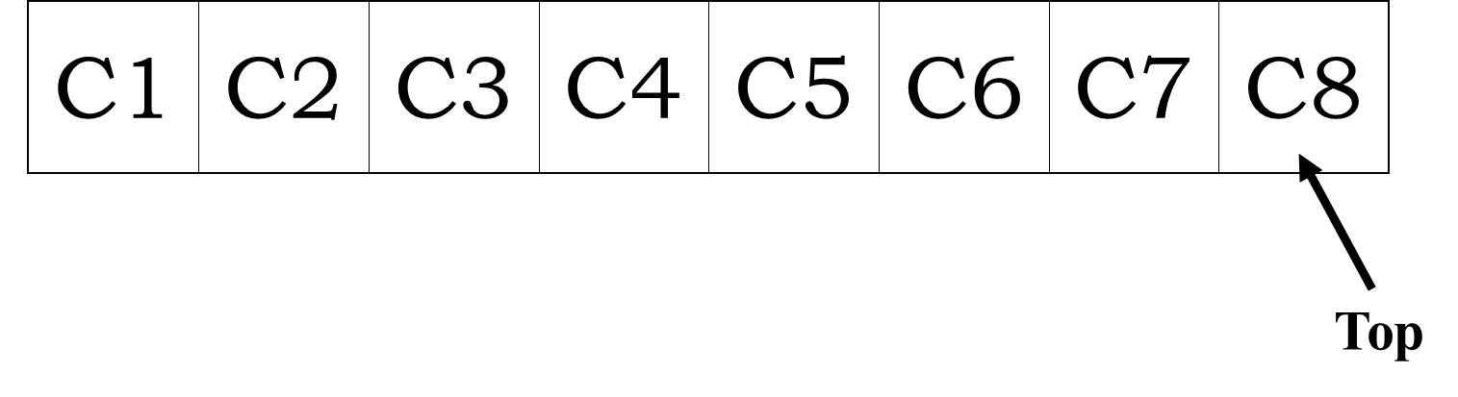

Figure 2 **Stack** Structure of customers

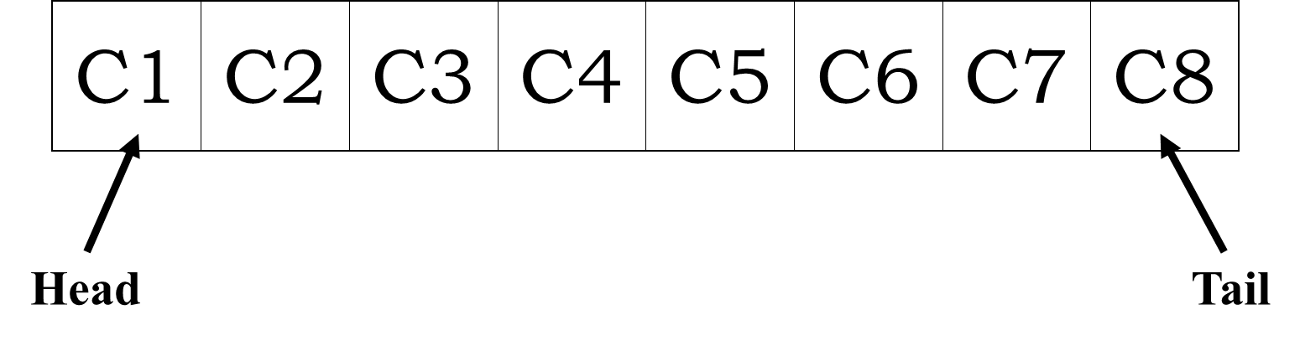

Figure 3 **Queue** Structure of customers

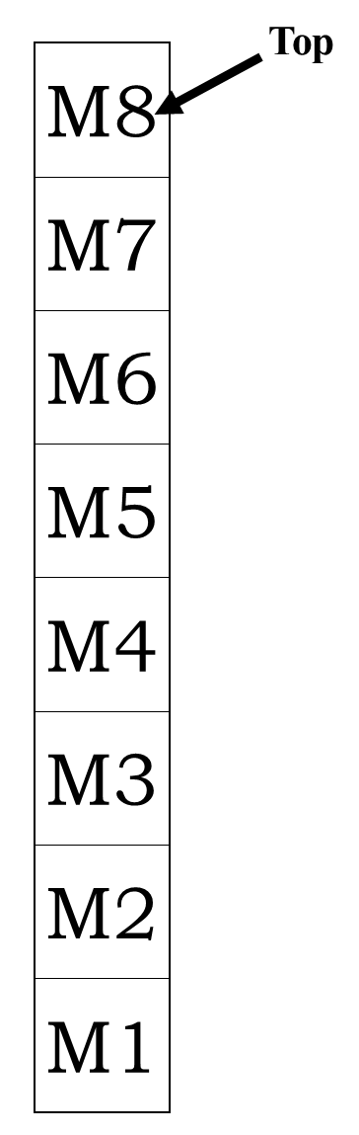

Figure 4 **Stack** Structure of a pile of magazines

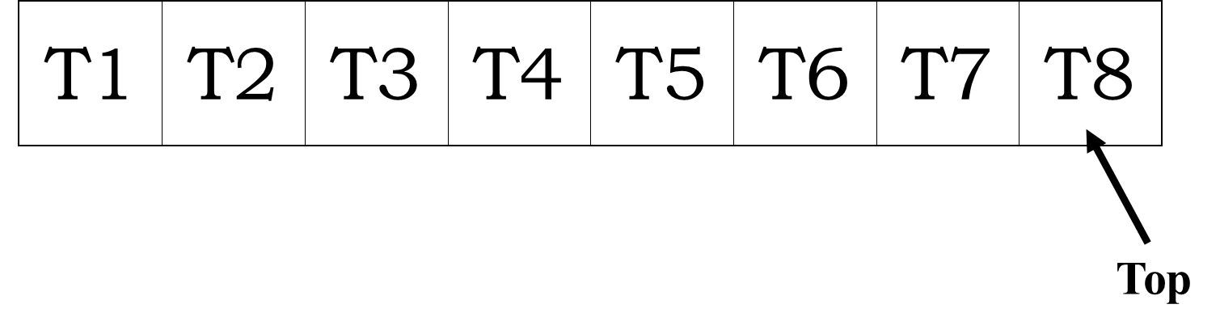

Figure 5 **Stack** Structure of a series of jobs

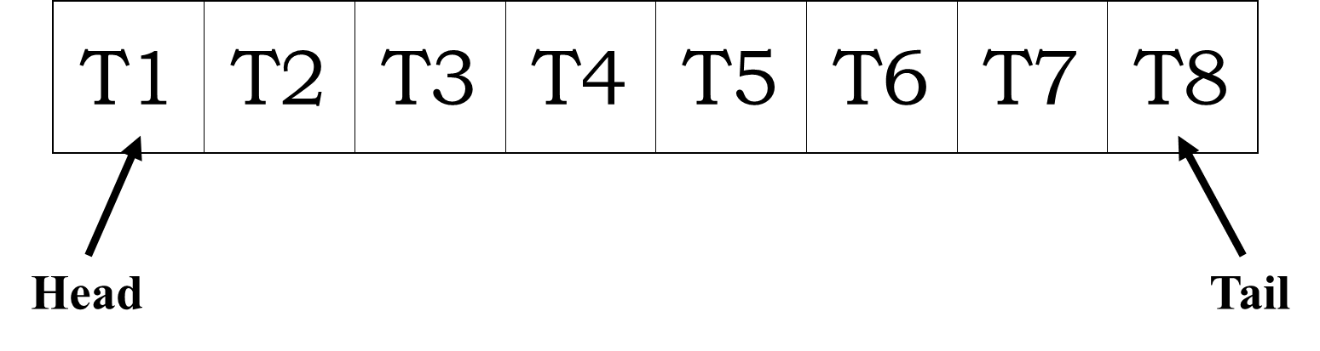

Figure 6 **Queue** Structure of a series of jobs

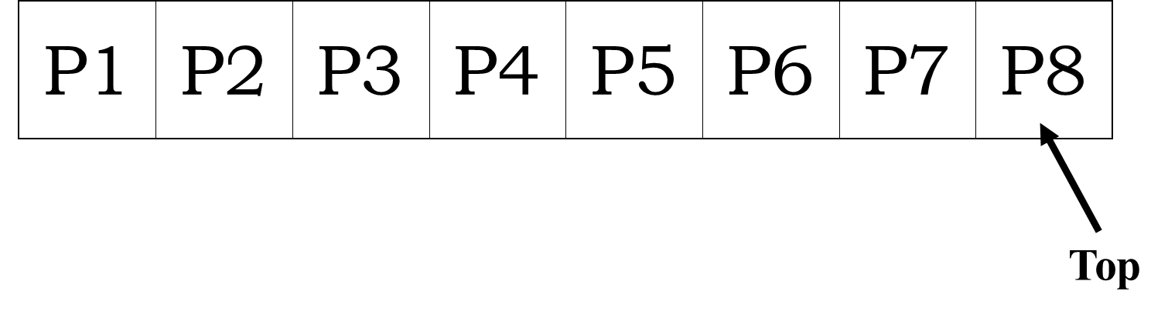

Figure 7 **Stack** Structure of a line of people

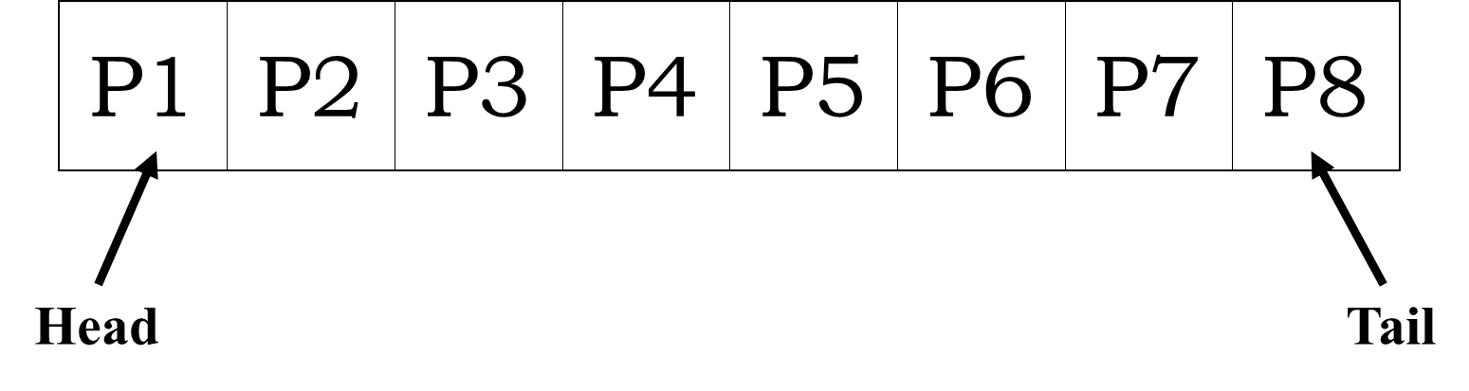

Figure 8 **Queue** Structure of a line of people