Proposal for
Friends Vision Childrens Homes

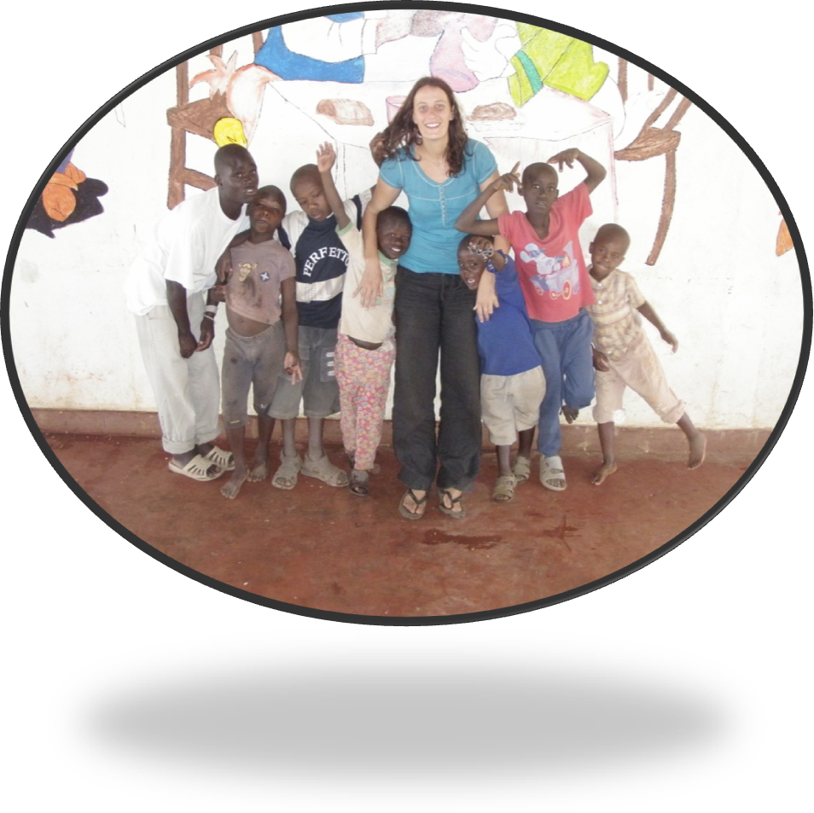
Written by the Board of Directors for Friends Vision Childrens Home January 2010
(Revised May 2010)

Table of Contents Page

Introduction ……………………………………………………………………………………. 3
Background ……………………………………………………………………………………. 4
The Proposal ........................................................................................ 5
Mission and Policy Statement ……………………………………………….. 5
Aims and Objectives …………………………………………………………….. 5
Goals ……………………………………………………………………………………. 5
The Home ………………………………………………………………………………………… 6
The Children ......................................................................................... 6
Medical Care …………..………………………………………………………………………. 7
Qualified Staff …………………………………………………………………………………. 7
Volunteer Placement ………………………………………………………………………. 7
Estimated Funding Needed ……………………………………………………………… 8
Getting Started …….……………………………………………………………….. 8
Community Centre …………………………………………………………………. 8
Individual Homes ……………………………………………………………………. 8
Monthly Maintenance Costs ………………………………………………… 8
Proposed Sources of Funding…………………………………………………………….. 9
Fundraising Ideas ................................................................................. 9
Management and Contact Details …………………………………………………… 10
Board of Directors ………………………………………………………………… 10
Committee Members ............................................................... 10
Contact Details ......................................................................... 10

Introduction
Every child in this world, either from east or west has a right to good food, safe drinking water, shelter, clothing, health care and an education. It is regrettable that the majority of children in developing countries lack most of the above, if not all. Some go without a meal for days on end, while others live in slums where healthcare is unheard of, hence exposing them to a lot of health hazards. No person, let alone a child should be forced to live in these conditions.
The Kenyan child is no exception from the above cases, especially with;
- Years of drought has left thousands of people with failed crops and little to no access to drinking water. This has increased malnutrition and mortality in children*.
- The 2007 post election skirmishes which left thousands of children orphaned and vulnerable after their parents and relatives were murdered by fighting communities
- High levels of HIV/AIDS related cases resulting in young children being left in the care of the aged population, who are unable to look after them
- High levels of poverty with nearly 7.5 million people (1/4 of the population) still earning less than one dollar a day*. This has resulted in high numbers of;
  - Malnutrition
  - Illiteracy
  - Street families
  - Drug and alcohol abuse
  - Teenage pregnancy
  - Child abuse, exploitation, neglect and abandonment
  - And, early death from preventable diseases, such as malaria, cholera, TB, typhoid and measles. The average life expectancy in Kenya is only 53 years old *.
* Sourced from www.unicef.org

Background
Friends Vision Children’s Home (FVCH) started as a dream from many people around the world. In 2008, Geoffrey Mwaura Kuria from Kenya was inspired by his niece Peris Wairimu Mwangi, who at the time was working for a well known charitable organisation, which brought volunteers from all around the world to Kenya to work in orphanages and children’s homes. Geoffrey would accompany Peris on trips to the orphanages to visit the children and together they wondered what they can do to help these underprivileged kids. It was here that they dreamed of providing these children with a loving home, an education and some much needed medical care.
Peris left her job to study social work, but kept the dream alive of one day building a home. After further discussions with Geoffrey, they decided to contact the volunteers that Peris had befriended during her time working at the volunteer house. Nearly everyone Peris contacted said that it was also a dream of their own and would help out in any way possible. They formed a board of directors with Jannah Currie from Australia, Cheryl Buynak from America and Jenny Martinez from Canada. They gained support and commitment from compassionate people from all around the world, and with that the ball started rolling with the dream of FVCH.

The Proposal

Mission and Policy Statement
To provide a stable foundation that is rooted in education and health care for orphaned, vulnerable, deprived and destitute children who have lost their own family. We will provide a loving and safe, family environment that enables children the right to a happy, educated, skilled and healthy life.
Aims and Objectives
- Provide love, food, shelter, clothing, education, safe drinking water, medical care and career opportunities to orphaned, deprived and destitute children
- Help cut down the number of street children in the Kenyan society
- Reduce HIV/AIDS related cases, through education and prevention
- Improve access to education for underprivileged children, by creating a sponsorship program
- Help children who are not academically inclined to acquire technical skills, which will allow them to support themselves in the future
- Continue the close working relationship with Government Rescue Centres and Children’s Homes in order to help provide the local community with the fundamentals needed in their society.

Goals
- Build a home that will raise, nurture and re-habilitate children, aged 2 and above.
- Employee trained, knowledgeable and caring staff to guide the children down the right paths
- Utilise the land in a way that it will become self-sustainable by growing our own crops, buy milking cows, install a rainwater tank and by creating a poultry farm
- Create an NGO (non-government organisation) that will provide a volunteer program, child sponsorship program and also to assist in fundraising
- Gain constant sources of funding to maintain the project.

The Home
FVCH has acquired 3 acres of land on the outskirts of the town of Naivasha, in the Great Rift Valley, Kenya. The land is lush and fertile, which will provide us with excellent conditions to make our home as self-sustainable as possible.
We plan to build up to 6 homes and a community centre on our land. Each house will act as an individual home, with up to 10 children (boys and girls) and a house mama. Each home will comprise of male and female bed and bathrooms, a bedroom for the house mama, living area, dining room, kitchen, store and laundry.
There will also be a two storey community centre with two training classroom, a library, computer room, TV/DVD room and a small medical clinic/store downstairs and an office and volunteer wing upstairs. Eventually we would like to run educational class not only for our children and staff, but for the surrounding community as well.
There will also be a large playing field, a small poultry farm and a communal shamba (farm) with crops such as maize, cabbage, spinach, potatoes, carrots, bananas, and avocado and mango trees. As time progress, we would like to manage and sell our crops and eggs to provide us with more funding.
The Children
The majority of children will come to our homes from Government Rescue Centres, via the Kenyan Children’s Court. Children are placed into these centres by government officials after they have lost their families for one reason or another and have no one else to care for them. Some have lost their families due to ill health, death, or abandonment; some have run away due to the abuse and desperation within their own homes, or some are simply lost. Most of the children have been taken off the streets by police and brought to these Rescue Centres.
After all avenues of tracing for their parents or relatives to care for the children have been exhausted, FVCH will take these children into our homes and care for them as if they were our own. They will attend a nearby public primary school, from grade 1 to 8, and then attend a boarding secondary school (grade 9 to 12). We will also provide vocational training for those children not academically inclined. Nursery classes will be held at the home. This home will always be there for the children, even when they leave to pursue their own dreams. They will always be able to call it their home.
We will provide everything a child needs to prepare themselves to gain the most they can out of life. Counselling will be a high priority as these children have been through more hardship then most of us can imagine.

Medical Care
The children will attend a nearby medical clinic/hospital when they fall ill. There will be a small medical clinic/store on site. All staff working at FVCH will be trained in Senior First Aid so minor injuries and illnesses can be treated at home. In time FVCH would like to extend their clinic to the surrounding community.
Qualified Staff
All staff working for FVCH will be qualified, caring and professionals. Additional training will be provided to our staff including, sensitivity training, cultural diversity awareness, HIV/AIDS awareness and prevention, emergency and safety procedures and hygiene awareness. This will provide them with skills to teach, communicate and build relationships with the children as well as the volunteers within their placement.
Volunteer Placement
A volunteer placement program will be established once the home is up and running. The program will allow persons from our global community to experience FVCH and the Kenyan lifestyle. Volunteers will stay at the children’s home, but have their own area in the community centre. They will be involved with the day to day running of one of the homes, helping the house mum with household chores, preparing the children for school, teaching/educating, counselling, playing and of course provide some much needed love and care. Simply being there for the children is one of the best things you can offer, as it brings the biggest smile to their little faces.
There will be an opportunity for the volunteers to see the beauty that Kenya has to offer. Having a well-rounded approach to volunteering in Kenya will enhance the quality of the lives that participate on the program, the children and the Kenyan tourism industry.
Any volunteer wishing to be placed at FVCH will undergo an application process before placement will be approved. This is a safety measure to protect all parties involved. Volunteers will also be asked to pay a fee to FVCH, which will provide them with housing, meals, cultural sensitivity and diversity training. A caretaker will ease them through their time spent in Kenya.
Friends Vision has a rented a house in Naivasha during the time of building, so any volunteers wishing to help out with building is welcome to stay here. Please contact us at admin@friendsvision.org for more information.

Estimated Funding Needed
FCVH is starting from square one. There will the costs of purchasing the land, constructing the home and fence, plus the purchase of a vehicle. There will also be monthly maintenance costs, all of which is described below.
Getting started
Item | Price (Kenyan Shillings) | Price (US Dollars)
3 acre of land | 350,000 | $4,600
Registration fees to council | 50,000 | $660
Fence construction | 150,000 | $2,000
Mini Van | 400,000 | $5,400
Connecting electricity | 34,000 | $450
Connecting water | 50,000 | $650
Total | 1,034,000 | $13,300

Community Centre
Item | Price (Kenyan Shillings) | Price (US Dollars)
Centre construction | 2,500,000 | $30,000
Centre furnishing | 100,000 | $1,300
Total | 2,100,000 | $31,300

Individual Homes
Item | Price (Kenyan Shillings) | Price (US Dollars)
Home construction | 1,500,000 | $20,000
Home furnishing | 200,000 | $2,500
Total | 1,700,000 | $22,500

Monthly Maintenance Costs
Item | Price (Kenyan shillings) | Price (US dollar)
Home supervisor | 15,000 | $200
House mama x 6 | 60,000 | $770
Security guard | 7,000 | $95
Food | 60,000 | $800
Medical care | 5,000 | $65
Fuel | 5,000 | $65
Water | 1,500 | $20
Electricity | 2,000 | $25
Other household goods | 5,000 | $65
Total | 160,500 | $2000
Proposed Sources of Funding
Friends Vision is looking for separate entities to sponsor and fund an individual home. Each home will be dedicated to the sponsor who will be allowed to choose its name and will be responsible for the building and monthly costs of their home. They can choose to be as involved in the project as they wish.
We are looking to gain sponsorship and support from international donor agencies and charities for the costs of building and maintaining the community centre. We will run fundraising events in Australia, Canada and America and will also have monthly supporters helping to fund our monthly maintenance costs.
Funds will be generated locally via several small projects on the land i.e the poultary farm. Crops will be grown to cut down on costs and to become as self reliant and sustainable as possible.
Fundraising Ideas
- Place a donation jar at your workplace
- Raffles
- Poker / casino / games nights
- Trivia nights
- Barbeque day / night
- Music / comedy nights
- Golf tournament day
- Car boot market
- Bingo nights
- Sponsored run – Half marathon, marathons

For more information or to donate please go to www.freindsvision.org

Management and Contact Details

Board of Directors
President: Geoffrey Mwaura
Vice President: Jannah Currie
Treasurer: Peris Mwangi
Assistant Treasurer: Jenny Martinez
Secretary: Cheryl Buynak

Committee Members
Geoffrey Mwaura Amy Weiner
Peris Mwangi Brian Weiner
Jannah Currie Raina Wolfe-Stein
Cheryl Buynak Marika Koulas
Jenny Martinez

Contact Details
Peris Mwangi
Phone: +254 720 389 418 (Kenya)
Jannah Currie
Phone: +61 410 121 437 (Australia), +254 716 325 709 (Kenya)
Email: admin@friendsvision.org
Website: www.friendsvision.org
Facebook group: ‘Friends Vision Childrens Home’ http://www.facebook.com/group.php?gid=227700237524&ref=mf

