How to Install Dow Certificate on Mac

1. Type in “Manage User Certificates” in Cortana search and open the top suggestion. This window should open:

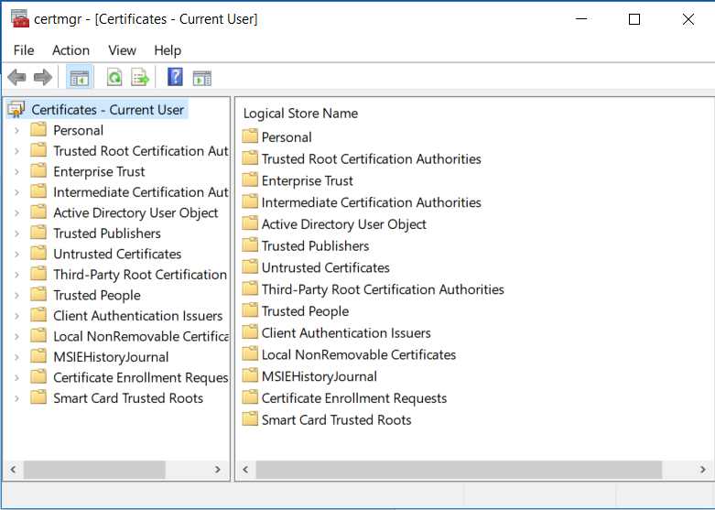

1. Expand the Personal folder and right click on Certificates > All Tasks > Request new certificate
2. Click Next to begin.
3. Verify that Active Directory Enrollment Policy is highlighted under the Configured by your administrator heading and click Next.

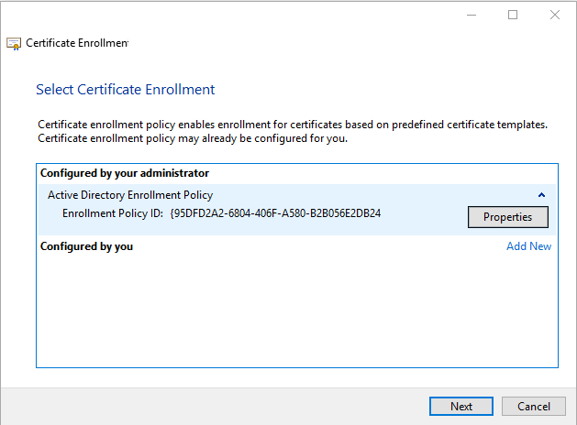

1. Check the box for Dow Internal User Authentication Manual and expand the details. Click on the Properties button.

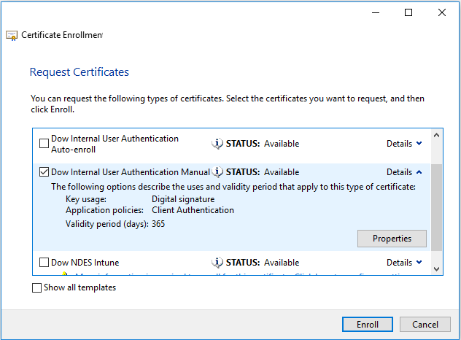

1. Navigate to the Private Key tab. Modify the Key Size to 2048 and Check the box to Make private key exportable. Click Ok to close the box.

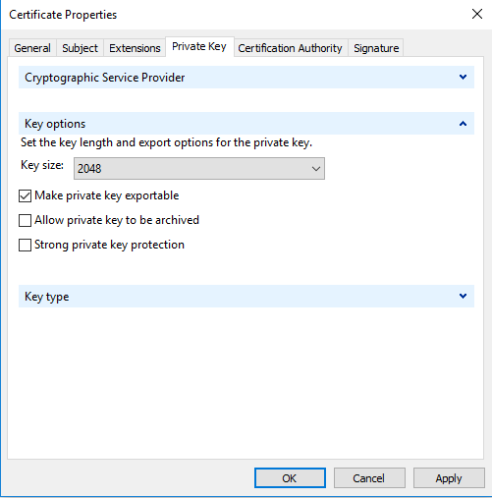

1. Click Enroll and wait for the certificate to be enrolled. Click Finish.
2. In the main cert manager window, find the newly created certificate in the right pane. It should be issued to your name, with the expiration date a year from today. Right click > All Tasks > Export.
3. The export wizard window will open. Click Next.
4. Click the button to select yes, export the private key.
5. Personal Information Exchange should be selected, as well as the checkbox to Include all certificates in the certification path if possible. Make sure to unselect anything else if it was automatically populated. Click Next.

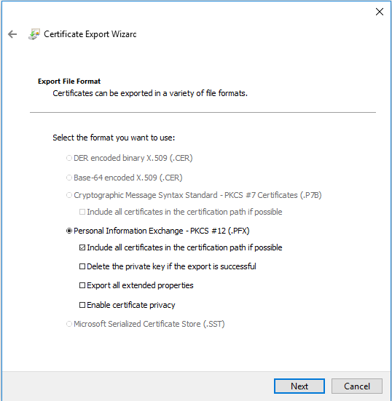

1. Check the password box and enter a password that you can remember. Click Next.
2. Browse to a location where you’d like to save the certificate and click Next.
3. Verify the information and click Finish.
4. Copy the newly exported certificate file to a USB drive. Connect the USB drive to the mac you’d like to copy it to.
5. On the mac, open Keychain Access and select File > Import Items
6. Find the exported certificate on the USB drive and click Open. It will ask you to enter the password you created in step 12.
7. You should see the certificate added to your list of certificates. Right click on the certificate and select Get Info.
8. Expand the Trust section and verify that Always Trust is selected.
9. Connect to T001. A popup will be shown asking for a username & password. There should be a drop down at the top, select the other option. This should remove the username & password entry boxes. Select your certificate from the dropdown box. There is no need to enter a username.