New Patient Intake Form
Susan Schopbach, DOM, AP
Doctor of Oriental Medicine Acupuncture Physician
Name (last, first) | Email
Address | Home phone **put a star next to best # to receive confirmation call**
City / State / Zip | Work phone |  |  | Cell phone
Employer and Occupation |  |  | Referred by
Emergency contact (name & phone) |  | Married |  | Date of birth
Do you have health insurance that you would like to use? Company____________ ID#_______________

Have you ever seen an acupuncturist before? YES NO Dr.s Name __________________________________

Are you currently under the care of a physician? If so, who, and for what condition(s)?
Surgical History (what and when)
MRI/Xrays (what part of body and when)
If you are experiencing pain –describe quality of pain(sharp, stabbing, aching…) Rate pain on scale #1-10
How long have you been experiencing your pain or condition?
Do you have limited range of motion?

Your condition is improved by…

Your condition is aggravated by…

Do you have high blood pressure or are you on blood pressure medications? YES NO

Metabolic Assessment Form

PART I
Please list the 5 major health concerns in your order of importance:

PART II
Please circle the appropriate number “0 - 3” on all questions below.
0 never 1 occasionally 2 often 3 always

Category I (Colon)

Feeling that bowels do not empty completely
0 1 2 3
Lower abdominal pain relief by passing stool or gas
0 1 2 3
Alternating constipation and diarrhea
0 1 2 3
Diarrhea
0 1 2 3
Constipation
0 1 2 3
Hard dry or small stool
0 1 2 3
Coated tongue of “fuzzy” debris on tongue
0 1 2 3
Pass large amount of foul smelling gas
0 1 2 3
More than 3 bowel movements daily
0 1 2 3
Use laxatives frequently
0 1 2 3

Category II (Gastric Enzymes)

Excessive belching, burping, or bloating
0 1 2 3
Gas immediately following a meal
0 1 2 3
Offensive breath
0 1 2 3
Difficult bowel movements
0 1 2 3
Sense of fullness during and after meals
0 1 2 3
Difficulty digesting fruits and vegetables;

undigested foods found in stools
0 1 2 3

Category III (Gastric Irritation)

Stomach pain, burning or aching 1- 4 hours after eating
0 1 2 3
Do you frequently use antacids
0 1 2 3
Feeling hungry an hour or two after eating
0 1 2 3
Heartburn when lying down or bending forward
0 1 2 3
Temporary relief from antacids, food,

milk, carbonated beverages
0 1 2 3
Digestive problems subside with rest and relaxation
0 1 2 3
Heartburn due to spicy foods, chocolate, citrus,

peppers, alcohol, and caffeine
0 1 2 3

Category IV (Pancreatic Enzymes)
Roughage and fiber cause constipation
0 1 2 3
Indigestion and fullness lasts 2-4

hours after eating
0 1 2 3
Pain, tenderness, soreness on left side

under rib cage
0 1 2 3
Excessive passage of gas
0 1 2 3
Nausea and/or vomiting
0 1 2 3
Stool undigested, foul smelling,

mucous-like, greasy, or poorly formed
0 1 2 3
Frequent urination
0 1 2 3
Increased thirst and appetite
0 1 2 3
Difficulty losing weight
0 1 2 3

Category V (Bile Enzymes)

Greasy or high fat foods cause distress
0 1 2 3
Lower bowel gas and or bloating

several hours after eating
0 1 2 3
Bitter metallic taste in mouth,

especially in the morning
0 1 2 3
Unexplained itchy skin
0 1 2 3
Yellowish cast to eyes
0 1 2 3
Stool color alternates from clay colored

to normal brown
0 1 2 3
Reddened skin, especially palms
0 1 2 3
Dry or flaky skin and/or hair
0 1 2 3
History of gallbladder attacks or stones
0 1 2 3
Have you had your gallbladder removed
Yes
No

Category VI (Blood Glucose Fluctuation)

Crave sweets during the day
0 1 2 3
Irritable if meals are missed
0 1 2 3
Depend on coffee to keep yourself going or started
0 1 2 3
Get lightheaded if meals are missed
0 1 2 3
Eating relieves fatigue
0 1 2 3
Feel shaky, jittery, tremors
0 1 2 3
Agitated, easily upset, nervous
0 1 2 3
Poor memory, forgetful
0 1 2 3
Blurred vision
0 1 2 3

Category (Insulin
VII
Resistance)

Fatigue after meals
0 1 2 3
Crave sweets during the day
0 1 2 3
Eating sweets does not relieve cravings for sugar
0 1 2 3
Must have sweets after meals
0 1 2 3
Waist girth is equal or larger than hip girth
0 1 2 3
Frequent urination
Increased thirst & appetite
Difficulty losing weight
0
0
0
1 2 3

1 2 3
1 2 3

Category VIII (Adrenal Fatigue)
Cannot stay asleep
0 1 2 3
Crave salt
0 1 2 3
Slow starter in the morning
0 1 2 3
Afternoon fatigue
0 1 2 3
Dizziness when standing up quickly
0 1 2 3
Afternoon headaches
0 1 2 3
Headaches with exertion or stress
0 1 2 3
Weak nails
0 1 2 3

1._____________________________________________________________________________
2._____________________________________________________________________________
3._____________________________________________________________________________
4._____________________________________________________________________________
5._____________________________________________________________________________

Category IX (Cortisol Elevation)

Cannot fall asleep
0 1 2 3
Perspire easily
0 1 2 3
Under high amounts of stress
0 1 2 3
Weight gain when under stress
0 1 2 3
Wake up tired even after 6 or more hours of sleep
0 1 2 3
Excessive perspiration or perspiration with

little or no activity
0 1 2 3

Category X (Thyroid – Decreased Metabolic Activity)

Tired, sluggish
0 1 2 3
0 1 2 3
Require excessive amounts of sleep to

function properly
0 1 2 3
Increase in weight gain even with low-calorie diet
0 1 2 3
Gain weight easily
0 1 2 3
Difficult, infrequent bowel movements
0 1 2 3
Depression, lack of motivation
0 1 2 3
Morning headaches that wear off

as the day progresses
0 1 2 3
Outer third of eyebrow thins
0 1 2 3
Thinning of hair on scalp, face or genitals or

excessive falling hair
0 1 2 3
Dryness of skin and/or scalp
0 1 2 3
Mental sluggishness
0 1 2 3
Category XI (Thyroid – Increased Metabolic Activity)
Heart palpations
0 1 2 3
Inward trembling
0 1 2 3
Increased pulse even at rest
0 1 2 3
Nervous and emotional
0 1 2 3
Insomnia
0 1 2 3
Night sweats
0 1 2 3
Difficulty gaining weight
0 1 2 3
Category XII (Pituitary - Decreased Metabolic Activity)
Diminished sex drive
0 1 2 3
Menstrual disorders or lack of menstruation
0 1 2 3
Increased ability to eat sugars without symptoms
0 1 2 3

Category XIII (Pituitary - Increased Metabolic Activity)
Increased sex drive
0 1 2 3
Tolerance to sugars reduced
0 1 2 3
“Splitting” type headaches
0 1 2 3

Category XIV (Males Only) -Prostate

Urination difficulty or dribbling
0 1 2 3
Urination frequent
0 1 2 3
Pain inside of legs or heels
0 1 2 3
Feeling of incomplete bowel evacuation
0 1 2 3
Leg nervousness at night
0 1 2 3

Category XV (Males Only) - Male Hormones
Decrease in libido
0 1 2 3
Decrease in spontaneous morning erections
0 1 2 3
Decrease in fullness of erections
0 1 2 3
Difficulty in maintain morning erections
0 1 2 3
Spells of mental fatigue
0 1 2 3
Inability to concentrate
0 1 2 3
Episodes of depression
0 1 2 3
Muscle soreness
0 1 2 3
Decrease in physical stamina
0 1 2 3
Unexplained weight gain
0 1 2 3
Increase in fat distribution around chest and hips
0 1 2 3
Sweating attacks
0 1 2 3
More emotional then in the past
0 1 2 3

Category XVI (Menstruating Females Only) - Female Hormones
Are you perimenopausal

Yes No
Alternating menstrual cycle lengths

Yes No
Extended menstrual cycle, greater than 32 days
Yes No
Shortened menses, less than every 24 days
Yes No
Pain and cramping during periods
0 1 2 3
Scanty blood flow
0 1 2 3
Heavy blood flow
0 1 2 3
Breast pain and swelling during menses
0 1 2 3
Pelvic pain during menses
0 1 2 3
Irritable and depressed during menses
0 1 2 3
Acne break outs
Facial hair growth
Hair loss/thinning
0
0
0

1 2 3
1 2 3
1 2 3

Category XVII (Menopausal Hormones)
How many years have you been menopausal?
________
Do you ever have uterine bleeding since menopause?
Yes No
Hot flashes
0 1 2 3
Mental fogginess
0 1 2 3
Disinterest in sex
0 1 2 3
Mood swings
0 1 2 3
Depression
0 1 2 3
Painful intercourse
0 1 2 3
Shrinking breasts
0 1 2 3
Facial hair growth
0 1 2 3
Acne
0 1 2 3
Increased vaginal pain, dryness or itching
0 1 2 3
PART III
How many alcohol beverages do you consume per week? ___________ How many caffeinated beverages do you consume per day? ______
How many times do you eat out per week? ___________
How many times a week do you eat raw nuts or seeds? _____________
How many times a week do you eat fish? ___________
How many times a week do you workout? ____________
List the three worst foods you eat during the average week? _____________________, _____________________, _________________
List the three healthiest foods you eat during the average week? _____________________, _____________________, _______________
Do you smoke?_______ If yes, how many times a day ____________ , a week ____________.
Rate your stress levels on a scale of 1-10 during the average week. __________________

Please list any medications you currently take and for what conditions:
____________________________________________________________________________________________________
Please list any natural supplements you currently take and for what conditions:
____________________________________________________________________________________________________

Feel cold – hands, feet, all over

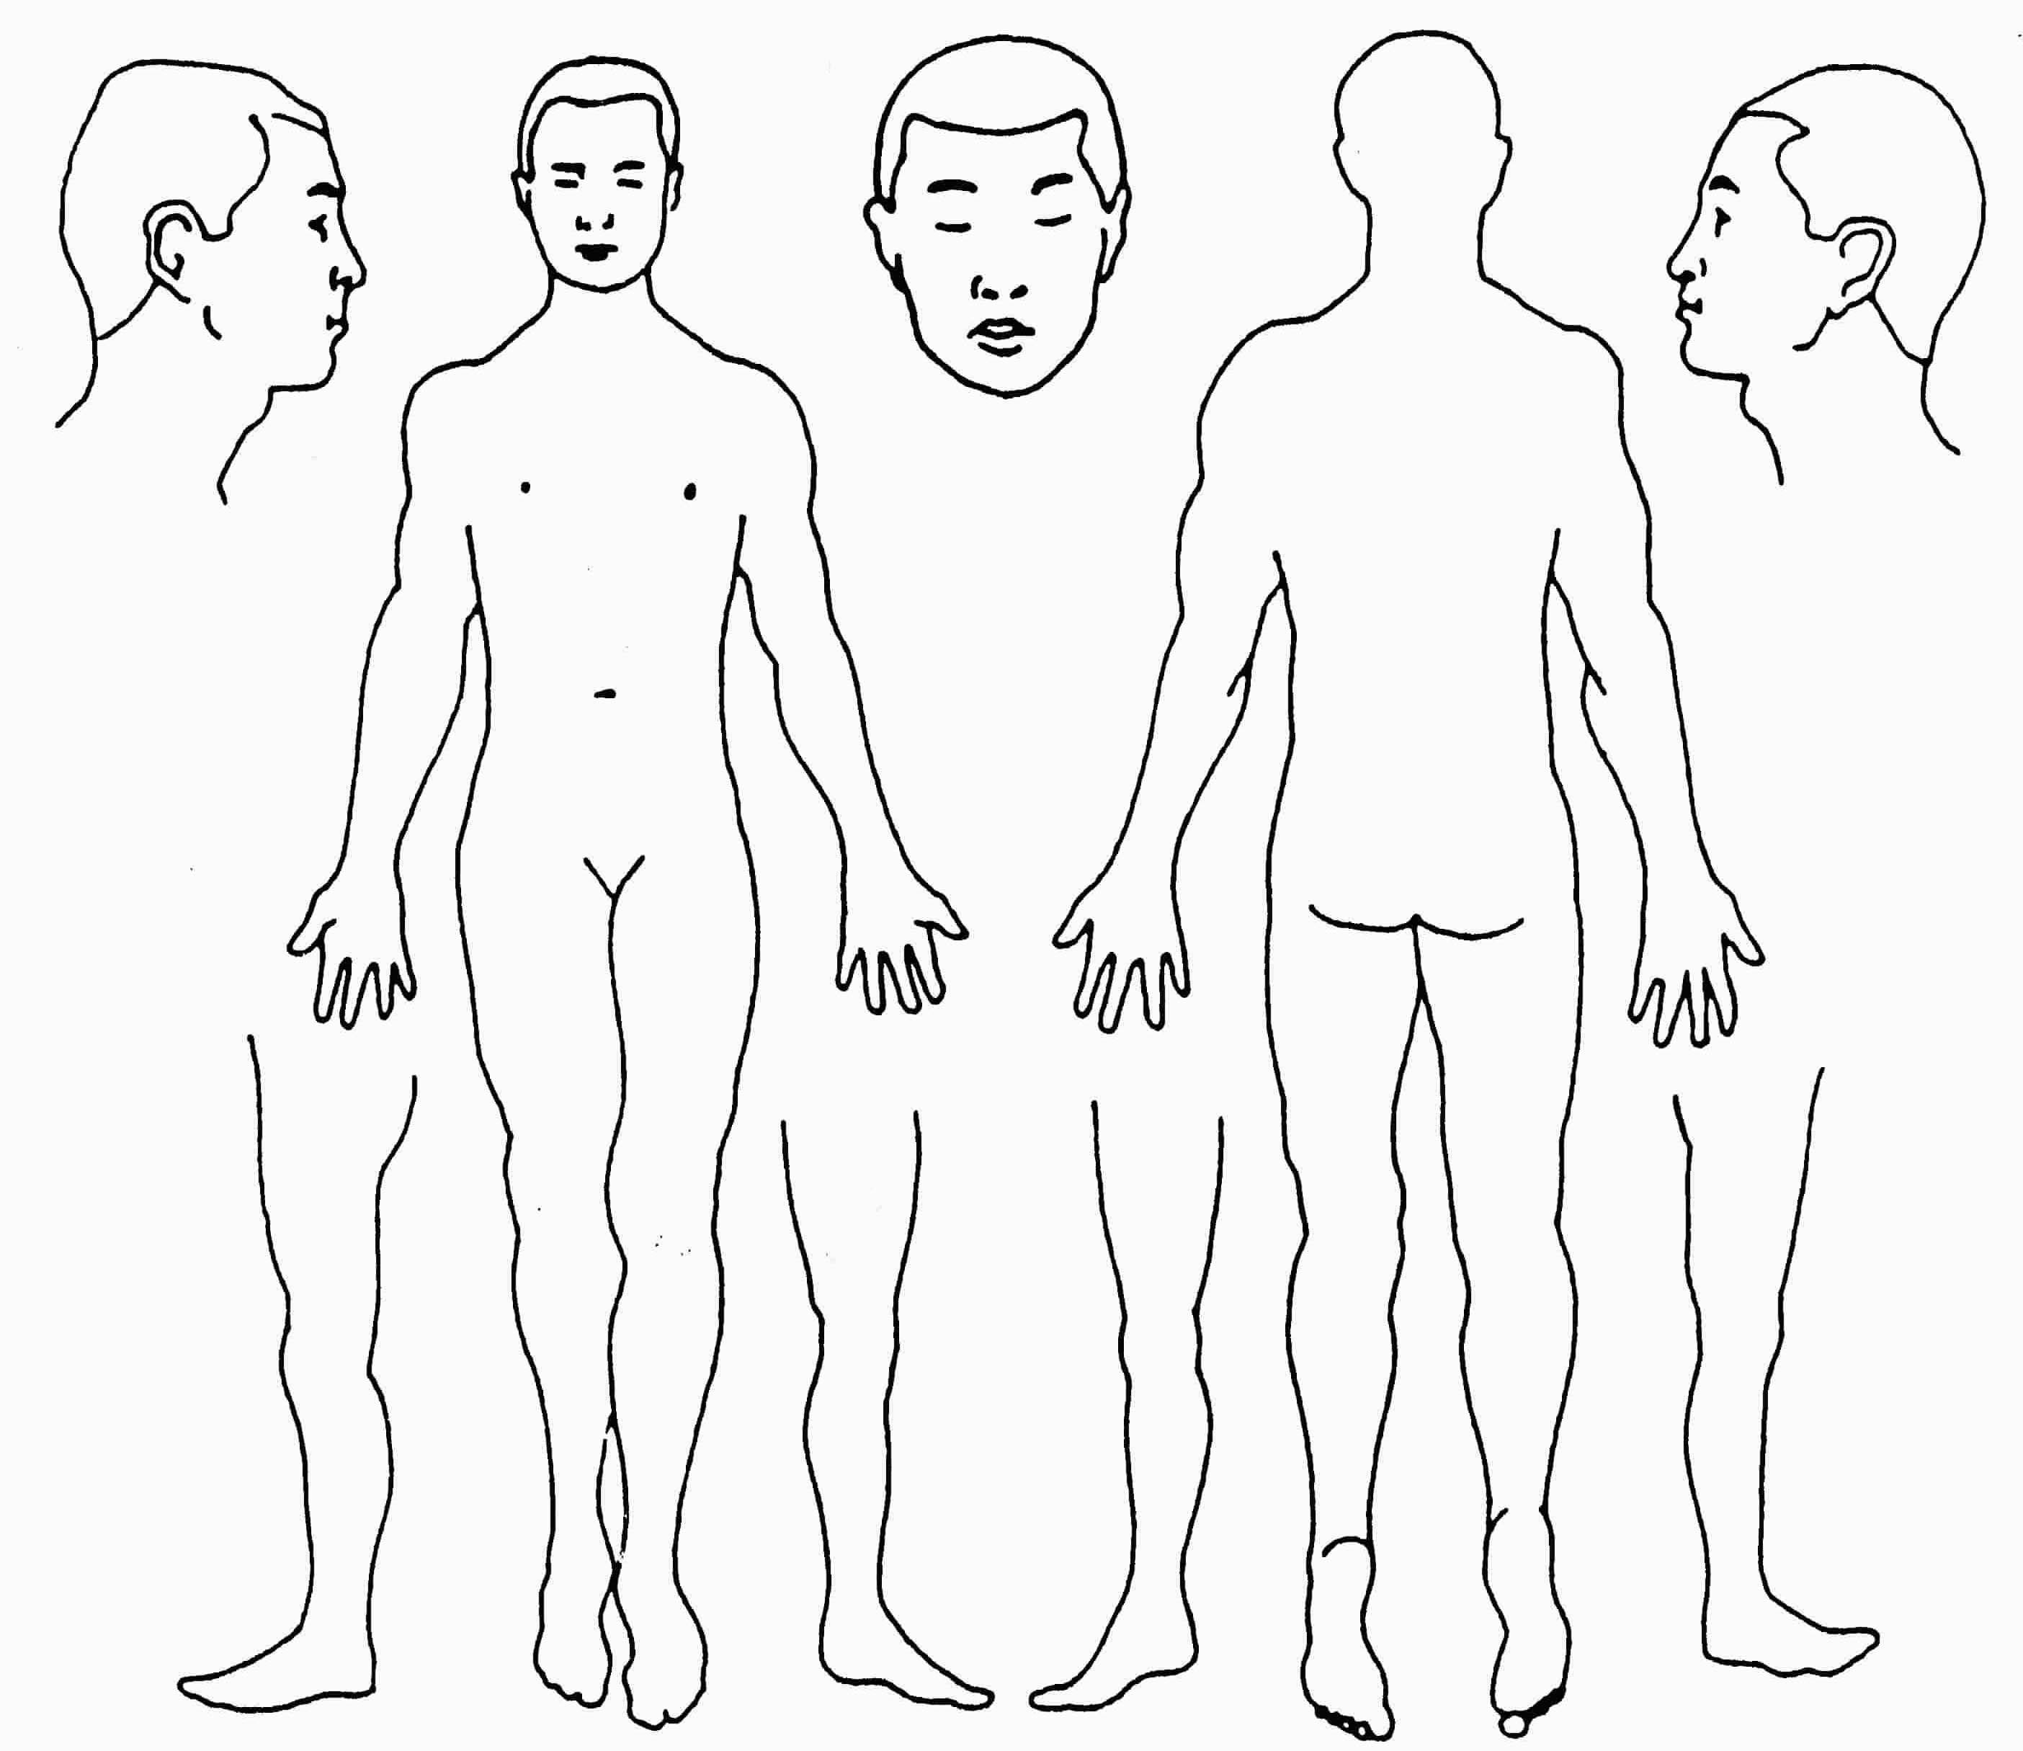
AREAS OF PAIN
Are you experiencing pain/discomfort
in any area of your body? Y N
If yes, using the models to the right,
please indicate the location of the
discomfort by using the symbol that
best describes the feeling:
+++ Sharp/stabbing
o o o Pins & needles
v v v Dull/aching
/ / / Numbness

CANCELLATION POLICY

If I cannot make an appointment, I will give a minimum 12 hours notice. If I miss one appointment, without notification, there will be no financial penalty. If a second appointment is missed without appropriate notification,
I agree to pay the missed appointment fee ($25.00) at the next visit.

ACUPUNCTURE INFORMED CONSENT TO TREAT
I hereby request and consent to the performance of acupuncture treatments and other procedures within the scope of the practice of acupuncture on me (or on the patient named below, for whom I am legally responsible) by the acupuncturist named below.

I understand that methods of treatment may include, but are not limited to, acupuncture, moxibustion, cupping, electrical stimulation, Tiu-Na (Chinese massage), Chinese herbal medicine, and nutritional counseling. The herbs may be an unpleasant smell or taste. I will immediately notify a member of the clinical staff of any unanticipated or unpleasant effects associated with the consumption of the herbs.

I have been informed that acupuncture is a generally safe method of treatment, but that it may have some side effects, including bruising, numbness or tingling near the needling sites that may last a few days, and dizziness or fainting. Bruising is a common side effect of cupping. Unusual risks of acupuncture include spontaneous miscarriage, nerve damage and organ puncture, including lung puncture (pneumothorax). Infection is another possible risk, although Acupuncture and Herbs uses only sterile single use, disposable needles and maintains a clean and safe environment. Burns and/or scarring are a potential risk of moxibustion and cupping.

I understand that while this document describes the major risks of treatment; other side effect and risks may occur. The herbs and nutritional supplements (which are from plant, animal and mineral sources) that have been recommended are traditionally, considered safe in the practice of Chinese Medicine, although some may be toxic in large doses. I understand that some herbs may be inappropriate during pregnancy. Some possible side effects of taking herbs are nausea, gas, stomachache, vomiting, headache, diarrhea, rashes, hives, and tingling of the tongue. I will notify a clinical staff member who is caring for me if I am or become pregnant.
.
I do not expect the clinical staff to be able to anticipate and explain all possible risks and complications of treatment, and I wish to rely on the clinical staff to exercise judgment during the course of treatment which the clinical staff thinks at the time, based upon the facts then known is in my best interest. I understand that results are not guaranteed.

I understand the clinical and administrative staff may review my patient records and lab reports, but all my records will be kept confidential and will not be released without my written consent.

By voluntarily signing below, I show that I have read, or have had read to me, the above consent to treatment, have been told about the risks and benefits of acupuncture and other procedures, and have had an opportunity to ask questions. This consent form is to cover the entire course of treatment for my present condition and for any future condition(s) for which I seek treatment. .

PATIENT SIGNATURE X__________________________________________ DATE____________________
(Or Patient Representative) (Indicate relationship if signing for patient)

ARBITRATION AGREEMENT
Article 1: Agreement to Arbitrate: It is understood that any dispute as to medical malpractice, that is as to whether any medical services rendered under this contract were unnecessary or unauthorized or were improperly, negligently or incompetently rendered, will be determined by submission to arbitration as provided by state and federal law, and not by a lawsuit or resort to court process except as state and federal law provides for judicial review of arbitration proceedings. Both parties to this contract, by entering into it, are giving up their constitutional right to have any such dispute decided in a court of law before a jury, and instead are accepting the use of arbitration.

Article 2: All Claims Must be Arbitrated: It is also understood that any dispute that does not relate to medical malpractice, including disputes as to whether or not a dispute is subject to arbitration, will also be determined by submission to binding arbitration. It is the intention of the parties that this agreement binds all parties as to all claims, including claims arising out of or relating to treatment or services provided by the health care provider including any heirs or past, present or future spouse(s) of the patient in relation to all claims, including loss of consortium. This agreement is also intended to bind any children of the patient whether born or unborn at the time of the occurrence giving rise to any claim. This agreement is intended to bind the patient and the health care provider and/or other licensed health care providers or preceptorship interns who now or in the future treat the patient while employed by, working or associated with or serving as a back-up for the health care provider, including those working at the health care provider's clinic or office or any other clinic or office whether signatories to this form or not. All claims for monetary damages exceeding the jurisdictional limit of the small claims court against the health care provider, and/or the health care provider's associates, association, corporation, partnership, employees, agents and estate, must be arbitrated including, without limitation, claims for loss of consortium, wrongful death, emotional distress, injunctive relief, or punitive damages.

Article 3: Procedures and Applicable Law: A demand for arbitration must be communicated in writing to all parties. Each party shall select an arbitrator (party arbitrator) within thirty days and a third arbitrator (neutral arbitrator) shall be selected by the arbitrators appointed by the parties within thirty days thereafter. The neutral arbitrator shall then be the sole arbitrator and shall decide the arbitration. Each party to the arbitration shall pay such party's pro rata share of the expenses and, fees of the neutral arbitrator, together with other expenses of the arbitration incurred or approved by the neutral arbitrator, not including counsel fees, witness fees, or other expenses incurred by a party for such party's own benefit.
Either party shall have the absolute right to bifurcate the issues of liability and damage upon written request to the neutral arbitrator.
The parties consent to the intervention and joinder in this arbitration of any person or entity that would otherwise be a proper additional party in a court action, and upon such intervention and joinder any existing court action against such additional person or entity shall be stayed pending arbitration.
The parties agree that provisions of state and federal law, where applicable, establishing the right to introduce evidence of any amount payable as a benefit to the patient to the maximum extent permitted be law, limiting the right to recover non-economic losses, and the right to have a judgment for future damages conformed to periodic payments, shall apply to disputes within this Arbitration Agreement. The parties further agree that the Commercial Arbitration Rules of the American Arbitration Association shall govern any arbitration conducted pursuant to this Arbitration Agreement.

Article 4: General Provision: All claims based upon the same incident, transaction or related circumstances shall be arbitrated in one proceeding. A claim shall be waived and forever barred if (1) on the date notice thereof is received, the claim, if asserted in a civil action, would be barred by the applicable legal statute of limitations, or (2) the claimant fails to pursue the arbitration claim in accordance with the procedures prescribed herein with reasonable diligence.

Article 5: Revocation: This agreement may be revoked by written notice delivered to the health care provider within 30 days of signature and if not revoked will govern all professional services received by the patient and all other disputes between the parties.

Article 6: Retroactive Effect: If patient intends this agreement to cover services rendered before the date it is signed (for example,
emergency treatment) patient should initial here. ________. Effective as the date of first professional services.

If any provision of this Arbitration Agreement is held invalid or unenforceable, the remaining provisions shall remain in full force and shall not be affected by the invalidity of any other provision. I understand that I have the right to receive a copy of this Arbitration Agreement. By my signature below, I acknowledge that I have received a copy.

NOTICE: BY SIGNING THIS CONTRACT YOU ARE AGREEING TO HAVE ANY ISSUE OF MEDICAL MALPRACTICE DECIDED BY NEUTRAL ARBITRATION AND YOU ARE GIVING UP YOUR RIGHT TO A JURY OR COURT TRIAL. SEE ARTICLE 1 OF THIS CONTRACT.
PATIENT SIGNATURE x ____________________________________________ DATE____________
(Or Patient Representative) (Indicate relationship if signing for patient)
OFFICE SIGNATURE x ______________________________________________________________

NOTICE OF PRIVACY PRACTICES
Our Notice of Privacy Practices provides information about how we may use and disclose protected health information about you. The Notice contains a Patient Rights section describing your rights under the law. You have the right to review our Notice before signing this Consent. The terms of our Notice may change. If we change our Notice, you may obtain a revised copy by contacting our office.
You have the right to request that we restrict how protected health information about you is used or disclosed for treatment, payment or health care operations. We are not required to agree to this restriction, but if we do, we shall honor that agreement.
By signing this form, you consent to our use and disclosure of protected health information about you for treatment, payment and health care operations. You have the right to revoke this Consent, in writing, signed by you. However, such a revocation shall not affect any disclosures we have already made in reliance on your prior Consent. The Practice provides this form to comply with the Health Insurance Portability and Accountability Act of 1996 (HIPAA).
The patient understands that:
- Protect health information may be disclosed or used for treatment, payment or health care operations
- The Practice has a Notice of Privacy Practices and that the patient has the opportunity to review this Notice
- The Practice reserves the right to change the Notice of Privacy Policies
- The patient has the right to restrict the uses of their information but the Practice does not have to agree to those restrictions
- The patient may revoke this Consent in writing at any time and all future disclosures will then cease
- The Practice may condition treatment upon the execution of this Consent
Signed:________________________________________Date:________________________________
This Consent was signed by:___________________________________________________________
(Print Name of Patient)
If patient is a minor, please print and sign name of guardian authorizing this treatment:
Print name:______________________________________________Date:_______________________
Sign name:_________________________________________________________________________
***If using GPS put in 925 Turner Rd***
(2221 is not actually on Lee Rd, it is on Turner Rd)
2221 Lee Rd. Winter Park ~ Exit 88/Lee Rd. off of I-4
From I-4 head east toward 17-92(Winter Park), go half mile
Use turning lane to make a left at Sunoco gas station onto Turner Rd
Turn into 1st one story tan bldg on left, behind white bldg(#2211).
Go in front double doors facing Turner Rd. Suite #14
2221 Lee Rd. Suite #14 Winter Park, FL 32789
www.acupuncture4wellness.net 407-718-5795

