Principal Component Analysis

# PCA and projection of images to eigenvectors set

Wavelengths 380 nm and 780 nm are removed from the dataset (no signal at these wavelengths).

Data: = (676 x 844) x 39

The data are centered, subtraction of data_mean (along rows)

SVD

Reduction of data using N of the image eigenvectors

Reconstruction of dataset (no centered)

When projecting on the eigenvector space defined by another image Img2, the reduction of the data using the N eigenvector of Img1 is formulated differently

Reconstruction of dataset (no centered)

3 eigenvectors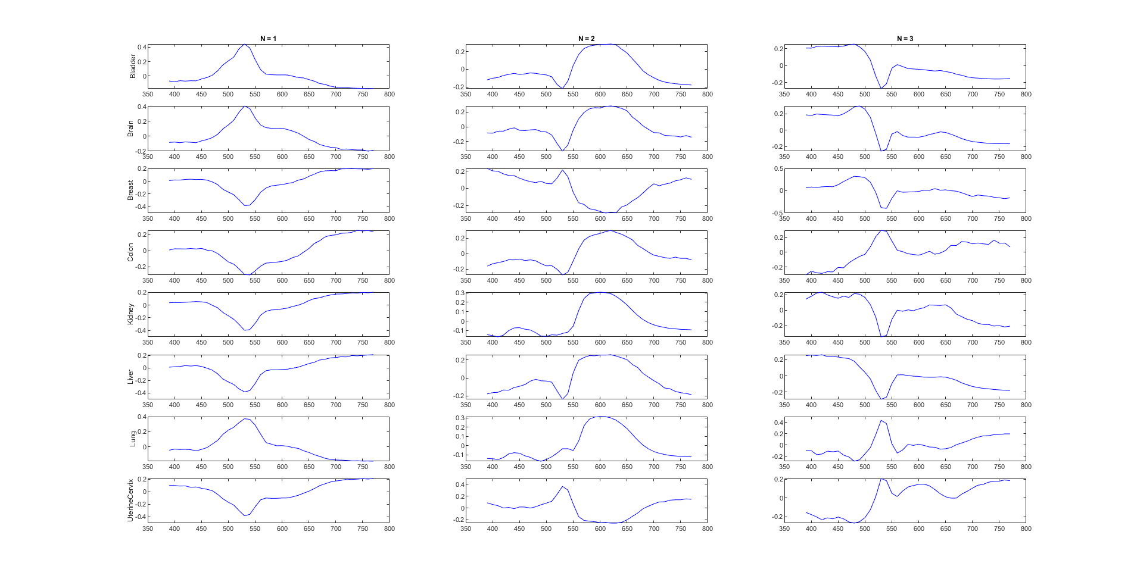

Projected images, 3 eigenvectors: 1rst row: the images are projected in the eigenvector space of the bladder sample and so on

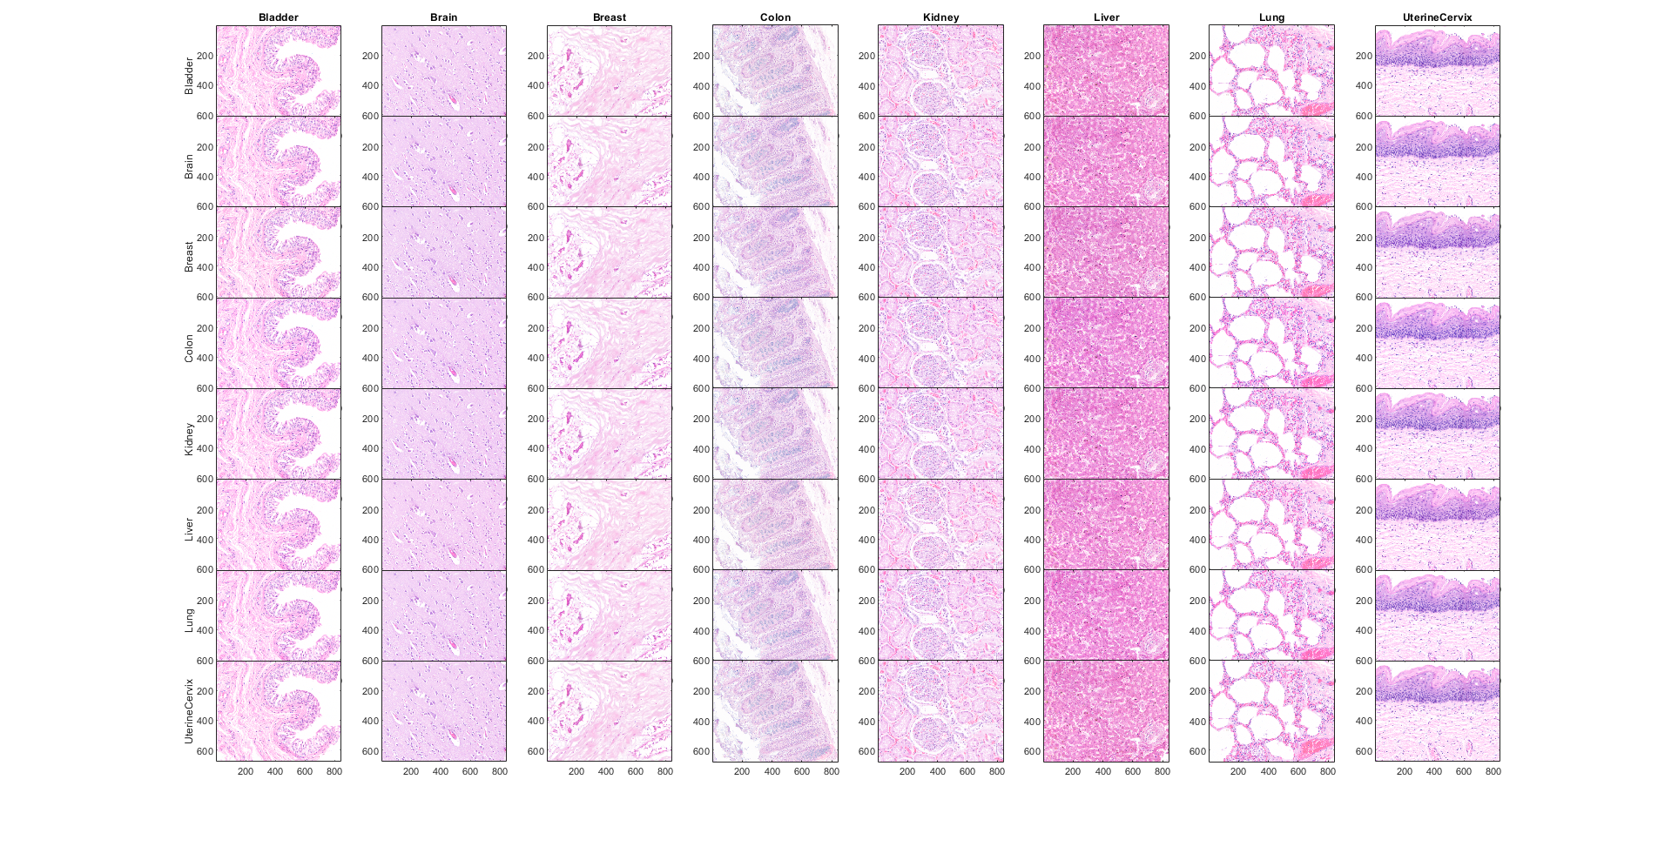

Heatmaps, 3 eigenvectors: 1rst row: the images are projected in the eigenvector space of the bladder sample and so on

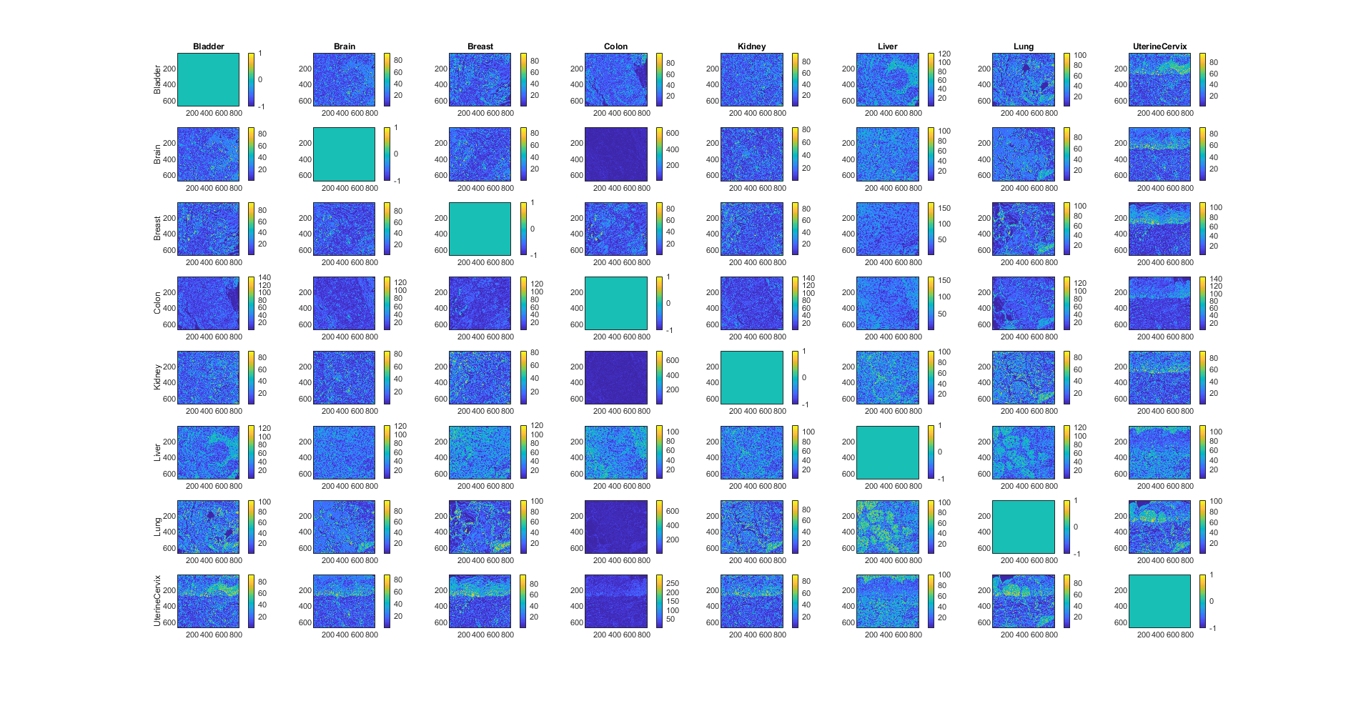

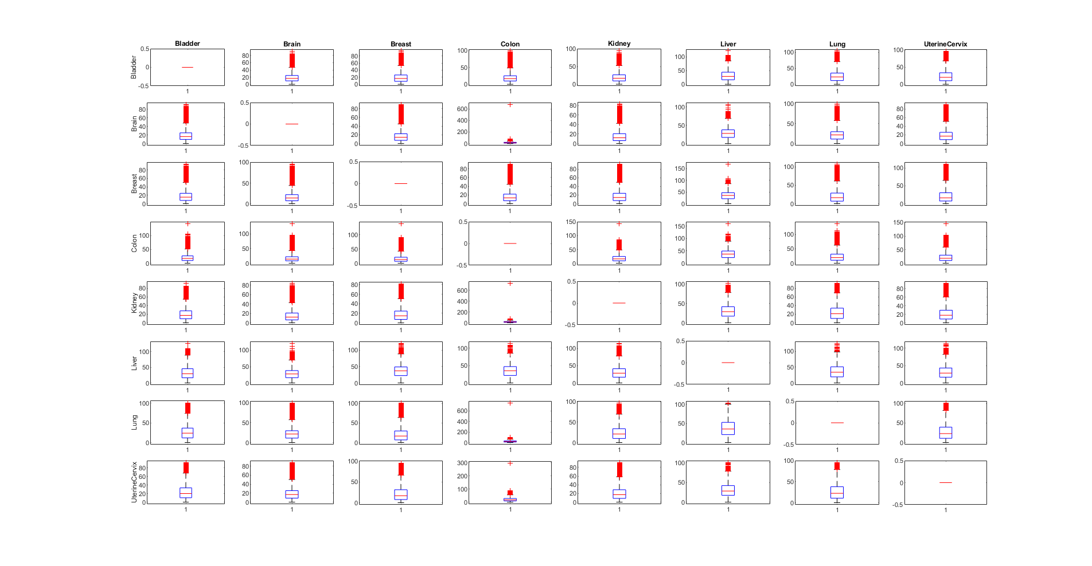

Max dE color difference

|  |  |  |  |  |  |  |  |
| --- | --- | --- | --- | --- | --- | --- | --- |
| 0.00 | 92.78 | 94.22 | 99.06 | 95.42 | 121.53 | 104.27 | 96.83 |
| 91.32 | 0.00 | 89.53 | 675.98 | 83.25 | 106.50 | 98.87 | 90.24 |
| 93.63 | 95.81 | 0.00 | 90.90 | 91.48 | 169.44 | 107.27 | 111.17 |
| 142.50 | 134.37 | 139.43 | 0.00 | 143.69 | 159.71 | 137.11 | 145.66 |
| 91.39 | 84.16 | 81.89 | 729.13 | 0.00 | 101.97 | 91.42 | 92.67 |
| 126.15 | 120.94 | 120.77 | 113.53 | 114.31 | 0.00 | 124.49 | 113.70 |
| 102.11 | 99.55 | 101.01 | 750.50 | 96.72 | 103.74 | 0.00 | 101.21 |
| 92.18 | 87.94 | 96.17 | 297.76 | 91.26 | 100.21 | 95.27 | 0.00 |