1.What are the two values of the Boolean data type? How do you write them?

**ANS:** there are two typesof boolen types – TRUE and FALSE

We can use them to check condition, if condition is true it will print the true statement .

2. What are the three different types of Boolean operators?

**ANS:** AND,OR ,NOT

3. Make a list of each Boolean operator's truth tables (i.e. every possible combination of Boolean values for the operator and what it evaluate ).

|  |  |  |  |  |  |  |  |  |  |  |
| --- | --- | --- | --- | --- | --- | --- | --- | --- | --- | --- |
| Operator | A | B | ANS | Operator | A | B | ANS | Operator | A | B |
| AND | TRUE | TRUE | TRUE | OR | TRUE | TRUE | TRUE | NOT | TRUE | FALSE |
| AND | TRUE | FALSE | FALSE | OR | TRUE | FALSE | TRUE | NOT | FALSE | TRUE |
| AND | FALSE | TRUE | FALSE | OR | FALSE | TRUE | TRUE |
| AND | FALSE | FALSE | FALSE | OR | FALSE | FALSE | FALSE |

4. What are the values of the following expressions?

(5 > 4) and (3 == 5) **FALSE**

not (5 > 4) **FALSE**

(5 > 4) or (3 == 5) **TRUE**

not ((5 > 4) or (3 == 5)) **FALSE**

(True and True) and (True == False) **FALSE**

(not False) or (not True) **TRUE**

5. What are the six comparison operators?

ANS: >,<,=,>=,<=,==,!=

6. How do you tell the difference between the equal to and assignment operators?Describe a condition and when you would use one.

ANS: assignment operator assigns a value to variable, and equal to operator checks and compares two values for equality and gives true and false

A=5 **assigns value 5**

5==6 **checks 5 is equal to 6 or not and gives result true and false (result is false)**

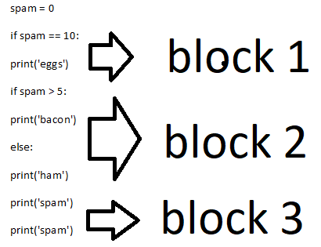7. Identify the three blocks in this code:

spam = 0

if spam == 10:

print('eggs')

if spam > 5:

print('bacon')

else:

print('ham')

print('spam')

print('spam')

8. Write code that prints Hello if 1 is stored in spam, prints Howdy if 2 is stored in spam, and prints Greetings! if anything else is stored in spam.

If spam==1:

Print(‘Hello’)

elIf spam==2:

Print(‘Howdy’)

Else:

Print(‘Greetings!’)

9.If your programme is stuck in an endless loop, what keys you’ll press? **Ctrl+C**

10. How can you tell the difference between break and continue?

ANS: both can be used in loop

A break terminates the loop and exits to the next statement

Continue skips the current statement and don’t exits the loop and continues the loop

11. In a for loop, what is the difference between range(10), range(0, 10), and range(0, 10, 1)?

**ANS : Range(10) : will generate sequence of numbers default from 0-9**

**Range(0,10) : will generate sequence of numbers starting from 0-9**

**Range(0,10,1) : will generate sequence of numbers starting from 0-9 with gap of 1**

12. Write a short program that prints the numbers 1 to 10 using a for loop. Then write an equivalent program that prints the numbers 1 to 10 using a while loop.

**ANS :**

**For LOOP**

for num in range(1,11):

print(num)

**WHILE LOOP**

num = 1

while num <= 10:

print(num)

num += 1

13. If you had a function named bacon() inside a module named spam, how would you call it after importing spam?

**ANS:**

import spam

spam.bacon()