Fulcinis
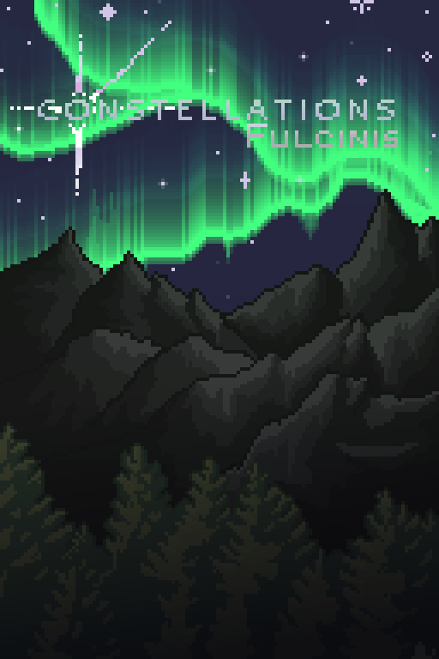
Constellations: Fulcinis cover art
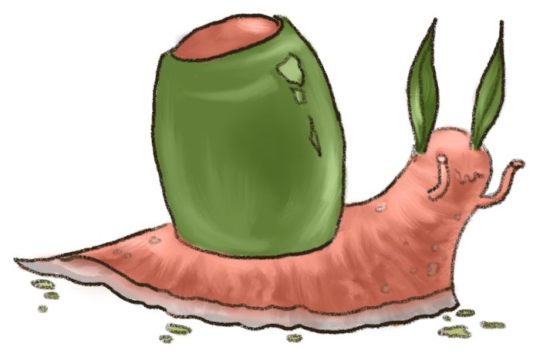
Olive Snail Productions
A careful compiling of source texts and original writing by the Olive Snail Production Team.
Jeremiah Alvarado, Briar Gall, Renato Gonzalez, Tamar Tidwell
All text herein is playtest material for a rendition of earlier devised TTRPG as developed by the team and retooled by Briar Gall. This early edition is a draft for more finalized versions.
Olive Snail Productions 2026

Forward
The water caught it.
Slow blinking stars fading in and out. The wind brushing against all that would impede it. A flash of lightning so brilliant it lit even the hidden places. The spacecrafts as they fell to the surface.
Every change, the rise and fall of those who strode the surface, the water saw it. Scattered in its surface, the memories of these things break, becoming sea foam on beaches or rocks tumbling from high cliffs. It clings to the surface of new life like moss. What is to come was always there, what was to be was already happening.
Our future left us here.

The Planet: Fulcinis
A largely wild planet, Fulcinis has stood as a monument to lost progress for nearly two centuries. Its history is mired in failed colonies, natural and supernatural disasters and a long line of survivors.
As it goes - or so anyone would tell you now; the goddess Seren launched a bow into the stars, and where her arrow landed, life would sprout. These fountains of life changed barren landscapes, took the features of the places where they landed, and molded them into life. She was ultimately just a vessel, not a caretaker.
A minor few would tell you this is merely a farce to get by. Seren, the goddess, is a government which forgot the planet to them. Her arrows? A barrage of specialized technology loaded with azoth.
The very substance of magic itself. Azoth is both fuel and force. It’s presence shapes and changes the creatures of the land itself, allowing them to adapt and live in better harmony with one another. At the same time, Azoth can be used to redefine the laws that govern the worlds, shape the elements and create spaces and things unimaginable to the masses.
Fulcinis in this way isn’t alone among the stars, but they are isolated. Elsewhere, life may have been shaped in new and different ways. However, Fulcinis is the focus of this text. Within there is information about the world for individuals.

No Place Like Home
Fulcinis is a smaller planet with two primary landmasses. In the past both were more heavily inhabited, people traded and moved from place to place establishing cities and towns.
Something was different about how Fulcinis reacted to azoth though. Not only did the plants creep, the animals thrived, but the plates beneath shifted, the clouds churned and the elements woke. Awake itself, it’s said the planet made living almost everywhere impossible. The natural forces seemingly conspired to destroy and damage any progress or place that the settlers of the land made.
Violent storms and shifting mountains drove people to extreme measures. Some turned to embrace the chaos to fight it, others turned among themselves. Infighting broke out across the planet.
As the population dwindled, several magical scholars came together to find some solution. They created a way to preserve some of each of their homes, and move them somewhere safe from the planets' fury.
They took segments of land, buildings, flora, and the environments themselves and moved them across the planet. These enclaves became the eclectic neighborhoods of the primary city, named for their invention which allowed the migration. Anchor.
Much of this history, the migration itself and the technology that made it possible has suffered the same fate as all that came before on Fulcinis. Reclaimed and erased.
Today, the majority of people still live in this city. Anchor is a sprawling bay city with diverse neighbors and microclimates shaped by the anchors that brought them to the bay in the first place. Other small settlements exist, but are rare and few between. The only other large, major city is on the south of the continent - Vellent.
Vellent used to be a port for trade, both by sea and sky as well as a military installation. Its construction was originally mostly integral infrastructure. This has been generally repurposed into various buildings as the community needs.

Technology
Technology has both regressed and advanced in uneven ways. In the past technology supposedly let people leap between planets, but nowadays, that same tech might be scrap, the ground beneath, or used to hold up your grandmothers faulty shelving.
Transportation is largely via trains that move across the vast swathes of city and further across the mainland beyond the city. Vehicles are a rare commodity that is held in small circles which trade in old parts and keep the knowledge of their construction alive and well.
There is a rudimentary connective internet. Its form is largely primitive and basic compared to what some might imagine. The basic pages, the connections are accessed from both cellular devices and large computer networks.
Medical treatment teeters on a belief of your neighborhood knows best. Different groups have different practices. Some believe more in the use of practical medicine, others more ritualistic, and in some cases more extreme cures.
Automation and industrialization are highly uneven between sectors due to gaps in knowledge and communication. These gaps have only grown through the years.
Weapons have retained a varying level of lethality. While cutting edge tech still exists its rarer and difficult for the average citizen to get a hold of. Examples might include energy based weapons powered by azoth and even many high strength ammunition based weapons. Within the city people still have some kind of protection either with them, or a family weapon. These aren’t to protect from other people but other threats, to hunt and otherwise.

Magic - Azoth
A substance and a force - Azoth is the name given to the magical and technical force that drives and changes all life. People use it as fuel and power, as well as for spells and casting. The material itself is mysterious and difficult to isolate - in isolation it’s volatile.
When used it is compiled through movements and certain amount of knowledge to move and change the various elements around oneself. The individuals components are often referred to as resonance. When all the pieces work together, they produce harmonious effects which alter the world in intended ways. When sloppily put together - or too much, too fast; they can cause other issues.
Azoth allows things to coexist and live with each other. When it’s out of balance, used improperly however - it can cause unintended alterations to the casters and landscape. These changes are referred to as Amelioration - an accumulation of one's changes due to azoth.
While not seen as a net negative thing by most - there are occasionally bad side effects to misusing azoth. Some changes can be fatal or worse.

Weather
Fulcinis is lovingly known as, The Weather Planet. Something about its nature upon taking azoth intensified all known natural phenomena. The weather, natural disasters and even the supernatural ones.
Blistering winds whip sand into frenzies, grasslands move like the raging ocean, rain brings prolonged flooding. The violent raging storms oft drive individuals inland and away from any body of water that isn’t significantly shielded or prepared for the elements.
Most folks these days have done extensive prep to avoid or withstand these events and even more live in general safe havens from them like Vellent and Anchor.
Seasons tend to be divided into two to five depending on the area. The two most common seasons being storm season and calm season. Or Shizuven & Iraven, (calm wind & angry wind) respectively.
Most places experience intense weather as such, and little happens during these seasons in most of the world, only the brave and stupid leaving shelter when they don't have to,
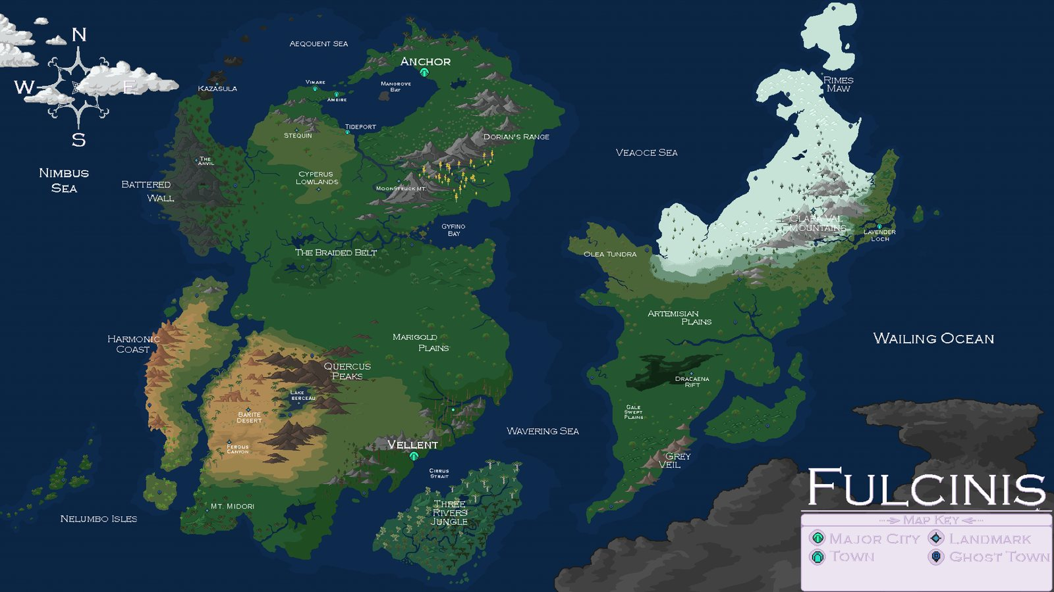
Map of Fulcinis

On Azoth…
So what does Azoth look like? When seen in the wild it is usually in a fluid state that shimmers like silver. In its fluid state it’s highly unstable and prone to explosion and other nasty indirect effects. When channeled it takes on forms of energy that resemble patterns and shapes found in nature. Generally the only time the public will see azoth in a non-energy state is in carefully constructed machines and devices known as vitrines which are designed to keep Azoth from casually reacting with the environment.
People have different ways to manage casting spells and utilizing azoth. Some use specialized tech, others movements, and some symbols etched in any number of ways. Azoth merely requires acknowledgement to be channeled. Whether that channeling goes well or not - is up to the skill of the caster.

Anchor
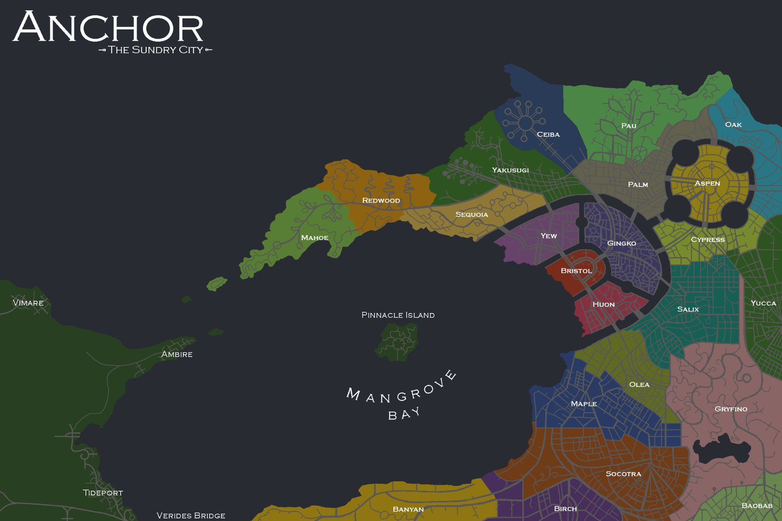 The City Of The Unmoored, The Sundry City. Anchor is a large sprawling urban complex of highly variable neighborhoods that change building style and climate across different blocks. Its people are just as much a mixed bag, hailing from different versions of history and cultures.
People in that way often have a certain pride in their neighborhoods - many behaving as large familial units rather than just as neighbors alone. Last names will often indicate in that way from which area someone hails from.
Neighborhoods in this way are the building block of Anchor. Each one consists of a planned section of some other place that was translocated to the bay and tied there by magic. They sprawl several blocks to large swathes of land at times. They are interconnected by both canals, footpaths, narrow roads and an expansive train and subway network.
To better understand your own history and connection the various neighborhoods are listed on the next few pages. You should choose where you’re from, either from the neighborhoods below or the additional locations talked about.
Anchor is subdivided into 23 distinct neighborhoods composed each of unique architecture, climates, cultures and traditions. The oldest of these districts is Bristol at the core of the bay, it’s primary function in the day to day is a place for businesses and politicians to work and operate rather than any sort of residential area.

Governance
Anchor is operated primarily by a parliament of proportionally elected officials from each of the various neighborhoods. These groups come together every week to work on and discuss issues in the city and beyond as well as prepare for any number of futures.
Parliament is partially assisted and joined by another system of judges, lawyers and clerks who maintain and enforce the laws and check any improper use of the systems.
There are few true prisoners, only relegated to heinous crimes, most punishment ends with reform and community service and improvement.

Rails, Trails & Automobiles, Sometimes Planes
Anchor is known for it’s narrow streets, packed to the brim with people. The actual roads are few and far between, often bridging underground rather than move through the actual city. Most people tend to use the abundant footpaths and trails to travel about, or rely on the large network of trains and subways.
The city is host to three distinct train networks, each with it the central hub in it’s originating neighborhood. These three neighborhoods are Gingko, Aspen and Socotra. These large stations host almost every possible line and connect to the inside and even far outside the city.
GUM (Gingko United Metro), ASN (Aspen Subway Network) and the SIR (Socotra Intercontinental Railway).
GUM maintains a large majority of the overground rails and networks in the northern half of the bay. Their network is well maintained but overall the oldest fleet of trains and vehicles.
ASN has a sprawling spider web of interconnected stops that all converge at the central station in Aspen. Their subways are among the most punctual and known to be reliable.
SIR is the only part of the rail network that services in and outside the city. They have the newest trains and devices outfitted on all of their routes. They have regular route to Vellent in the south, however this line is notorious for needing constant maintenance.
As far as planes go - they are uncommon. There are no large airports or commercial airlines to speak of. Aircraft are generally small and privately owned and used as more hobbyist crafts than true transport methods due to the dangerous upper atmosphere.

Education
While there are public schools, they usually end around 17-19 for most. After that individuals are expected to take on various mantles in either their personal life or beyond. This might include taking over a family business, or interning/apprenticeships with a selected person or group.

Companies
There are a number of larger business groups in Anchor and beyond, most scale is naturally capped however to allow for healthy competition. (generally) Occasionally infighting and rivalries have led to some less than ideal occurrences between competitors.
Most business are privately owned and licensed, or not, through their neighborhoods. Larger business typically have varying degrees of stipulations put on them upon expanding beyond their original turf making it non-ideal for most.
The largest businesses in Anchor (and beyond) are talked about more below.

Religion, Beliefs
Naturally as the neighborhoods vary, so does belief. People in different areas usually have varying stories which account for the old world vs the new one, and it's unique in its grounding in some fantasy to skewed versions of shaky facts.
Those with beliefs to entities or the like usually keep it private, choosing to visit shrines set up nearby or carrying mementos of their patrons.
Only two neighborhoods have active religious services in larger temples.

Freighters
Over all, these are workers most valued by the various sectors in the city and beyond. Not many choose to endeavor in the field of cargo movement in such hostile environments. Both private and publicly held groups exist within and around the cities.
They operate specialized vehicles designed to withstand powerful disasters and often are gone for long periods during the year. Since the road system is mostly rudimentary and even none existence most groups have created their own private routes and paths which are usually specific to the group. Such information is guarded in some cases but most openly trade optimal travel information if asked.
Training usually takes years and often includes lengthy internships alongside and experience freighter.

Rangers
A group of highly skilled individuals with detailed knowledge of different sects of land. These groups offer careful and thorough observations of the wild and it’s changes. They have strict inner group codes and laws and operate closely with various governing bodies and groups.
Their primary makeup is of several corps which are deployed on planned expeditions regularly with some staying for longer periods of time. During these deployments they make notes, take photos and videos, draw, and generally document the environment and creatures in it.

Morality
The law of the land - do good for the group, and you'll be rewarded. Act selfish in a way that takes from other - get punished. Most crimes are seen neutrally unless they directly harm others or the community in this way.

Pets & Plants
It is generally frowned upon to have undocumented animals, and plants anywhere in the city. City officials have enacted strict quarantine and paperwork to assure that anything brought in doesn’t affect the balance of azoth and life.

Verides Bridge
A brilliant deep green bridge spanning over a massive river breaking the east and west jaw of the bay apart. It’s considered a marvel of modern engineering as it has not once succumbed to any disaster that’s befell the region.

Pinnacle
A quiet isle at the center of the Mangrove Bay. It has a small park and old relics scattered across it. The area is generally restricted access as it is considered a historic site for the city.

Panacea No. I
A delicious drink that was supposed to change the world. That’s what Pancea No. I was supposed to be. Instead, it was a bitter medicine concoction with the consistency of slime. Its poor sales were due in part to the marketing push to put it out as a soft drink, rather than as a medicine.

Ladder Corp.
Among those in the bay, Ladder Corp stands out as one of the highest performing companies. This is in part due to their integration in many aspects of a dangerous life lived on Fulcinis.
Dyaus, Bora, Rudra & Avani - the corps founding four. All were members of separate provinces in the time that preceded the current age. Their fellowship was a means to serve the different interests of their community in the early discussions of the formation of the megacity of Anchor. They came together alongside scholars and had many meetings regarding their own beliefs on what it meant to relocate such large swathes of people and land.
When it came to the unmooring they gathered as many additional hands as they could to start helping those moving to the bay. They’d provide food and materials to ease any troubles associated with the large diaspora into the area.
Their purpose, to prepare the average person for the worst. As part of their mission they have a number of departments dedicated to different aspects of disaster preparedness, aftermath and even cleanup.
Now they have different headquarters which are focused on different parts of their mission - or rungs on the ladder. Their motto, “We’ll help lift you of it.”
One member of the original board still sits in on meetings - an elf of exceptional age by the name of Avani Archo. Most of her duties nowadays are ceremonial as she doesn’t recall much - but her advice still guides the occasional decision in moments of lucidity.

Bower Hospitality
As a group Bower manages a number of small hotels, inns and structures throughout the city and even some beyond. Their mission has long been to provide safe and comfortable havens for all individuals no matter where they are.
As part of this mission they have invested a significant amount of time and effort into how to navigate various disasters and have their buildings and guests prepared for anything that could happen.

Protea
A fashion company and major clothing brand within Anchor and known even in the far south for their excellent craftsmanship and design. Typically, less practical and more visual, their clothing is meant for formal and specific events rather than the everyday.

Isthmus
A clothing brand known for their hardy - well-worn clothes. They specialize in practical wear for the field and in the factory.

Sorrel
One of the few and only car brands currently in operation sorrel is known for their small compact vehicles. Their designs tend to emphasize curves and often obtuse colors.
Outside their business as car manufacturer and sales force they operate large taxi service within the Anchor metro.

Cloth & Cogs
A unique manufacturing specializing in parts for all types of machinery. They own numerous warehouses within the Banyan district.

The Unmooring
A ritual - and an event. The Unmooring was a magical ritual devised by a series of scholars to transport and anchor lands and people as quickly and safely as possible from across the globe. The coalition that came together did so out of necessity - disasters had been on the rise for decades prior and forced the various provinces and cities of Fulcinis into retreat.
The turbulent times meant many records of the events surrounding the Unmooring were poorly kept and fewer still remember everything.
You work for the eponymous Ladder Corp in Anchor!
Whether you are a low level volunteer - or a board member - everyone has an important part to play.
Their dedication to disaster preparation and cleanup has kept the city and it’s citizens safe from all kinds of problems across the last few centuries.
Every day a new problem - a new thing to quash. Your expertise helps preserve the beautiful streets of Anchor for another day.

Stoat Mining Co.
A rumor once said that this mining company was started by a Stoat of colossal proportions - others would know it was actually a couple by the names of Kaeo and Dee.
Founded 26 years ago they developed Stoat as a means of rehabilitating old mines while figuring out how to balance the need for certain rare minerals with the inherit geological risks of Fulcinis. Dee’s contribution to the city and to their many mines was a suite of powerful tech used to minimize the impact of earthquakes. She alongside her partners research gave new life to old tunnels and structures in the nearby mountains that have been abandoned for decades.
Stoat now operates around a hundred mines and queries in the north - each providing both relics, rock and metal to everyone.

WRECK-lamation
A group of ragtag mechanics with a lot of spare time. They are primarily run by a Raccoon family, the ownership still very much unclear to any outsiders. This company came together over several turbulent changes of ownership and feuds.
WRECK is both a primary trash service and a scavenging and repair business. They will look for old landfills and take what they find back to their warehouses to work on and breathe new life into them. Their specialty is old vehicles which they resell on their many lots particularly to any fieldworkers or adventuring types.

Anchor: The Neighborhoods

Bristol
Traits: Boisterous, Organized, Formal
Style: Clean, bright buildings, emphasis, short, muted colors, mazelike, tall
Climate: Dry, Sparse, Thin-Air, Rocky
Bristol is only home to a very small population of office workers and politicos who spend most of their time in their own neighborhoods. The heart of the city it's central to any big events that involve big speeches or parades through the canals of town.
The Bristol Parliamentary building stands right at the edge of the bay and acts as a locus for political action in the district. The building is home to several distinct large meeting spaces, apartments and offices.
At the districts heart is Dorian's Amphitheater. A place for celebrations and other outdoor events. It's cupped on all side by a sprawling green space open to the sky.
On the outer edge is a maze like wedge of different offices that act as headquarters to the various businesses and companies in the bay.

Gingko
Traits: Glamorous, Traditional, Polished
Style: Wooden, Craftsmanship, Careful planning, fabric, dense
Climate: Humid, middling temperatures, heavy snow and rain, sun-drenched
Among the highest populous neighborhoods Gingko is a fanning district near the heart of the city. It boasts the highest concentration of wooden only buildings in any part of the world.
Much of the hubbub surrounds large market streets which stretch in all directions. Stalls filled with food, clothes, jewels, weapons and even old tech coexist next to each other under large canopies embroidered with stories of people that have lived in the area over its history.
Homes tend to be smaller but more efficient than other areas - family groups tend to be large and live close to each other.
Much of Gingko surrounds different ancient buildings serving different community purposes. They carefully maintain the old architecture and have been slower to try and re-modernize.

Huon
Traits: Chaotic, Adaptive, Welcoming
Style: Stone, open markets, variation in height, old and new
Climate: Seasonal, heavy winds and rain, densely vegetated
Among the first to be translocated to the bay - Huon was notably one of the few instances of something going wrong during transit. Large swathes of the old city were lost and interspliced with the vigorous nature of the land.
While the old buildings are mostly piecewise because of this, they've found new life over the years. Old and new styles have blended wood and stone into unique and variable buildings which peek between trees.
The area is largely green space but still home to a high number of people. They make an effort to embrace the chaos they were dealt and incorporate it into their style and aesthetic.

Yew
Traits: Competitive, Hierarchical, Supportive
Style: Clashing, Earthen-Clay Structures, Brick streets, sleek and brutal
Climate: Colder, moderate rainfall, cloudy
Tall, winding streets packed with row homes of varying types. Yew is a tight-knit neighborhood with clear social structure stemming from familial order.
Walking down the brick streets one is likely to see a number of open studios and artisans working day and night. Each row of buildings serving different often wildly opposite functions within a few feet of each other. Most of the residential buildings are tucked in the same buildings further back, only accessible through side alleys and gates which often confuse visitors.
With often overcast weather the area is bright with lights and is a mainstay in their stamp on city. Production of high-powered, unique, tactical and more types of lights largely being output through various small warehouses and workers in the area. In as such they had a number of beautifully crafted light sculptures and areas showing off the careful work of the area.

Aspen
Traits: Communal, Insular, Idealistic
Style: Orderly, Large interconnected complexes, Bright warm colors,
Climate: Freezing, sunny, infrequent but heavy snowfall, thin air
An early concept and a first in the area, Aspen is the newest neighbourhood in the bay. From the beginning it was an attempt at a planned city scape. The careful geometry and purposeful street layout all placed with care and purpose. The idea began as the cities solution to the growing population and a footprint for future areas to join the region.
The area is constructed of several concentric rings of buildings, at their center a large natural park known as Pando. While consideration was put into movement and life, not as much had been done to bring any kind of personal touch to the architecture. It took the several first generations moving into the bleak concrete scape to start changing that.
Murals and decorated building fronts took the charge and from there, Aspen took off. Nowadays, its home to the corporate offices of Ladder and a few other companies as well as the cities only private airport.

Cypress
Traits: Rigid, Isolated, Creative
Style: lone buildings, murals, open parks, earthen tones, murals and street painting
Climate: Mild climate, warmer, windy
Interspersed through a winding open forest is the smaller neighborhood of Cypress. Most of this section of the city is made of small isolated groupings of buildings connected by narrow stone roads which few vehicles ever traverse.
The buildings are generally made from timber and logs and tend to be on the smaller side. The isolating nature of the area has turned it into a pseudo resort for many creative types as several studios have opened in the area; offering quiet and a place to work and think.
The living population is rather low and dwindling, what's left of the original people in the area often going elsewhere for better opportunities.

Salix
Traits: Relaxed, Loyal, Moralistic
Style: Arches, layered roads and paths, building openings on multiple levels
Climate: Seasonal, humid, wet
One of the three oldest locations within the city, Salix has a dense history for a short existence. Much of its story follows three warring families with a long-standing feud, each living in a single building, one on top of the other. Not wanting to interact with those below they instead built out - or so the story goes. Each layer was thus named after the family head, from top to bottom; Susanoo, Sierra, and Samir. Salix in that way is built of several connected and overlapping layers one on top of the other.
Tall spires peak out from the jumble of buildings often acting as central landmarks for the residents there. Most outsiders have difficulty navigating from one level to another and often are stuck at the bottom most level.
Over time careful renovations had to be made to account for heavy rainfall and flooding in the lower levels; and so one of the most intricate sewer and drainage systems to date was designed beneath and throughout the area.

Yucca
Traits: Formal, Pious, Prepared
Style: Mixed buildings, open-air amphitheaters, small rocky parks with canopy areas, monuments to various community leaders past and present
Climate: Sunny, Generally dry, hot, rocky, large day to night temperature swings
A strong sense of devotion to various deities is present in the large flat prairie like area. Yucca is home to a set of converging roads all dispersed between unique rock formations that break the monotony of the plains. Many of these rocks are carved over time to represent important figures and community heads.
Most of the buildings are low to the ground, many partially under it to escape the heat of the day. The structures are largely made out of clay and rock and have kept their deep reds and earthen hues over the decades.
You’d notice that in the center of each block there tends to be some type of temple - these are usually dedicated to some kind of familial deity. The structure any type tend to vary but carry many of the same notes.

Gryfino
Traits: Contemplative, Nosy, Careful
Style: Spacious, repurposed buildings, Largely low isolated wooden cabin like buildings
Climate: Cooler, wetland, peat,
In the same way that Cypress is mostly wilderness- Gryfino is largely the same. The sprawling neighborhood was originally abandoned after translocation and only began to see a trickle of people back in after a few years. The sparse winding roads carve around a deep lake in the middle of a wooded swampland.
The few buildings tend to be cabins built by multiple generations over time and unkept by tradition. The few none wooden buildings are those that were repurposed into community spaces for events and gatherings.
Notably the people of the area are gifted at various forms of pruning, topiary, and manipulating plants and their growth to fit different needs and visions. They have largely mastered forming structures by bending branches and guiding plants and one of the main attractors to the area is their careful practices involving such.

Maple
Traits: Adaptable, forthright, Leisurely
Style: Large connected building structures, beige and red tones, tight streets
Climate: Seasonal, mild but cooler
While some sections of the cities sprawl up, Maple is one that sprawled out and inwards. The narrowest streets in the entire city - the area is made up of large blocks of mix used buildings which often surround a private inner courtyard or area away from the street.
Notably the trees sprawl above the streets providing ample cover during warmer seasons and turning the streets into green corridors through the year. The autumn is generally a site to behold as the city burst with vivid reds as the maples prepare for the cold. The area often holds many festivals and even one of the cities largest parades during this time of year to celebrate the changing of the leaves.

Baobab
Traits: Gourmands, Inventive, Convivial
Style: Skyscrapers, soft and swooping, metal and clay common building materials,
Climate: Hot, dry air, sandy, low rain-fall, drought affected
Originally built in a dry savanna - the area relied on a number of aqueducts to carry water to the city from the nearby mountains. Upon their movement to the bay many of these structures lost their original purpose. Many were recycled in a way which paid homage to their original form, and now across the swathes of the neighborhood large skyscrapers interconnected by sky bridges break the skyline.
Between them are several smaller buildings which are generally in a similar style, large clay and metal buildings with beautiful glass work inlaid - a specialty of the area.
A number of the most popular and notoriously difficult to get into restaurants inhabit the area and have suffused the area with a booming food culture which envies almost any other area in the city.

Socotra
Traits: Scholarly, Domineering, Adventurous
Style: rigid isolated buildings, spires, stone primarily, harsh angles, intricate carving
Climate: Rocky, moderately dry, high heat, high winds
Socotra is known for their stone carvings and mosaics scattered through the winding streets of the area. The actual buildings are usually disconnected stone structures - the product of a generations careful construction. Within and along several of the stone walls are carefully maintained trees and plants through espalier.
Hidden amongst the many residential are a number of the cities only formal schools. These usually consist of several structures over a large campus which has been maintained and constructed to support the day to day of students of different age groups.

Birch
Traits: Festive, Cohesion, Irritable
Style: plaster facades, Connected buildings, hot springs
Climate: Colder, longer winters, sunny,
A scape of several connected buildings made of colored plasters and wood, Birch is a notably colorful neighborhood with a deeply connected community.
They are known for their number of geological hot springs which both heat the floors and the bones of the weary through their cold winters. The neighborhood will see an influx of other residents from outside as a result during long cold periods of the year. In the same vein they have become a region known for the hospitality and a few groups dedicated to hosting extended stays in remote locations well outside the city.

Banyan
Traits: Gossipy, Traditional, Individualistic
Style: Small individual domiciles, distant, wood and fiber, warehouses
Climate: Warm, humid, high rainfall, intense sun, highly vegetated
One of the least dense neighborhoods, Banyan is the highway to the rest of the disconnected world. It’s home to a number of fisheries, and warehouses throughout which store various supplies and machinery for the city.
As one of the industrial backbones of Anchor the people that work here tend to form deep communities with those that work with rather than who they were born with. The culture has led to a disconnect on some levels but built a unique social structure.
Outside the warehouses and factories most of the housing the area is built to be temporary. Groups will build and replace structures almost yearly to meet their different needs and wants - they’ll use wood, fibers and other materials to do so. Mapping the various blocks tends to be a nightmare in this way, leading to most mapmakers to label familial or working groupings rather than buildings themselves in the area.

Ceiba
Traits: Spiritual, Diverse, Communal
Style: Large community living spaces, Ceramic tile, bright turquoise and coral, animal and plant inspired layouts and floor plans
Climate: subtropical, sunny, medium rainfall, long dry summers
Piled high and on top of each other, this neighborhood is a shrine to the wildlife within and around it. Many of the living spaces are open to the outside and connect with several others through various corridors to community spaces.
The floors and walls are adorned with tile, some have mosaics depicting various creatures in the area. Nature and plants often break through buildings in micro parks or gardens often blurring the lines of the natural and manmade.
While they don’t particularly believe in any deity or entities as a whole - there are many intergroup superstitions, beliefs and practices surrounding things in the natural world.

Sequoia
Traits: Individualistic, Quiet, Careful
Style: Few tall apartments, Underground tunnels, large interior atriums
Climate: mountainous, humid, heavy snowfall, sparse vegetation
Over a series of deep valleys Sequoia is laid out in a few loosely connected circles of buildings that are somewhat isolated from each other. The valleys are sparsely vegetated aside the tall trees, the forest floors adorned in rock, moss and ferns.
Within each circle in the valley several older apartment buildings surround a central community space where businesses set up shop, either temporarily or in small structures.
Many of these older buildings are connected by sprawling underground networks which were built as a way to get around during heavy snowfall - they are generally still used in the same way, some though have fallen out of use to due to time and require maintenance.

Yakusugi
Traits: Adventurous, Traditional, Artistic
Style: Built into the ground and rock, high peaked roofs, curving architecture, secure structural buildings
Climate: Seasonal, extreme weather, high winds, heavy rain, rocky
A community used to disaster - the area of Yakusugi consists of old structures built to last for generations against all elements. Originally built along what has colloquially become known as the battered wall - they became used to natural disasters and the consequences of being ill prepared for them.
Many of their buildings are specially outfitted against both seismic events and weather of all kinds - largely made of metal and stone. While this might lend to a cold aesthetic in some places, the people of this area made an effort to expand their aesthetic identity to be more. Adornments as they are called are changed generationally and are aspects of the structures and houses which are understood to be temporary - the bones underneath being what is meant to last. This could include roofing tiles, wooden paneling, statues and artworks. The buildings underneath are usually severe and cold without the decorations.

Redwood
Traits: Active, Adventurous, Communal
Style: Tall buildings, sparsely connected circle of buildings, Swirling patterns,
Climate: Mild weather, foggy, cool
Composed of a loose community of skyscrapers dotting up the hill at random intervals - Redwood is a disjointed community by and large. Recognizing their roots originally as several scouting parties that took up residence near one another before the mooring - the spirit of exploration has largely remained intact in the community. Maps, survival gear, and anything else would could ask for are found here in abundance at high quality.
The community hosts frequent out of city outings and is home to one of the largest groups of explorers and phenomenon mappers in the world. They are largely associated with the Storm Chasers and groups of that nature.

Mahoe
Traits: Communal, Traditional, Naturalistic
Style: Medium height mixed material buildings, Stilted buildings, warm colors
Climate: Warm, windy, humid
Deep-rooted tradition holds this community together - more so than most. At the northern arm of the bay their community is sprinkled through a number of locally protected parks and recreation areas which they have helped develop and ensure are thriving.
They often ferry researchers and workers between Mahoe and Ambire in a series of exchange programs in the hopes of learning how to be better stewards of the lands and their ever shifting identities.
Most of the homes are multifamily structures connected to one another through tunnels and spaces which are shared by everyone. They will cook, clean and share responsibilities amongst everyone. They believe in learning a little bit of everything, to them, it’s important a person be well-rounded.

Olea
Traits: Historical, Reverent, Carefree
Style: shorter buildings, maze like streets, colorful plaster, large community spaces, older
Climate: Moderate climates, generally dry, sunny
Some of the oldest buildings in the city reside tucked in the winding streets of Olea. Between ancient olive trees and tall plaster buildings, small foot bridges cross overhead and tunnels connect all parts of this area.
The unconventional layout of the are tends to emphasize the various landmarks over anything in particular. It’s possible to see one of the buildings or monuments from any point in the neighborhood in this way. The community will gather in various markets throughout the year around the streets turning the area into a frenzy of noise and activity.

Oak
Traits: Craftsmanship, Familial, Scholarly
Style: Continuous streets, medium height buildings and row houses, brick and other materials, domed structures
Climate: Seasonal, rainy, variable weather
On the opposite coast of the bay, this small section of the city arches across a ridge of small hills and mountains and is loosely connected to itself by tunnels. This led to a great diversification in the community itself and even the neighborhood being subdivided more among the residents. On one end you have a community of scholars carefully researching subjects wide and far, on the other you have craftspeople of different trades working day and night.
The area is often traveled by younger people looking to be taken on as an apprentice in a particular field of work.

Palm
Traits: Relaxed, Inclusive, Individualistic
Style: Wooden, covered walkways, large windows, linens
Climate: Sandy, high humidity, warm, extreme sunlight
Frequent high winds turn this area into a small city of sails throughout the day. High canopies of fabric and elevated houses and buildings make up the infrastructure of Palm. The buildings are largely wooden and known for their careful carving and structure.
Among the many things brought with them on traveling to the region were their unique sheep and livestock. Their production of wool and materials paramount to the community thriving and growing to this day/ They are thus known for their clothing and fashion industries. Everything from high-end ball gowns to carefully crafter field armor - they are known for it all.
The underside of the walkways is often only traversed by engineers, sanitation and other workers. This made the area ideal for a large community of goblin & raccoons to inhabit the area.

Pau
Traits: Convivial, Carefree, Unconventional
Style: Simplistic, Concrete, Integrated in natural spaces, lots of glass
Climate: Warm, dry, vegetated
Concrete flowing structures with large glass windows look down on the streets of this community in among the high hills to the north ridge of the city. Pau is a highly populated corner of the city known for their warm attitudes and high spirits. “The light of the city” some call them. Frequent festivals and long traditions echo throughout the streets all throughout the year.
Known for their architects and contractors - many people seek experts from the area to help them through various stages of construction and ideation. Not one building looks exactly the same - so much so that they have prided themselves on making it a part of their identity as an area.

Magnolia - In Construction
In the same way that the neighborhood of Aspen was constructed - Magnolia has been in development for some time. This section of land is a planned neighborhood in the south of the city partially disconnected from the main hubs.
The area was developed at the behest of three main subway lines as a way to improve service and expand their operations. The plan for the area is to act as a major transportation hub and have facilities specifically dedicated to research and development of better and improved methods of movement.
Currently, there are no residents officially living there asides contractors and a few representatives of the various transportation groups helping with consultation directly.

Outside The City
While uncommon now, there are few and far between that still dare to live in the wilderness outside the city. The prevalence of natural disasters and the shifting nature of azoth make living in these places dangerous.

Outside Settlements

Tideport
An old theme park that was transitioned into a temporary shelter. Nowadays, its inhabitants are mostly engineers and various technicians that run weather stations and other specialized monitoring equipment. The culture here is mostly live and leave me the fuck alone.

Ambire
At the other end of the jaw of Mangrove bay is the small settlement of Ambire. Unofficially joining the others in the bay just a few years ago, Ambire is an upcoming area with a surprising number of residents displaced by a natural disaster in their original home.
The islands where they were from were home to a diverse number of species of plants and animals which they are attempting to preserve in controlled and sustainable ways. To this they act as conservationists and often promote travel to remote locations through several programs they have funded.

Vimare
The farthest north anyone settles nowadays - Vimare is a coastal city with a menial population of around 2000 people. Largely dependent on the sea - they have grown accustomed to the violent waves and currents and have been hailed as the best sailors in the world.
Primary exports include fish, their byproducts and old tech and things dredged from the sea floor. The community here is insular and often cold to outsiders - it takes time to be accepted into their ranks and often involves proving your worth. They don’t take anyone that can’t fend for their selves. Within the confines of their groups you’ll find joy and abundance. Older folks tend to be rarer - as many risk their lives' day to day, driving life expectancy in the area very low.

Vellent
The only other major city on the planet that is still functional. Vellent is along the southernmost coast of the eastern continent. Vellent is a mixed city of travelers and researchers - long storied and built of metal, clay and wood. The people here are in touch with the nature around them and have the calmest weather on the planet.
It was built on the bones of an old military facility in the side of a mountain that specialized in large vehicles and machinery. The place was mostly abandoned and left to the elements - it’s only been the last fifty years that people have moved back in, repairing and trying to bring life back to the bones of the old structures.
As such the city has two major sectors. The mountain sector is highly specialized to this day and is primarily business, tech and research. Below the mountains and along the beaches are a winding maze of streets of merchants, temporary structures and hostels for hosting nomadic groups and individuals. The people are generally warm and welcoming - often grateful to see outsiders and host them in any way they can.

Lavender Loch
On the eastern continent the number of people dwindles further. The groups that do exist are often unheard from or not recorded in any formal manner.
The Lavender Loch is a set of small villages and towns along the inner shores of the eastern coast. Perhaps one of the oldest continuously settled places on the planet, it has a rich history which they are proud of.
They are primarily made up of folks that didn’t leave with the others during the rising era of disasters. These people banded together and held fast to their homes and towns through disaster, strife and unimaginable hardship. Some might call them paranoid now - but they are prepared for almost any eventuality because of their persistent survival.
What was left was a group of some of the most unshakable folks the world has ever seen.

Nomadic Groups
On all corners you can find groups popping up, and disappearing without a word to the wind. Some are experts in their movements and have persisted long enough to be written of in record, while other collectives have been wiped from the consciousness of the world.
These groups are numerous and diverse in their banners. While you may not come upon them in day to day, some do come and go from larger settlements for trade, or even to leave the lifestyle.

Ghost Towns
Ghost Towns are epicenters of old tech and a lifetime past. These settlements remnants are often surrounded in disaster and difficult to traverse to. The nature of them has long been buried but the presence of large amounts of azoth has been recorded in nearly all of them.
People and even most life avoid them anymore - either due to superstition or rightful caution.

Outside Factions & Beliefs
Some groups come together over ideals rather than geographical boundaries. Some subjects of these types of groups are listed below.

The Revelers
A group of highly decorated individuals who believe a certain amount of chaos in the day-to-day make life a littler more tolerable. This group actively convenes in the city of Anchor and is composed of those who feel disenfranchised by their neighborhoods. They have a matched yet unique style of dress which is purposely obtuse to stand out. Showier, the better.
They have a deep belief in the individual over the collective and freedom above all else. Occasionally criminals, sometimes philanthropists - how each person feels about them is variable.

Storm Chasers
These folk believe the innate chaos of the planet is what we were meant to embrace. They live on the fringes of various small settlements and frequently move to different locations.
Their nomadic lifestyle follows and embraces the chaos of the world beyond the cities.
Their lives are often shorter, many willingly risking their lives to investigate the natural disasters and tantrums of the planet up close. This risky behavior however has provided a deep amount of insight into disaster preparedness.

The Veiled
There is a small collective which claims to have found unblinking wisdom in an old computer system. They live in a small compound in the deep mountains, only occasionally venturing out for parts and pieces to continue to power and build up their proclaimed computer god.
Their actions are not their own, they have become reliant on this computer system. Most directives are received and followed by to the T. They are a notably passive group. Reports claim the computer seems to be compassionate about keeping them alive.

The Vitiated
This group believes that azoth itself is alive. At the top of their ranks are the ears, who claim to hear the words and carry out its will. Underneath are the speakers, and the audience. Speakers disseminate the message from the ears, and the audience serves them both. Hierarchy in this way is critical to their beliefs.
This group engages in peculiar magical rites and undergoes the changes of azoth willingly as a means of proving devotion. Those that vitiate far enough are promised to be immortalized as gods among their pantheon.

The Gambol
A small subset of people who have differing beliefs surrounding death. A few groups will continue to choose to live well past death as a means of service, to help and keep their communities growing.
The particular magics and resonance used to create states of undeath are well guarded and not usually shared outside certain circles. They maintain the means and magics to do so and actively will perform the rites even for those outside the circle, but will not share how it is done.

The Ardent
Whether its personifying nature, or creatures of folklore, there are small groups that find themselves devoted to different entities in all corners of the world. You can find them anywhere - from a small shrine in the city, to a tiny village deep in the highlands. The groups are not a monolith and are unique to the people they belong too.

Fulcinis: The World At Large
Outside of Anchor there are a number of locations that are mapped and documented to varying degrees. Below is some information on some of these locations in more detail.

Auraver
The Western Continent, the largest continuous landmass on the planet. Originally selected for it’s gentler temperament when it came to weather; Auraver is home to the majority of settlers on the planet and the greatest variety in natural environments and climates.
The land is generally broken up by large mountain ranges and massive fields of rolling grass called Temperlocs. The south is generally drier, the northern area receiving more rain.

Ventoth
The Eastern continent, the smaller of the two continents on Fulcinis. Frigid and brutal it was home to very few originally - those living their for its abundance in specialty resources rather than quality of life. The north is persistently berated by harsh winter storms which come in off the Veaoce Sea.

Nelumbo Isles
Home to many varieties of fruiting and flowering plants and trees - these islands have only ever had a few inhabitants at a time. Notably though, the flora here has a certain animalistic quality. The original port has long since been washed to sea.
Smugglers will often utilize the strange flora to synthesize new and different chemical compounds including medicines and even poisons. Some might find their labs makeshift and otherwise floating offshore or hidden among the dense jungles.

Three Rivers Jungle
Also, Trovame to Vellent locals, is a large island with a myriad of old tech ruins embedded in the deep jungles. The rolling hills and mountains break the thick canopy in few places, leaving for a dense and difficult to navigate landscape. It’s believed that the island was originally less wildered, only succumbing to the ravages of the wild in the last century or so.

Battered Wall
Also called the last defense, is a deeply marred mountain range along the western coastline. The mountains are constantly bombarded by massive typhoons and storms which almost always are broken up by their knife like peaks. Very few lifeforms manage to successfully live here - and the ones that do are well hardened to its conditions.
Some communities will traverse the dangerous slopes to hunt these creatures as rites of passage.

The Anvil
The highest mountain on the planet - The Anvil stands starkly against the other mountains in the range. Dark bands of stone make the peak almost disappear during storms. It’s deeply banded by wind and rain, almost appearing as if it could break apart any day.

Nimbus Sea
A warm ocean that stretches the western coast, its currents carry a number of storms to the mainland, quickly intensifying them as it does. Few attempt to sail the choppy waters.

Stequin
A basin at the base of a small mountain range to the southwest of Anchor. The basin is home to a teeming wildlife population and is base to several nomadic groups throughout the year in the appropriate seasons. The non-mountainous borders are made of high cliffs and rocky walls which become large waterfalls during storm seasons.

Dorian’s Range
Named for an exploration party first sent to the north to scout areas, these mountains are known for their scenic beauty. Deep valleys, forested and cut by rivers and small bodies of water they garner tourists from north and south to their largely unexplored expanse.
The waters here are home to large quantities of luminescent algae and other creatures which glow when disturbed. During storms, it makes the flowing rivers and lakes look like star filled skies unto their own.

Moon Struck Mt.
A large mountain in Dorian’s range notable for its odd shape. A large chunk was blown through the side leaving it looking like a gaping mouth. The shape is due to a meteorite strike before anyone had even inhabited the area.
Few make the climb, but it said to be the only point with clear views to all ends of the continent.

Aeqouent Sea
A slightly warm and ambivalent sea that stretches north of Mangrove bay and is surrounded by a volcanic chain of islands to it’s north.

Kazasula
A once thriving island chain long abandoned due to intense volcanic activity.

The Braided Belt
A swath of rivers, lakes and swamp lands cutting through central Auraver. The wetlands here are home to a number of large amphibians.
The area is also host to a few groups which have adapted well to the available materials of the swamps and peat lands.

Gryfino Bay
Once the home of those of the Gryfino neighborhood, this bay is largely surrounded by a number of unusually shaped trees. They bend away from the coast as if laid flat at one point in their life before curving up. Nowadays numerous ruined homes and infrastructure litters the coast here.
The cool current from the north makes the waters ideal for large variety of kelp and seaweeds.

Marigold Plains
A swathe of the heartland of Auraver, these grasslands are home to a large super bloom event every year after storm season.

Quercus Peaks
A sandstone mountain range that hugs the eastern side of the Barite Desert of Auraver. These mountains are notoriously difficult to navigate and full of sprawling caves and valleys. They are made up of brilliant warm red and orange clays and sandstone which makes them almost shine in the early and late hours.

Barite Desert
Rocky and sprawling, this desert is teeming with life in several disconnected pockets across its hills and dunes.

Ferrous Canyon
A deep canyon cutting through the southern half of the Barite Desert. Notably along an old fault line the canyon is mineral rich and used to house several now abandoned mining operations.

Harmonic Coast
The mountain range on the western side of the Barite Desert on a long separating island. The coast has long been uninhabited but is known for its intense winds. During certain times of the year you can hear the coast almost whistle various tunes as the wind passes through the mountains.

Mt. Midori
A large active stratovolcano on the southern end of Auraver. The surrounding area is closely monitored by various research teams.
The mountain itself has never directly erupted but is bursting with rich amounts of new lifeforms that researchers have difficulty keeping a complete catalogue of.

Wavering Sea
A moderately warm ocean with strong easterly currents. It is the safest passage between the two continent. It’s known for its beautiful reefs and often temperate aligned coasts.

Veaoce Sea
A bitterly cold ocean with strong churning currents. Large winter storms and other weather tend to churn where its waters meet the Wavering Sea.

Rimes Maw
A dangerous ocean passage in the northernmost stretch of Ventoth. It’s claimed many sailors lives over the years. Over half the year the area spends covered in ice.

Clara Val Mountains
Among the highest peaks in the world, these mountains are almost always snowcapped. Between them several glaciers feed springs, lakes and rivers which flow out to the sea. The mountain act as a buffer for those on the easternmost coast.
Any living creature here tends to be hardy or well adapted to burrowing and living under stone and ice.

Olea Tundra
A large expanse of largely cold tundra that separates the northern and southern reaches of Ventoth. This area is populated mostly by a number of birds, bears, wolves and foxes.
The coast is rocky and typically warmer than the inland area of the tundra, as such many creatures tend to flock to the coast during peak cold season in land.

Artemesian Plains
Known for the high population of bioluminescent creatures, this area was largely uninhabited due to geological instability due to the presence of multiple fault lines. Trains or other land vehicles rarely traverse the area and most travel is around, or over the expanse of land for this reason.

Dracaena Rift
An every expanding rift in the center of Ventoth, it’s expected one day to be where the continent splits in two. There are several paths down that are expectedly treacherous and prone to landslides and falling rocks.
The rift floor is scattered with debris from over many years. These rocks have largely been colonized by a number of mosses and lichens as well as creatures which have taken on the qualities of the moss.
Large reptiles tend to the plants and live in many of the caverns and hollows throughout the rift.

Gale Swept Plains
A surprisingly calm Temperloc that is known for gentle winds and easy travel. The grasses here grow several times taller than in many regions marking the need for new paths to constantly be cut through the area.
The insects here are much larger than most areas in the same vein.

Grey Veil
The southernmost reach of Ventoth is home to a mountain range which overlooks the wailing sea. Largely undisturbed this area is relatively calm most of the year. Onlookers will travel to storm watch and camp.
There are a number of mountain dwelling creatures, from uniquely adapted deers, to goats and more that call the range home.

Wailing Ocean
Sailors to this day call the sound of the wind off this ocean the Wailing, once named something else it has become a graveyard for many ships and vessels.
Storms constantly churn over its strong waters, the little light it usually gets only being from the lightning in its clouds.
The area is also known for its periodic meteor strikes.

Fulcinis: Calendar & Seasons
This is the traditional calendar for the Anchor region of the map.

Seasons
The planet is part of a system with a giant red dwarf star called Imminfax. This planet has no moon; the night is dark and only lit by its creatures and other phenomena. The year is divided into five seasons, with some places varying on the number of seasons.

Years
The years have reset several times; they begin a new clock at major historical moments. The current year is 672.

Months
Each month is 72 days. Important dates and holidays are marked below each month.

Shizuven (Season Of Calm Wind)
- 1st - Day of First Rising Sun
- 47th - Mooring Day

Haven (Season Of Wet Winds)
- 22nd - Nahemvo, Day Of Celebration

Calven (Season Of Warm Winds)
- 70th - Shelter Day

Iraven (Season Of Violent Winds)
- 5th - Remembrance Day

Yuven (Season Of Cold Winds)
- 1st - Skyvi, Cloud Break Day
- 54th - Day Of Feast
- 56th- Day Of Famine
72nd Setting Of Last Sun

Days
The standard week is 8 days. The days of the week are listed below.
- Raivo (Ra)
- Skyvo (Sk)
- Kevo (Ke)
- Fevo (Fe)
- Yuvo (Yu)
- Gealvo (Ge)
- Setvo (Se)
- Navo (Na)

Fulcinis: Demographics

Anchor
Population: 15.6 Million
21 % | Human
18 % | Elves
11 % | Orc
8 % | Dwarves
5 % | Satyr
11 % | Raccoon
9 % | Goblin
2 % | Sea Folk
3 % | Fairy
3 % | Bear
2 % | Aerum
2 % | Dryad
3 % | Undead
1 % | Automaton
1 % | Other

Vellent
Population: 5.7 Million
26 % | Human
14 % | Elves
13 % | Orc
11 % | Dwarves
3 % | Satyr
8 % | Raccoon
10 % | Goblin
3 % | Sea Folk
3 % | Fairy
3 % | Bear
2 % | Aerum
1 % | Dryad
1 % | Undead
1 % | Automaton
1 % | Other

World
Estimated Population: 25 Million
22% | Human
18% | Elves
14% | Orc
13% | Dwarves
6 % | Satyr
5% | Raccoon
6% | Goblin
3% | Sea Folk
3% | Fairy
3% | Bear
2 % | Aerum
1% | Dryad
1% | Undead
1% | Automaton
2% | Other

