The Verge: Planets & Systems

Hellhole System

Hellhole Planet “Nov Niam”
- Around 10-15K of the 45k crew died on the way
- Isolation, Paranoia, Fading Hope
- Horror Setting
- People Wander Off As They Suffer And Vitiate
- Open secret of the Settlers Vitiating. People are Changing but they are scared to talk about it. It is mostly a physiological change.
- While landing the ship was damaged. The settlers have not realized this yet but are suffering the consequences
- Things that Vitiated on the planet became predatory, and cunning
- They felt unsure they could make it home so decided to continue to the new world and hope for the best

Sceluren System
- Jungle Planet
- Ring Planet
- Planet Tortuga
Jungle Planet is Mult Alarb, Ilfrino is Ring Planet. Tortuga is Reavoi.

Jungle Planet: Mult Alarb

Luxazor System

Sebetoraz
Sebetoraz is the only planet as it orbits a star composed of pure azoth.

Obsseren System
- Serensine
- Murexalt
- Sonarut
- Outsider Planet

Blackhole Planet “Serensine”
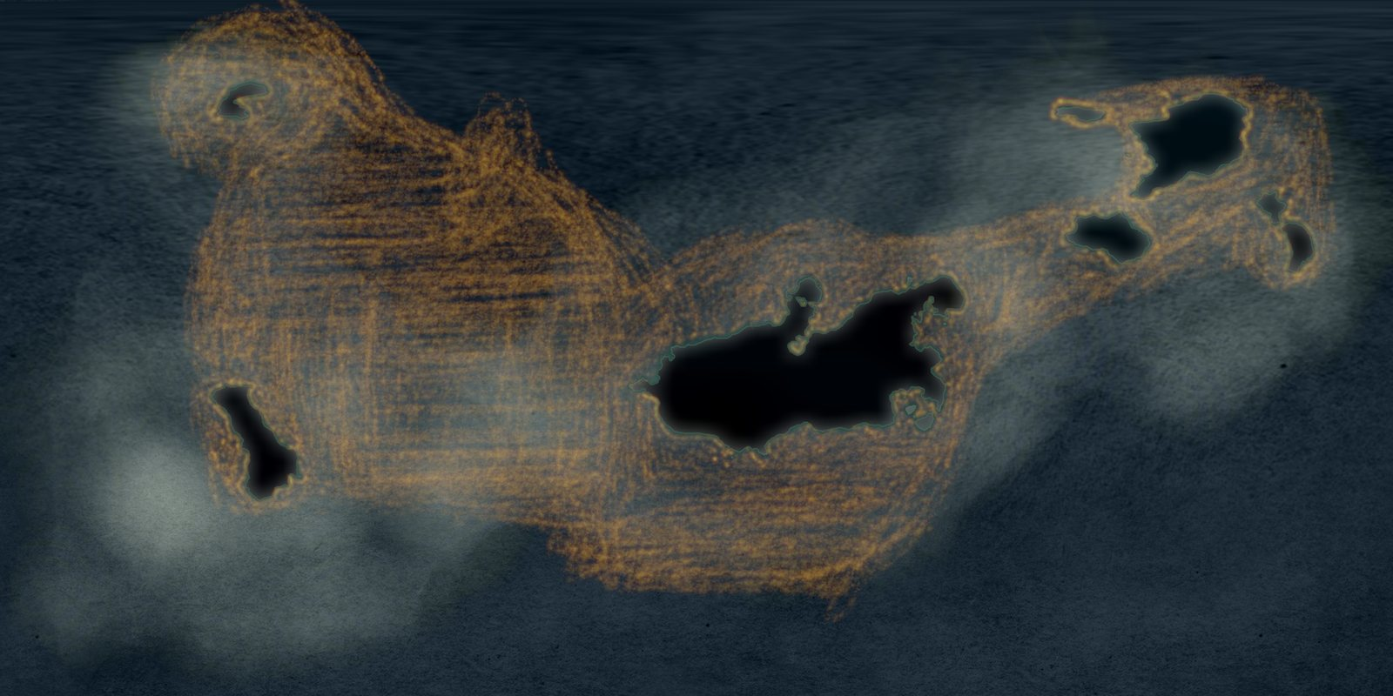
Serensine, from the Planets deck

Industry
- Starship Academy: The Best in the Galaxy. All the top Pilots Come here for training. The academy also Provides the essential service of protecting Serensine from Meteorites.
  - The Academy is located on the largest central lake, Azoce, To safely keep the fledgling pilots away from the cities.
- Tourism: People come from far and wide to visit the hot springs and get away from the city. This planet is considered the most serene in the whole galaxy, although some consider the silence and darkness offputting.
- Agriculture: Vertical farming is the name of the game, most people here work in agricultural factories. Most of this food is then shipped offworld

Murexalt
- Skipping Stones
- Small Satellite planets in debris belt, act as relay stations to bounce communications from Inner To Outer
- Old Crews, watching the sky

Imminfax System
- Imminfax
- Senexoth
- Fulcinis
- Twin Planets

Weather Planet “Fulcinis”
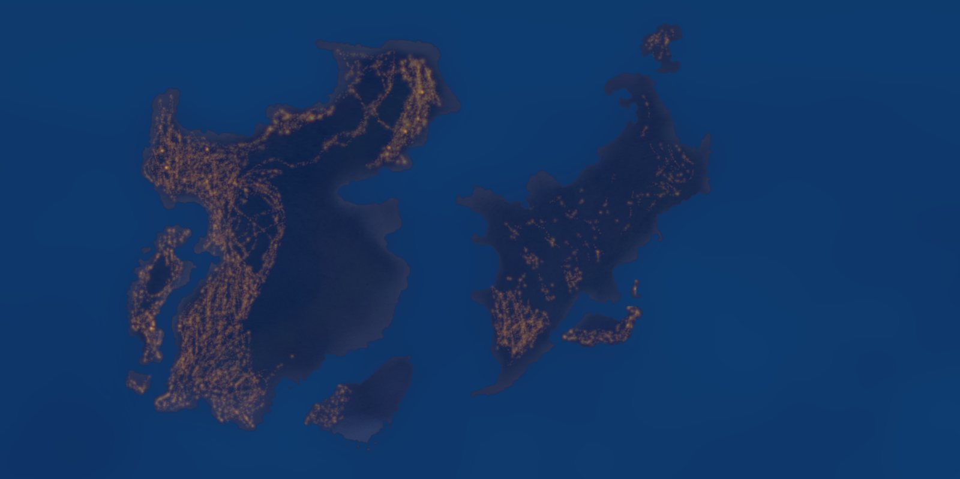
Fulcinis, from the Planets deck

Planetary History
- Historically
- Was one of the initial launch projects, headed by Tor[High rank] Serencoh[Star Toucher], The second head of the official exploration department following their successors step down. The project was to be the first test of their interstellar travel colonies among the basin.
- This being so it’s initial failure came at the hands of unusual planetary anomalies causing distressing effects on the inhabitants. Abandoning it was a difficult decision and one that could potentially haunt the program.
- With faltering support for these distant colonies and the exploration program they had to think on their toes. The solution, a rebranding.
- The planet was to become the only colony to be settled and then resettled. And the resettling had to be grand, shown as triumph over the strange. It’s eventual success would propel the program to where it is now.
- Contemporary
- After leaving the planet some remained amongst the ruinous Ghost Towns in the plains. These areas were notoriously dangerous from various environmental hazards. Those that stayed behind wanted to study the Azoths potential to affect worlds.
- Their presence is considered undesirable as many of their decisions at the fall of the original colony are seen as their failures. Schisms have long formed between the different factions.
- Large “living” storms proliferate on the surface causing havoc for the areas within the lowlands. Other hazards including earthquakes plague the surface.
- Newer colonie cities are more established in the mountainous regions. Due to dealing with the extremes of the planet their infrastructure has grown to be the most robust of the verge. Their factories used to develop new spacecraft and the like.

Planetary Conditions
- Living Storms, Massive and powerful.
- Extreme displays of solar winds
- Weather has forced many to farm either in reinforced greenhouses or underground in many areas.
- The magical interference in part stems from mages in the Ghost Towns, testing the extents of their abilities. Their actions directly correlated with the eventual early fall of the colony.
- Plants that do live above the surface have deep strong roots. These are both a nuisance or a blessing depending on the group. Some of those in the ghost towns use the roots to reinforce structures.
- Creatures are far sturdier in many regions, developing super survival techniques.
- Underground is treacherous but teeming with flora and life. Sinkholes, shifting caverns, deep springs, etc are all highly common.
- Some of these disgraced researchers have attained semi-occult status.
- Individuals are generally better equipped to deal with high altitude and low oxygen.

Geography
- Largely mountainous with large swathes of plains. These plains, are home to many of the ghost town colonies. Many have evolved beyond their original intentions.
- Battered Wall, a mountainous range along the Aeqouent Sea. It is subject to some of the most intense weather, leaving many of the rocks poked with caves and holes.
- Mountains, four primary ranges. Each is home to different colony groups. The primary power being home to the industrial sector on the planet.
  - Altus Peaks: Highest peaks, with lowest valleys between. Least inhabited sector. Politically Varied
  - Vellent Peaks: Seat of power. Heavily inhabited cities trace up the steep mountains.
  - Pixatus Peaks: Cities are variable. Environmental hazards are in high numbers here.
- Ghost Towns
  - Sprawl out often in spider like networks with safety roads between.
  - Stequin, landing site, home of the original seed.
  - Necalte: Ghost towns weaving in and out of the ground
  - Crepitus: unstable region
- Large Plains: Mareba, Grass Seas
  - Mareba Umniloc: Uneven sweeping hills. Has deep valleys with rivers that run from the peaks
  - Mareba Tempurloc: Home of the oldest living storm, largely wetlands. Swampy.
  - Mareba Calciloc: Warm, temperate. Ideal living area, seen as a tourist attraction.
  - Mareba Tallumloc: Mines and old quarries.
  - Mareba Miracloc: Home to some of the planets most untamed areas.
- Wind Swept Trees

Events
- Original Settlement: planet was seen as prime for farming and mining, many of the early colonies were established as bastions for the industries.
- Resonance Failures: several events which were early natural disasters predating the eventual chaos that would become more commonplace.
- Call For Extraction: Much resistance, silent part of history. Sabotage and propaganda against the homeworld. They are trying to take our home, what we fought for. Small skirmishes broke out.
- Rise Of Dangerous Conditions: Some individuals sought to utilize the strange resonance [possible outsider experiment the cause] to push the battle their way, caused greater than intended damage.
- Leaving: After this point many that swore to stand by the world left. Unable to justify the conditions.
- New Settlements
- Magical Conflicts
- Pressure for some of the more pliable ghost towns to rejoin proper society, met with pushback
- Dedicated large space program

Senexoth
- Historically rich, many Azoth incidents predated the area, source unknown. They’ve left little of their presence behind, only their fossils
- Archaeologically significant
- Maze like, arcane ruins criss cross into the surface
- Antiquities, old terrible[terrible as in awful, awful as in just terrible] artifacts
- Resulting world state is significantly behind in all realms technological due to power hungry casters and disasters
- Fossil Planet

