Senexoth: Map

Map of Senexoth
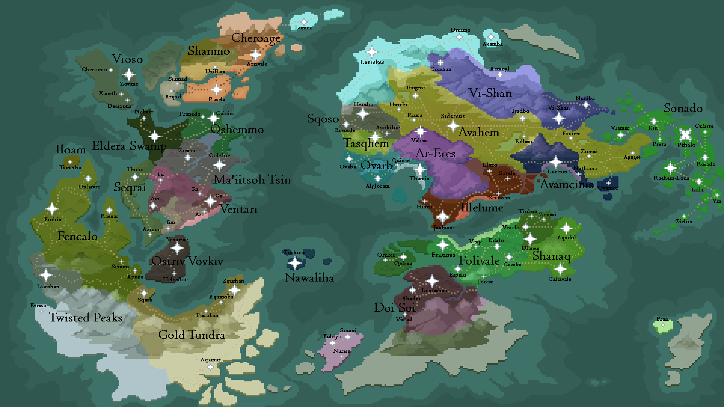
Map of Senexoth with place names

Terrain Map
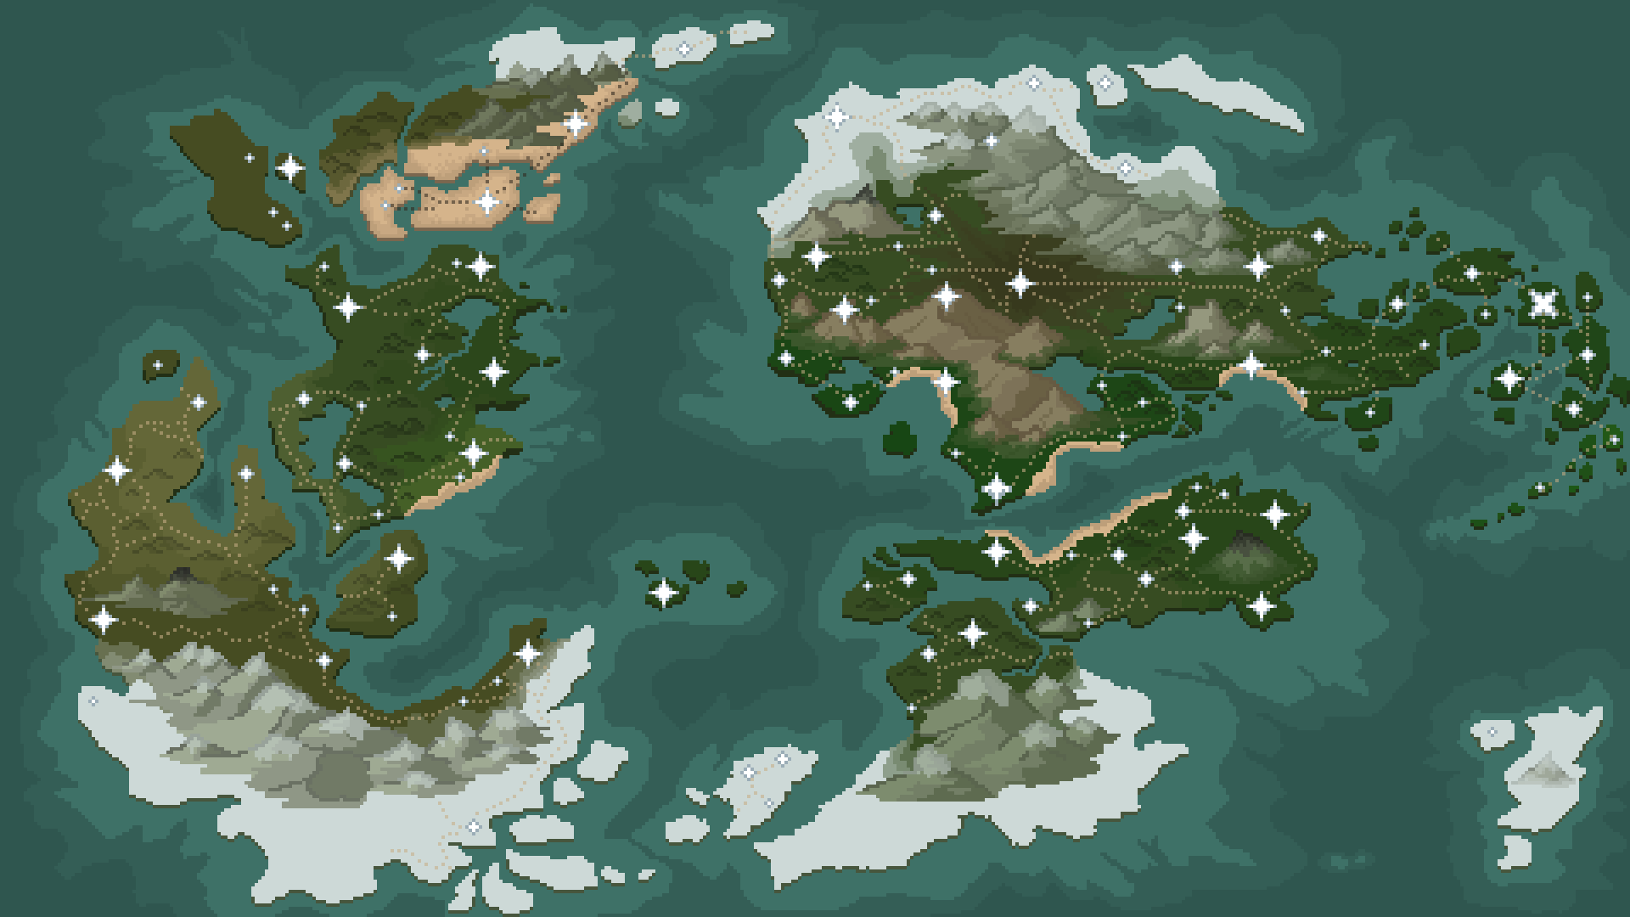
Map of Senexoth, terrain only

