Market Intelligence Research Brief
Student Name: Wisdom Azaglo
Date: 2026-09-06
Topic/Company: Global Video Game Publishing Market — strategic repositioning study for a mid-size publisher (evidence: Kaggle 'Video Game Sales' dataset, gregorut/videogamesales)

1. Research Objective
Objective: Should a mid-size video game publisher continue to prioritize premium console/PC unit-sales publishing, or pivot investment toward recurring monetization, mobile/PC growth platforms and Asia-Pacific distribution? This research supports the FY2027 portfolio and platform-investment decision by combining the company's historical sales dataset (16,598 best-selling titles, 1995-2016) with current external market signals (2024-2026).

2. Scope of Research
Markets or industries covered: INCLUDED - global video game software market: console, PC and mobile publishing; premium (unit-sale) and recurring-monetization (subscription, live-service, microtransaction) business models. EXCLUDED - hardware markets, gaming peripherals, esports/event revenue, gambling-adjacent social casino, and non-game entertainment (film/streaming).
Competitor types included: INCLUDED - mega-publisher consolidators (Tencent, Sony, Microsoft/Activision Blizzard, Nintendo, EA, Ubisoft, Take-Two, Krafton) and the mid-tier independent segment our company belongs to (historical analogue cohort: THQ, Sega, Namco Bandai, Konami). EXCLUDED - pure app-store micro studios and user-generated-content platforms (e.g., Roblox creators).
Timeframe considered: historical baseline 1995-2016 (dataset period, with 2016 treated as incomplete); external signals 2024-2026 with projections to 2028.
Key constraints: lab environment research window (~2 hours of agent/research runtime); dataset covers only titles selling >=100k units and mostly physical retail, so digital and free-to-play revenue are out of scope; external figures are secondary-source aggregates surfaced by Amazon Quick Research.

3. Research Approach
Types of questions asked: (1) descriptive-internal questions over the dataset (publisher shares, annual trajectories, platform generations, regional mix); (2) current-state external questions (market size and growth, platform revenue mix, publisher revenues, pricing norms); (3) structural-change questions (M&A and what it signals, subscription/live-service health, generative-AI cost impact); (4) validation questions (what does the dataset NOT show, where do sources diverge, what confidence should each insight carry).
How research effort was prioritized: the internal dataset was analyzed first to establish a verifiable quantitative baseline (shares and trajectories recomputed from the raw CSV); Quick Research was then scoped to the four decision-critical unknowns (market size/growth, platform mix, consolidation, business-model shifts); finally the agent integrated both and every claim was re-labeled by source type before confidence scoring.
Tools used within Amazon Quick Suite: (1) Space 'WA - Market Intelligence - Video Game Publishing' hosting the Kaggle dataset as the internal knowledge base; (2) Chat agent 'WA - Market Intelligence Agent - VG Publishing' (purpose: analyze dataset + external signals to produce market analysis and leadership brief) used for the internal analysis, integrated analysis and final brief; (3) Quick Research produced the external report 'Global Video Game Publishing Market Intelligence 2024-2026: Competitive Landscape, Platform Trends, and Strategic Risks' (report ID e7c70710); (4) agent chat conversations retained in QuickSuite (screenshots in submission).

4. Key Market Insights

Insight 1 - The market transformed, it did not shrink
Insight Summary: Physical/tracked unit sales peaked at 678.9M units in 2008 and fell ~89.6% through 2016, while the total market grew to $182.7B in 2024 and is projected to ~$227B by 2028 (~4.9% CAGR). Value creation moved from box sales to recurring monetization.
Supporting Evidence or Signals: Dataset: recomputed annual series 678.9M (2008) -> 264.4M (2015) from vgsales.csv [Dataset]. External: market-size path $182.7B -> $227B and 4.9% CAGR from Quick Research report [Quick Research].
Why This Insight Matters: A strategy anchored to unit-sales economics competes in yesterday's market; FY2027 budgeting must price live-ops and content pipelines as the P&L center.

Insight 2 - Consolidation is squeezing mid-tier publishers
Insight Summary: Concentration is structural and accelerating: top-5 publishers already held ~52.7% of historical sales (dataset), and mega-deals (Microsoft-Activision $68.7B; Take-Two-Zynga $12.7B; reported $55B EA buyout involving Saudi PIF) create an oligopoly with higher barriers for mid-tier firms.
Supporting Evidence or Signals: Dataset: top-5 share 52.7%, Gen7->Gen8 concentration 54.4%->60.5%; THQ arc 33.3M (2007) -> 0.4M (2013) precedes its bankruptcy [Dataset]. External: named transactions above [Quick Research].
Why This Insight Matters: Independence becomes a strategic option with an expiry date: differentiate (IP, community, efficiency) or position for sale.

Insight 3 - Mobile and PC are the growth vectors; console is mature
Insight Summary: The dataset was 72.6% console / 2.9% PC, but today mobile is ~55% of revenue (~$108B) and PC is growing +10.4% YoY while console is flat-to-mature.
Supporting Evidence or Signals: Dataset: platform shares recomputed (console 72.6%, handheld 22.4%, PC 2.9%) [Dataset]. External: mobile ~55%/$108B and PC +10.4% YoY [Quick Research].
Why This Insight Matters: Over-indexing on premium console under-exposes us to the two fastest monetization surfaces; PC ports and mobile adaptations of catalog IP are the cheapest re-entry.

Insight 4 - Geographic gravity shifted to Asia-Pacific
Insight Summary: North America's share already declined 51.4% -> 47.6% late in the dataset while 'Other' regions ~doubled; APAC is now the largest games region globally.
Supporting Evidence or Signals: Dataset: regional mix recomputed (NA 49.2%, EU 27.3%, JP 14.5%, Other 8.9% overall with declining NA trendline) [Dataset]. External: APAC leadership and mobile-first monetization [Quick Research].
Why This Insight Matters: Growth plans need APAC-aware distribution, localization and monetization rather than NA-first launches.

Insight 5 - Generative AI is a cost lever but culturally contested
Insight Summary: AAA budgets now $200-400M per title; GenAI could cut development costs by nearly half (Morgan Stanley estimate), but player backlash and workforce concerns constrain adoption.
Supporting Evidence or Signals: External only: Quick Research report, citing Morgan Stanley and recent launch failures (e.g., Sony's Concord as a live-service warning signal) [Quick Research]. No dataset support (costs are out of dataset scope).
Why This Insight Matters: First-mover cost advantage is real but must be deployed quietly in non-narrative pipelines to avoid brand damage.

5. Visual Evidence
Chart Type: horizontal bar chart (top-10 publishers) combined with a line chart (annual global unit sales 1995-2015) - 'decision_chart.png', built from the raw Kaggle CSV and mirrored in the agent's tabular outputs.
What the visualization shows: Nintendo leads with ~1,787M units (20.0% share) ahead of EA (1,110M), Activision (727M), Sony (608M); the line chart shows the 2008 peak (678.9M) and sustained decline to 2015 (264.4M), annotated with the current $182.7B/$227B external context.
How it supports the insight: the bar panel evidences the concentration behind Insight 2; the line panel evidences the unit-sales decay vs. revenue-growth divergence behind Insight 1.
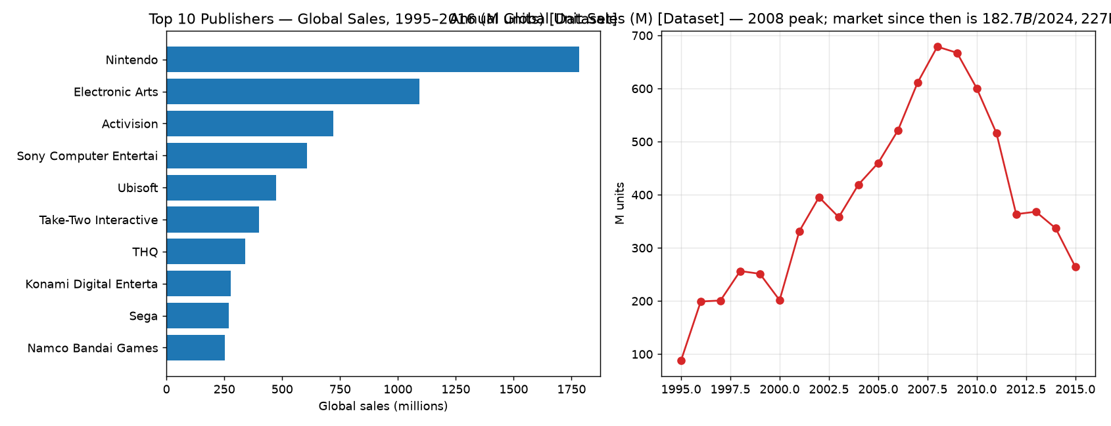

6. Confidence Assessment
Source quality: Internal evidence is a public Kaggle dataset recomputed from raw CSV (verifiable, high quality for its coverage window). External evidence comes from Quick Research surfacing market-research aggregates and one bank estimate (useful, but secondary and partly single-sourced).
Consistency across sources: High consistency on direction (growth, concentration, platform shift, APAC rise) between dataset trends and external report; magnitudes differ by definition (units vs revenue). The EA $55B buyout figure is the least corroborated item.
Timeliness of information: Dataset ends mid-2016 (2016 row incomplete) - stale by design; external signals captured 2026-09-06 describing 2024-2026 (fresh). Insight 5 is current-only and therefore lowest confidence.
Overall confidence level: Medium-High overall. Per insight: I1 High, I2 High (Medium on EA deal figure), I3 High/Medium, I4 Medium, I5 Low-Medium.

7. Limitations and Risks
Missing data: digital storefront, mobile and free-to-play revenue absent from the dataset; no development-cost, margin or engagement (hours/DAU) data anywhere; post-2016 internal coverage gap of ~10 years.
Conflicting signals: unit-sales collapse (-89.6%) vs. revenue growth (+5%/yr) looks contradictory until the revenue-model shift is acknowledged; 'subscription is the future' vs. Game Pass subscriber losses after a 50% price rise - the two external signals conflict and were presented as a recalibration rather than a trend kill.
Potential bias or ambiguity: dataset lists only >=100k-unit retail titles (survivorship + retail bias, pre-merger publisher identities); Quick Research aggregates may double-count consumer-spend categories; all artifacts were drafted by one agent configured by me, mitigated by manual recomputation from raw CSV but selection bias remains possible.

8. Strategic Implications
What decisions could this inform? (1) FY2027 investment mix: fund live-ops/recurring-monetization capability on existing IPs and a PC/mobile port program for catalog titles; (2) market strategy: APAC-aware publishing partnerships and localization budget; (3) corporate strategy: periodically re-test independence vs. sale-to-consolidator options as concentration rises; (4) production: pilot GenAI in non-narrative asset pipelines while monitoring community sentiment.
What should not be concluded from this research? (1) Do NOT conclude the industry 'shrank' between 2008-2016 - the unit-sales decline measures a data-source shift (retail-tracked bestsellers) not demand; (2) do NOT treat the 2016 datapoint as a real market collapse (reporting lag) nor the ~89.6% decline as current-state risk; (3) do NOT conclude subscriptions are failing overall from the Game Pass pricing episode alone; (4) do NOT use the EA $55B figure as settled fact until confirmed by primary deal disclosures.

9. Summary for Leadership
Between our dataset era and today, the video game market moved from $8.8B units of tracked retail sales (1995-2016) to a $182.7B (2024) revenue market growing ~5% per year toward ~$227B by 2028 - the demand curve never broke, only the monetization model did. Growth now sits in mobile (~55% of revenue) and a resurgent PC segment, while premium console unit sales we historically optimized are a mature slice. Publisher power is concentrating through record M&A (Microsoft-Activision $68.7B, Take-Two-Zynga $12.7B, reported EA buyout), which squeezes mid-tier publishers from both cost and distribution sides - the dataset's own history shows the end-state risk (THQ fell from 33.3M units in 2007 to near zero by 2013). Generative AI may halve AAA production costs but carries community backlash risk. Geographic gravity has moved to Asia-Pacific, and subscription/live-service pricing power is weaker than assumed after the Game Pass 50%-price-increase backlash. Overall confidence is Medium-High: every insight is corroborated by two independent evidence bases, with magnitudes that rely on external aggregates carrying lower confidence. Recommended immediate steps: stand up a recurring-monetization/live-ops capability on one flagship IP, launch a PC/mobile port program, and open APAC distribution partnerships this fiscal year.

