Lecture 3 Lab Session
  - RV32I Instructions and Programs
Student handout | 120 minutes | Individual report with paired exploration
Name: Student Handout Solution Student ID: RV32-LAB3-2026 Date: November 11, 2026
In this lab, you will make a small processor program explainable. Predict what each instruction changes, execute it in a simulator, and use register and memory evidence to explain the result. The main experiment uses the lecture array [3, -1, 4].

Learning outcomes
- Trace arithmetic instructions using current register values and the program counter.
- Distinguish an address from the value stored there; explain word and byte transfers.
- Verify an array loop for empty and nonempty inputs, including its stopping condition.
- Diagnose the first incorrect state and package the loop as a simple function.

Session schedule
Minutes | Activity | Evidence to keep
0–10 | Setup and prediction routine | RV32 setting and actual addresses
10–25 | A Registers and instruction effects | Completed state table
25–45 | B Memory and byte transfers | Byte map and load results
45–80 | C Array sum and instruction count | Boundary tests and loop snapshots
80–100 | D Debug three mutations | First failure and repair
100–115 | E Turn the loop into a function | Working code and preserved state
115–120 | Exit ticket and submission | Short explanations

Before starting
Review lecture slides 7–18, 19–33 and 34–65. For byte transfers and functions, use slides 71–79 and 83–90. You should know hexadecimal notation, two’s complement and basic while loops. All arrays in this lab contain 32-bit integers.

Setup and working rules
- Download RARS 1.6 from the official link on the final page. Start the jar with Java, for example: java -jar rars1_6.jar. The instructor should prepare this before class.
- Use the default RV32 mode and Default memory configuration. Ensure RV64 mode is off. Assemble only the file you are working on; turn off any option that assembles every file in its directory.
- Open 01_register_trace.s, assemble it, and locate the text, register and data displays. Check the assembled Basic instruction column when the source uses la or li.
- Set a breakpoint on the instruction next to the named label. A breakpoint stops before that instruction. Use single step to execute one real machine instruction and observe the new state.
- After changing n, data or code, save and reassemble. Start each independent test from its initial state. A reset of only the PC does not restore overwritten memory.

Keep the teaching model consistent
Use 32-bit registers, byte-addressed little-endian memory and ordinary 4-byte RV32I instructions. A word occupies four bytes. Observe the assembled addresses; the lecture’s data base 0x1000 and zero-based instruction listing are illustrative, not addresses to type into RARS.
Let B mean the actual array base and S mean the actual address of trace_start. Write both once and express later addresses as B+offset or S+offset. Offsets are in bytes unless explicitly stated otherwise.
Numbered name | ABI alias | Use in this lab
x0 | zero | Always reads zero
x5, x6, x7 | t0, t1, t2 | Sum, index, pointer in Task C
x8 | s0 | Temporary only in standalone Task C
x10, x11 | a0, a1 | Base and length inputs
x28 | t3 | Temporary in the Task E function
x1, x2 | ra, sp | Return address and stack pointer

The assembler conveniences la and li may expand into multiple instructions. Task C excludes its input wrapper from the count. The final a7=10 / ecall sequence exits RARS; it is outside the experiment’s counted region and is not a portable operating-system interface.
For every task, write a prediction before running. If the observation differs, locate the first differing instruction before changing the program.

Task A Register trace
Time 15 minutes | File 01_register_trace.s | Lecture slides 7–18
The setup establishes x5=9, x6=4 and x7=0. Stop at trace_start. The following four instructions form the experiment.
sub x7, x5, x6
addi x5, x7, -1
add x6, x5, x7
add x0, x5, x6

- Fill the prediction table without running the code. Each row describes the state after that instruction.
- Single-step the four instructions and compare the observed values. Stop at lab_done before its nop.
- Record the PC immediately before and after the first sub. Explain the change in bytes.
- Find the machine-code word for sub in the assembled display. Explain why source text and machine encoding are two representations of the same operation.
After instruction | x5 | x6 | x7 | x0
Initial state | 9 | 4 | 0 | 0
sub x7, x5, x6 | 9 | 4 | 5 | 0
addi x5, x7, -1 | 4 | 4 | 5 | 0
add x6, x5, x7 | 4 | 9 | 5 | 0
add x0, x5, x6 | 4 | 9 | 5 | 0

PC before sub: 0x0000000C (12) PC after sub: 0x00000010 (16)
Explanation: In RV32I, all base instructions are strictly 4 bytes (32 bits) wide, and memory is byte-addressed. Sequential execution advances the Program Counter by exactly +4 bytes (from 0x0C to 0x10). The machine-code word for "sub x7, x5, x6" is 0x006283b3 (funct7=0x00, rs2=x6/00110, rs1=x5/00101, funct3=0x0, rd=x7/00111, opcode=0x33/0110011). Assembly mnemonics and 32-bit machine words are two equivalent representations of the same operation: assembly is human-readable symbolic text, while the machine word is the exact binary encoding executed by processor hardware.
A1 Why does the third instruction use the new x5 value?
Answer: Instructions execute in strict sequential program order. The second instruction (addi x5, x7, -1) computes 5 - 1 = 4 and commits this value into destination register x5 before the third instruction (add x6, x5, x7) reads x5 as its source operand. In hardware datapaths, the updated value is available immediately.

A2 The last addition calculates a value. Why does x0 still contain zero?
Answer: In the RISC-V RV32I architecture, register x0 is hardwired to constant zero. Although the ALU calculates 4 + 9 = 13, any write to register x0 is permanently discarded by hardware logic, ensuring x0 always reads 0x00000000.

Checkpoint: show your state table to your partner. Identify a source register that is unchanged by each of the first three instructions.
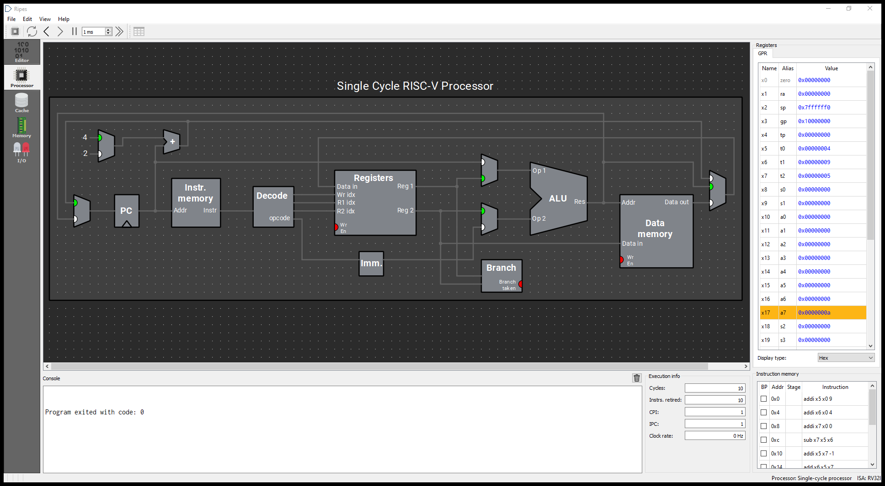
Figure A: Ripes execution proof for Task A (01_register_trace.s) showing register updates and 10 instructions retired.

Task B Memory and byte transfers
Time 20 minutes | File 02_memory_bytes.s | Lecture slides 19–29 and 71–79
This is a fresh memory experiment. Let M be the assembled address of sample. A word store first writes 0x12345678; a byte store then overwrites only the byte at M+1.
la t0, sample
li t1, 0x12345678
sw t1, 0(t0)
word_stored:
addi t2, x0, -17
sb t2, 1(t0)
bytes_changed:
lw t3, 0(t0)
lb t4, 1(t0)
lbu t5, 1(t0)

- Predict the four bytes after sw. Run to word_stored and inspect memory.
- Predict which byte sb changes. Run to bytes_changed. Record the bytes in increasing address order, then reconstruct the new 32-bit word.
- Predict t3, t4 and t5; run to lab_done and compare. Show all three as eight-digit hexadecimal values. Also give signed decimal t4 and unsigned decimal t5.
Checkpoint | M | M+1 | M+2 | M+3
After sw | 0x78 | 0x56 | 0x34 | 0x12
After sb | 0x78 | 0xEF | 0x34 | 0x12

Actual M: 0x10000000 t3: 0x1234EF78 t4: 0xFFFFFFEF (-17 signed) t5: 0x000000EF (239 unsigned)
B1 Why do lb and lbu read the same byte but produce different 32-bit values?
Answer: Both instructions read the exact same 8-bit byte from address M+1, which is 0xEF (binary 1110 1111). "lb" (load byte, signed) performs sign extension: it copies bit 7 (which is 1) across bits 31..8, resulting in 0xFFFFFFEF (signed decimal -17). In contrast, "lbu" (load byte unsigned) performs zero extension: it fills bits 31..8 with zeros regardless of bit 7, yielding 0x000000EF (unsigned decimal 239).

B2 Does sw or sb change t0 or t1? How many bytes does each store write?
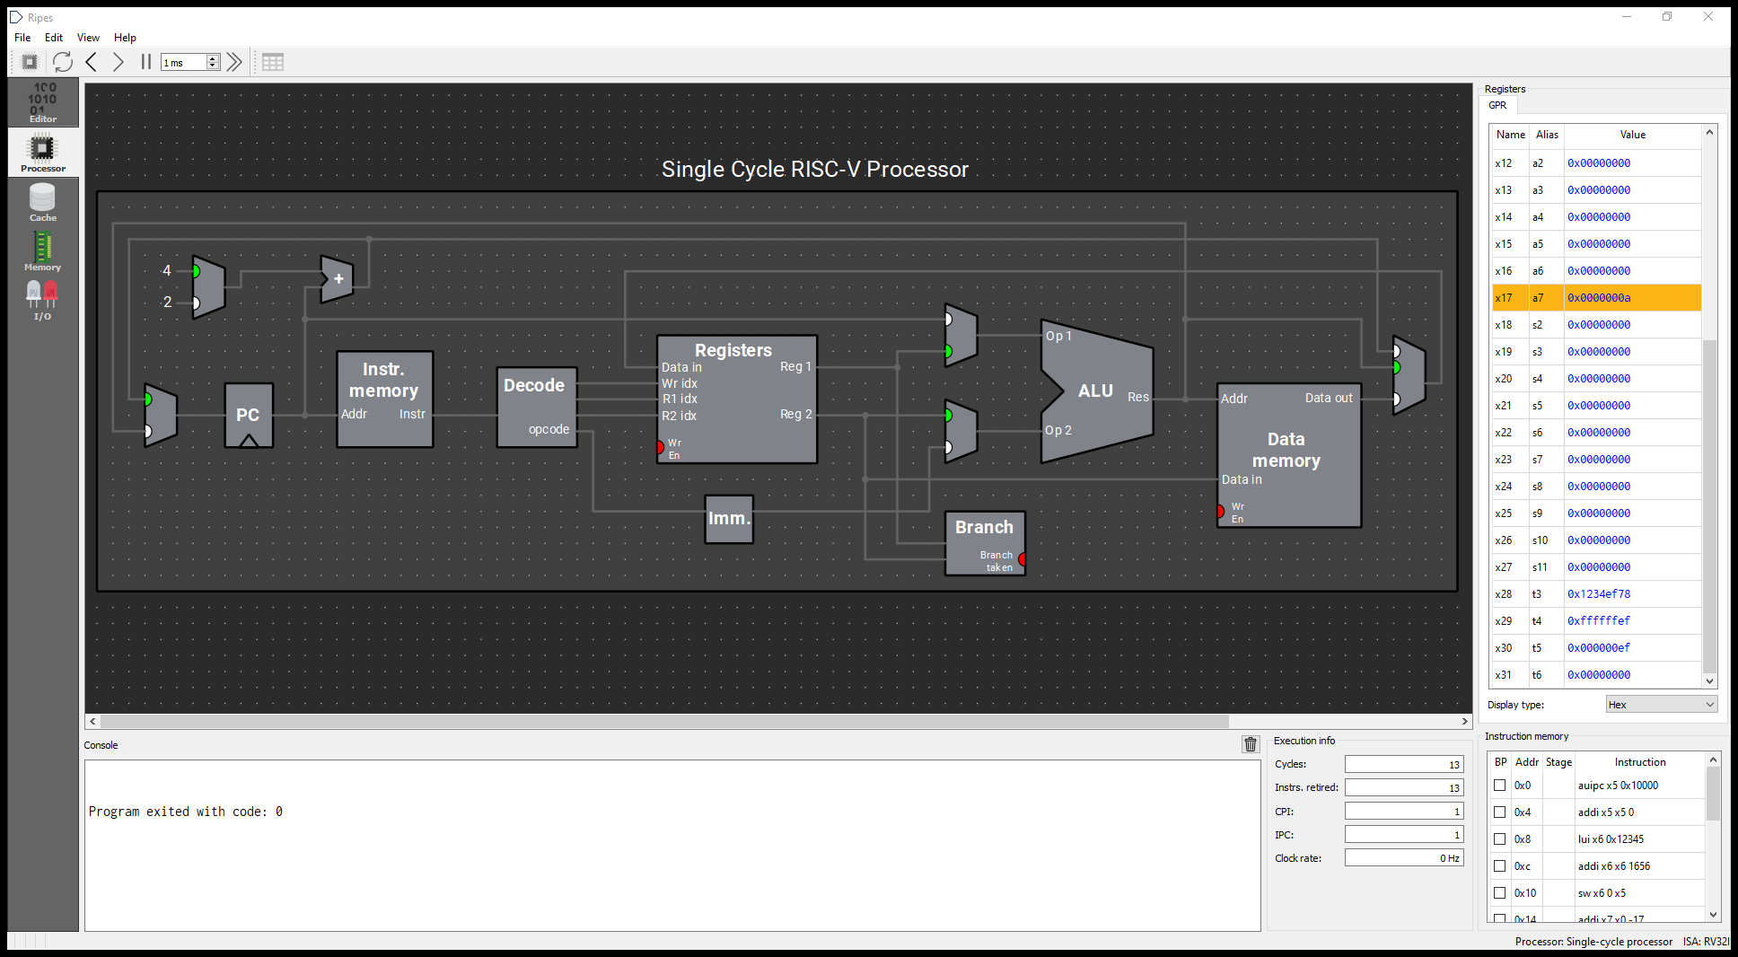
Figure B: Ripes execution proof for Task B (02_memory_bytes.s) showing t3=0x1234ef78, t4=0xffffffef (-17), and t5=0x000000ef (239).
Answer: Neither sw nor sb changes registers t0 or t1. Store instructions transfer data from CPU registers into memory; they do not write to general-purpose registers. "sw" writes a full 32-bit word (4 contiguous bytes: M through M+3), while "sb" writes exactly 1 byte (8 bits: M+1 only).

If the data panel shows whole words, use little-endian decomposition to fill the byte table. Do not reverse the displayed word value itself.

Task C Trace the lecture array program
Time 35 minutes across this page and the next | File 03_array_sum.s
The wrapper loads the actual array base into x10, sets the selected length in x11, and clears x8 to zero. These are input preparation. Begin counting at trace_start and stop when the PC reaches end, before executing its nop.
trace_start:
addi x5, x0, 0 # running sum
addi x6, x0, 0 # processed element count
addi x7, x10, 0 # current pointer
loop:
beq x6, x11, end
lw x8, 0(x7)
add x5, x5, x8
addi x7, x7, 4
addi x6, x6, 1
jal x0, loop
end:
addi x0, x0, 0 # stop BEFORE this instruction

Label or instruction | Address relative to S | Purpose
trace_start | S+0x00 | Initialize the sum
loop / beq | S+0x0C | Test before memory access
lw | S+0x10 | Read one word
jal x0, loop | S+0x20 | Return to the condition
end / nop | S+0x24 | Stopping point, not counted

- Write B and S from the assembled program. Predict the n=3 run before stepping.
- Set breakpoints at trace_start, loop and end. Capture each state immediately BEFORE loop’s beq executes, including the final visit that exits.
- At each checkpoint, record x5, x6, x7 and x8. To continue from a loop breakpoint, single-step the beq and then run to the next breakpoint.
- For each load, record the effective address and the value read. After a pointer update, inspect x8 again: did changing the address also load the next value?
This is a standalone trace. Its use of x8 is copied from the lecture. In Task E, you must observe the function calling convention because x8 is also the callee-saved register s0.

Task C Boundary cases and counting
For n=3, fill these snapshots immediately before beq. B is the actual array base. The wrapper initializes x8 to zero so an empty run has an explicit unchanged sentinel.
Elements processed | x5 sum | x6 index | x7 pointer | x8 last load
0 | 0 | 0 | B (0x10000000) | 0 (sentinel)
1 | 3 | 1 | B+4 (0x10000004) | 3
2 | 2 | 2 | B+8 (0x10000008) | -1
3 | 6 | 3 | B+12 (0x1000000C) | 4

Reassemble and test n=0, 1, 2 and 3. Only change the INPUT_N line. The input contract is 0 ≤ n ≤ the number of allocated elements. Predict first; record observations in your report.
n | Final sum | Final index | Final pointer | Last load address | Instruction count
0 | 0 | 0 | B (0x10000000) | None (no load) | 4
1 | 3 | 1 | B+4 (0x10000004) | B (0x10000000) | 10
2 | 2 | 2 | B+8 (0x10000008) | B+4 (0x10000004) | 16
3 | 6 | 3 | B+12 (0x1000000C) | B+8 (0x10000008) | 22

Count exactly the same region as the lecture
Count executed real instructions from trace_start until the PC first reaches end. Include the final taken beq. Exclude the input wrapper, end nop and RARS exit sequence. A whole-program counter includes a different region and is not directly comparable.
Group | Executions for length n
Three initialization instructions | 3 (initialization: addi x5, addi x6, addi x7)
Condition test | n + 1 (condition test: beq x6, x11, end; evaluated n times true + 1 exit)
Body and jump back | 5n (loop body: lw, add, addi x7, addi x6, jal; 5 instructions * n iterations)
Total | 6n + 4 (Verification: n=0: 4; n=1: 10; n=2: 16; n=3: 22)

C1 For n=0, which instruction prevents an array load? What evidence confirms this?
Answer: The "beq x6, x11, end" instruction prevents the load. Since x6 = 0 and x11 = 0 initially, the equality condition is true on the very first evaluation, jumping directly to "end" and skipping "lw x8, 0(x7)". Evidence: (1) register x8 retains its initial pre-loop sentinel value 0x00000000; (2) pointer register x7 remains at base address B without advancing; and (3) exactly 4 dynamic instructions retire from trace_start to end.
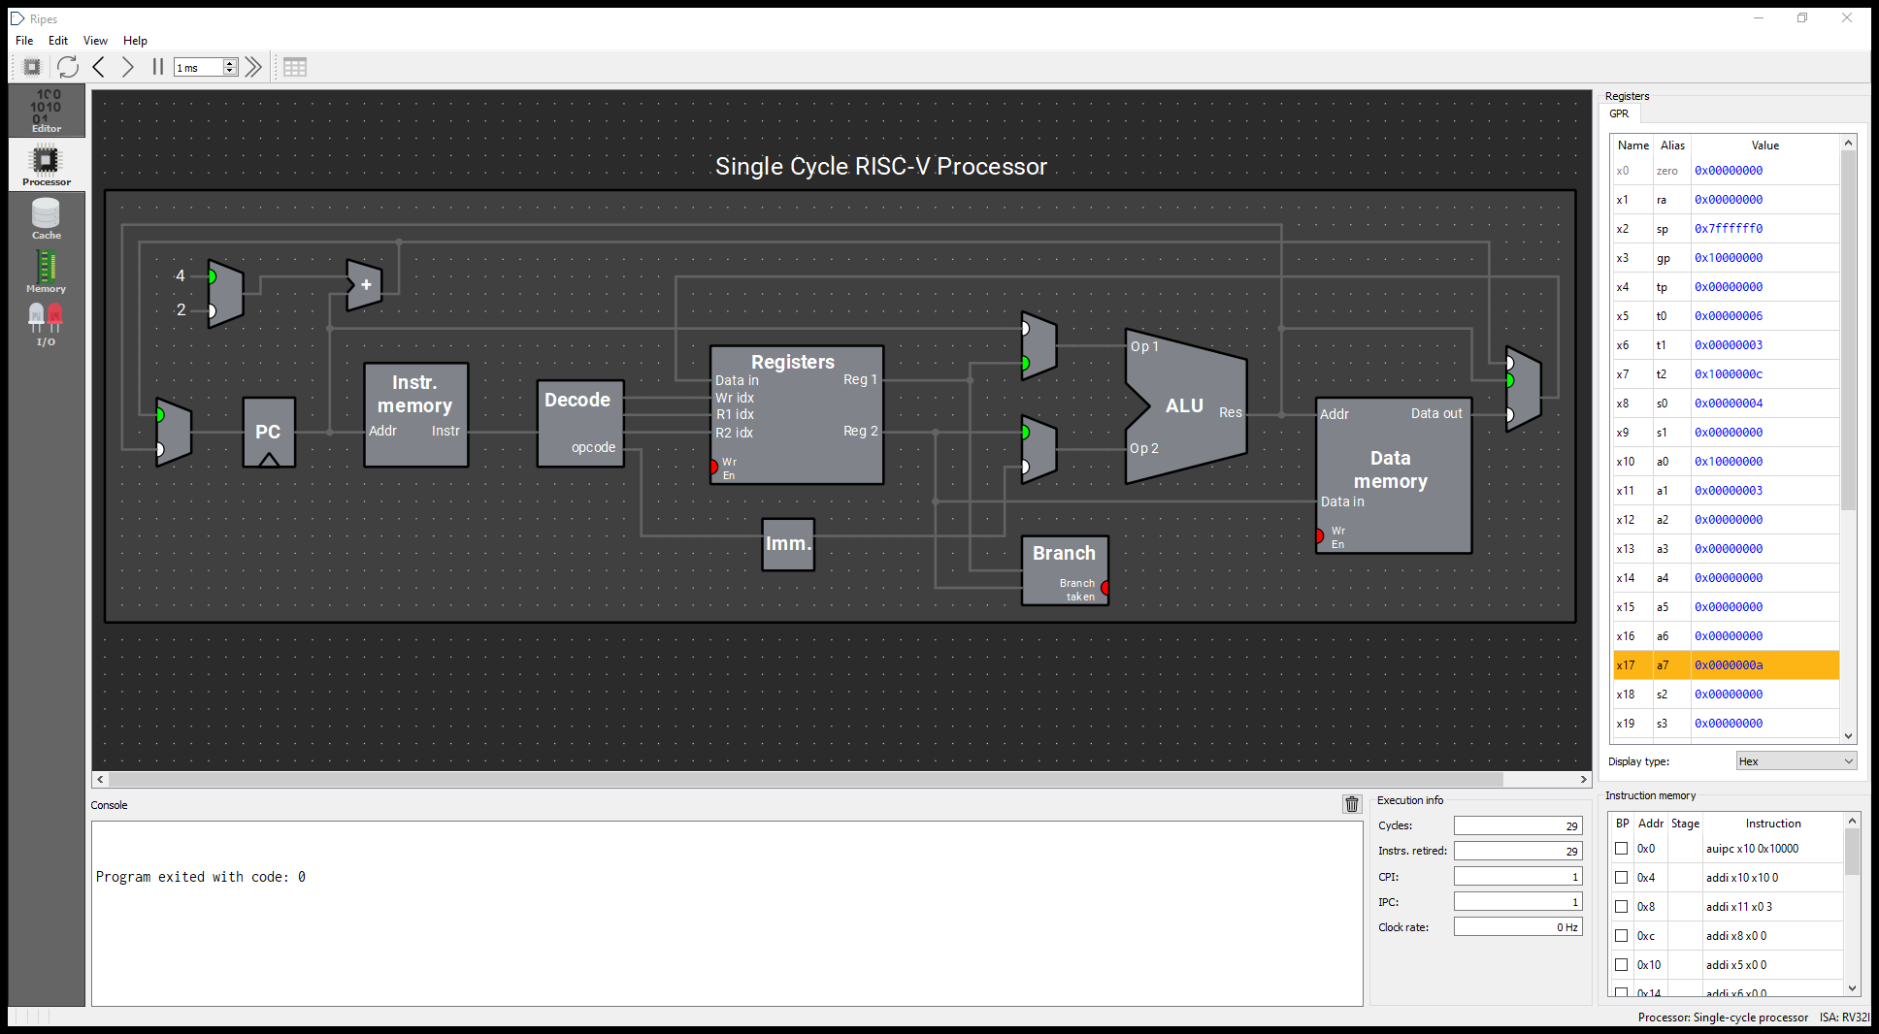
Figure C1: Ripes execution proof for Task C with n=3 (array sum = 6, pointer = B+12, 29 total retired cycles).
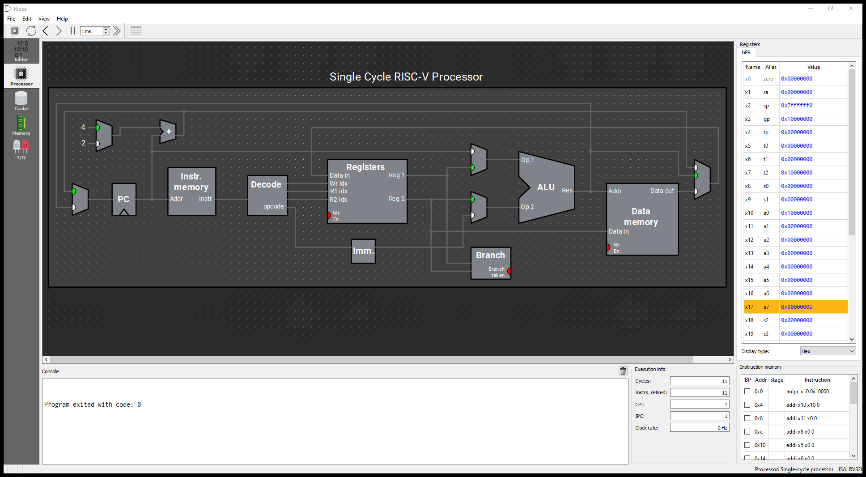
Figure C2: Ripes execution proof for Task C with n=0 (empty array boundary test; x8 remains sentinel 0).
C2 At the final checkpoint for n=3, why can x7 be one word beyond the array?
Answer: In iteration 3, after "lw" loads the final element (array[2]=4 at address B+8), the instruction "addi x7, x7, 4" advances the pointer to B+12 in preparation for a hypothetical next iteration. Then index x6 increments to 3 and branches back to "loop". At the condition test "beq x6, x11, end", 3 == 3 evaluates to true and branches to "end" before any load occurs. Advancing x7 is speculative for the next iteration, but no memory access occurs at B+12.

Transfer test
Transfer test results (array=[5, -2, 9], n=2): Predicted sum = 3, Observed sum = 3; Final index x6 = 2; Final pointer x7 = B+8 (0x10000008); Last load address = B+4 (0x10000004); Dynamic instruction count = 6(2)+4 = 16. The value 9 is NOT read from memory because n=2 restricts execution to indices 0 and 1; the loop cleanly terminates when index x6 reaches 2 before attempting to load index 2 (value 9 at B+8).

Task D Find the first incorrect state
Time 20 minutes | Work on three separate copies of 03_array_sum.s
Introduce only one mutation at a time. Predict the earliest failure, run the indicated test, and repair the code. Reassemble between tests. Explain the first incorrect state or access rather than reporting only a wrong final sum.

D1 Advance by the wrong unit
addi x7, x7, 1 # replace the original +4

Use the original array with n=3. Step through the first pointer update and the next load. Record the new address and the simulator’s response. Explain why a 32-bit word array needs a four-byte stride.

D2 Read before checking the length
Move the existing lw above beq, removing it from its original position. The start of the loop now reads:
loop:
lw x8, 0(x7)
beq x6, x11, end
add x5, x5, x8
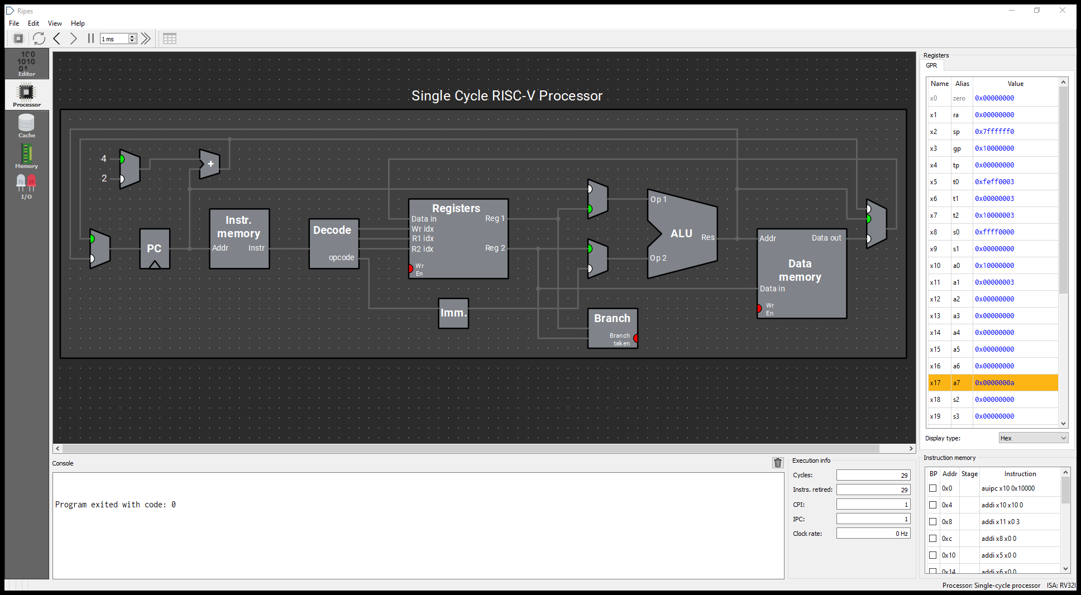
Figure D1: Ripes execution proof for Mutation D1 (wrong stride +1 instead of +4 causing unaligned read and wrong sum).
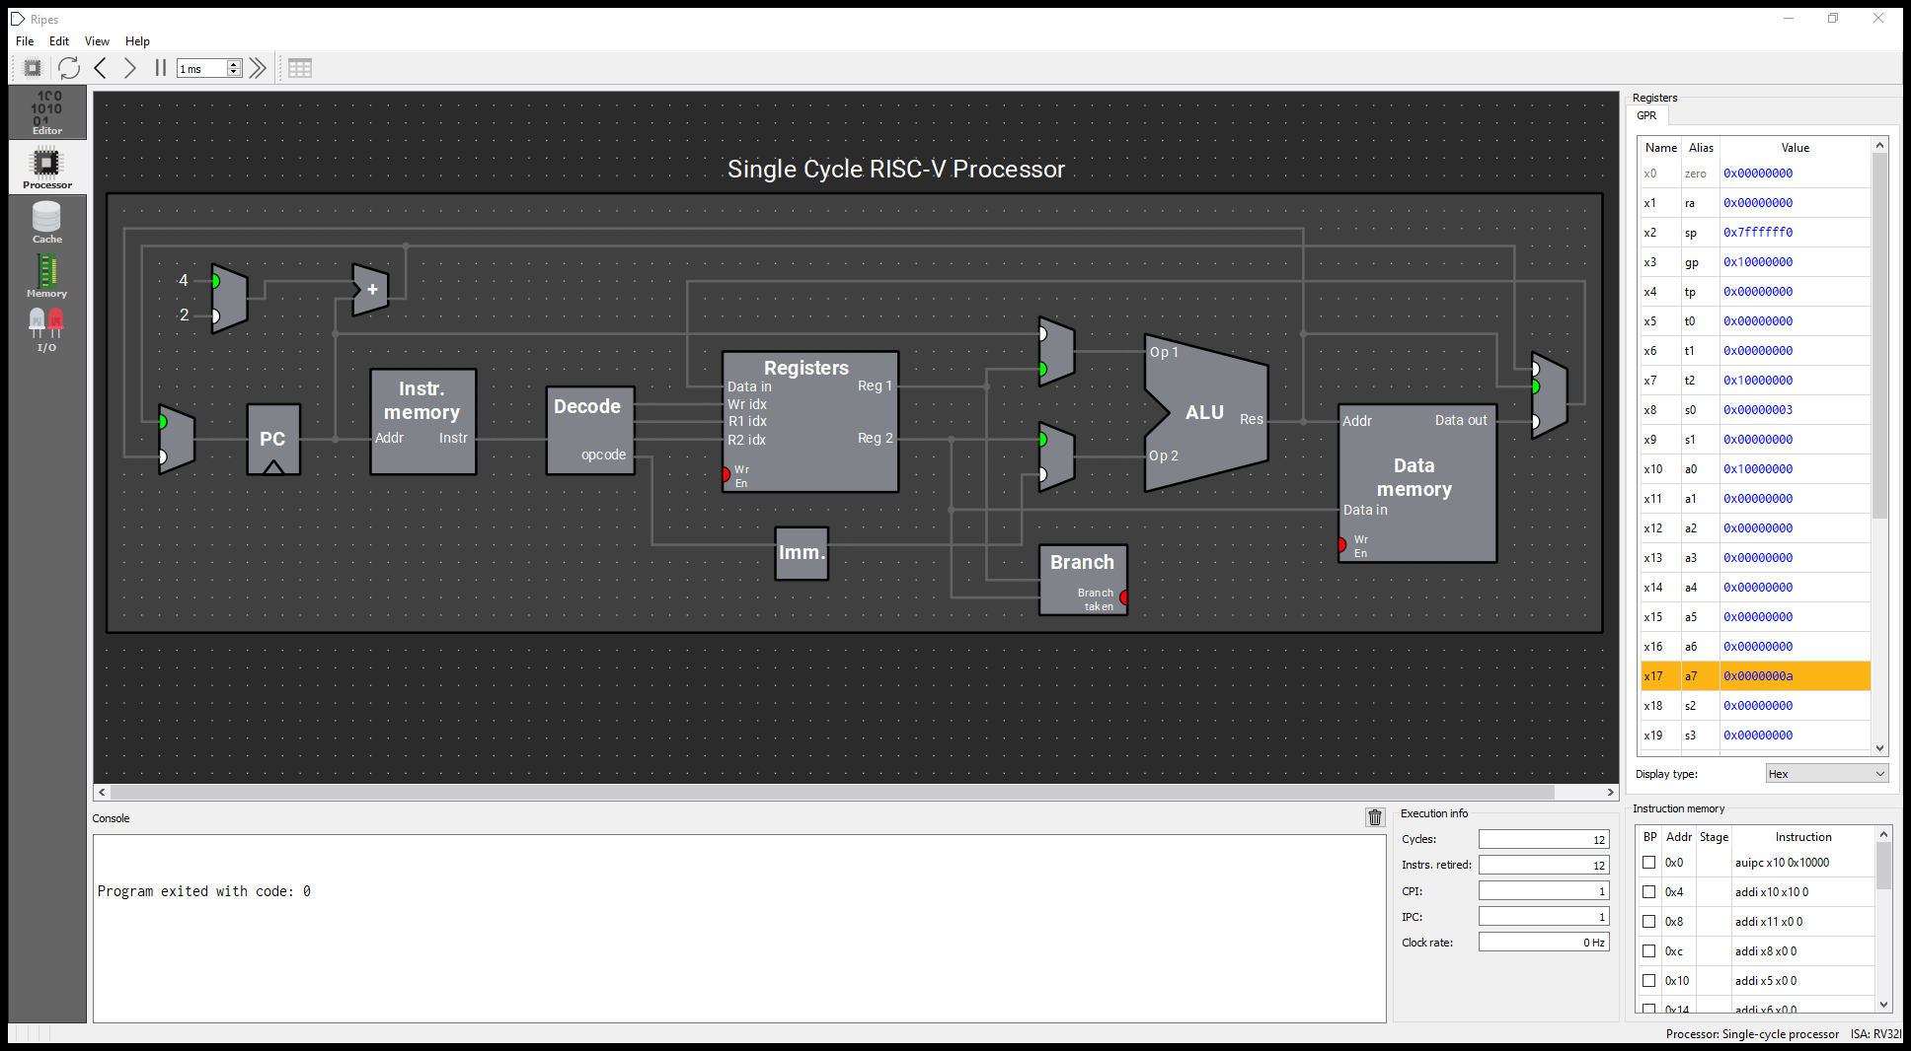
Figure D2: Ripes execution proof for Mutation D2 (premature read: x8 overwritten with 3 when n=0).

Set n=0 and keep x8 initialized to zero in the wrapper. Observe x8 at end. The final sum can still be zero: explain why that alone does not establish correctness. An allocated array is present, so an unwanted read need not trigger an address error.

D3 Stop updating the index
Delete addi x6, x6, 1 and use n=3. Single-step only two loop iterations, then stop. Compare x6 with x7. Do not run this mutation indefinitely; it eventually reads beyond the intended array.
Bug | First incorrect state or access | Repair and retest result
D1 | In iteration 2 (x6=1), pointer x7 is B+1 instead of B+4. Instruction lw x8, 0(x7) performs an unaligned word load across byte boundaries [B+1..B+4], loading corrupted data (0x0400ffff instead of -1) and yielding an incorrect sum of 3. | Repair: Change addi x7, x7, 1 back to addi x7, x7, 4 (stride must be 4 bytes per 32-bit word). Retest: x7 advances cleanly by 4 bytes; final sum correctly equals 6.
D2 | For n=0 with sentinel x8=0, lw x8, 0(x7) executes unconditionally BEFORE beq tests the length. Even though n=0 requires zero memory loads, x8 is erroneously overwritten with array[0]=3 (an illegal speculative read). | Repair: Move beq x6, x11, end back BEFORE lw x8, 0(x7) (check-before-access paradigm). Retest: with n=0, loop branches immediately to end; x8 remains sentinel 0.
D3 | In iteration 2, x6 remains 0 instead of 1, while x7 advances to B+4. Because x6 never increments, the termination condition x6 == x11 (3) is never satisfied, causing an infinite loop that reads past array bounds. | Repair: Restore addi x6, x6, 1 inside the loop body. Retest: index increments properly each iteration; loop terminates cleanly after 3 iterations with sum=6.

D4 Which test would you choose first when checking whether a loop reads too early?
Answer: Test with n = 0 (the empty array boundary test) with an explicit pre-cleared sentinel in destination register x8 (e.g., x8 = 0). For an empty collection (n=0), zero elements exist, so a correct loop must never touch memory. If "lw" is placed before the condition check, running with n=0 immediately executes the load instruction and alters the sentinel register value, instantly exposing the premature read without requiring memory page faults.
Checkpoint: restore the original program and demonstrate that n=0 and n=3 both pass. Keep one clear trace or screenshot of a fault and its repaired run.

Task E Make a callable sum function
Time 15 minutes | File 04_sum_function_starter.s | Lecture slides 83–90
The caller passes a0=base and a1=n, then executes jal ra, sum_array. Your function returns the sum in a0. The supplied placeholder always returns zero; replace it with a working loop.
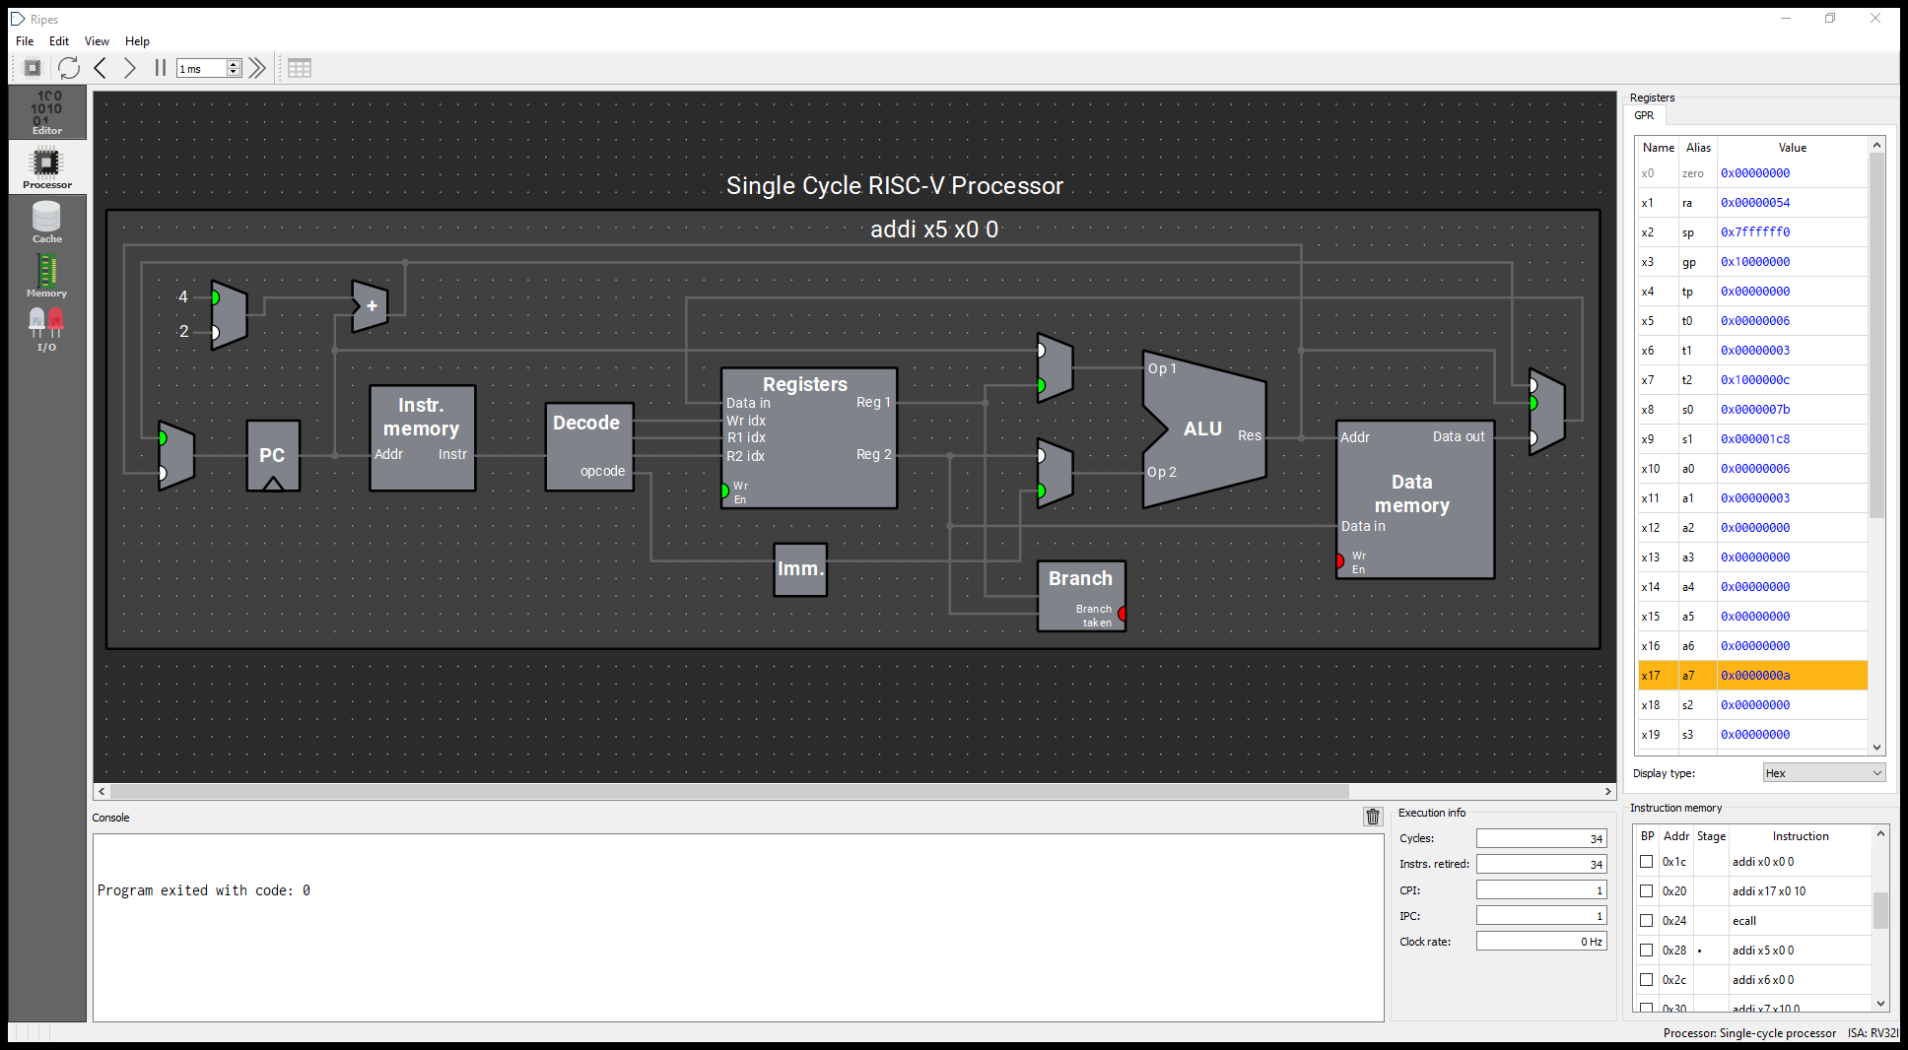
Figure E1: Ripes execution proof for Task E function with n=3 (a0=6, caller s0=123, s1=456, and sp preserved).
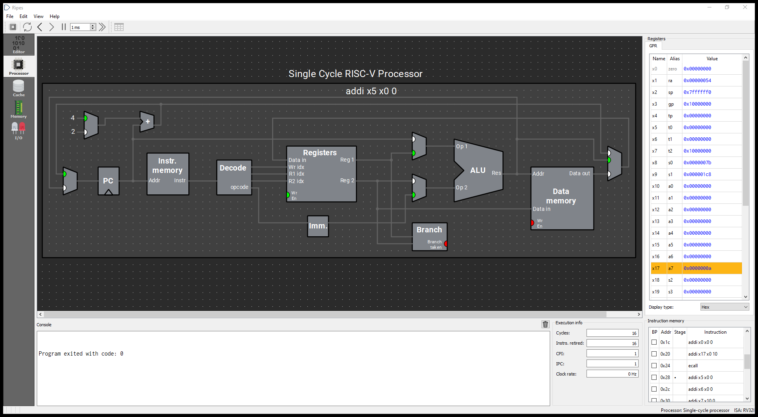
Figure E2: Ripes execution proof for Task E function with n=0 (a0=0, caller s0=123 and s1=456 preserved).
Value | Register | Requirement
Input base and length | a0 and a1 | Use valid nonnegative n
Running sum and index | t0 and t1 | Initialize both to zero
Pointer and loaded value | t2 and t3 | Check before every load
Return value | a0 | Copy the final sum here
Caller values | s0=123 and s1=456 | Preserve both
Return and stack state | ra and sp | Return to after_call; preserve sp

- Copy the loop structure from Task C. Use the register mapping above, with t3 instead of x8 for the loaded word.
- At the exit, copy the sum to a0 and return using jalr x0, 0(ra). This function calls no helper functions.
- Run n=0, 1, 2 and 3. Break at after_call before its nop, and record a0, s0, s1 and sp.
- Observe ra at function entry. Verify that it points to the instruction after jal, and explain how jalr uses it.
E1 Why can this leaf function avoid a stack frame?
Answer: A leaf function is a function that makes no nested function calls. Consequently, its return address in register "ra" is never overwritten and can be retained in "ra" throughout execution. Furthermore, our function uses exclusively temporary caller-saved registers (t0, t1, t2, t3) without modifying any callee-saved registers (s0..s11) or spilling variables. Because ra remains intact and no callee-saved registers are touched, allocating a stack frame (adjusting sp) is entirely unnecessary.

E2 Why is replacing t3 with x8 unsafe if the function does not save and restore x8?
Answer: In the standard RISC-V calling convention (ABI), register x8 is designated as "s0" (a callee-saved register / frame pointer). The ABI contract mandates that any function modifying a callee-saved register must preserve its value across the call by saving it onto the stack at function entry and restoring it before returning. In our caller, s0 holds 123. If sum_array overwrites x8 without saving and restoring it, the caller's s0 is corrupted upon return, violating the ABI contract.

The wrapper aligns the simulator’s startup sp to 16 bytes before calling. Compare sp immediately before and after the call, after this setup step. The function itself should not alter sp.

Optional extension after the session
Write outer(a0) = double_value(a0) + 1 using a nested call. Save the incoming ra in a 16-byte stack frame, restore it, and return. With a0=7, check the result and verify that sp is restored. This extension is not required for the 120-minute session.

Submission and exit ticket
Submit one report using report_template.md and your completed 04_sum_function.s. Include predictions, observed results, and explanations. Keep the starter files unchanged and make your edits in copies. You may submit the report as PDF or Word according to the instructor’s collection method.

Submission checklist
- A: state table and PC observation; B: byte maps and extended load values.
- C: n=0,1,2,3 results, all four n=3 checkpoints, count derivation and transfer test.
- D: diagnosis and repair for each mutation, with one useful trace or screenshot.
- E: completed source, return values and preservation checks; four exit-ticket answers.

Suggested assessment
Item | Points
A Register trace and explanations | 15
B Byte layout and load interpretation | 20
C Boundary tests, checkpoints and count | 30
D Diagnosis and repair | 20
E Correct function and preserved state | 15
Total | 100

Exit ticket
- What does lw x8, 0(x7) place in x8: the address or the word stored at that address?
Answer: It places the 32-bit data word stored in memory at the effective address (x7 + 0), NOT the address itself. In our trace, when x7 = 0x10000000, lw places the value 3 into x8, while x7 continues holding the address.
Answer: No. "addi" is an arithmetic ALU instruction that performs integer register addition purely within the CPU datapath; it does not generate a memory address or activate data memory read lines. Observed register x8 remains completely unchanged when addi x7, x7, 4 executes.
Answer: Exactly 16 real instructions. Derived from the formula: 3 (initialization) + (n + 1) (condition tests) + 5n (loop body & jump) = 6n + 4. For n = 2, count = 6(2) + 4 = 16 instructions.
Answer: (1) Register x8 retains its initial pre-loop sentinel value of 0x00000000 throughout execution; (2) Pointer register x7 never advances beyond base address B; and (3) The total instruction count between trace_start and end is exactly 4 (3 initialization instructions + 1 taken beq), proving that "lw x8, 0(x7)" was never fetched or retired.
- Does addi x7, x7, 4 read memory? Explain using your observed x8.
- For Task C with n=2, how many real instructions execute within the stated boundary?
- What observation supports the claim that n=0 performs no array load?

Reference links
Course source: Lecture 3 Instructions and Programs, integrated 96-slide edition. Slide numbers below refer to that edition.
RARS 1.6 release and download:
https://github.com/TheThirdOne/rars/releases/tag/v1.6
RARS environment call reference:
https://github.com/TheThirdOne/rars/wiki/Environment-Calls
RISC-V calling convention reference:
https://riscv-non-isa.github.io/riscv-elf-psabi-doc/

