# CS 340 Project 2 README

## About the Project/Project Title

The main purpose is to create a CRUD functionality for project two. This specific project has a main purpose to creating a Python module that will enable create, read, update, and delete functionality. Create and Read functionality is half of the full part of CRUD, and update and delete is the other half of the CRUD functionality. In this project II created the second half of CRUD and develop the update and delete functionality for this main project two.

## Motivation

The main purpose of this assignment of creating a python is to enable create, read, update, and delete functionality of CRUD. This project exists to use and understand mongo dB and how mongo dB can be used for various projects to create, read, update, and delete functionality.

## Getting Started

To get a local copy follow the steps below to save the files from Github

* Open terminal
* Access the directory where you want to locally save the files. Ex: cd desktop/file/CRUDPython/
* Run the git pull command to pull files and save locally: git pull <https://git.aamirr.com/CRUDPython/CRUD/projecttwoa>

## Installation

Tools needed: Jupyter Notebook and Terminal.

Follow the steps below to install and use Jupyter Notebook

* Initially install Jupyter Notebook via terminal command: pip install jupyter
* Once Jupyter is installed properly, launch jupyter via terminal command: jupyter notebook
* Once jupyter is launched properly, access the PY file and IPYNB file
* To execute the IPYNB file, select ‘Run’ after accessing the IPYNB file

## Usage

### Code Example:

AnimalShelter.py code sample

### Tests:

* Initially install Jupyter Notebook via terminal command: pip install jupyter
* Once Jupyter is installed properly, launch jupyter via terminal command: jupyter notebook
* Once jupyter is launched properly, access the PY file and IPYNB file
* To execute the IPYNB file, select ‘Run’ after accessing the IPYNB file

crudTesting.IPYNB

### Screenshots:

Uploading data to mongo DB:

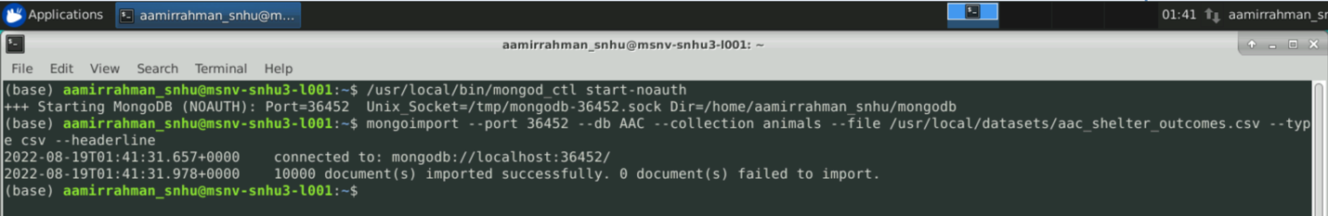

Creating an admin account (username and password)

Creating a user account (username and password)

## Contact

Your name: Aamir Rahman