BQE Wisp Quick Start Guide
Single executable installation on Windows

(Note – Upgrade instructions are located at the end of this document)
Install BQE Wisp, open its browser interface, configure your station, and create your first satellite pass
schedule. The Windows executable includes Python; a separate Python installation is not required.

1 Install desired third party prerequisites.

(Add to system/user path where possible.)
Name | Use | Location
Satdump | LRPT (Weather) decoding | https://www.satdump.org
Hamlib | Rig Control. | https://github.com/Hamlib/Hamlib/releases

2 Install BQE Wisp
Download BQE_Wisp.exe
Download location: TBD. Save the executable in a convenient folder, such as C:\bqe_install.
Choose the installation folder
Open Command Prompt or PowerShell in the folder containing the download. Run the command below.
The --dir value is the parent folder that will hold bqe_wisp. Use a new or empty folder and keep quotes
around its path.
.\BQE_Wisp.exe --dir "C:\bqe"
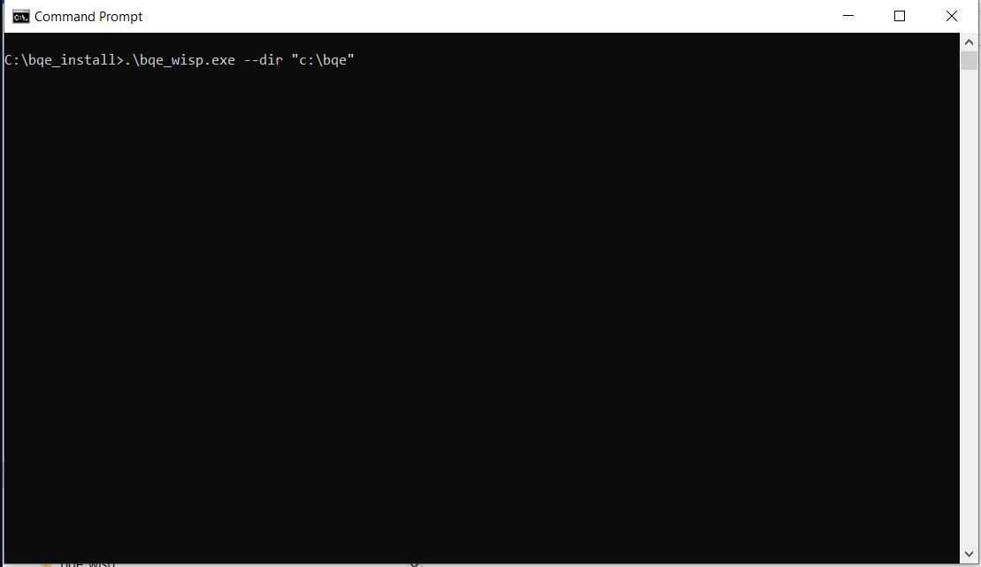
This example creates C:\bqe\bqe_wisp. Replace C:\bqe with your preferred location. Keep the console open
while first-run preparation completes.
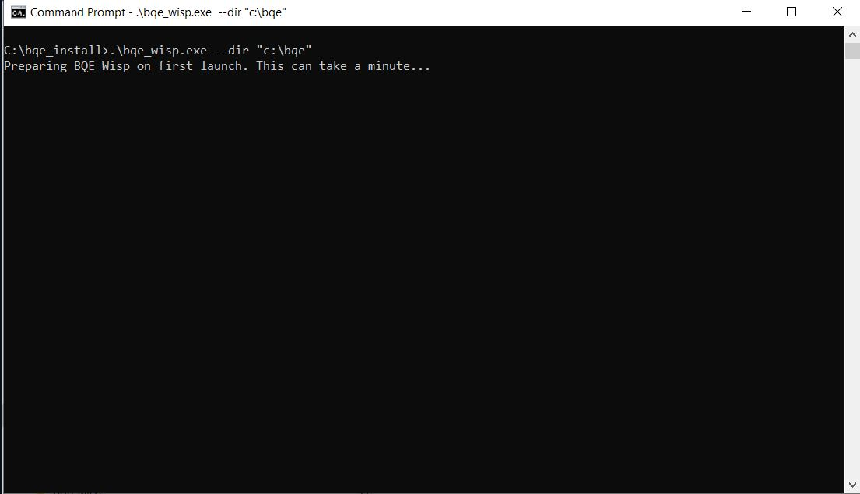
First launch prepares the application files and may take a minute.

Allow access and open the interface
When Windows displays the Grant access / Windows Security Alert dialog, select BOTH Private networks
and Public networks, then click Allow access. The request may identify the application as Python, as
shown below.
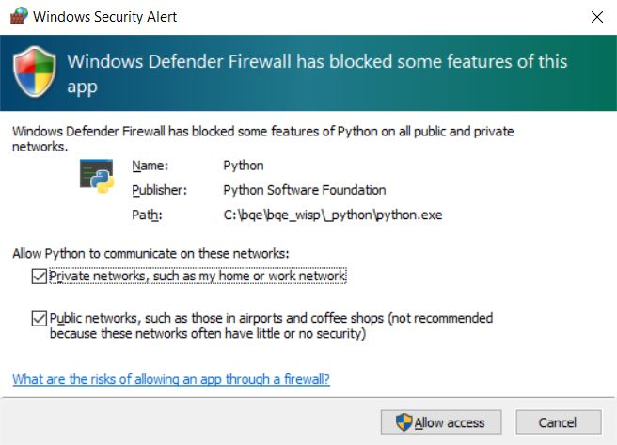
Both network checkboxes must be selected before allowing access.
Wait for the server to start
Look for the highlighted “Web console available at” message. Open the displayed URL in your web browser. In
this example, it is http://localhost:8028/.
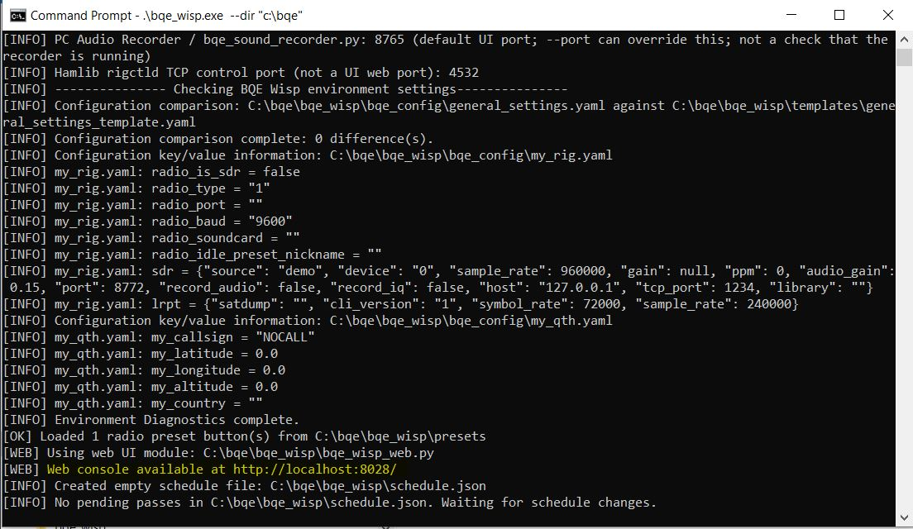
The highlighted URL opens the BQE Wisp user interface on this computer.
Keep the console open while using BQE Wisp. For later launches of the same build, run BQE_Wisp.exe normally; it
remembers the installation folder. Keep that folder to preserve your settings and recordings.

3 Station specific setup
Configure your radio and station location before creating a schedule. Use the Config menu in the top
menu bar to find the configuration submenu’s and add your stations’s radio and QTH.

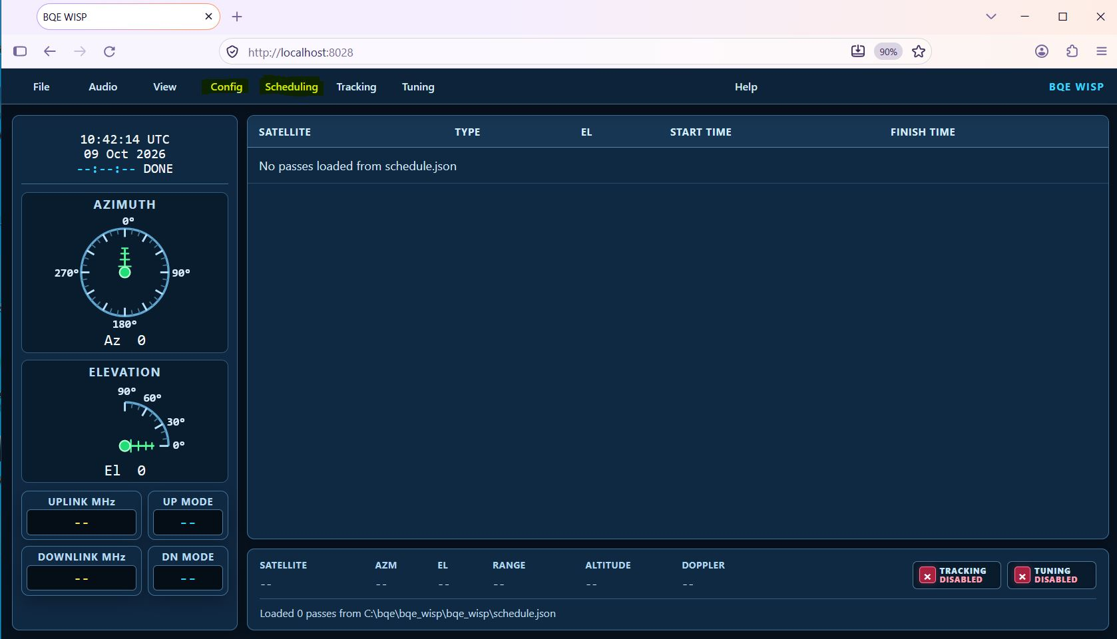
Config opens the station settings; Scheduling contains the pass scheduling tools.

Config → QTH

Station location in my_qth.yaml
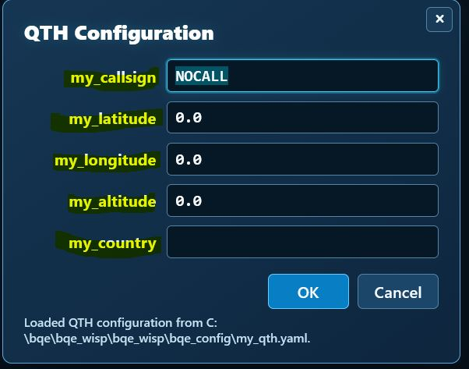

Fill in my_callsign, my_latitude and my_longitude in decimal degrees, my_altitude in meters, and my_country.
Use negative latitude for south and negative longitude for west. Accurate coordinates are needed to predict
passes for your station. Ignore the lrpt value for now.

Radio type refers to the hamlib type assigned to your radio. Typing rigctl -l from a command prompt will list all the possible radio types. Radio port should either be a Com port for windows, or a dev/ttyUSB device for linux.

The “radio_soundcard” refers to the soundcard interface between your computer and your radio. This is typically either a SignalLink USB box, or a modern radio with a built in sound card. For Yaesu radios, this presents as USB Audio Codec.

Click OK to save the information.

Config → Radio

Radio settings in my_rig.yaml

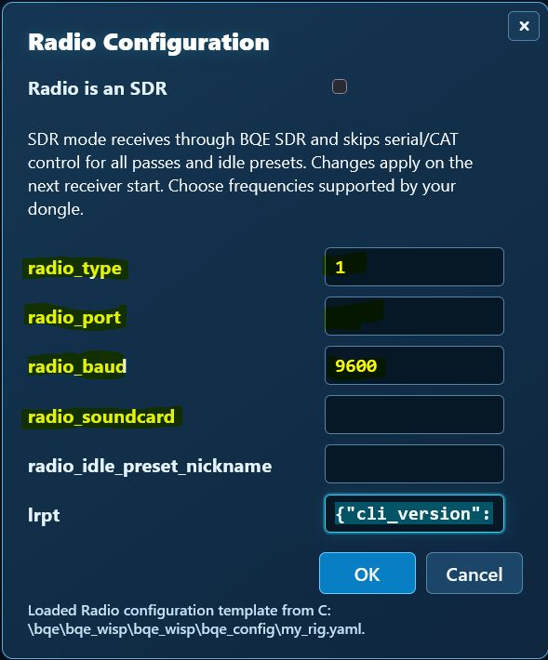

For a conventional radio, enter radio_type (the Hamlib rig model ID), radio_port (for example, COM3),
radio_baud (the radio’s CAT speed), and radio_soundcard (the audio input used for reception). Use values that
match your equipment.
For an SDR, select the “Radio is an SDR” checkbox and configure the receiver settings appropriate to your device.
Click OK to save the radio configuration.

Restart the server
After saving both dialogs, choose File > Restart Server from the top menu bar. Wait for the server to restart,
then reconnect or refresh the browser if needed. Continue to scheduling when the interface is available again

4 Creating a schedule

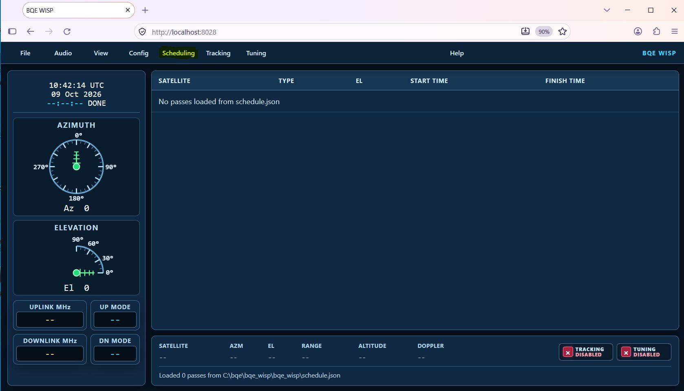
The highlighted Scheduling menu contains Update Keps and Auto-Schedule Passes.
1 Update the Keplerian elements
Choose Scheduling > Update Keps. This downloads the orbital elements used to predict satellite passes.
An Internet connection is required for the download.
Wait at least one full minute
It is wise to wait a full minute between updating the keps and scheduling passes so the download
can finish. The scheduling options will be greyed out anytime the Update Keps is actively running.
2 Automatically schedule passes
Choose Scheduling > Auto-Schedule Passes. BQE Wisp calculates passes using the configured
satellites from bqe_config/satellites.yaml, your QTH, and the updated orbital elements to calculate upcoming passes, then writes the schedule. Scheduling can take between 20 seconds and 2 minutes depending on the number of satellites to be scheduled, and the speed of your computer.
3 Check the schedule
Wait for scheduling to finish and check the main pass list for satellites and their start and finish times. An
empty list means there are no scheduled passes to display; review your QTH and satellite settings before
trying again.

5 Operation

Once these steps have completed, BQE_Wisp will begin to process satellite passes. The browser session may be opened and closed at will. As a pass starts, the Azimuth and Elevation icons will become active, and the frequency and mode information will appear just below. Active passes will be shown in yellow. Passes which have already taken place will be shown in a greyed out color.

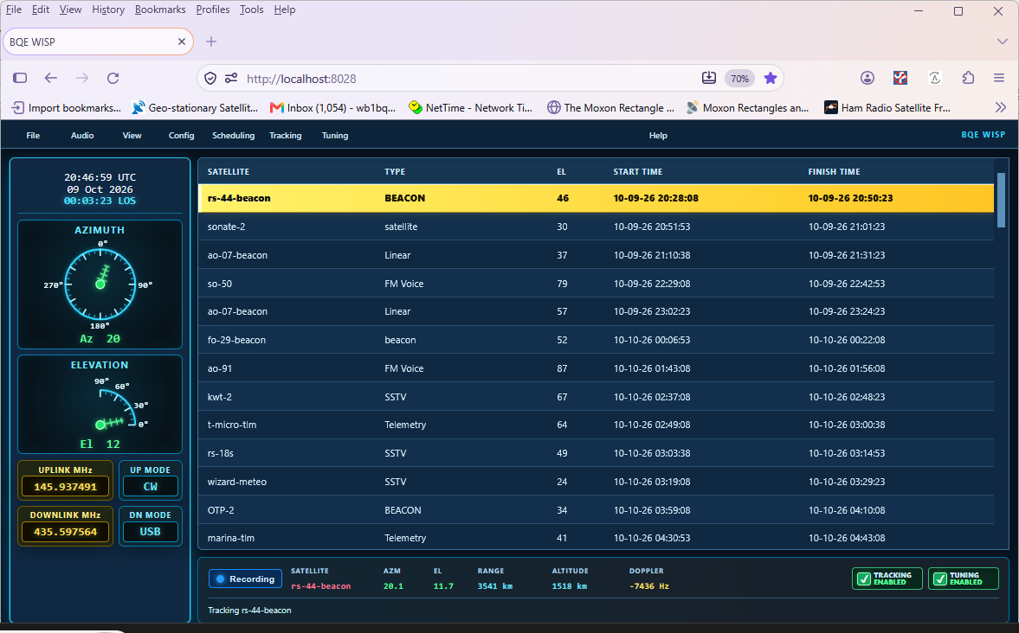

To stop the server, please use either “File → Exit” from the browser, or hit CTRL-C twice with a second or 2 between each time to allow shutdown to occur in an orderly fashion.

6 Upgrade Instructions (From BQE Wisp V0.7-beta3 or later)

These instructions assume a previously working copy of bqe_wisp v 0.7_beta3 or later, located in the default location (C:\bqe on windows). The example here is windows based, but a similar technique applies to Linux as well, with different path notations.

To prepare for upgrade, follow these steps:

- In the current copy of BQE Wisp, enter the UI and backup both the user settings and downloaded data (if desired) to a folder location outside of the c:\bqe folder tree.

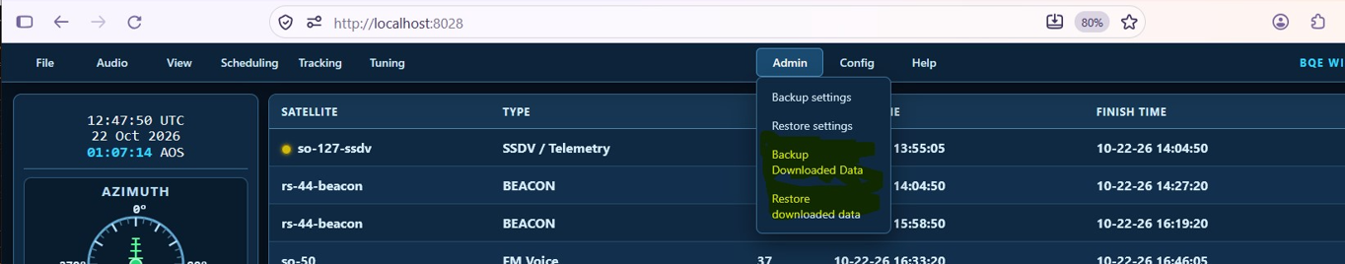

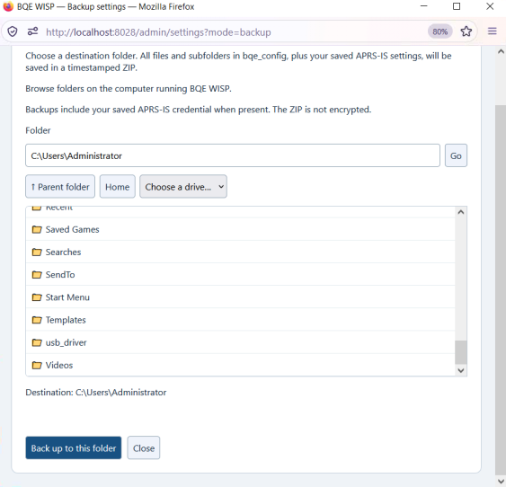

  - The settings backup saves the contents of the bqe_config folder.

  - The downloaded data backup saves data downloaded from the various satellites. (i.e. telemetry, recordings, sstv images.) WEATHER DATA IS NOT BACKED UP. This is due to the large size of each weather reception (~500mb), and the fact that old weather data is not generally interesting. It can be saved manually from the bqe_wisp/plugins/bqe_lrpt_decoder/recordings folder if desired.

To upgrade BQE Wisp, follow these steps.

- Delete the entire contents of c:\bqe

- Copy the appropriate zip for your platform to c:\bqe

- Unzip the zip locally into the bqe_wisp folder. (Using winzip, this can be done with “Extract to here”. If using the windows right click unzip, modify the path such that the content unzips into c:\bqe.)

  - The zip itself can be deleted after bqe_wisp is extracted. Please do not delete bqe_wisp, as it will be used in the future to launch the application.

- Run c:\bqe\bqe_wisp.exe from the command line, or double click it in windows explorer. This will extract a new bqe_wisp folder tree and start the server.

- Connect to the server (http://localhost:8028) and use the admin menu to restore the data backed up previously.

- Restart the server

- Use the Schedule menu bar item to download new keps and generate a new schedule

