# 订单

## 订单下单接口

<http://10.10.30.95:8280/manage/main/diy/online/book>

<http://127.0.0.1:8080/phoenixOrder/manage/main/diy/online/book>

com.tuniu.css.order.manage.pdy.maintain.web.api.DiyOrderServer

## 发起占位

com.tuniu.css.order.manage.flight.bpm.called.delegate.FlightOccupyDelegate

## 占位反馈

TSP：ORD.NM.DiyConfirmManageController.occupyRevert

## 订单下单参数SQL

SELECT DATA FROM ord_ru_create_data WHERE order_num IN(SELECT order_num FROM phoenix_ru_order WHERE order_id IN(14039484,14039527));

## 订单的占位反馈SQL

SELECT a.* FROM prd_ru_act_ord_status a WHERE a.order_id = '13476821' and type = 2 and req_json like '%"resourceType":21%';

type=2占位

type=11出票

# 确认管理

## 查询适配反馈SQL

SELECT a.*,b.type FROM flw_purchase_seq a LEFT JOIN flw_order_seq b ON a.seq_id = b.id AND b.type=4 AND b.del_flag=0 WHERE b.order_id = 13159033 AND a.del_flag=0;

SELECT a.*,b.type,b.remark as ordremark FROM flw_purchase_seq a LEFT JOIN flw_order_seq b ON a.seq_id = b.id AND b.type=2 AND b.del_flag=0 WHERE b.order_id = 5686913 AND a.del_flag=0;

flw_purchase_seq—适配交互表

flw_order_seq—订单交互表

flw_order_seq.type=2—占位

flw_order_seq.type=4—出票

## 查询订单交互SQL

SELECT a.* from flw_order_seq a WHERE a.order_id = 5686913;

//使用flw_order_seq 表中的order_request中的值，来查询MongoDB中的订单下单参数

db.orderRequest.find({"_id" : ObjectId("55bae7a1e4b057cd27289051")})

# 适配

## 查看适配占位信息SQL

SELECT * FROM flight_pnr_occupy_rq WHERE order_id =

## 查看订单有效PNR

select * from flight_pnr_main where order_id = 5693685 and status = 1;

#状态 0未生成，1已生成，2待取消，3已取消，4已出票，5部分出票，6出票失败

## 查看票号和PNR的关联SQL

select * from flight_issue_ticket_detail;

# 资源

## 资源表描述

资源和舱位的关系表：flight_indiv_cabin_group_res_domestic

航班的舱等表：flight_indiv_cabinfare_domestic

航班起降信息表（团期有关）：flight_indiv_depart_arrive_domestic

航班信息表：flight_indiv_flight_domestic

资源表：flight_indiv_journey_res_domestic

资源价格表（团期有关）：flight_indiv_price_domestic

舱位表：flight_indiv_seat_domestic

old table(国内)：nfd(起价)

资源表：flight_individual_traveler_seat（id 即为resId）

航班表：flight_individual_traveler_flight

起降信息：flight_individual_traveler_depart_arrive

团期价格表：flight_individual_traveler_date_price

起价表：flight_city_inland_depart_price_arrive

起降信息：flight_depart_arrive

new table(国内)：inquiry

资源表：flight_indiv_journey_res_domestic

航班表：flight_indiv_flight_domestic

起降信息表:flight_indiv_depart_arrive_domestic

舱等价格表：flight_indiv_cabinfare_domestic

舱位表：flight_indiv_seat_domestic

资源与航班舱位组合关系表：flight_indiv_cabin_group_res_domestic

价格表：flight_indiv_price_domestic

国内特惠推荐表：flight_depart_price_domestic

起降信息：flight_depart_arrive

### 携程相关表

`flight_indiv_rule_domestic_ctrip`,

`flight_indiv_sale_control_domestic_ctrip`,

`flight_indiv_seat_price_domestic_ctrip`

## 资源查询SQL（航班，舱位）

select * from flight_indiv_journey_res_domestic where res_id = 233583209;

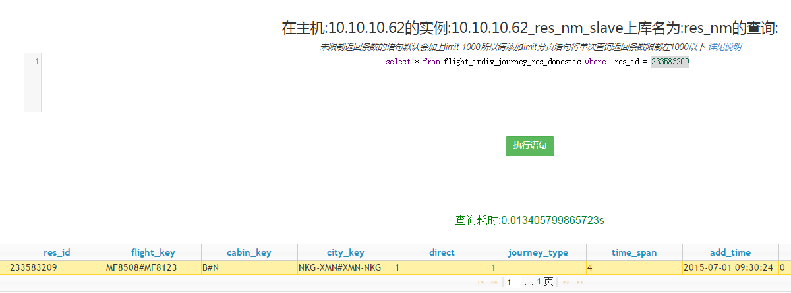

# 黑屏

## 查航班（航班号+团期）

AV:MU2974/17JUL

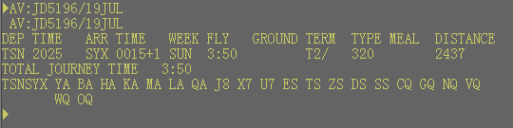

## 查询PNR

RT HG3KVP

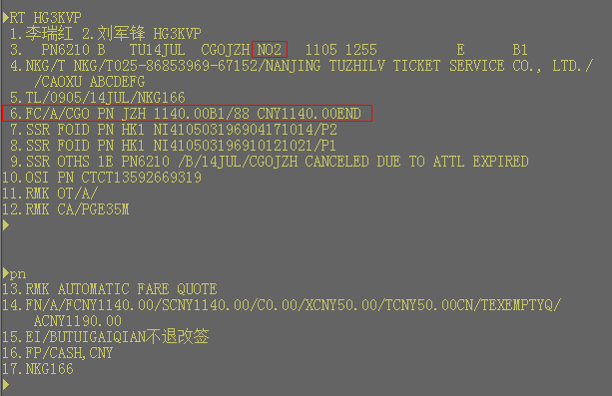

NO2是状态，最重要的就是关注这个状态。FC是运价信息，pn是翻页信息。

# MySql

## 查看数据库中连接现状

show processlist;