SharePoint File Validation Tool (FileChecker.exe) Readme

Contents
About FileChecker.exe 1
Sample Language Implementations 1
Using FileChecker.exe 1
Desktop Usage 1
Sample Output (FileCheckerResults.csv) 2
Additional Options 2
Command Line Usage 3

About FileChecker.exe
FileChecker.exe identifies illegal characters, length restrictions, and more in one or more file names that can potentially prevent proper synchronization with Microsoft SharePoint and OneDrive for Business or fail to render through the Microsoft SharePoint or OneDrive for Business Web UX.
See http://blogs.technet.com/b/wbaer/archive/2014/05/24/file-and-folder-considerations-with-onedrive-for-business.aspx for additional information.

Sample Language Implementations
This sample is available in the following language implementations:
- C#

Using FileChecker.exe

Desktop Usage
Open FileChecker.exe
Click Browse and select the root directory that contains the files on which validation will be performed.
Click Validate to validate files in the selected directory.
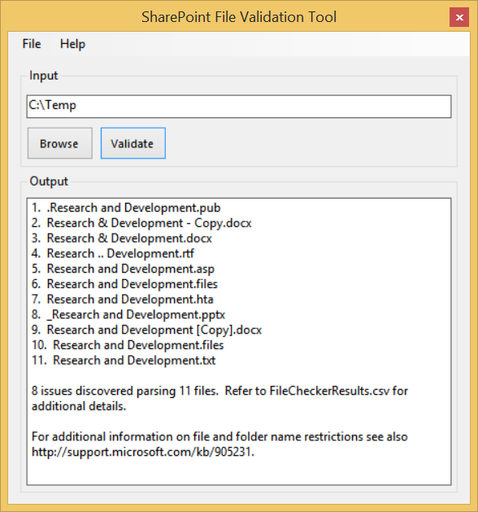
The Output window lists the parsed files in the selected input directory in addition to any issues encountered during validation.
The detailed results are copied to FileCheckerResults.csv created in the directory where FileChecker.exe was run.

Sample Output (FileCheckerResults.csv)
Condition | File Name | Invalid Character | Path | Rule Violation
Error | .Research and Development.pub | . | C:\Temp\.Research and Development.pub | You cannot start a file name by using the period character.
Error | Research & Development.docx |  | C:\Temp\Research & Development.docx | Files cannot be empty.
Error | Research .. Development.rtf | .. | C:\Temp\Research .. Development.rtf | You cannot use the period character consecutively in the middle of a file name.
Error | Research and Development.asp | .asp | C:\Temp\Research and Development.asp | Files cannot be of the following type .asp
Error | Research and Development.hta | .hta | C:\Temp\Research and Development.hta | Files cannot be of the following type .hta
Warning | _Research and Development.pptx | _ | C:\Temp\_Research and Development.pptx | If you use an underscore character (_) at the beginning of a file name the file will be a hidden file when using Open in Explorer.
Error | Research and Development [Copy].docx | [] | C:\Temp\Temp2\Research and Development [Copy].docx | You cannot use the following character anywhere in a file name [].
Error | Research and Development.txt |  | C:\Temp\Temp2\Research and Development.txt | Files cannot be empty.

Additional Options
Click File | Exit to close FileChecker.exe.
Click Help | Command Line Help for command line options with FileChecker.exe.
Click Help | TechCenter Web Site to open the TechCenters for IT Products and Technologies in a new browser window.
Click Help | About for information about FileChecker.exe.

Command Line Usage
Copy FileChecker.exe to a location on your computer.
Open the Command Prompt window and enter FileChecker.exe <drive>:\<path>
Note:
To open a command prompt, follow these steps:
- Swipe in from the right edge of the screen, and then tap Search.
(If you're using a mouse, point to the upper-right corner of the screen, move the mouse pointer down, and then click Search.)
- Enter cmd in the search box, and then tap or click Command Prompt.
Example:
FileChecker.exe -d "C:\Users\<user>\Folder"
Open FileCheckerResults.csv to view the results. The report is created in the location where FileChecker.exe is run. See Sample Output (FileChecker.exe) above.

