The AI Reliability Ladder, Measured Rung by Rung
Pushpdeep Mishra · Wejdan Bagais
Seven reliability layers around a language model, measured one at a time on a task with a real answer key — what each one bought, and what it charged.

Five key takeaways
1. Four of five open-weight models produced byte-identical output across three identical runs, so whether a system is reproducible turns out to be something you choose when you pick the model — and the one model that varied bought 6.5 accuracy points while costing a spread wider than every improvement we shipped.
2. Our bootstrap confidence interval excluded zero on the first draw and the effect's sign reversed by the third, because resampling documents prices the corpus and is blind to the variance between generations.
3. A free string comparison against a controlled vocabulary identified a subset of answers roughly 85% correct across five model families spanning a factor of 2.8 in headline accuracy.
4. That same check has zero coverage on a corpus where the span is a bare number, so it has a precondition you can test in one query before building on it.
5. Two paid layers cost 518,042 tokens for −0.004 accuracy, while the layer that dropped errors from 62.9 to 4.0 per 100 spent nothing and paid instead in a currency no single-figure summary reports: 196 of 248 records referred to a person.

What an AI reliability ladder is for
A language model is not a dependable component. The same input can produce a different output on the next call, and the model itself will be replaced within a release cycle or two. Everything else in a production system is deterministic; this one part is not, and the standard response is to put layers around it until the whole behaves as though it were.
An AI reliability ladder is that stack, and there is broad agreement on its shape: check the output against something deterministic, ask the model to correct itself, sample it several times and take the majority, have a second model judge the first, withhold what cannot be corroborated, and send the rest to a person. Six layers, each reasonable, each with published work behind it — and the assumption underneath all of them is that they stack. Every rung buys reliability, and somewhere up the ladder is the point where the next stops being worth its cost.
Nobody, as far as we could find, had measured that end to end on one task with a real answer key. So we built all seven and measured each one — and found that the staircase is not there, that the only layer which reliably paid was the free one, and that the most useful thing we built was not a layer at all but the accounting underneath them.

The task, and the result
Read a patient's forum post about a drug. Find every adverse reaction the writer says they had. Assign each one a SNOMED CT code. There is a real answer key — CADEC, 1,250 posts, 9,111 annotated mentions — and the task is the shape of a great many production pipelines: pull structured records out of prose, normalise them against a controlled vocabulary, be prepared to defend each one.
"Be prepared to defend each one" is not the same problem as accuracy, and it is the harder one. A system that is 80% right and cannot tell you which 80% is unusable anywhere a wrong answer costs something.
Here is what we ended up with, stated before the reasoning that produced it:
The system ships 21% of its answers. On those it makes 4.0 errors per 100, against 62.9 for the bare model and 63.3 for everything the paid layers could do to it. It sends the other 196 of every 248 records to a person.
That is not a good result. It is an honest one, and most of this article is about the things we built that did not contribute to it.

1. The ground moves more than our improvements do
Before making a model's output trustworthy, check whether it is stable. Three draws of one frozen configuration, same documents, same machine, same hour:
 | draw 0 | draw 1 | draw 2 | spread
F1, exact span | 0.395 | 0.408 | 0.401 | 1.3 pt
F1, overlap span | 0.469 | 0.475 | 0.471 | 0.6 pt

A 1.3-point spread is unremarkable until you notice that every extraction improvement this project shipped was smaller than it. Prompt changes, span filters, a reranking stage — all lived inside the noise band of the thing producing them.
Then we ran the same experiment across five open-weight models, and the premise turned out to be wrong.
model | distinct outputs over 3 identical draws
llama3.1:8b | 1
mistral:7b-instruct | 1
qwen3:8b | 1
granite4:micro-h | 1
gpt-oss:20b | 3

Four of five are bit-reproducible — identical output files, byte for byte, across three independent runs. Only one varies, and it is the only Mixture-of-Experts model in the set. qwen3 is a reasoning model and granite4 a Mamba/transformer hybrid, so neither deliberation nor architectural novelty is the variable; sparsity is what separates them, which fits the known mechanism. One MoE model cannot establish that, but the consequence does not depend on it:
Reproducibility is a model-selection choice with a measurable price. gpt-oss:20b buys 6.5 exact points over llama3.1:8b and pays a 1.3-point run-to-run spread for them.
We found that four months in, because we had only ever run one model.

2. The significance test that certified noise
We measured a reranking stage with a paired bootstrap over documents, and got +0.0217 overlap F1, CI [+0.0000, +0.0433] — an interval excluding zero. In most write-ups that is where the analysis stops. We ran it twice more: +0.0217, +0.0087, −0.0089. The sign reverses.
The bootstrap was not broken. It resamples the documents of a single run, so it prices the corpus sample and nothing else; the run-to-run variance from section 1 is invisible to it, because every replicate is drawn from one fixed set of model outputs. A significance test that sees one generation per configuration cannot see the dominant noise term.

3. What a free deterministic check can and cannot see
If the output will not hold still, attach something to it that will. The controlled vocabulary is the obvious candidate: SNOMED CT does not resample. We measured what six such checks catch by planting each error class into an otherwise-perfect answer set, 8,666 records at a time:
planted error | caught
code that exists in no release | 1.000
span shifted two characters | 1.000
fabricated quote | 1.000
real code, wrong branch of the hierarchy | 1.000
random plausible clinical finding | 0.000
near-miss finding sharing a head word | 0.001

On the classes they are built for these checks are exact, at zero cost, with no model call. The bottom half is why the rest of this article exists: give the system a real, active, correctly-typed clinical finding that is simply the wrong one and every check passes it. The right code is not in the source text, so nothing mechanical can put it there.
So the vocabulary cannot tell you an answer is right. It can sort answers into three states — REJECT, ACCEPT (the vocabulary uses these very words), and BAND (plausible, unverifiable) — and 57% of even a perfect answer set lands in BAND, a number knowable before you spend a token.
One setting is worth naming. The ACCEPT/BAND divider is a string comparison, and the lenient option lifts free coverage from 43.1% to 54.5%. We then planted near-miss codes — a real finding sharing its head word with the correct one:
setting | near-misses caught | near-misses placed in ACCEPT
contained | 0.1% | 19.0%
exact | 0.1% | 0.1%

Neither catches them, but the lenient setting actively vouches for one in five — worse than missing them, because you act on it.

4. The one thing that worked
The ACCEPT/BAND split predicts correctness, and unlike the headline number it barely moves between draws. Across five model families, three draws each, fifteen runs:
model | exact F1 | ACCEPT lane | BAND lane | ratio
gpt-oss:20b | 0.401 ±0.007 | 84.6% | 35.9% | 2.36×
llama3.1:8b | 0.336 ±0.000 | 80.4% | 28.8% | 2.79×
mistral:7b-instruct | 0.206 ±0.000 | 83.3% | 14.6% | 5.70×
granite4:micro-h | 0.185 ±0.000 | 89.3% | 14.6% | 6.12×
qwen3:8b | 0.141 ±0.000 | 83.3% | 30.3% | 2.75×

Headline F1 ranges 0.141 to 0.401 — a factor of 2.8. The ACCEPT lane ranges 80.4 to 89.3, and its ordering has no relationship to model quality: the worst model by F1 has the highest ACCEPT lane.
The check identifies a subset of answers that are ~85% correct regardless of which model produced them, and it earns more the worse the model is.
The reason is structural: the quantity is conditional on a deterministic property of the record rather than on the run. You cannot make the model repeatable. You can make your knowledge about it repeatable.

5. The corpus where none of it works
We ported the whole system to FiNER-139 — SEC filings, where the task is to tag numeric facts with one of 139 US-GAAP XBRL tags. Same code, same rungs, same models; the port cost sixteen one-line harness edits and no changes to rung logic.
The result is not a worse score. It is no score: ACCEPT 0, BAND 291, REJECT 1, coverage 1.0 → 0.0, every record routed to a person. The identical system that ships 21% of its answers on CADEC ships 0% here.
Every tag exists, so the vocabulary check works perfectly. It is the lexical check that has nothing to compare. On CADEC it matches "chronic pain" against |Chronic pain|; on FiNER it must match "47.6" against |EffectiveIncomeTaxRateContinuingOperations|, and a number shares no tokens with a name by construction.
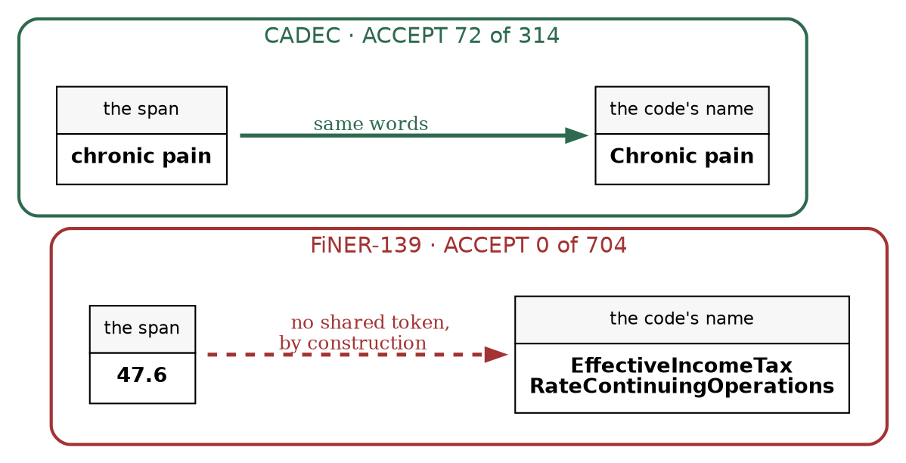
Fig. 1: The lexical check compares the extracted span against the code's own name. On one corpus they are drawn from the same language; on the other they cannot overlap. Source: author-created with Graphviz.
Deterministic evidence of this kind is available when the vocabulary's words and the source's words are drawn from the same language. It is unavailable when the span is a bare quantity.
That is the method's precondition, and it was invisible for five phases because the project had one corpus.
The most alarming part is how it fails. err_per_100 at the abstention step is 0.0 — a perfect error rate over an empty output. A system whose safety property is "abstain unless corroborated" degrades to "abstain always" the moment corroboration is inapplicable, and it does so silently, reporting flawless numbers.
The port paid for itself in defects, too. Three that had been invisible for five phases surfaced within hours: the judge's prompt was never ported, so a model grading SEC filings was asked whether the span was "really an adverse reaction"; CADEC's exclusion list, a claim about one answer key, was applied to every corpus; and a mistyped model name burned 133 minutes of compute before failing at the rung that needed it. Diversity in what you test against finds a class of bug that depth of testing does not.

6. What the four paid resolvers bought
We built four resolvers on the residue and expected a staircase.
The first asks the model to fix what the checks caught, stating the failure back as a fact. The mechanism is sound and it fired once in 248 records, for a reason section 7 explains. The second asks the model again and takes the majority; it cost 2.6× the extraction token budget and a 152-second p95 latency, and scored +5 on the tuning set and 0 out of sample. The voter and the answerer are the same model, so the vote carries no information the original answer lacked. The third asks a different model to judge, which separates weakly and less where it counts: 1.65× on the tuning set, 1.23× held out, against the free check's 2.36–6.12×. A string comparison against a controlled vocabulary out-separates the LLM judge on the only axis a judge is for, at zero marginal cost.
One caveat became a finding. Our judge is a 3.2B model grading a 20B one, and on CADEC it said nothing useful about codes, which we read as a limit of a small model. On FiNER the same model adjudicates codes fine — because 139 tags fit in its context and 129,675 SNOMED concepts do not. A judge cannot adjudicate a vocabulary it cannot see.
The fourth resolver resolves nothing. It withdraws every answer the stack could not corroborate and routes the record to a person, and it is the only one that moves the number: errors per 100 fall 62.9 → 4.0 against the bare model, while coverage falls 100% → 21%.
Every point of that fall is the free check from section 3, acted on, and paid for in a third currency — human attention.
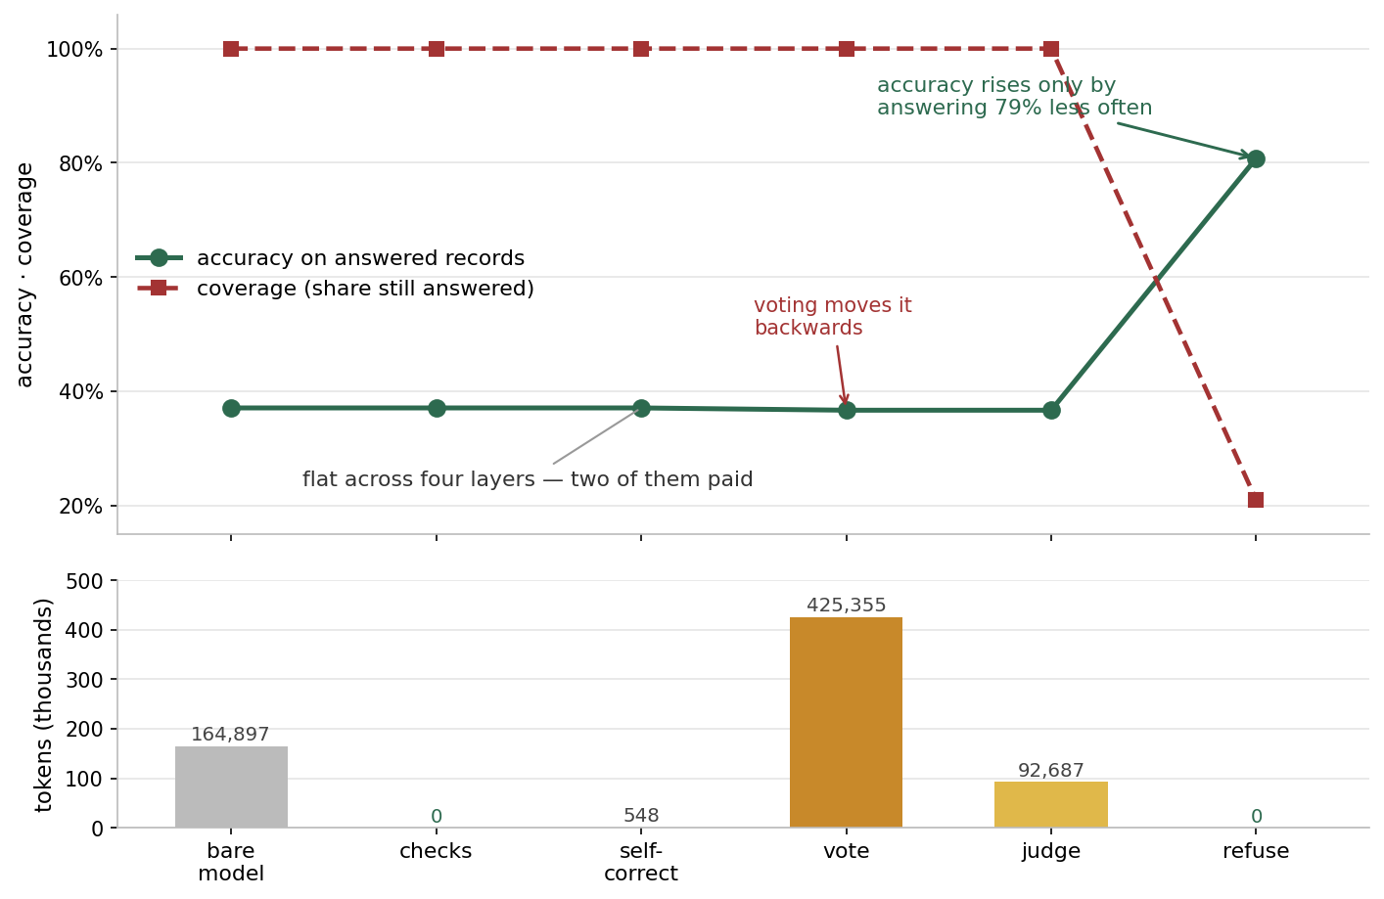
Fig. 2: Accuracy on answered records is flat through four layers and falls at the voting step; it rises only when the system stops answering. Token cost below. Source: author-created with Matplotlib.
layer | answered accuracy | what it bought | tokens | p95
bare model | 0.371 | — | 164,897 | cached
deterministic checks | 0.371 | +0.000 | 0 | 0
self-correction | 0.371 | +0.000 | 548 | cached
voting | 0.367 | −0.004 | 425,355 | 152.2 s
second-model judge | 0.367 | +0.000 | 92,687 | 1.5 s
refusal | ships 0.808 | +0.437, at 21% coverage | 0 | 0
person | — | — | 196 records | —

Read down the two middle columns together. Accuracy does not move until the refusal step, and then it moves by declining to answer. The two paid model resolvers cost 518,042 tokens between them for −0.004 — which is not a poor exchange rate so much as an undefined one, since there is no positive quantity to divide into. The layer that moved the number spent nothing.
The exchange rate that does exist is the one nobody prices: 0.437 accuracy for 196 of 248 records referred to a person. Whether that is worth paying depends entirely on what a wrong answer costs you, which is a number only you have — and which is why we report the three currencies separately and refuse to fuse them. A layer that is free in tokens and ruinous in human attention will look like a bargain in any single-figure summary.

7. What no single-layer test could see
Every deferral terminated in a field nothing read. Each paid resolver correctly declined to act on its own evidence and named the refusal step as the one that would act. Self-correction wrote r2_declined, voting wrote r3_unanimous_none, the judge wrote r4_verdict. The refusal step reads none of the three. No test could have caught it, because every layer does exactly what its own documentation promises. The hole is between them.
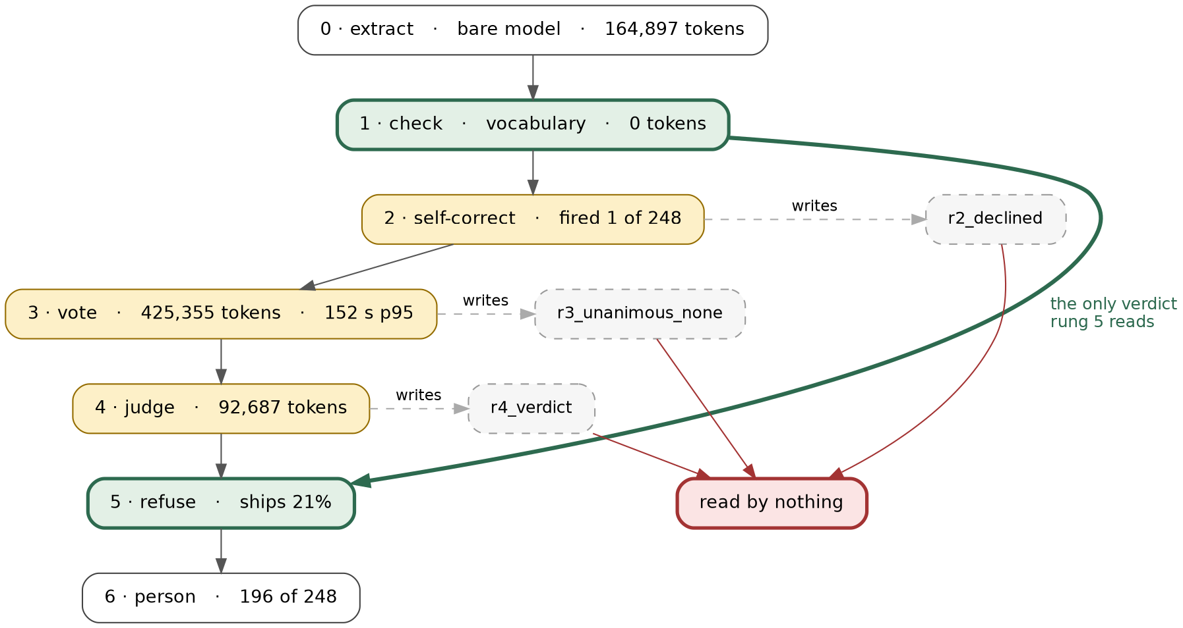
Fig. 3: Where each layer's verdict goes. Self-correction, voting and the judge each write a field; the refusal step reads none of them. Source: author-created with Graphviz.
A fix three layers down silently disabled two layers up. The checks used to reject 5.1% of records, nearly all for an unlocatable span, until extraction improved and a span filter began dropping those at source. The rejection rate fell to 1 record in 248 and self-correction's trigger set went with it. Nothing broke; both layers still pass every test and report honestly. A layer with nothing to do is indistinguishable from inside from a layer doing nothing.
A third defect says something about metrics. Voting overwrote codes without re-validating, so records shipped marked verified against a code they no longer had. Fixing it moved exact F1 from 0.204 to 0.204 — because precision and recall cannot distinguish an unwarranted answer from an incorrect one, which is the entire distinction the system exists to make.

How we found these
None of the layers above announced that it had stopped working. Each ran, returned, wrote its field and passed its tests. What surfaced them was a loop we fell into rather than designed, and it is the transferable part of this project.
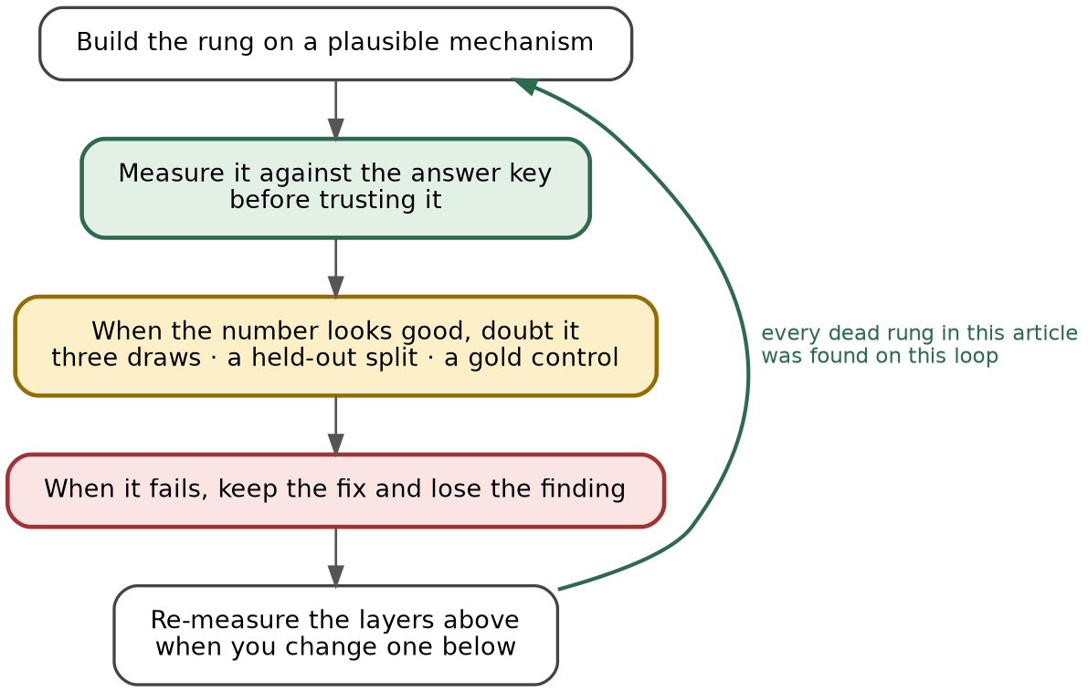
Fig. 4: The measurement loop. Every dead layer in this article was found on it. Source: author-created with Graphviz.
The step that does the work is the third. A layer that has just produced a good number is the least likely thing in a system to be re-examined, and it is where every one of our false results lived: a reranking stage with an interval excluding zero, a judge with a 2:1 separation, a voting layer with five net fixes. All three evaporated under a second draw, a corrected prompt, or a held-out split.
The fourth step is the one that costs something. When the judge's separation turned out to be living in an accidental prompt defect, fixing the defect meant losing a published-looking result — and the fix was still right.

What we would tell you
We set out believing that stacking reliability layers buys reliability. Measured end to end, the layers made errors visible rather than fewer — worth a great deal, and not what they were bought for.
Condition your confidence on something that does not resample — a vocabulary, a schema, a type check, a compiler — and establish its precondition before you build on it. Test that free layer against your answer key first: every rejection there is false by construction, so you get its false-positive rate for nothing. Ours went from 9.3% to 0.13%.
Then treat the accounting as part of the system rather than a report on it. Grep for the readers of every field you write, re-measure the top when you change the bottom, and print coverage beside every error rate.
The system ships about a fifth of its answers, at four errors per hundred instead of sixty-three, and hands the rest to a person. That is not what we set out to build. But the machinery that makes the other four-fifths legible to that person turned out to be worth more than any of the layers that tried to answer them.

What we could not settle
Three questions this project raises and does not answer.
The reproducibility mechanism rests on one sparse model against four dense ones. That is suggestive and it is not a result: it wants a wider set of Mixture-of-Experts models, and if sparsity is the variable it should hold across them and fail on a dense model of similar size.
The precondition in section 5 was discovered after the fact, by running the whole system for hours to learn something a single query would have told us. Each layer has a property its value depends on — whether the checks ever fire, whether samples re-find the same spans, whether a judge separates known-good from known-bad input — and every one is measurable on a development split before the layer is built. Whether such a preflight actually predicts which layers will pay is the obvious next experiment, and we have not run it.
And the second corpus is a demonstration, not a matched comparison: one run, no tuning history, and a task shape different enough that some of what we measured may belong to numeric spans rather than to the ladder. A third corpus with a lexical vocabulary would test whether the ~85% ACCEPT lane belongs to controlled vocabularies in general or to SNOMED in particular.

Limitations
The held-out split was spent once, so its intervals are the claim. The judge is a 3.2B model grading a 20B one. Human cost is a count of records routed, never minutes — no reviewer session was timed. The near-miss corruption is synthetic. CADEC is public and from 2015, so it is almost certainly in pretraining, which inflates the bare-model baseline and makes every gain here conservative. FiNER-139 is CC-BY-SA-4.0 and that arm is reproducible from a clean checkout; CADEC is not redistributable.
Code, the measurement ledger, every decision record, and the source for each figure in this article: https://github.com/wbagais/reliability-ladder

Cuts from the 4,569-word version, for review: the answer-key boundary ceiling (~0.67 deterministic, capping exact F1 near 0.70); the menu-order and prompt-duplication findings; `granite4` rescued by retrieve-and-pick; `qwen3` ranked wrongly by a single metric; the oracle desk ceiling; the bootstrap methodology detail; and the full "Reproducing this" section, which belongs in the README.

