The Final Light

**Run ‘til the end of the world**

**By KIAI Entertainment**

**Adriana Cuellas**

**Daniel Magalhaes**

**Galiya Nassipova**

**Thiago Castilho**

**All work Copyright © 2018 by KIAI Entertainment.**

**All rights reserved.**

Table of Contents

I. Game Overview 4

II. Game Play Mechanics 4

III. Camera 4

IV. Controls 5

V. Interface Sketch 5

VI. Menu and Screen Descriptions 6

VII. Game World 6

VIII. Levels 6

IX. Game Progression 7

X. Characters 7

XI. Enemies 7

XII. Weapons 8

XIII. Appendix 9

Version History

|  |  |  |
| --- | --- | --- |
| Date | Version Number | Updates |
| 03-Feb-2018 | 1.0 | Initial document |
| 16-Feb-2018 | 2.0 | Reviewed after Professor’s Evaluation |

# Game Overview

Fight for justice in the Dark Age and start a new era!

You are Eleanor, that was incarcerated by his cruel husband Henry after she rebelled against him. Eleanor defended people’s freedom using only her cleverness and strategy. But now, alone, she is facing the worst of the Middle Ages! Fight Plague, Famine, War and the most feared enemy, the Black Death. Find the keys to escape of the maze and run for your life.

Prove yourself as a skillful player, escape from the Castles, find the Goblet of Knowledge and you will be free to live in Renaissance!

This 2-player game is easy to control and has simple rules. Suitable for children and adults who love escaping games, no weapons.

Do justice for Eleanor and end these cruel medieval years! Be brave!

# Game Play Mechanics

* Find the hidden keys for the respective doors
* Runaway from the monsters
* Deploy traps
* Avoid traps

# Camera

Top-down

# Controls

Use directional arrows or w, s, a and d keys on the keyboard to move the character up, down, left and right. Use the space bar to deploy traps.

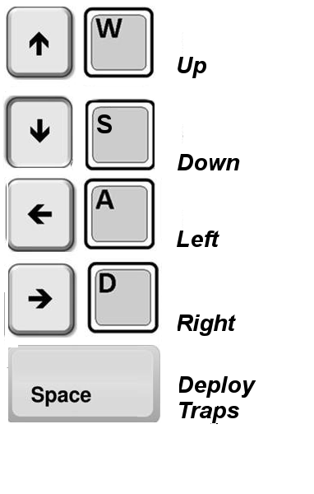

# Interface Sketch

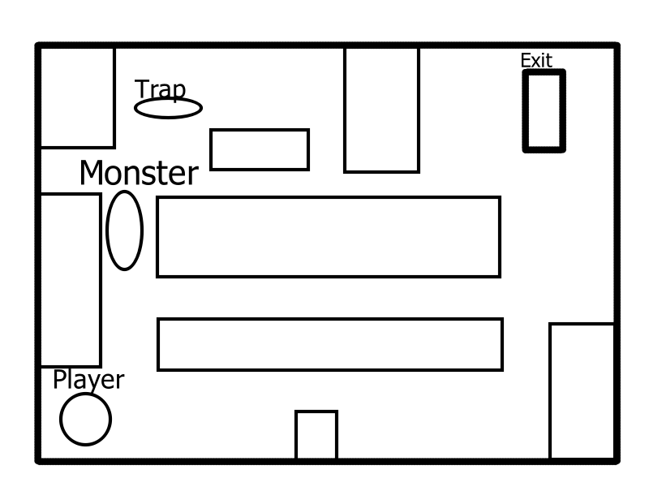

# Menu and Screen Descriptions

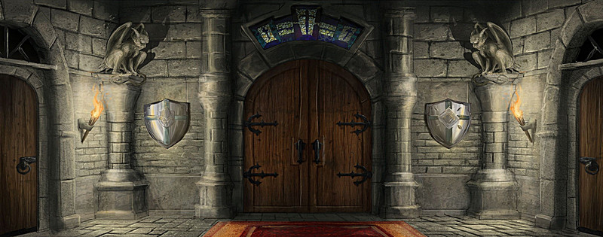

*Start Game*

*About*

*Quit*

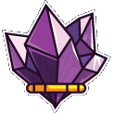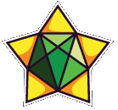

# Game World

* Dungeon of Castles Caernarvon, Warwick and The Tower of London
* Scarce Light
* Monsters are the worst of Middle Ages: Famine, Revolt, War, Pandemic, Plague and the most lethal of them, Black Death.
* Medieval Age (Scenario with Armors, Swords and Shields, no guns or modern weapons)
* No weapons for the character

# Levels

1. Level 1 - **Caernarvon Castle**
   1. 1 monster – **Famine**
   2. 1 door
   3. 1 trap
2. Level 2 - **Warwick Castle**
   1. 2 monsters - **Revolt, War**
   2. 2 doors
   3. 2 traps
3. Level 3 – **The Tower of London**
   1. 3 monsters including a boss - **Pandemic, Plague** and **Black Death**
   2. 3 doors (one leading to a trap)
   3. 3 traps

# Game Progression

The game progresses through each level increasing the enemies speed (aggressiveness) and in number of enemies. To achieve the next level Eleanor must find the key for the door(s) of the level and escape from the level’s monster.

The player will be able to drag attention of the enemies to lead them to traps in the dungeon. Eleanor can just escape from the monsters or kill them using a trap. In the final level, she must kill the boss.

# Characters

Eleanor - the players avatars will be Eleanor, a brave girl which was betrayed and jailed in a dungeon. She didn't have any clues about where she is being held and why the place is crowded with monsters.

# Enemies

The enemies are grotesque monsters representing the worst from Middle Ages. They seek the player through the maze inside the dungeon. They are strong and kill the player as soon as they touch it.

The boss is the faster monster that stands in front of the last exit door at level 3.

# Weapons

The player can use the traps placed on the ground to kill the monsters. The traps are fixed but the player could drag the attention of a monster to lead it to a trap.

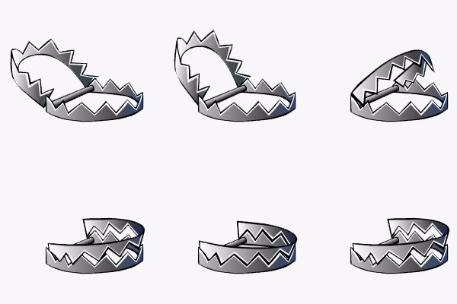

# Appendix

**Caernarvon Castle** - The building of Caernarvon Castle in Wales was started in 1283 by the English King Edward I (1272-1307). The Druid Wizard, Merlin, and several prophecies, were strongly associated with Caernarvon. Merlin was believed to have been born in a cave outside Caernarvon. The name Caernarvon is believed to be derived from 'Caer Myrddin' meaning Merlin's town or fortress.

**Warwick Castle** - The bloody history of Warwick Castle is steeped in treachery, murder and mystery. Famous historical figures and events feature in the history of Warwick Castle including William the Conqueror, the Wars of the Roses, Lady Jane Grey, the Civil War and the Age of Chivalry with Knights and tournaments.

**The Tower of London** - The most famous castle in England is closely associated with William the Conqueror who invaded and conquered England in 1066. The Tower of London is notorious for the bloody executions, imprisonment and torture of the prisoners who were incarcerated in this famous castle of the Middle Ages.

(Source: Middle Ages for Kids <http://www.lordsandladies.org/famous-castles-of-the-middle-ages.htm>)