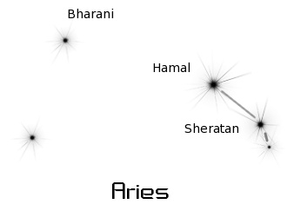https://wpclipart.com/space/constellations/charts/

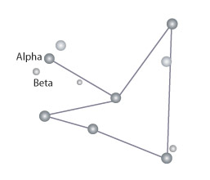http://chandra.harvard.edu/photo/constellations/index.html

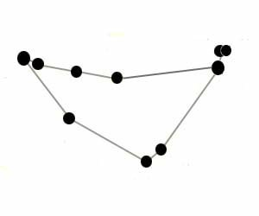http://www.solarsystemquick.com/universe/star-constellations.htm