We have created two dashboards and each dashboard has few kpis and some charts.
KPIs on dashboard1:
- Min Fare
- Max Fare
- Average Fare
- Total Flights
Also there are seven filters provided which can be used to analyze the results. Filters are applicable to all charts except one. Find below more details:
Class Filter This filter filters data based on flight class. Flight class can be either “Economy” or “Business”. This filter applies to all charts except “Avg_Fare by class”, since this chart is used to show fare for all the available classes.
Days left filter This filters data based on number of days prior to departure. As per the data, it can have value from 1 to 49. This filter applies to all charts except “Avg_Fare by days_left”, since this chart is used to show fare for all the days left.
Source City and Destination City filter To work with source and destination city, we have created one column with name ‘Route’, which is the combination of source and destination cities. These two filters are applicable to all the charts, except “Avg_Fare by Source_Destination”, since this chart is used to show fare for all the routes.
Airline filter This filters data based on Airline type. This filter applies to all charts except “Avg_Fare by Airline” chart, since this chart is used show fare for all the airlines.
Departure Time and Arrival Time filtersTo work with departure and arrival time columns, we have created one column Depart_Arrival_Time, which is combination of Departure Time and Arrival Time. These filter apply to all charts except “Avg_Fare by Depart_Arrival_Time”, since this chart is used to show fare for all the Departure times.
Also Page1 it answers following questions two questions asked in the mini project:
- Does ticket price change based on the departure time and arrival time?
Yes, Depart time as Afternoon and Arrival time as Late evening has highest fare with following filters in place:
- Class: Economy
- Days left: 20
- Source City: Bangalore
- Destination City: Delhi
- Airline: Vistara

- How the price changes with change in Source and Destination?
Yes, Kolkata to Bangalore flight has highest average fare, provided following filters in place.
- Class: Economy
- Days left: 20
- Departure Time: Early Morning
- Arrival Time: Afternoon
- Airline: Vistara

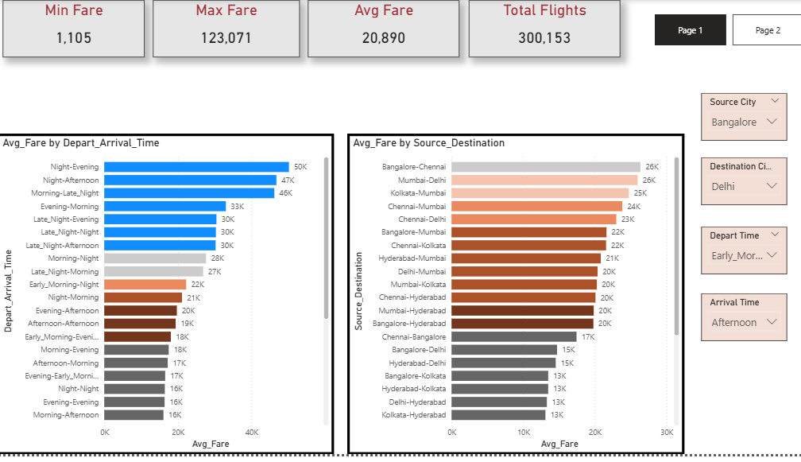

Page2 answers following questions:
- Does price vary with Airlines?
Yes AirAsia has the lowest average price, Air India has the highest average price, provided following filters were in place:
- Class: Economy
- Days left: 20
- Source City: Bangalore
- Destination City: Delhi
- Departure Time: Early Morning
- Arrival Time: Afternoon

- How is the price affected when tickets are bought in just 1 or 2 days before departure?
Yes, prices are costlier if tickets are bought 1 or 2 days prior to flight date, provided following filters are in place:
- Class: Economy
- Airline: Vistara
- Source City: Bangalore
- Destination City: Delhi
- Departure Time: Early Morning
- Arrival Time: Afternoon

- How does the ticket price vary between Economy and Business class?
Yes, business class is costlier than economy class, provided following filters are in place
- Days left: 20
- Airline: Vistara
- Source City: Bangalore
- Destination City: Delhi
- Departure Time: Early Morning
- Arrival Time: Afternoon

