Working Bamazoncustomer.JS ScreenShots

1. Creating the MySQL Database

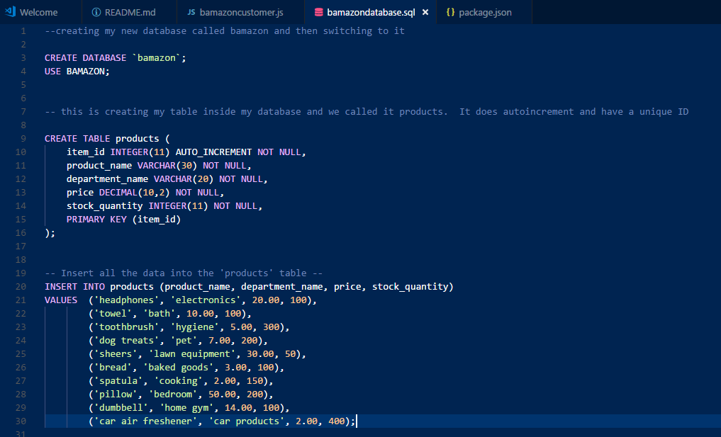

1. Creating the server connection

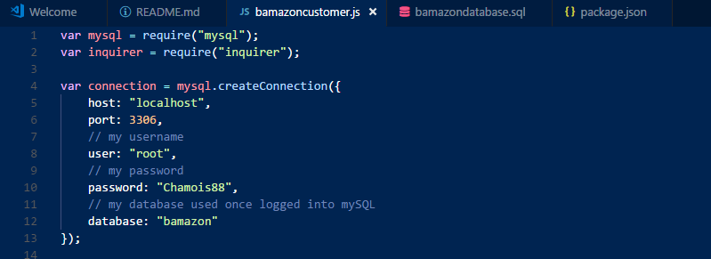

1. Working app pictures in terminal

