* Expand the model for the travel agency to travel. services such as:

1. Car rental from car rental companies
2. Hotel reservations from local hotels in the area

For these two services, we can add Business.CarRental package, UserInterface.CarRental package, Business.HotelReserve package and UserInterface.HotelReserve package based on the original project. The expanded UML diagram is as follows:

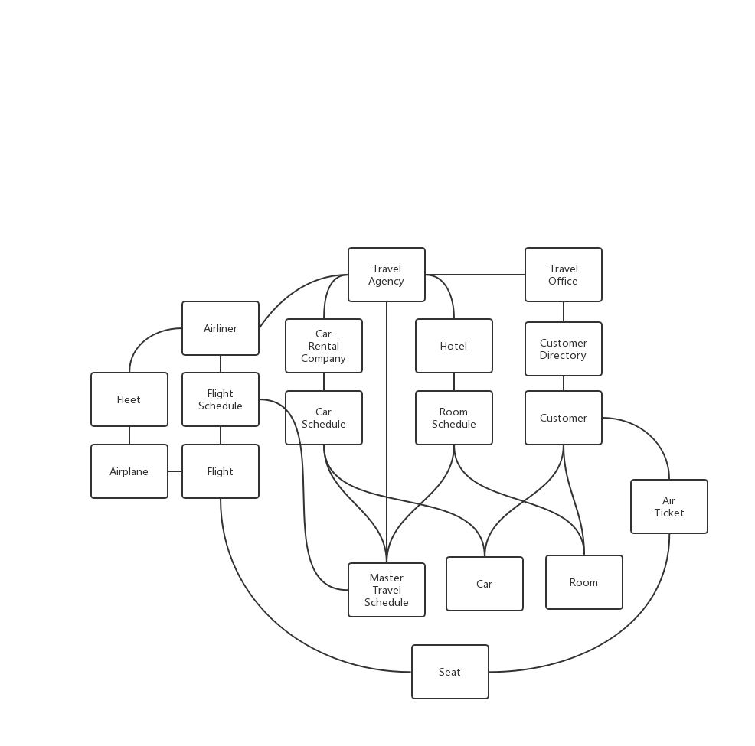

In terms of the class, make the following changes: Add the CarRentalCompany class, CarSchedule class and Car class to the Business.CarRental package. Add the Hotel class, RoomSchedule class and Room class to the Business.HotelReserve package. Their composition is partially same as Airliner, FlightSchedule and Flight. Class is similar. Eventually these records will be stored in the Travel Agency and Master Travel Schedule. For the Customer class, Car and Room are added to their attributes, and their scheduled hotels and cars are recorded separately.

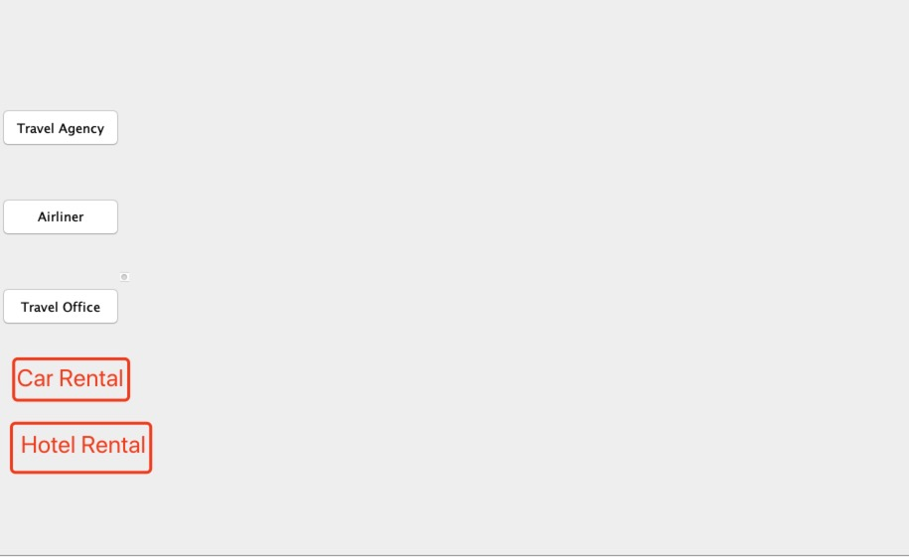

In terms of the interface, make the following changes: In the TravelAgencyMain interface, add the Car Rental and Hotel Rental buttons. Click on these two buttons to go to ManageCarRentalJPanel or ManageHotelRentalJPanel. Similar to ManageAirlinersJPanel, in these two interfaces, users can create, update, delete and find CarRentalCompany/Hotel, Car/Room.

In addition, when the user clicks the Search Flight button in the Travel Office's Manage-CustomerJPanel, it can jump to the following interface:

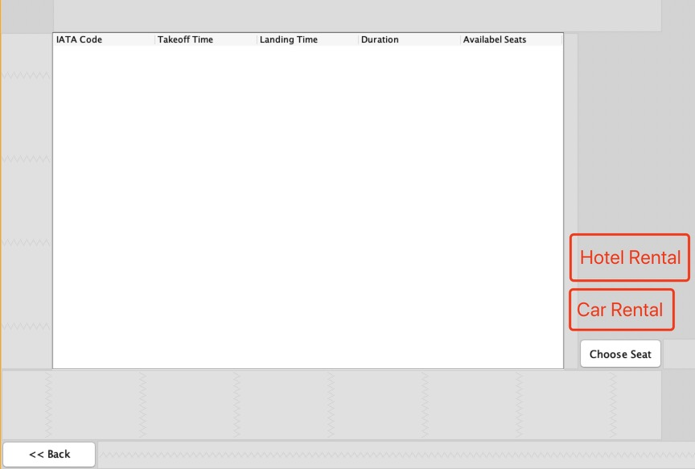

In this interface corresponds to a customer's flight. Add the Hotel Rental button and the Car Rental button next to the Choose Seat button. Select a flight from the form and click on the new button to enter the hotel reservation or car rental booking interface.

In the Hotel Rental Panel, users can choose a hotel at the departure or destination to view room reservations and book a room. Similarly, in the Car Rental interface, users can choose a car rental company at the departure or destination to view car rentals and rent a car.