# Purpose

To define the process instructions and guidelines for LMS Administrators (LMS Admins) to use in Intuitive’s Learning Management System (LMS) to administer quality systems training.

To be used as a recommended, but optional, guidance for LMS Admins to administer training outside of Intuitive’s quality system training (e.g. professional or management development).

# Scope

This Work Instruction covers the creation and modification of Content Objects, Items, Curricula, Assignment Profiles, Assessments (Quizzes and Exams), Reports and Classes within Intuitive’s Learning Management System as well as managing registrations and completions of training through the Learning Management System.

# References

## Internal References

|  |  |
| --- | --- |
| 859165 | WI, Learning Change Request (LCR) |
| 854017 | SOP, Quality System Records |
| 854231 | SOP, Good Documentation Practices |
| 1048297 | WI, Distributor RAQA ISU Account and Curriculum |
| 1039082 | WI, Supplier Account Application Management |

## External References

NA

# Definitions/Acronyms

|  |  |
| --- | --- |
| LMS (Learning Management System) | SAP SuccessFactors used by Intuitive to record, maintain and manage training activities to employees, distributors, suppliers, or MSA workers for whom training requirements are established. It is also used to deliver online training. |
| LMS Admin | Individual who has access to the LMS Administrator website where he/she manages training, enrollments, assignment of learning, and reporting. |
| LOA (Leave of Absence) | An extended absence of an employee as defined by Human Resources. |
| Item | The most basic unit of learning. Items are assignable units that typically represent all forms of training activities including, but not limited to, online, instructor-led courses, external training, and on-the-job training. |
| Content Object | A record that contains instructions for the Learning Management System specifying where to find and how to launch a unit of online content such as an online course, exam, tutorial, or other online training. |
| Curriculum | A group of one or more items, requirements, or sub-Curricula. Curricula organizes items into groups so that the items can be assigned to users or groups of users and tracked collectively. |
| Class | An instance of an instructor-led training, scheduled for a specific date and time and given specific resources for that date and time. |
| Attribute | A piece of information about a user that is file transferred from SAP (a repository of employee data) to the LMS. Examples of attributes include email address, organization, title, etc. |
| Assignment Profile | Allows the LMS Admin to automatically assign curricula, libraries, items and/or a role to users based on attributes of a user. Users whose attributes match those of the Assignment Profile are automatically assigned the curricula, libraries, items and/or a role associated with the respective Assignment Profile. Additionally, users whose attributes change so that they no longer match those of a particular Assignment Profile will be removed from that Assignment Profile. |
| Quality System Documents | Any documented procedure utilized for implementing Quality Management. |
| MSA (Managed Services Agreement) Worker | Non-employees such as consultants, typically working for Intuitive under some form of service agreement. |
| Required Fields | Fields in the LMS that the software and/or Intuitive require to be completed. |
| Optional Fields | Fields in the LMS that an LMS Admin might decide to complete to provide themselves or users with additional information or fields that might be useful based on the training. |
| Fields Not Used | Fields that are not populated in the system because their functionalities are not being used in Intuitive’s implementation of the LMS. |
| APL (Approved Product List) | Controlled document listing countries approved for products to ship or sell to. |
| Agile | Automated Change Control System (ACCS) used at Intuitive to manage the Learning Change Requests workflow. |
| LCR (Learning Change Request) | A workflow in Agile used to request, authorize and document changes made by an LMS Administrator to a Learner’s training requirements, Curricula and Assignment Profiles in the LMS. |
| Learner/user | An Intuitive employee, distributor, supplier or MSA worker for whom training requirements are established. |
| AICC | Aviation Industry CBT Committee (AICC) primarily uses the HTTP **AICC** Communication Protocol (HACP) to facilitate communication between the course content and the learning management system (LMS). |
| SCORM | Shareable Content Object Reference Model (**SCORM**) is an XML-based framework used to **define** and access information about learning objects so they can be easily shared in the learning management system (LMS). |
| RPA | Robotic Process Automation |
| Bot | A customized script of tasks to perform. It is a unique sequence of tasks, inputs, logic, and outputs used to perform a business process. |

## Organization Acronyms:

Following is a list of the functional organizations, their acronyms and a description of the groups included within:

|  |  |  |
| --- | --- | --- |
| **Organization** | **Acronym** | **Description** |
| Agile | AGL | Agile documents |
| Corporate | CORP | For assigning all employee policies that come from HR or Finance |
| Customer Service | CS | Customer Service, RMA, Field Service, Product Support |
| Engineering | ENG | Engineering, New Product Introduction |
| Facilities | FAC | Safety, Facilities |
| Finance | FIN | Finance, Accounting, Contracts, Accounts Receivable, Accounts Payable |
| Human Resources | HR | Human Resources, Learning & OD, Staffing |
| Information Technology | IT | Information Technology |
| International | INTL | Non-USA locations of Employees |
| Legal | LEG | Legal |
| Manufacturing | MFG | Manufacturing, Shipping/Receiving, Purchasing, Continuous Improvement |
| Marketing | MKT | Upstream Marketing, Downstream Marketing |
| Mexicali | MEX | Mexicali office |
| New Product Development | NPD | New Product Development |
| New Product Introduction | NPI | Engineering new product introduction to manufacturing |
| Operations | OPS | Engineering, Quality, Manufacturing |
| Project Management Office | PMO | Project Management Office |
| Quality | QA | Quality Assurance |
| Quality Systems | QS | Quality Systems |
| Regulatory | REG | Regulatory, Document Control |
| Sales | SAL | Clinical Sales, Capital Sales, Sales Training & Development |
| Service and Secondary Markets | SSM | Service and Secondary Markets or customer service group |

## Security Domains:

A domain is a security attribute associated with some entities in the LMS that determine which LMS Admin may view and access the entity. LMS Admins may only view and/or edit certain records in the Security Domain(s) for which they have been given permission. In general, LMS entities are associated with functional groups.

|  |  |  |  |
| --- | --- | --- | --- |
| **Security Domain ID** | **Level** | **Parent Domain ID** | **Functional Groups(s)** |
| INTU | 0 |  | Intuitive |
| INT | 1 | INTUITIVE | Internal (Human Resources) |
| SALES | 2 | INTERNAL | Sales & Marketing |
| MAIN | 2 | INTERNAL | Groups other than Sales & Marketing |
| MSA | 3 | MAIN | Quality Systems (for Managed Services) |
| SUPPL | 2 | EXT | For Suppliers and Vendors records |
| DISTR | 2 | EXT | For Distributor Partner records |
| JV-CN | 2 | EXT | For JV China records |
| BOD | 1 | EXT | Board of Directors |
| EXT | 0 |  | External |

# Responsibilities

## An LMS Admin is responsible for the following:

* Maintaining the LMS by creating and managing Content Objects, Learning Items, Curricula, Assignment Profiles, and other information related to training.
* Adding/Removing learning requirements to/from Learners under applicable direction or approval of a Functional Manager (refer to WI, Learning Change Request (LCR), 859165).
  + The assignment of training items maintained in Agile will be directed through the use of a Learning Change Request (LCR).

Note: *Completion of LCR ILT training, offered by Document Control, is required in order for an LMS Admin to create LCRs in Agile.*

* Creating and maintaining Classes for Learning Events.
* Testing Content Objects, Items, Curricula, Assessments, and Assignment Profiles to ensure they are performing as expected.
* Recording the completion of internal instructor led and outside learning events on a learner’s LMS training record upon the request of an instructor or learner.
* Following the Leave of Absence Process (LOA) according to SOP, Training, 854019.
* Training to this document - 859163 WI Learning Management System (LMS) Administrators- and complete on-the-job training (OJT) in order to receive ISU Admin access.
* Adhere to relevant QMS procedures outlining requirements for properly documenting training events and management of the associated training records (refer to 854231 DOP, Good Documentation Practices and 854017 SOP, Quality Systems Records) as necessary.
* Deactivate infrastructure that is obsolete, un-used, or otherwise replaced by a most current version or revision.

# Table of contents

1. Purpose 1

2. Scope 1

3. References 1

3.1. Internal References 1

3.2. External References 1

4. Definitions/Acronyms 1

4.1. Organization Acronyms: 3

4.2. Security Domains: 4

5. Responsibilities 5

5.1. An LMS Admin is responsible for the following: 5

6. Table of contents 5

7. Procedure 9

7.1. Naming Convention 9

7.2. Content Objects 10

7.2.1. Creating a Content Object. 10

7.2.2. Import to iContent Server. 13

7.2.3. AICC Import (Legacy) 16

7.2.4. Creating a Content Package 18

7.2.5. Searching for Content Package (to view, edit, or delete) 20

7.3. Assessments 20

7.3.1. Creating a Quiz 20

7.3.2. Configuring the Quiz 22

7.3.3. Adding Questions to the Quiz 23

7.3.4. Creating an Exam 25

7.3.5. Configuring the Exam 26

7.3.6. Adding Questions to the Exam 27

7.3.7. Delivering Assessment to Learners 29

7.3.8. Deactivating an Assessment 30

7.4. Items 31

7.4.1. Creating an Online Item 31

7.4.2. Creating an Instructor-Led Item 42

7.4.3. Revising an Item 43

7.4.4. Making a Revised Item Production Ready 45

7.4.5. Content Reassignment 45

7.5. Curricula 45

7.5.1. Creating a Curriculum 45

7.5.2. Searching for Curricula (to view, edit, copy, delete or deactivate) 48

7.6. Classes 49

7.6.1. Creating a Class for an ILT 50

7.6.2. Reserving Registration Slots 53

7.6.3. Enrolling Users in a Class 54

7.6.4. Withdrawing a User from a Class 55

7.6.5. Searching for Classes 56

7.6.6. Cancelling a Class 57

7.7. Assignment Profiles 57

7.7.1. Creating an Assignment Profile 57

7.7.2. Execute Changes and Update Users and Assignments on Assignment Profile 61

7.7.3. Deactivating an Assignment Profile 62

7.7.4. Reactivating an Assignment Profile 62

7.7.5. Searching for an Assignment Profile 63

7.8. Assigning and Removing Learning Assignments 64

7.8.1. Adding an Item to a User 64

7.8.2. Adding an Item to a Group of Users 64

7.8.3. Adding a Curriculum to a User 65

7.8.4. Adding a Curriculum to a Group of Users 66

7.8.5. Adding a User to an Item Request List 67

7.8.6. Removing an Item from a User 67

7.8.7. Removing an Item from a Group of Users 68

7.8.8. Removing a Curriculum from a User 68

7.8.9. Removing a Curriculum from a Group of Users 69

7.8.10. Removing a User from an Item Request List 69

7.9. Programs 70

7.9.1. Adding a New Program 70

7.9.2. Changing a Program 71

7.9.3. Removing a Program from Users 71

7.9.4. Deleting a Program 72

7.9.5. Creating a Direct Link for Users to Access Program Assigned 72

7.10. Email Notifications 72

7.10.1. Sending Email Notifications to Users 72

7.11. Record Learning Event 73

7.11.1. Recording One Learning Event Type for Multiple Users 73

7.11.2. Recording Multiple Learning Event Type for Multiple Users 75

7.11.3. Editing Learning History 76

7.11.4. Attaching Document to a Learning History 77

7.11.5. Removing Attached Document from a Learning History 77

7.11.6. Printing Out Certificates of Completion 78

7.12. Editing Required Dates 79

7.13. Reports 80

7.13.1. Searching for a Report 80

7.13.2. Running a Report 80

7.13.3. Scheduling a Report to run 80

7.14. User Support 81

7.14.1. Searching for a User Report 81

7.14.2. Previewing a User’s Libraries 81

7.15. Managed Services Users 82

7.15.1. Creating a Managed Services User 82

7.15.2. Editing Managed Services User Data in SAP ECC 82

7.15.3. Editing Managed Services User, Distributor Partner or Supplier/Vendor Data in Active Directory 82

7.15.4. Inactivating a Managed Services User or Suppler/Vendor or Distributor 82

7.16. **ISI Distributor Partner Setup and Maintenance** 82

7.16.1. Creating a Distributor Partner User 82

7.16.2. Inactivating a Distributor Partner User 83

7.17. **Supplier/Vendor Users** 83

7.17.1. Creating a Supplier/Vendor User 83

7.18. **Obsolete Document** 83

7.19. **Leave of Absence (LOA)** 84

8. Process flow 85

9. Attachments 85

# Procedure

## Naming Convention

**ID Field** Naming Convention Guidance:

**{ORG}_{DEPARTMENT/FUNCTION-DESCRIPTOR}_{LOCATION}_{SEQUENCE # or PLATFORM}**

Example: REG_QMS_CS_ISJ

Notes:

* ID’s are created in all caps and use underscores (_) to separate sections of the ID.
* **{ORG}** designates the organization/department/group creating Content Objects, Items, Curricula, Assessment, or Assignment Profiles. See Section 4.1 for a list of organization acronyms.
  + Documents that originate in Agile use AGL as the {ORG}.
* **{DEPARTMENT/FUNCTION-DESCRIPTOR}** is used to further describe the Content Object, Item, Curricula, Assessment, and Assignment Profile (i.e. a descriptor based on the topic covered).
* **{SEQUENCE # or Platform}** provides a unique identifier. For Agile documents, this is the document number.
* **{LOCATION}** Global vs. Region Specific. Specifies whether the Content Object, Items, Curricula, Assessments, or Assignment Profiles applies to all users/learners depending, or regardless of location.

**Title Field**

Naming Convention Guidance: {Title}

Example: Design Verification and Validation

Notes:

* Best Practice: keep it short and easy to remember.
* For Agile curricula, the title starts with the {Document Number} followed by the {Title}
* For Agile items, the title starts with the document number, the revision (*XY placeholder above),* then the title.
* For non-Agile items, the “Title” format is up to the LMS Admin.

**Description Field**

Naming Convention Guidance: {Description}

Example: This is a 6-day daVinci-S (IS2000) or 5.x robot platform training class. The objective of this course is to orient trainees on the Safety Practices of ISI.

Notes:

* The “Description” format is up to the LMS Admin. Depending on how the content is created, the Description may default to be the same as the title.
* For Agile curricula, the {Description} is the same as the Curriculum Title.
* For non-Agile curricula, the {Description} is optional and its format is solely up to the LMS Admin.
* Best Practice: Include the name of the owner of the curriculum so LMS Admins know whom to contact if the curriculum needs to be modified.
* Best Practice: add key words in the description to improve search capabilities.

## Content Objects

Content Objects are records that contain instructions for the LMS specifying where to find and how to launch a unit of online content such as an online document, course, exam, tutorial, or other online training. Each content object points to one launchable file.

Content Objects are not directly assignable to users. They must be added to an Item, which can then be assigned to users.

To access the **Content Objects** section, expand **Learning Activities > Content Objects.**

### Creating a Content Object.

*Initial Setup*

1. Expand **Learning Activities > Content Objects.**
2. Click **Add New**.
3. Required Fields:
   * + 1. Enter the **Content Object ID** (see naming convention guidance section 7.1.).
       2. Enter the **Title** (see naming conventions guidance section 7.1.).
       3. Enter the **Security Domain** or select one from the search page by clicking the search icon.

*Note: See Section 4.2 for a list of domains.*

* + - 1. Enter a **Description** (see naming convention guidance section 7.1.).
      2. Enter “ISI” for **Build Company** to ensure consistent recording of completion.

1. Optional Fields:
   1. If available, enter details about the content: **Build User, Build Location,** and **Build Date.**
   2. Uncheck the boxes for **Content Object** **is Active** and **Content Object is Online** to make the content inaccessible to users until it is tested and ready for assignment.

*Note: Test that the content object, once added to an item, works as the LMS Admin intended before assigning to users.*

* 1. If available, enter the **Developer Tool** details.

*Note: This is required if content is created using a software application like Storyline, Camtasia, DreamWeaver, etc.*

1. Click **Add**.

*Key Fields to Review/Populate*

**Summary Tab**:

1. Title, Security Domain, Build User, Build Company, Build Location, Build Date, Content Object is Active, Content Object is Online, Description and Developer Tool are prepopulated from the initial set up information.

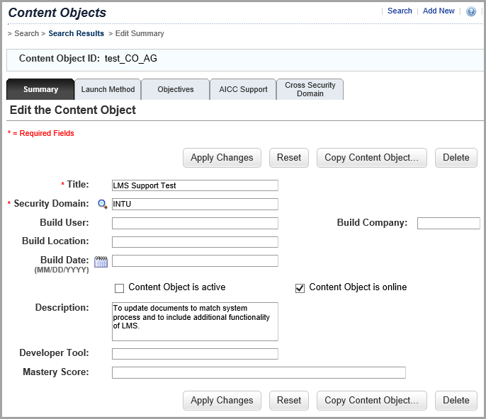

1. Optional Fields:
   1. Enter a **Mastery Score.**

*Note:**When a value is entered in this field, it is the score the user must achieve to complete the selected content object and be awarded completion status for the content object (not the item). Entering a Mastery Score will override any mastery score that was set when publishing the content.*

1. Click **Apply Changes** to save changes to the tab.

**Launch Method Tab**

*Note: The content must be loaded into the appropriate LMS Content Server folder before adding to the Launch Method Tab.*

1. Required Fields:
   1. Select the appropriate launch method using the radio buttons.

*Note: De-select* ***Content Player*** *(system default),**it is not used at Intuitive.*

* + - 1. Select **Document Type**.
      2. Select **AICC** for courseware that is AICC-based.
      3. Select **Browser** to have the system utilize the user's browser to launch and run the selected content object.

*Note: Content must have an AICC Wrapper or be published as a PDF to use this method.*

* + - 1. Select **SCORM** for courseware that is SCORM-based.
  1. Click **Filename** field to enter the path to the content in the LMS Content Server.

*Note: The path to the file must be in the format, “https://isu.intusurg.com/foldername/filename”. For files with AICC wrappers, enter the path to the AICC wrapper file in the filename field, “https://isu.intusurg.com/courses/INTU/Regulatory/AICC_Wrapper_01/wrapper.html”.*

1. Optional Fields:
   1. Enter any parameters to be communicated when launching the course in the **Parameters** section.

*Note: For files with AICC wrappers, enter the path to the content to be enclosed by the AICC wrapper in the Parameters Field in the format “docURL= https://isu.intusurg.com/foldername/filename”.*

* 1. Enter the **Offline Filename** if the content will also be available using the offline content player.

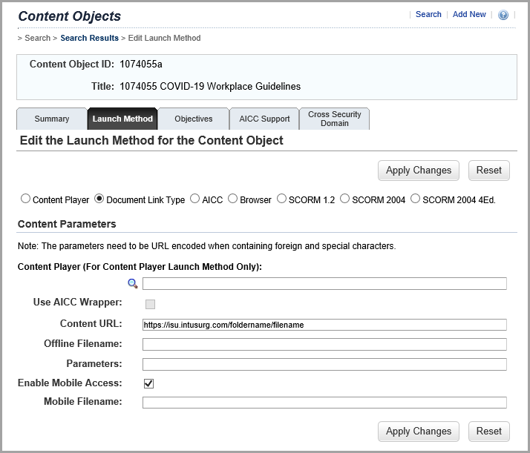

1. Click **Apply Changes** to save changes to the tab.

**Objectives Tab**

*Note: This tab is not currently used.*

**AICC Support Tab**

1. Optional Fields:
   1. Enter **AICC Support** information that will be automatically passed to the player program if the player selected for this object is AICC-compliant.
2. Click **Apply Changes** to save changes to the tab.

*Note: At this point, the content object has been created. There is no button to finalize all the tabs as changes are saved when* ***Apply Changes*** *is selected.*

### Import to iContent Server.

*Note: The content must be compressed into a Zip file from Articulate Storyline prior to initial setup.*

*Initial Setup*

1. Expand **Content > Import Content.**
2. Step 1 – Select Action screen displays

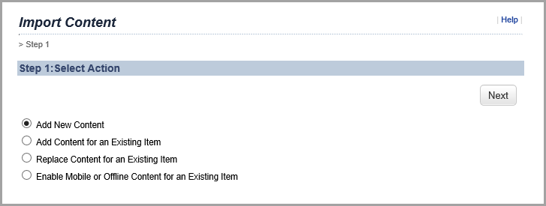

* 1. Select **Add New Content** button.

*Note: For production items, do not recommend using Add Content for an Existing Item and Replace Content for an Existing Item. It is recommended to only create the content object then update the Item manually. As for Enable Mobile or Offline Content for an Existing Item, please go to the content object directly to enable.*

* 1. Click **Next.**

1. Step 2 – Select Files screen displays.

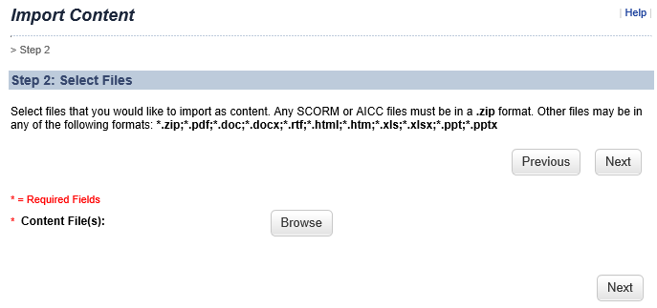

* 1. Click the **Browse** button to locate the file(s) to upload.
  2. Select the training module compressed into a zip file to upload then click on Open.
  3. Click **Next.**

1. Step 3 – Configure Content and Item Settings screen displays.

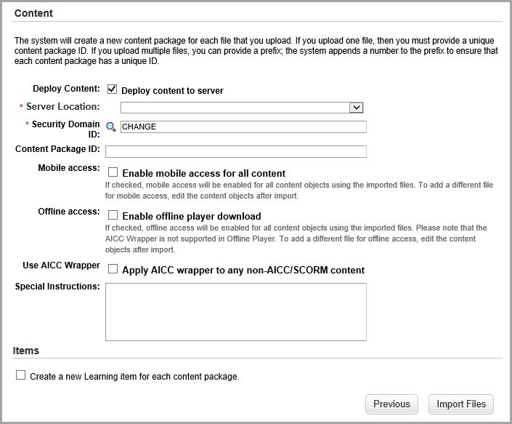

* 1. For **Server Location,** select iContent folder for your group.
  2. Fill in the **Security** **Domain ID** field or select one from the Search Domains page by clicking the Search icon.
  3. Check the **Enable Mobile access** **for all content** if you want mobile access to your imported files.
  4. Check the **Enable offline player download** if you want offline access to your imported files.
  5. Check the **Apply AICC wrapper to any non-AICC/SCORM content** if you want to use an AICC Wrapper.
  6. Enter any Special Instructions.
  7. If applicable check box “Create a new Learning item for each content package.” and complete the following fields:
     1. Item Type – select item type
     2. Item ID – enter ID (refer to naming convention 7.1)
     3. Item Title – enter title
     4. Assignment Type – select assignment type
     5. Security Domain ID – select domain
     6. Content is available for launch (available for users) – check box
     7. Add to History on Completion of All Content – check box
     8. Skip content structure page on launch – check box only if 1 content object (Note: if more than 1, do not check)
     9. Add to History on Pass – check box only if 1 content object (Note: if more than 1, do not check)
     10. Allow review of AICC/SCORM content from the Learning History – check box if applicable
     11. Completion Status – select completion status
     12. Library ID – select library to publish to if applicable
     13. Category ID – select category if publishing to library

1. Click **Import Files.**
2. Click on Edit Content Object IDs and change ID (refer to naming convention 7.1)
3. Click on **Apply Changes**.
4. Click on **Schedule Job**.
5. For Contact Email Address, enter your email address.
6. Click on **Finish**.

### AICC Import (Legacy)

A file of the content must be loaded into the appropriate LMS Content Server folder before adding to the LMS using the Import Tool.

*Initial Setup*

1. Expand **System Administration > System Management > AICC Import (Legacy)**
2. Step 1 – Import AICC File displays

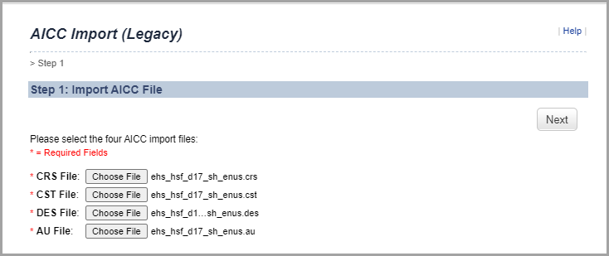

1. For each Require Field, click “Choose File” and enter the appropriate file selection.
2. Click **Next**.
3. Step 2 - Edit Course Information displays

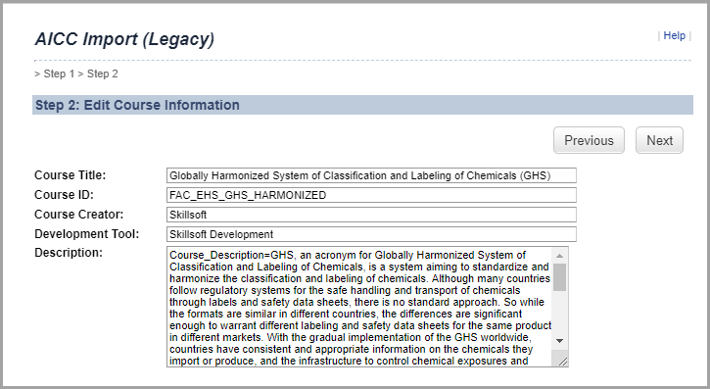

1. Review pre-populated fields. For Course ID, reference the naming convention guidance in section 7.1
2. Click **Next**.
3. Step 3 – Read Through Instructions displays

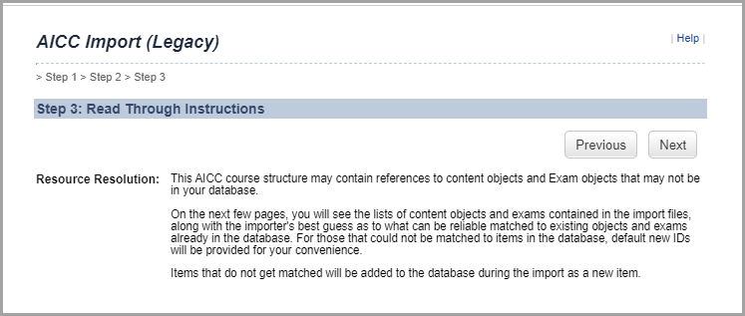

1. Click **Next**.
2. Step 4 – Resolve Content Object(s) displays

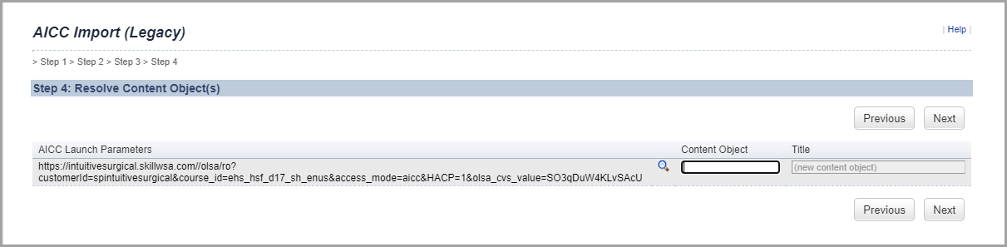

1. In the Content Object field, enter the ID to match the Course ID.
2. Click **Next**.
3. Step 5 – Configure content with New Item displays
4. Select New Item:

Enter Item Type from drop-down list

Enter Item ID (reference naming convention guidance in section 7.1)

Enter Revision Date

Enter Revision Time

1. Click **Next**.
2. Step 6 – Complete AICC Import settings displays
3. Check box for “Content is available for launch (available for users)”
4. Check box for “Mark Item complete when all objects are complete”
5. Select Online Completion Status from drop-down list
6. Click **Finish**.

### Creating a Content Package

*Initial Setup*

1. Expand **Content 1.>Content Packages.**
2. Click **Add New**.
3. Required Fields:
   1. Enter the **Content Package ID** (see naming convention guidance section 7.1.).

*Note: Content Package naming follows the naming convention guidance for Content Objects.*

* 1. Enter the **Title.**
  2. Type the **Security** **Domain ID** or select one from the search page by clicking the search icon.

*Note: See Section 4.2 for a list of domains.*

* 1. Enter a **Description.**

*Note: Content Package naming follows the naming convention guidance for Content Objects.*

1. Optional Fields:
   1. Enter details about the content: **Build User, Build Location,** and **Build Company.**
   2. Enter the **Build Date.**
   3. Enter **Copyright** details.
2. Click **Add.**

*Key Fields to Review/Populate*

**Summary Tab**

1. **Title, Security Domain, Description, Build User, Build Location, Build Company, Build Date** and **Copyright** are prepopulated from the initial set up information.

**Content Tab**

1. Required Fields:
   1. Enter the **Object Label** (this is the title that is visible to users).
   2. Select the **Object Type** (**Folder**, **Exams**, or **Content**).
   3. Enter the **Folder**, **Exams** or **Content**, or upload the content using the search icon.

*Note: An LMS Admin can add any number of exams or content. To change the order in the package, change the number in the* ***Order*** *field.*

1. Click **Add** (after each upload).
2. Click **Continue.**

*Note: At this point, the content object has been created. There is no button to finalize all the tabs, as changes are saved when Add is clicked.*

### Searching for Content Package (to view, edit, or delete)

1. Expand **Content > Content Packages.**
2. Use the search page to filter the list of items.
3. In the search results page the LMS Admin can choose to view or edit a content object.
   1. To **view**, click the View icon
   2. To **edit**, click the Edit iconand make edits. Click **Apply Changes**.
   3. To **delete**, click the Edit iconand click **Delete**.

*Note: A confirmation pop-up window appears. Click* ***OK*** *to delete or* ***Cancel*** *to abort the process.*

*Note: Content Packages can only be deleted if they have not been added to an item or a curriculum that has been assigned to a user.*

## Assessments

With this tool, admins may create quizzes or exams. Quizzes are lightweight assessments that do not require centralized management of questions. Exams are formal assessments that support all quiz features such as randomization of questions using objective-based question pools and question variants, as well as version-level tracking and reporting of responses.

### Creating a Quiz

* + - 1. Expand Content > Assessments
      2. Click Add New. An Add New Assessment box appears.

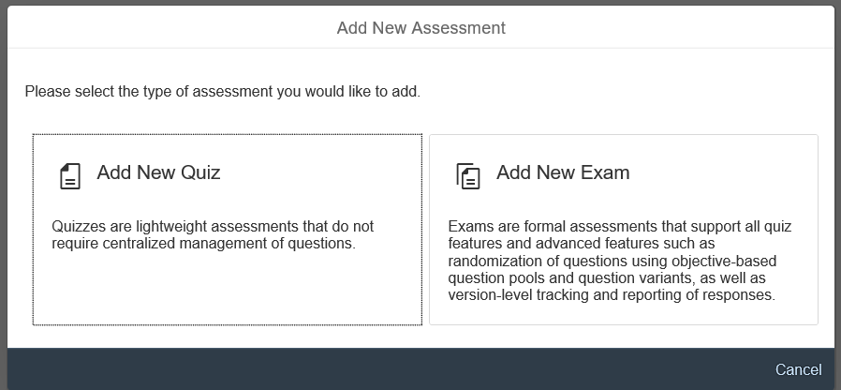

* + - 1. Click Add New Quiz

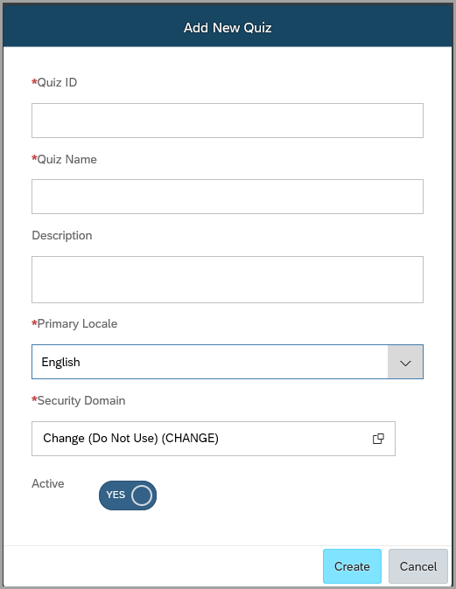

* + - 1. Enter in Quiz ID, Quiz Name, Description, Primary Locale, and Security Domain.

*Note: Quiz ID field naming follows the naming convention guidance in section 7.1. Active is prepopulated by the system.*

* + - 1. Click Create.

*Note: An overview screen appears. You are now ready to add questions to your quiz or configure various settings for your quiz.*

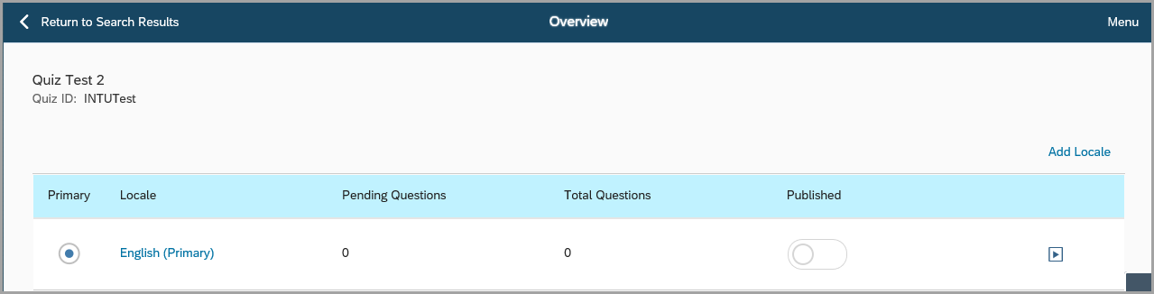

### Configuring the Quiz

Once a quiz is created, the admin may configure various Global or Localized settings.

1. Click Menu (in the upper-right corner of the screen) to see a list of options.

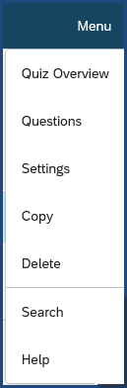

1. Click Settings. The Settings screen appears.

Global Settings include quiz type (sequential or free-form), feedback display, number of attempts, passing percentage, as well as whether or not you want to have a results summary, allow quiz review, allow for quiz to be resumable, and if you want to randomize questions. Localized settings include the locale (language) to use, quiz name, description, and messages to be displayed to the users.

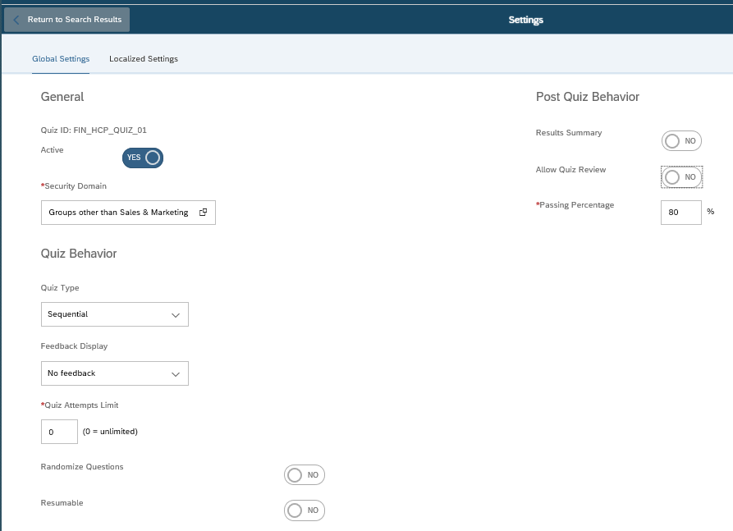

### Adding Questions to the Quiz

1. Expand Content > Assessments.
2. Search for your assessment link and click on it to open.

*Note: The overview screen appears. You are now ready to add questions to your quiz.*

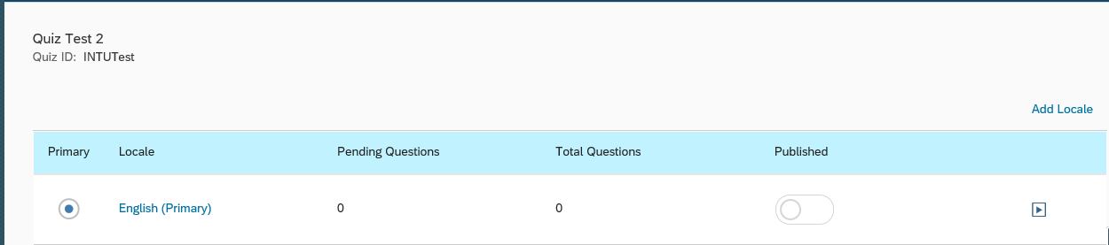

1. Click Menu (in the upper-right corner of the screen) to see a list of options.

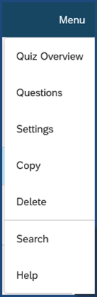

1. Click Questions.

*Adding Questions to a Quiz:*

1. Select the question type (Single Answer, Multiple Answers, True or False, Ordering, or Fill-in-the-blank) and complete the Question field and Answer fields.
   1. Answer fields may be removed or added as necessary.
   2. The answers may be randomized by enabling the Randomize Answers box.
   3. Click on the radio button in front of the correct answer.
2. If the feedback is enabled, enter correct and incorrect answer feedback.
3. Click the Save button.
4. Click on  to add another question.
5. Repeat steps 5 through 7 until you have added all the questions for the quiz. *Note: You can delete a question by clicking on the Delete Question icon  or you can preview a question by clicking on the Preview icon* 
6. Click Menu and then select Quiz Overview.
7. Slide the slider to Published next to each locale (i.e., English (Primary)

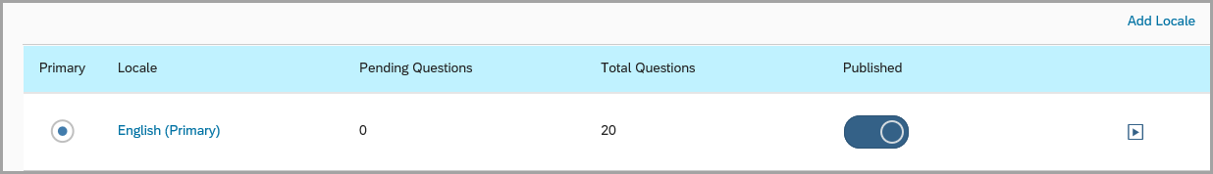

1. Click Yes to confirm that you want to publish to this locale.

### Creating an Exam

1. Navigate to Content > Assessments.
2. Click Add New. An Add New Assessment box appears.



1. Click Add New Exam

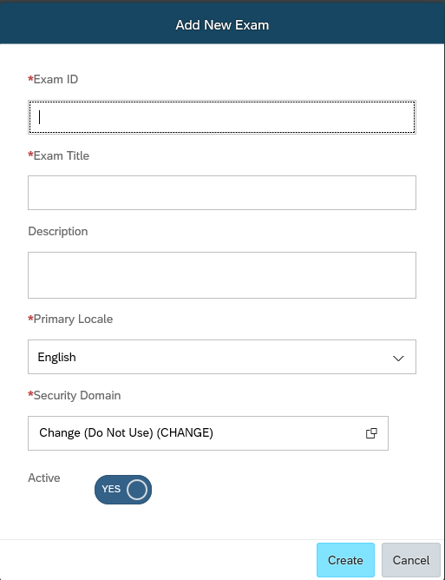

1. Enter in Exam ID, Exam Title, Description, Primary Locale, and Security Domain.

*Note: Exam ID field naming follows the naming convention guidance in section 7.1. Active is prepopulated by the system.*

* + - 1. Click Create.

*Note: An overview screen appears. You are now ready to add questions to your exam or configure various settings for your exam.*

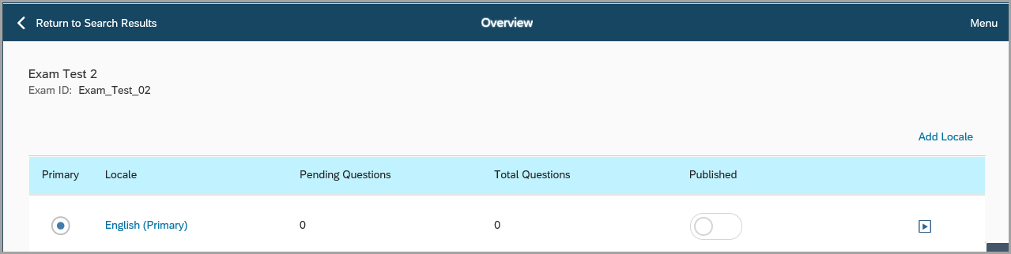

### Configuring the Exam

Once an exam is created, the admin may configure various Global or Localized settings.

1. Click Menu (in the upper-right corner of the screen) to see a list of options.

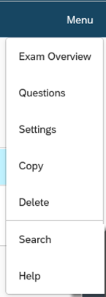

1. Click Settings. The Settings screen appears.

Global Settings include exam type (sequential or free-form), feedback display, number of attempts, display points to user, passing percentage, as well as whether or not you want to have a results summary, results details, allow exam review, allow for exam to be resumable, and if you want to randomize questions. Localized settings include the locale (language) to use, exam name, description, and messages to be displayed to the users.

*Note: Exams include all the settings that quizzes have, plus additional settings that can be seen on the right side of the Exam Settings screen (see below).*

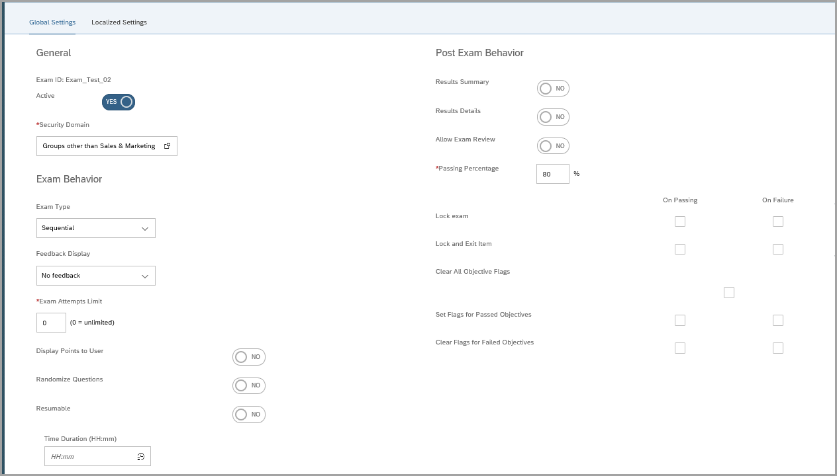

### Adding Questions to the Exam

1. Expand Content > Assessments.
2. Search for your assessment link and click on it to open.

*Note: The overview screen appears. You are now ready to add questions to your Exam.*

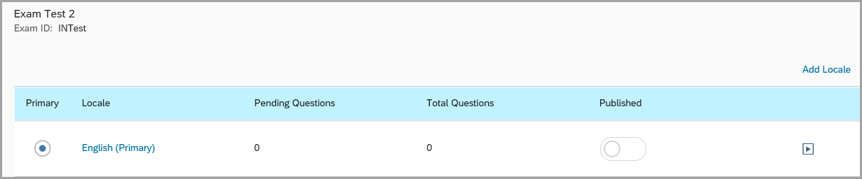

1. Click Menu (in the upper-right corner of the screen) to see a list of options.

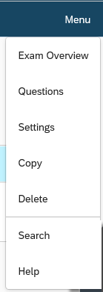

1. Click Questions.

*Adding Questions to an Exam:*

1. Select the question type you want to create: Single Answer, Multiple Answers, True or False, Ordering, or Fill-in-the-blank.

*Note: The Create Question Screen appears.*

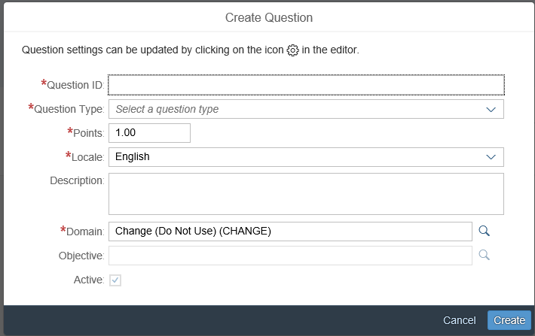

1. Enter in the Question ID and Domain.
2. Select Create.
3. Enter in your Question and Answers.
   1. Answer fields may be removed or added as necessary.
   2. The answers may be randomized by enabling the Randomize Answers box.
   3. Click on the radio button in front of the correct answer.
4. If the feedback is enabled, enter correct and incorrect answer feedback.
5. To make the question available, click on the slider box next to Available



*Note: Before you can publish an Exam, all Exam Questions must be Available.*

1. Click the Save button.
2. Click on  to add a New Question, an Existing Question, or an Existing Objective.

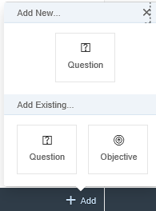

*Note: If you choose to add an Existing Question or Objective you will be directed to the Question or Objective Library.*

1. Click on Add New Question
2. Select a Question Type from the drop down list.
3. Repeat steps 8 through 12 until you have added all exam questions.
4. Click Menu and then select Exam Overview.
5. Slide the slider to Published next to each locale (i.e., English (Primary)



1. Click Yes to confirm that you want to publish to this locale.

### Delivering Assessment to Learners

1. Expand Learning Activities > Items
2. Search for the Item the assessment will link to.
3. Click on the item link and then select the Online Content tab.
4. Click Add Content Object drop down and choose Add Assessment

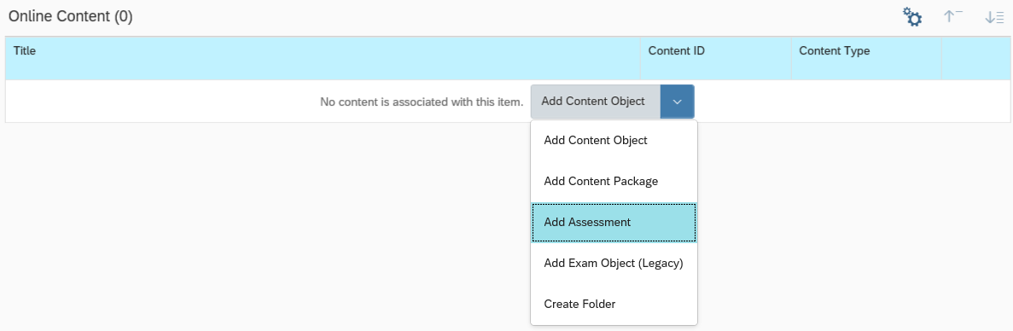

1. The Add Assessment screen displays.

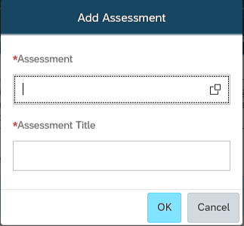

1. Required Fields:
   1. Enter in the Assessment ID or search for the Assessment ID.
   2. Enter in an Assessment Title.
2. Click OK.
3. Click Save.

*Note: If the following warning notifications appears, reference section 7.4, Step 7.*

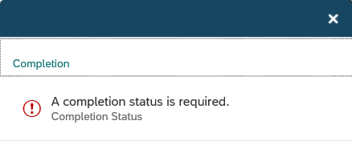

### Deactivating an Assessment

*Note: Prior to deactivating/unpublishing an assessment, remove relationship from Item (reference ).*

1. Expand Learning Activities > Assessment
2. Search for your assessment link and click on it to open.
3. Change “Published” setting to Unpublished
4. For the following confirmation, select Yes

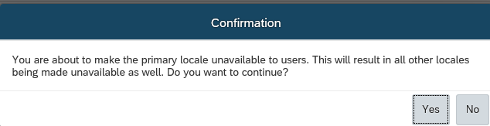

1. On right hand side, click on Menu and select Settings.
2. For Active status, select No.
3. Click Save.

## Items

An item is the most basic unit of learning. It is an assignable unit, which typically represents all forms of training activities, including online, instructor-led courses, external training, and on-the-job training.

To access items, expand **Learning Activities > Items.**

### Creating an Online Item

*Initial Setup*

1. Expand **Learning Activities > Items.**
2. Click **Add New**.
3. Required Fields:
   1. Select from the **Locale** drop-down menu.
   2. Select “*Online, web-based training (ONLINE)”* from the Item Type drop-down menu.
   3. Enter the **Item ID** and **Title** (see naming convention guidance above in section 7.1)**.**
   4. Type a **Security** **Domain ID** or select one from the search page by clicking the search icon.

*Note: See Section 4.2 for a list of the domains.*

* 1. Enter a **Description** of the item (see naming conventions guidance above in section 7.1).
  2. The **Revision Date** can be typed in as today’s date or click the calendar icon to select a date.
  3. The **Revision Time** must be typed in as the current time.
  4. Change the **Revision Number**.
  5. The **Active Status** default is displayed.
  6. The **Create Date** can be typed in as today’s date or click the calendar icon to select a date.

1. Optional Fields:
   1. Select from the **Org Unit Report Group** drop-down menu.
   2. Select from the **Assign. Type ID** drop-down menu.
   3. Select an **Approval Process ID** from the drop down menu and check the box next to **Approval Required** to receive approval before viewing the online item.
   4. Select the check box next to **Include in** **Org Unit Training Report**
   5. Select the check box next to **Approved**.
   6. Select the check box next to **Auto Enroll from Waitlist**.
   7. Select the check box next to **Require E-Signature**.
2. Not Used:
   1. Prevent Multiple Class Registration Interval
   2. Comments
   3. Certificate Expiration Text
   4. Certificate Description Text
3. Click **Add** and **Save** to proceed to next step to save your Online Item and exit ISU. Upon login to ISU, previously created Online Item can be found in the **Recents** section, or can be located by searching for the item.

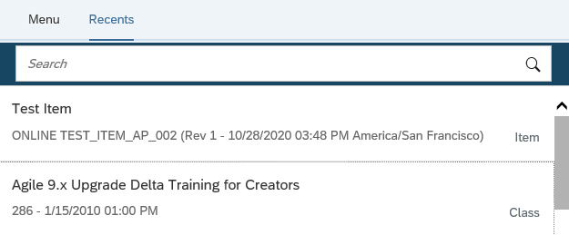

***Add Content***

1. Click on **Online Content**. Select  icon to access *Online Content Settings*.
2. Required Fields:
   1. In the **Completion Status** field drop down menu, depending on the Item Type, select one of the options to be granted to users upon
3. Optional Fields:
   1. In the Launch tab, turn on **Content is available for launch (available for users)** to enable users to access content.
   2. In the Completion tab, turn on **Add to History of Completion to All Content** to automatically mark the item as complete upon completion of all content objects.
   3. In the Completion tab, turn on **Allow users to review content from Completed Works.**
   4. In the Completion tab, set the **AICC Max-Normal** to 99 (this is the maximum number of AICC content objects the system can open simultaneously within that item).
4. Click on **OK**.
5. From **Online Content**, click on drop down list to select the different types of online content to add.

*Note: There are three types of online content an LMS Admin can add that are outlined below.*

1. To add **Content Object,** select from drop down list **Add Content Object**
   1. Required Fields:
      1. Enter the **Content Object ID** or select one from the search page by clicking on search icon.
      2. Enter the **Object Title** to be displayed to users.
   2. Click **OK**.
   3. Click **Save**.
2. To add **Content Packages**, select from drop down list **Add Content Package**
   1. Required Fields:
      1. Enter the **Content Package ID** or select one from the search page by clicking on search icon.
   2. Click **OK.**
   3. Click **Save**.
3. To add **Assessment,** select from drop down list **Add Assessment**
   1. Required Fields:
      1. Enter the **Assessment ID** or select one from the search page by clicking on search icon.
      2. Enter the **Assessment Title** to be displayed to users.
   2. Click **OK**.
4. Click **Save & Exit**.

***Add Libraries***

1. Click on **Libraries** tab.
2. Click on **Add Libraries.**
3. Entera **Keyword** or **Library ID** or click on **Search** to select from list.
4. Click *the* ***Add*** *checkbox to add the item only**or click the* ***Add Classes*** *checkbox and* ***Add*** *checkbox to add future classes to the library along with the item.*



1. *Click* ***Add***

*Note: The sections under Library Options (Flag, Reason, Until, and Expires) are Not in Use.*

*Key Fields to Review/Populate*

**Additional Settings**

1. Click on **Item Details** tab**.**
2. Required Fields:
   1. Select the appropriate **Assignment Type**.

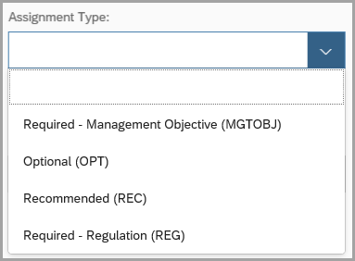

* 1. Provide the **Contact’s Email** of the person responsible for this item. This is visible to users under the item summary.
  2. **Require E-Signature** defaults to off. If this is required, please turn on. This functionality has been enabled for item types: DOC, ONLINE, and TEST.

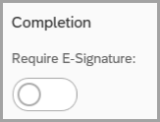

1. Optional Fields:
   1. Select the **Org Unit Report Group ID** from the drop down menu to note the item should show up on the **Organization Unit Training Requirements Report**.

*Note: The numbers organize the way the items on the report are presented. Items are presented in numeric order.*

* 1. To require a user to complete training within a time period on an item at initial assignment, provide the following information:
     1. Select from drop down list the **Initial Basis**. There are two options:
        1. For the **Calendar** option, the system uses a range of time (month, quarter, year, etc.) to calculate the initial period (i.e. the initial period starts the following month, quarter, year, etc.).
        2. For the **Event** option, the system uses the actual date of assignment to calculate the initial period (i.e. the initial period starts right away).
     2. Enter the **Initial Number**. This is a number that, when associated with the **Initial Period**, sets how many days, weeks, months, quarters, or years the user has to complete the item.
     3. Enter the **Initial Period**. This is the time period that, when associated with the **Initial Number**, sets how many days, weeks, months, quarters, or years the user has to complete the item).
     4. Enter the **Initial Required Date Basis**. If you select Assignment Date as the required date basis, then the system calculates all of the completion statuses and next assignment dates based on when the curriculum was assigned to a user. If you select Hire Date as the required date basis, then the system Hire Date to calculate completion status and next assignment dates. If any user's hire date changes, then the system automatically recalculates required dates.
  2. To require a user to retrain on an item, provide the following information:
     1. Select from drop down list the **Initial Basis**. There are two options:
        1. For the **Calendar** option, the system uses a range of time (month, quarter, year, etc.) to calculate the initial period (i.e. the initial period starts the following month, quarter, year, etc.).
        2. For the **Event** option, the system uses the actual date of assignment to calculate the initial period (i.e. the initial period starts right away).
     2. Enter the **Retraining Number**. This is a number that, when associated with the **Retraining Period**, sets how many days, weeks, months, quarters, or years the user has to complete the item as a retraining or recertification.
     3. Enter the **Retraining Period**. This is the time period that, when associated with the **Retraining Number**, sets how many days, weeks, months, quarters, or years the user has to complete the item as a retraining or recertification.
  3. For the **Approved** setting, select *Yes* to note that the item has been reviewed and approved (Items do not have to be selected as approved to be used. This check box does not trigger other system activity).
  4. Enter the **Approved By** and **Approval Date** information for the approval of the revision.
  5. Add the expiration date of the certification in the **Certificate Expiration Text** field.
  6. Enter the **Item Goals** (i.e. the goals of this training). This is visible to the user in the item summary.
  7. For the **Include in Org Training Report** setting, select *Yes* to list the item in the Organization Unit Training Requirements Report that is sent to managers.
  8. Enter thedescription of the item in the **Certificate Description Text.** This will display on the Certificate.
  9. For the **Unregistered User can Access Online Content** setting, turn *On* toallow users to access to online content associated with an item even if the users are not registered to for a class.
  10. For the **Certificate Template**, select from the down-down selection as appropriate.
  11. Enter a description of the intended target group of users for this item in the **Audience** Field. This is visible to the user under the Item Summary.
  12. Add any additional **Comments.**

*Note: This section is only visible to the LMS Admin.*

1. Fields applicable to Scheduled Items only:
   1. **Auto Enroll from Waitlist** – select *Yes* or *No*.
   2. **User can Request a Class** – select to turn *On* or *Off*
   3. **User can Waitlist** – select to turn *On* or *Off*
   4. **Minimum Enrollments** – enter # of enrollments.
   5. **Maximum Enrollments** – enter # of enrollments.
   6. **Prevent Multiple Class Registration Interval** – enter # of days.

**Assignment Profiles Tab**

1. Optional Fields:
   1. To add one or more assignment profiles to the Item, click on **Add Assignment Profiles**.
   2. To remove one or more Assignment Profiles from the Item, check box under **Remove** for corresponding Assignment Profile and click on **Save**.

*Note: The system assigns items to the curriculum or removes them from users when the Assignment Profile automatic process next executes and when users move into or out of the associated assignment profile. You must execute changes for each assignment profile that you add to the curriculum before the system assigns the curriculum to the users who meet the conditions of the assignment profile. For more info on executing changes to an assignment profile, please refer to section 7.7.2.*

**Content Tab**

1. Contents are prepopulated from the initial setup information. If you want to remove any content, please click on remove icon. If you want to add content, please refer to Step 7 under Add Content section.

**Libraries Tab**

1. Libraries are prepopulated from the initial setup information.
2. To add a library, click on **Add Libraries**
3. Entera **Keyword** or **Library ID** or click on **Search** to select from list.
4. Click *the* ***Add*** *checkbox to add the item only**or click the* ***Add Schedules*** *checkbox and* ***Add*** *checkbox to add future classes to the library along with the item.*
5. *Click* ***Add***

*Note: The sections under Library Options (Flag, Reason, Until, and Expires) are Not in Use.*

1. To remove a library, check box next to Library ID and click on **Remove**.

**Curricula Tab**

1. An LMS Admin can view the list of curricula to which the item is assigned. To change which curricula assignments for the item, refer to section 7.6.

**Prerequisites Tab** (Optional)

1. Click on icon to access **Create Group**
   1. Enter **Title**
2. Click on  icon to access **Add Prerequisites**
   1. To add **Items**:
      1. Click on **Items** tab and enter the **Item ID** and/or click **Search** then select items that must be completed prior to accessing this item.
      2. To select the item, check **Add** then click on **Add**
   2. To add **Curricula**:
      1. Click on **Curricula** tab and enter the **Curriculum ID** and/or click **Search** then select curriculum that must be completed prior to accessing this item.
      2. To select the curriculum, check **Add** then click on **Add**
3. Click **Save** to save changes.

**Categories Tab** (Optional)

1. **Categories** is prepopulated from the set up information.
2. To add Categories, click on **Add Categories** and check box under **Add** for corresponding ID and click on **Add.**
3. To remove Categories, check box next to Category ID and click on **Remove.**

**Substitutes Tab (**Optional)

1. Click on  icon to access **Add Substitutes.**
   1. Enter the **Item ID** and/or click **Search.**
   2. For selected item, enter the **For-Credit Status** that the user receives upon completing the corresponding substitute for the item.
   3. Check the **Provide Credit for Base Item if Not Assigned** check box to have a separate learning event recorded in the users learning history for the current item when the substitute item granting substitute is successfully completed.
   4. Enter an **Effective Date** or click on the calendar icon to select the date that the substitute status is effective.
   5. Check **Add.**
2. Click on **Add.**

**Classes Tab** (Applicable to Instructor Led Training only)

1. You can use the Classes tab to view all of the classes that are based on this item. Because the system also shows the number of registered or enrolled users for each class, you can also use this information to help balance the registration for each offering of this item.

*Note: The following tabs can be accessible by clicking on the right down arrow or* ***Scroll Right****.*



**Surveys Tab** (Optional)

1. Optional Fields:
   1. To add Survey, go to section Course Feedback Survey: User Satisfaction,for **Survey**,click on search icon to search for Questionnaire Survey and click on **select.**
      1. Enter **Days to Complete** and check **Required For Item Completion** if applicable.
   2. To add pre/post test for item, go to section Learning Evaluation: Mastery of Content, select from drop down list.
   3. To add Follow-up Evaluation, go to section Follow-up Evaluation: Application of Learning, for **Survey**,click on search icon to search for questionnaire Survey and click on **select.**
      1. Select applicable **Participants.**
      2. For **Assign,** enter # of days to assign after item completion.
   4. To copy an Evaluation from an item.
      1. Expand **Learning Activities** >**Items**.
      2. Search for an Active item with “Evaluation” in the Item Title field.
      3. Select the item. Item detail description screen is displayed.

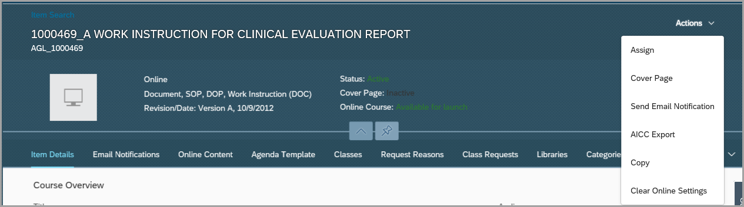

* + 1. From the Actions menu, click **Copy**. Copy Item screen is displayed.
    2. Check **Copy Surveys**, assign a New Item ID, then Click Copy.
    3. Details of the new item screen is displayed.
    4. Click on the right down arrow or Scroll Right. Select Surveys.

**Instructors Tab** (Applicable to Instructor Led Training only)

1. **Check Instructor Authorization** check box, to enable system to check for authorized instructors when an LMS Admin add or modify the agenda of a class.
2. To add an authorized Instructor to an Item, enter **Instructor ID** or click on **add one or more from list** to search then click on **Add.**
3. To remove an authorized Instructor from the Item, check box under Remove for corresponding Instructor ID and click on **Apply Changes**.

*Note: If an administrator inserts or selects an instructor who is not authorized to teach the item in the Primary Instructor box, then the system warns (but does not prevent) the administrator from selecting an instructor who is not authorized to teach the item.*

**Email Notifications Tab** (Optional)

1. Optional Fields:
   1. Edit the text and add attachments for the following notifications:

*Note: Click* ***Apply Changes*** *after changing each notification or adding each attachment.*

* + 1. **Class Cancellation Notification for the Item.**
    2. **Registration Email Notification for the Item.**

Note: Enter information providing details for the Item registration in the Notifications tab > Edit Registration Text.

* + 1. **Withdraw Email Notification for the Item.**
    2. **Waitlist Email Notification for the Item.**
    3. **Waitlist Removal Email Notification for the Item.**
    4. **Pending Email Notification for the Item.**

**Requests Tab** (Optional)

*Note: This Tab is not used when setting up an online item. It is used to manage requests after an item is created.*

**Document Links Tab** (Optional)

1. Enter the **Document ID** or click on **add one or more from list** to search for document then click on Add. These materials display to the user under “related documents”.

*Note: Documents posted here are not tracked. They are reference material only.*

**Grading Options Tab** (Optional)

1. Optional Fields:
2. Select the appropriate grading option: **Inherit From Item Type, Numeric Based, or Value-Based.**

*Note:**Select* ***Inherit from Item Type*** *to use the grading method of the selected item type.*

1. For **Numeric Based** grading options, type the range of numbers, **Minimum** and **Maximum** that will result in the corresponding **Completion Status** (selected from the drop down). Click **Add.**
2. **For Value-Based** grading options, type the grade **Rating** that will result in the corresponding **Completion Status** (selected from the drop down). Enter a description for that rating**.** Click **Add**
3. Click **Apply Changes** to save the grading option selected.

**Request Reasons Tab** (Optional)

1. Create a **Request Reason ID** and **Description** to provide users with pre-created reasons for requesting the item. If nothing is entered, the user will be able to enter his/her reason.
2. Click **Add**. If changes are made after clicking **Add**,then click **Apply Changes**.

### Creating an Instructor-Led Item

*Initial Setup*

1. Please refer to section 7.4.1:
   1. For **Item Type**, select “Instructor Led Training (ILT)” from the drop-down menu.
   2. Enter the **Item ID** and **Title** (see naming convention guidance above in section 7.1)**.**
   3. For **Number of** days, select from drop down list.
   4. For **Hours per day**, enter #.
   5. If applicable, click on **Agenda Template** tab**.**
      1. Add a **Description**, the **Day**, **Duration** of the agenda, and **Location Type** (the **Delay Start** feature provides breaks between agenda and is optional).
      2. To add more, click on **Add New Time Slot.**

*Note: At least one (1) Time Slot must be created for instructor led items.*

* 1. Click on **Save & Exit.**

### Revising an Item

Revising an item creates a new independent revision of that item. An LMS Admin may choose to revise an item to note content or other significant changes (for instance, a new structure to the training, new instructor, etc.)

1. Expand **Learning Activities > Items.**
2. In the search resultspage, find the item and click on the **Item**.
3. Under **Actions**, click on **Revise.**
4. Required Fields
   1. Enter the **New Revision Date**, **Time**, and **Revision Number.**

*Note: Revision time cannot be in the future.*

1. Optional Fields:
   1. Edit the **Time Zone.**
   2. Edit the **Title.**
2. Click on **Next.**
3. In Step 2:
   1. Check box for **Do you wish to copy the content relationships for this item to the new revision?** Checked box will copy the item’s current substitute relationships to the new revision.
   2. Check box for **Do you wish to change all authorized instructors to the new revision?** Checked box to copy all authorized instructors to the new revision.
   3. For online items only, check box for **This item has online settings. Do you wish to include the online settings in the new revision of this item?** Checked box to copy the online settings to the new revision.
4. Click on **Next**.
5. In Step 3:
   1. If you select **Make this Item Production Ready**, the item is one that is finished and ready to be used in curricula or classes.
   2. If you select **Do not make this item production ready** skip to section 7.4.4.
6. In Step 4:
   1. Check box for **Do you wish to inactivate previous revisions of this item?** Select this check box to inactivate previous versions of this item. Inactivation removes the previous revision and replaces the new revision for any time you select the item in the future.
   2. Check box for **Do you wish to update curricula potentially affected by this new item revision?** Select this check box to update all item/curriculum relationships for curriculums which have the item being revised associated with them. When you select this check box, Step 5 appears.
   3. Check box for **Do you wish to update User learning plan assignments potentially affected by this new item revision?** Select this check box to update all users' learning plans who have the item assigned to them. The learning plan is updated to reflect the new revision.
   4. Check box for **Do you wish to change all future classes to use/access the new revision?** Select this check box to cause all classes that have already been scheduled and that use previous revisions of the item to use the new revision of the item.
7. Final Step: There are two options:
   1. Begin the process immediately by clicking the **Run Job Now** button
   2. For jobs that affect over 50 records, schedule a background job to run at another date and time.
      1. Click the **Schedule Job** button. The **Schedule Background Job** page will appear.
      2. Click the **Schedule this Job to be Executed on** radio button. Required Fields: (*Note: Use* ***View Available Time Slots*** *to see allowable time blocks for scheduling.)* 
         1. Enter **Date** or click the calendar icon to select a date.
         2. Enter in a **Time** when the process to be executed.
         3. Enter the **Time Zone** from the drop down menu.
         4. Enter a **Job Description**.
         5. Include an email address if **Notify via email upon completion** is checked.
         6. Click on **Finish.**
         7. Click on **Return to New Revision.**

### Making a Revised Item Production Ready

If an LMS Admin revises an item but chooses not to make it production ready at the time of the revision, he/she can prepare it for production release by following these steps.

1. Expand **Learning Activities > Items.**
2. In the search resultspage, find the item and click on the **Item**.
3. Under **Actions**, click **Finalize Revision**.
4. Refer to section 7.4.3. steps 10 thru 11.

### Content Reassignment

If Content Object modifications are required (e.g. title change, update content object, etc.), LMS Admin must reassign content to affected users.

1. Expand **Learning Activities > Items**.
2. In the search results page, find the item and click on the **Item**.
3. Under Online Content, click icon for content, then Select **Edit**.
4. Execute Content Object modifications, and then click **OK**.
5. Click on Save.
6. In the confirmation pop-up window, click on **Reassign** to select users to reassign or **Cancel** to abort the process.
7. Select users to reassign, then click **Finish** and Schedule Job.

## Curricula

A Curriculum is a group of one or more items, requirements or subcurricula. Curricula organize items into groups so that the items can be assigned to users or groups of users and tracked easily. Depending upon the Curricula settings, objects or items within the Curriculum must be completed by the user for the Curriculum to be marked as complete.

To access Curricula, navigate to **Learning Activities > Curricula.**

### Creating a Curriculum

*Initial Setup*

1. Expand **Learning Activities > Curricula.**
2. Click on **Add New**.
3. Required Fields:
   1. Create the **Curriculum ID**, **Title**, **Description** (see naming convention in section 7.1).
   2. Accept the **Creation Date** default (today’s date), type a new date, or click the calendar icon to select a date.

*Note: The date cannot be a future date.*

* 1. Type a **Security** **Domain ID** or select one by clicking the search icon.

*Note: See Section 4.2 for a list of domains.*

1. Optional Fields:
   1. The **Active** checkbox is pre-selected. Un-check the check box to make the curricula un-available for users to view or access.
   2. **Subsequent Failures Reset Curriculum Status**, when checked, the system calculates whether the status should be complete or incomplete based on the user's latest attempt at completing the item. If the user's latest attempt is incomplete, the system calculates the expiration and required dates based on the date and time of the last unsuccessful attempt.
2. Click on **Add**.

*Key Fields to Review/Populate*

**Additional Settings**

1. **Title, Description, Active, Creation Date, Subsequent Failures Reset Curriculum Status, Security Domain,** are prepopulated from the initial setup information.

**Contents** **Tab**

1. Click on **Manage Content**.
   1. To add an Item, from drop-down list, select **Items**.
      1. Enter **Item Type** and **Item ID** and click on **Search.**
      2. Select Item by checking corresponding box under Add and click on **Add**.
      3. To update the items initial assignments, retraining assignments, and ignore previous completions values, click on **Edit**. Then **Apply Changes** before clicking **Return to Content Data**.
   2. To add a Subcurricula, from drop-down list, select **Subcurricula**.
      1. Enter the **Curriculum ID** or click on **Search**.
      2. Select Curriculum by checking corresponding box under Add and click on **Add**.
      3. To view items in the Curriculum and verify initial and/or retraining assignment values, click on **.**
      4. To update the items initial assignments, retraining assignments, and ignore previous completions values, click on **Edit**. Then **Apply Changes** before clicking **Return to Content Data**.

*Note: Values updated within this field will not apply when item resides in another curriculum.*

* 1. To change the display order, click on arrows keys under **Display Order** to change the order.

**Assignment Profiles Tab**

1. Optional Fields:
   1. To add one or more assignment profiles to the Curriculum, click on **Add Assignment Profiles**.
   2. To remove one or more Assignment Profiles from the Curriculum, check box next to corresponding Assignment Profile ID and click on **Remove.**

*Note: The system assigns items to the curriculum or removes them from users when the Assignment Profile automatic process next executes and when users move into or out of the associated assignment profile. You must execute changes for each assignment profile that you add to the curriculum before the system assigns the curriculum to the users who meet the conditions of the assignment profile. For more info on executing changes to an assignment profile, please refer to section 7.8.3.*

**Document Links Tab**

1. Optional Fields:
   1. To add a Document, click **Add Document Links** then click **Search** and check the box under **Add** for the corresponding ID and click **Add.**
   2. To remove a Document, check the box next to Document Link ID and click **Remove.**

*Note: Documents posted here are not tracked, they are reference material only.*

**Libraries Tab**

1. To add a library, click on **Add Library.**
   1. Enter the **Libraries ID** or click on **Search** and check the box under **Add** for corresponding Libraries ID and click on **Add** to add the curriculum only**.**

*Note: Click* ***Add Items*** *to* *allow users to self-assign and access the items within the curriculum.*

* 1. Fields Not in Use:
     1. **Select Flag**
     2. **Until (date)**
     3. **Reason**
     4. **Expires**

1. To remove items within a curriculum from the library, check the box under **Remove items** and click on **Save**.
2. To remove a library, check the box next to Library ID and click on **Remove**.

**Categories Tab** (Optional)

1. To add a Category, click on **Add Categories** and check the box under **Add** for the corresponding ID and click **Add.**

*Note: Check the box* ***Add to Items*** *to Categories to items within the curriculum.*

1. To remove Categories, check the box next to the Category ID and click **Remove.**

**Job Codes Tab** (Not used by LMS Admins)

### Searching for Curricula (to view, edit, copy, delete or deactivate)

1. Navigate to **Learning Activities > Curricula.**
2. Use the search page to search for a Curriculum.
3. To select a Curriculum, click on the **Curriculum ID**.
4. Under **Actions**, LMS Admin can **Assign, Send Email Notification, Copy, Delete, or Deactivate.** Please note **Cover Page** and **Create Curriculum Classes** is not used.
5. To copy the Curriculum, click on **Copy.**
   1. Enter a **New Curriculum ID** (see naming conventions guidance in section 7.1).
   2. Select the appropriate check boxes for **Document Link info, Job code relationships (**not used by LMS Admins)**, Item relationships, Curriculum hierarchy relationships, User assignments,** and/or **Add new curriculum to the library.** Please note **Requirement relationships** and **Cover Page** are not used.
   3. Click **Copy.**
6. To delete the Curriculum, click on **Delete.**
   1. In the confirmation pop-up window, click **Delete** to delete or **Cancel** to abort the process.

*Note: Curricula should only be deleted if they are not assigned to a user, included in an assignment profile, shows up on a user’s list of learning activities, or is on a user’s learning history. Curricula used in production should only be deactivated.*

1. To deactivate the Curriculum, click on **Deactivate**
   1. You may **Deactivate** as well as select the options to:
      1. Remove from active assignment profiles and execute changes
      2. Remove from active libraries
      3. Remove Associated items from library
      4. Unassign from active users

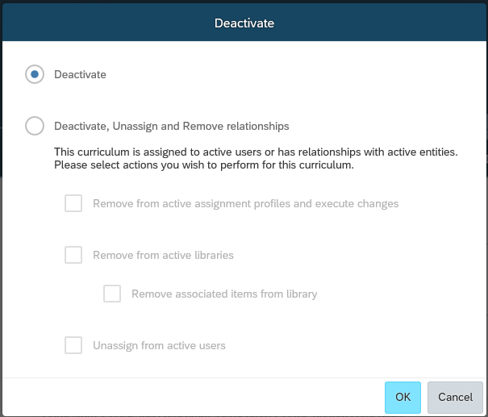

## Classes

A class is an instance of an instructor-led item. It has a date and time and given specific resources for that date and time.

To access the Classes section, navigate to **Learning Activities > Classes**

### Creating a Class for an ILT

*Initial Setup*

1. Navigate to **Learning Activities > Classes.**
2. Click **Add New.**
3. Required Fields:
   1. Enter the **Item ID** or click the search iconto select one.

*Note: The* ***Item ID****, when selected, will populate the* ***Item Type*** *and* ***Title*** *fields.*

* 1. Enter a **Security** **Domain ID** or click the search iconto select one.

*Note: See Section 4.2 for a list of domains.*

* 1. Click the calendar icon to select a **Start Date**. Enter a **Start Time** and change the **Time Zone**, as necessary.

1. Optional Fields:
   1. Add a **Description** of the class. This is visible to the user during registration for the class.
   2. **Libraries** box is checked by default to publish to associated libraries. LMS Admin can uncheck this to not publish the class.
   3. Select the **Facility** wherethe training will be located**.**
   4. If the facility is not listed, click on the plus sign (**Enter ad hoc Facility**) to the right of the drop down box to add facility information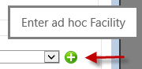

*Note: This facility is not stored in the Facility reference list and is only set up for this Class.*

* + 1. Enter **Name** and applicable information and click on **Save.**
  1. Select the **Primary Instructor.**
  2. Select the **Primary Location.**

1. Fields Not Used:
   1. **Manage Equipment.**
2. Click **Save**.

*Key Fields to Review/Populate*

**Additional Settings**

1. Click on **Details. Domain, Facility, Class Time Zone,** and **Description** areprepopulated with the initial setup information.
2. Required Fields:
   1. Add **Contact Name** and **Contact Email Address** for the contact person for this class.

*Note: This info will be displayed in the* ***Class Details*** *under* ***Contact Information****.*

1. Optional Fields:

*Note: Some of the fields below are prepopulated from the associated item.*

* 1. To require approval for a user to attend the class, select the **Approval Process** and select *Yes* for **Approval Required**.
  2. To require approval for user to withdraw the class, select the **Withdraw Approval Process** and select *Yes* for **Approval Required to Withdraw**.
  3. For **Status**, select *Active* to have the class appear in the catalog.
  4. For **Auto Enroll from Waitlist**, select *Yes*to have the system automatically move users from the wait list to an open registration slot.
  5. For **User can Waitlist**, select *Yes* to have the system automatically add users to the waitlist if the offering is full.
  6. For **Unassign Item When Admin Withdraws**, select *Yes* to have the system automatically remove the item from the users learning plan when withdrawn.
  7. For **Require Withdrawal Reason**, select *Yes* to allow user to select a reason when they withdraw from self-assigned classes.
  8. Choose *Yes* on the **Email confirmation to the User** section.

*Note: Allows system to send notification via Outlook calendar. If the Agenda of the Class is modified to a different time,* ***Resend Registration Email Notifications*** *must be selected under* ***Actions****.*

* 1. Choose *Yes* on the **Email confirmation to the Manager** section.
  2. Choose *Yes*on the **Email confirmation to the Instructor** section
  3. Choose *Yes*on the **Email confirmation to the Contacts** section
  4. Choose *Yes* on the **Email confirmation to the Reservation Owner** section
  5. Enter any **Comments.**

*Note: Comments are visible to LMS Admins only.*

* 1. To manage registration parameters for the class, complete the **Registration Close Date, Registration Close Time, Last Date to Withdraw, Withdraw End Time, Minimum Enrollments, Maximum Enrollments, User can Self-Register** fields**.**

1. Clickon **Save** to save changes to the tab**.**

**Registrations Tab**

1. Click on **Action** dropdown(Optional Action).
   1. **Send Notifications to:** Select the appropriate check boxes for those you want to notify after you register or withdraw users from the Class.
   2. **Email Slot Confirmations to:** Not used.
   3. **On User Removal:** To remove the classes associated Item from the User’s Learning Assignments, check the box **Remove the Associated Item from the Learning Plan.**

**Libraries Tab**

1. To add a libary, click on the  icon to Add Libraries**.**
   1. Enter the **Library ID** or click on **Search** and check the box under **Add** for the corresponding Library ID and click **Add** to add the class**.**

*Note: Before you can associate this class with one or more libraries, you must first associate the item with each of those libraries on the item record (Learning Activities > Items >Libraries tab).*

* 1. Fields Not in Use:
     1. **Price**

1. To remove a library, check the box under **Remove** and click **Save**.

**Agenda Tab**

1. Optional Fields:
   1. Agenda should default from Item selected.
   2. To add new time slot, click on  icon to **Add Group**.
      1. Add **Description, Start Date, Start Time, End Date, End Time and Time Zone**. If applicable, add Resources by clicking drop-down list to add.
      2. Click on **Save And Close**.
   3. To copy an existing agenda, click on **Copy Segments.**
      1. Indicate **Number of Times to Copy.**
      2. Click on **Copy**.

**Contacts Tab**

1. Required Fields:
   1. Type the **User/Instructor ID** (and indicate the **Contact Type**) or click **add one or more users from the list** or **add one or more instructors from the list**.
2. Click **Apply Changes** to save changes to the tab.

**Email Notifications Tab**

1. Optional Fields:
   1. Edit the text and add attachments for the following notifications:

*Note: Click* ***Apply Changes*** *after changing each notification or adding each attachment.*

* + 1. **Class Cancellation Notification for the Item.**
    2. **Registration Notification for the Item.**

*Note: Enter information providing details for the Item registration in the Notifications tab > Edit Registration Text.*

* + 1. **Withdraw Notification for the Item.**
    2. **Waitlist Notification for the Item.**
    3. **Waitlist Removal Notification for the Item.**
    4. **Pending Notification for the Item.**

### Reserving Registration Slots

A registration slot is a reserved space in a Class. Slots are reserved for organizations and are counted when calculating the number of current registrations and available seats.

1. Expand **Learning Activities > Classes**.
2. Enter in the **Class ID** or other search parameters and click on **Search**.
3. Select the Class by clicking on the **Class ID**.
4. Select the **Registration** tab.
5. Click on drop-down list for Add Users and select **Add Slots**.
6. Required Fields:
   1. Enter the **Organization ID** or select one by clicking the search icon.
   2. Enter the **Number of Slots** to reserve.
   3. The **Reservation Date** is prepopulated. To change, enter a new date or click the calendar icon.
   4. The **Registration Time** is prepopulated. To change, enter a new time.
   5. The **Time Zone** is prepopulated. Use the drop down menu to change.
7. Fields Not Used:
   1. **Price Per Slot.**
   2. **Chargeback Account (s).**
8. Click on **Save**.

*Note: At this point, the organization and the number of assigned slots display in the* ***Slots*** *tab under* ***Enrolled****.*

### Enrolling Users in a Class

1. Navigate to **Learning Activities > Classes.**
2. Use the search page to search for Class.
3. To select a Class, click on the **Class ID.**
4. Select the **Registrations** tab
5. To add a new user, click on drop-down list for Add Users and select **Add Users**.
   1. Enter applicable search criteria and click on **Search**.
   2. Check the box under **Add** for corresponding User(s).
      1. Required Fields:
         1. Select a **Registration Status** if something other than **Enrolled.**
      2. Optional Fields:
         1. Select a **Slot ID** if the user will be occupying a reserved slot.

*Note: This is only available if slots have already been reserved for an organization.*

* + 1. Fields Not Used:
       1. **Chargeback Account.**
       2. **Price** (and associated currency).
       3. **Order Ticket**.
  1. **Email confirmations to** by default are User, Instructor, and Supervisor. If applicable, check where appropriate to email confirmations to User(s).
  2. Click on **Add.**

1. To add a user from the request list, click on drop-down list for Add Users and select **Add Users** **From Request List.**
   1. Check box under **Add** for corresponding User(s).
      1. Required Fields:
         1. Select a **Registration Status** if something other than **Enrolled.**
      2. Optional Fields:
         1. Select a **Slot ID** if the user will be occupying a reserved slot.

*Note: This is only available if slots have already been reserved for an organization.*

* + 1. Fields Not Used:
       1. **Chargeback Account.**
       2. **Price** (and associated currency)**.**
       3. **Order Ticket**.
  1. **Email confirmations to** by default are User, Instructor, and Supervisor. If applicable, check where appropriate to email confirmations to User(s).
  2. Click on **Add.**

### Withdrawing a User from a Class

1. Navigate to **Learning Activities > Classes.**
2. Use the search page to search for Classes.
3. To select a Class, click on the **Class ID**.
4. Select the **Registrations** tab.
5. Under **Enrolled**, click on user nameand select **Modify**.
   1. Required Fields:
      1. Change the **Status** to **Cancelled**.
   2. Optional Fields:
      1. The **Registration Change Date** is prepopulated. To change, enter a new date or click the calendar icon.
      2. The **Time** is prepopulated. To change, enter a new time.
      3. The **Time Zone** is prepopulated. Use the drop down menu to change.
      4. Click on **Save.**

### Searching for Classes

1. Expand **Learning Activities > Classes**.
2. Use the search page to search for Classes.
3. To select a Class, click on the Class ID.
4. To edit tabs, please refer to section 7.7.1 for further instructions for each tab.
5. To copy, under **Actions,** click on **Copy.**
   1. Optional Fields:
      1. Select the appropriate check boxes for **Copy Group Instance, Copy New Class to the library, Copy Related Documents, Use item default agenda day numbers,** and **Copy to consecutive Days.**
      2. Select the radio button of the offering details the LMS Admin would like to copy (i.e. **Copy Single, Copy Multiple-Daily Based, Copy Multiple-Weekly Based,** or **Copy Multiple-Monthly Based**).
      3. Check the **Override adjusted registration cut-off date** check box to change the default registration cut-off date.
      4. Enter a new **Cutoff Date**, **Time**, and **Time Zone.**
   2. Required Fields:
      1. Enter a **New Start Date** or click the calendar icon to pick one.
      2. Check the day of the week to start the session in the **Schedule On** field.
   3. Click on **Next.**
   4. Review the information for accuracy.
   5. If you select the **Send Enrollment Notification to Instructor** check box and click Copy, then the system sends a notification (using the SystemEnrollmentNotification template ID) to the instructor of each agenda.
   6. Click on **Copy.**
   7. The **Summary** page will appear displaying the details of the new **Class**.
   8. Click on **OK.**
6. To delete, under **Actions,** click on **Delete.**
   1. In the confirmation pop-up window, click **Yes** to delete or **No** to abort the process.

*Note: Classes can only be deleted if they are not assigned to a user, not included in an assignment profile, do not show up on a user’s list of learning activities or learning history.*

### Cancelling a Class

1. Expand Learning Activities > Class
2. Search for the **Class ID**.
3. Under Actions, click on **Cancel**.
4. In the new window, **Class** and **Cancellation Date** are prepopulated. Click **Next**.
5. Skip **Edit Realized Costs** (Intuitive is not using Commerce capability). Click **Next**.
6. In the **Post Cancellation Action Settings**, select the appropriate check boxes.
7. Review the summary of the cancellation.
8. Click **Finish**.

*Note: The* ***Status*** *page will appear with a summary of the cancellation details.*

## Assignment Profiles

LMS Admins may use assignment profiles to assign curricula and items to groups of users. Using assignment profiles allows the LMS Admin to manage multiple assignments for multiple users with a single assignment profile.

Once an assignment profile is created and executed, it is maintained by a regularly scheduled job. Therefore, assignment profiles allow ongoing automatic training assignment to new users and users whose attributes (for example, job position, job location, region, employment status, job title, etc.) change over time.

To access Assignment Profiles, expand **Manage User Learnings > Assignment Profiles.**

### Creating an Assignment Profile

*Initial Setup*

1. Expand **Manage User Learning > Assignment Profiles.**
2. Click on **Add New**.
3. Required Fields:
   1. Enter the **Assignment Profile ID** and **Description** (see naming conventions for guidance under section 7.1).
   2. Enter a **Security Domain ID** or select one by clicking the search icon where the assignment profile will reside.

*Note: See Section 4.2 for a list of domains.*

* 1. Enter the **Contact Email Address** of the LMS Adminwho will maintain the assignment profile.
  2. Enter the **Created For** field with the requestor/business owner of the Assignment Profile.
  3. Enter the **Notes** field with information on the purpose of the assignment profile or reference the LCR#.

1. Click on **Add**.

*Key Fields to Review/Populate*

**Assignment Details Tab**

1. Click on **Assignment Details** tab.
   1. **Description, Security Domain, Contact’s Email**, **Created For**, and **Notes** are prepopulated with the initial setup information.
   2. Status is **Active**

**Rules Tab**

1. Click on **Rules** tab**.**
2. Add Security

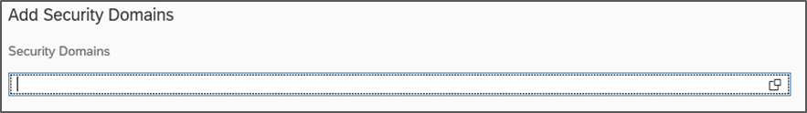

* 1. Click on the Security Domains right hand tile.
  2. Enter your search criteria and click on **Search**.
  3. Check the box under **Top level Only** and/or **Include Sub Domains**, corresponding to the Domain ID and click on **Add**.

1. Setup Rules
   1. Click on **Create Group**.
      1. Enter a title for **Enter Group Name** field.

*Note: The Group field must be populated in order to add an attribute. Groups are used to create the “and” filter relationship (by marking attributes in the same group) or the “or” relationship (by marking attributes in different groups).*

* 1. Click on the **Select Attribute** drop-down list and select an **Attribute** from the list.

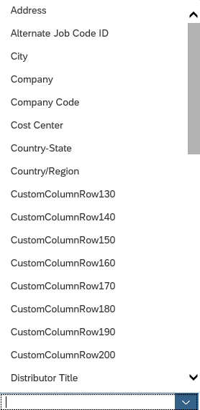

* 1. Click on the **Select Operator** drop-down list and select an operator from the list.

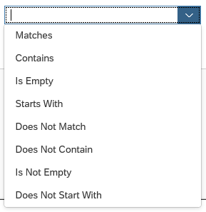

* 1. Enter a **Value** or **Option** for each attribute.
  2. To add additional rules for AND relationships, click on **Add Rule** and repeat steps a thru d until all desired attributes are added.
  3. To create an OR relationship, click on **Add a New Group** and repeat steps a thru d.

*Note: Each group of rules MUST contain a rule for Emp Status=3 (Active). This will automatically remove assignments for users temporarily or permanently inactive.*

Clickon **Save.**

* 1. Click on **Download Preview Users** to test that the selected domain and attributes captured the intended users.

*Note: Be aware that attributes are subject to change in SAP, which may affect the assignment profile and, therefore, the assignment of training.*

**Libraries Tab** (Not used by LMS Admins)

**Items Tab**

1. Click on **Items** tab.
2. To add an Item, click  to **Add Item**.
   1. Enter an **Item ID** or click on **Search.**
   2. Check box under **Add** for corresponding Item ID and click on **Add.**

*Note: After being added to an assignment profile, a program can have one of the following statuses: Valid (the assignment profile has been executed), Pending Addition (the assignment profile has not been executed) or Pending Deletion (the assignment profile has not been executed).*

*Note: Items distributed through an assignment profile are to be used for one-time training purposes. Users will only receive training to that specific revision. Future revisions to that document will not be released to users.*

1. To remove an Item, check box next to Item ID and click on  icon to remove.

**Curricula Tab**

1. Click on **Curricula** tab.
2. To add a Curriculum, click  to **Add Curricula.**
   1. Enter a **Curriculum ID** or click on **Search.**
   2. Check box under **Add** for corresponding Curriculum ID and click on **Add.**

*Note: After being added to an assignment profile, a program can have one of the following statuses: Valid (the assignment profile has been executed), Pending Addition (the assignment profile has not been executed) or Pending Deletion (the assignment profile has not been executed).*

1. To remove a Curriculum, check box next to Curriculum ID and click on  icon to remove**.**

**Programs Tab**

1. To add a Program, click  to **Add Programs.**
   1. Enter a **Program ID** or click on **Search.**
   2. Check box under **Add** for corresponding Program ID and click on **Add.**

*Note: After being added to an assignment profile, a program can have one of the following statuses: Valid (the assignment profile has been executed), Pending Addition (the assignment profile has not been executed) or Pending Deletion (the assignment profile has not been executed).*

*Note: Programs distributed through an assignment profile are to be used for one-time training purposes. Users will only receive training to that specific revision. Future revisions to that document will not be released to users.*

1. To remove a Program, check box next to Program ID and click on  icon to **Remove.**

**Role Tab** (Not used by LMS Admins)

### Execute Changes and Update Users and Assignments on Assignment Profile

1. Under **Actions**, click on **Execute Changes.**

*Note: Executing Changes releases the curriculum, Item, or program on the Assignment Profile. This is reflected with updates to the curricula, Item, or program listed in the users' Curricula, Item, or Program tab and the items associated with the curricula/program in the users' Learning Plan tab.*

* 1. To run the process immediately:
     1. Click the **Run this job immediately, if allowable** radiobutton.
     2. Click **Finish**.

*Note: If the job is too large (i.e. affects more than 50 records), the system will require the LMS Admin to schedule the job to occur at another time.*

* 1. To defer the process until later:
     1. Click the **Schedule Job** button.
     2. Click **View Available Time Slots** for allowable dates/times for background jobs.
     3. Enter the **Date, Time,** and **Time Zone.**
     4. Enter notes specific to the transaction in the Description field when scheduling a job in order to have this information available for reference if the job fails.
  2. Click on **Finish**.
  3. Click on **Back to Assignment Profile.**

1. Under **Actions**, click on **Update Users and Assignments.**

*Note: Update Users and Assignments for an Assignment Profile each time an attribute about the user changes. This automatic process is scheduled to run hourly however an LMS Admin can manually click here to update users and assignments for the specific Assignment Profile. Assignment Profiles that are not executed are skipped during the Assignment Profile scheduled job and cannot be manually updated either.*

### Deactivating an Assignment Profile

1. Under **Actions**, click on **Deactivate.**
   1. To deactivate an Assignment Profile without un-assigning assignments from users, select **Deactivate.**

*Note: This disables the Assignment Profile therefore no further assignments will occur. Current assignments to users are preserved. If an LMS Admin wants to un-assign assignments from users later on, under* ***Actions****, click on* ***Unassign.***

* 1. To deactivate an Assignment Profile and un-assign assignments from users, select **Deactivate and Unassign.**

*Note: This disables the Assignment Profile and un-assigns assignments from users.*

* 1. To run the process immediately:
     1. Click the **Run this job immediately, if allowable** radiobutton.
     2. Click **Finish**.

*Note: If the job is too large (i.e. affects more than 50 records), the system will require the LMS Admin to schedule the job to occur at another time.*

* 1. To defer the process until later:
     1. Click the **Schedule Job** button.
     2. Click **View Available Time Slots** for allowable dates/times for background jobs.
     3. Enter the **Date, Time,** and **Time Zone.**
  2. Click on **Finish**.
  3. Click on **Back to Assignment Profile.**

### Reactivating an Assignment Profile

1. Under Actions, click on **Reactivate**.
   1. To run the process immediately:
      1. Click the **Run this job immediately, if allowable** radiobutton.
      2. Click **Finish**.

*Note: If the job is too large (i.e. affects more than 50 records), the system will require the LMS Admin to schedule the job to occur at another time.*

* 1. To defer the process until later:
     1. Click the **Schedule Job** button.
     2. Click **View Available Time Slots** for allowable dates/times for background jobs.
     3. Enter the **Date, Time,** and **Time Zone.**
     4. Enter notes specific to the transaction in the Description field when scheduling a job in order to have this information available for reference if the job fails.

### Searching for an Assignment Profile

1. Expand **Manage User Learning > Assignment Profiles**.
2. Use the search page to search for Assignment Profile.
3. To select an Assignment Profile, click on the **Assignment Profile ID**.
4. To edit tabs, please refer to section 7.7.1. for further instructions for each tab.
5. To copy, under **Actions,** click on **Copy.**
   1. Required Fields:
      1. Enter a **New Assignment Profile ID** (see naming convention guidance referenced in section 7.1.)**.**
   2. Optional Fields:
      1. Select the appropriate check boxes for **Copy Assignment Rules (Security Domains and Rules)**, **Copy Curricula Data,** and **Copy Item**
      2. Fields Not Used:
         1. **Copy Competency Profile Data**.
         2. **Copy Plan Data**
      3. Click **Copy.**

*Note: The new Assignment Profile will appear.*

1. To delete, under **Actions**, click on **Delete.**
   1. In the confirmation pop-up window, click on **Ok** to delete or **Cancel** to abort the process.

*Note: Assignment Profiles may ONLY be deleted if they have never been executed or used to assign new training requirements to users in production. Otherwise, an Assignment Profile may be deactivated instead.*

## Assigning and Removing Learning Assignments

This section covers how to assign and remove items and curricula from a user or a group of users without using Assignment Profiles. Reference the LCR process 859165 for when and how to document learning changes.

### Adding an Item to a User

1. Expand **People > Users.**
2. Enter the **User ID** or other search parameters and click on **Search**.
3. Select the user by clicking on the **User ID**.
4. Click on **Assigned Items** tab.
5. Click on **Add Assigned Items.**
6. Enter in the **Item ID** or other search parameters and click on **Search.**
7. **Assign Date** defaults to today’s date. Enter different date as needed. Note: Assign date cannot be in the future.
8. Check box under **Add** and click on **Add.**

*Note 1: The Item has been added to the user and will display in the* ***Assigned Items*** *section****.***

*Note 2: Training materials for distributors may only be assigned if and when:*

*a) The country, or countries, the distributor supports is listed on the APL for the system, accessories, and/or instrumentation associated to the training materials. Example: Skills Simulator approved to sell in Korea, etc.*

*b) The user is certified to service the specific system platform. Example: Certified on IS3000 to service a Skills Simulator.*

### Adding an Item to a Group of Users

To execute a one-time manual batch assignment of one or more items to a group of users, it may be easier to use the tool under Manage Assignments. Using this tool, the LMS Admin has the ability to select multiple users and assign one or more items to the selected users.

1. Expand **Manage User Learning > Manage Assignments.**
2. Select the **Add Items** radio button.
3. Click on **Next**.
4. Enter the **User ID** or click **add one or more** **from list** to searchthen click on **Add.**

*Note: An LMS Admin can add filters to their search (such as country, organization group, position title, etc.) by clicking* ***Add/Remove Criteria****.*

1. Select the User ID by checking box under **Add** for corresponding User and then click on **Add.**
2. If User ID added needs to be removed, check box under **Remove** for corresponding User ID and click on **Apply Changes.**
3. Click on **Next**.
4. Enter in the **Item Type** and **Item ID** or click **add one or more from list** to search.
5. Select the Item ID by checking box under **Add** for corresponding Item and then click on **Add.**
6. If Item ID added needs to be removed, check box under **Remove** for corresponding Item ID and click on **Apply Changes.**
7. Click on **Next.**
8. Note the assignment information.
   1. Required Fields:
      1. Select the **Assign. Type** for each Item from the drop-down list.
   2. Optional Fields:
      1. **Assign Date** defaults to today’s date. Enter different date as needed.

*Note: Assign date cannot be in the future.*

1. Click **Next**.
2. Click **Run Job Now** to add the item(s) to user(s) immediately or click **Schedule Job** to run the job on a specific date and time.

*Note: Use* ***Schedule Job*** *for jobs that are larger than 50 records.*

1. If click on **Run Job Now** then confirmation page will appear with the status.
2. If click on **Schedule Job** then click on **Finish** and Background Job Status page will appear.

### Adding a Curriculum to a User

This process allows the LMS Admin to add one or more curricula to a single user.

1. Expand **People > Users**.
2. Enter the **User ID** or other search parameters and click on **Search**.
3. Select the user by clicking on the **User ID**.
4. Click on **Curricula** tab.
5. Click on **Add Curricula.**
6. Enter in the **Curriculum ID** or other search parameters and click on **Search.**
7. **Assign Date** defaults to today’s date. Enter different date as needed.

*Note: Assign date cannot be in the future.*

1. Check box under **Add** and click on **Add.**

*Note: At this point, the Curriculum has been added to the user and will display in the* ***Curricula*** *section.*

### Adding a Curriculum to a Group of Users

To do a one-time manual batch assignment of one or more Curricula to a group of users, it may be easier to use the **Manage Assignments** tool. Using this tool, the LMS Admin has the ability to select multiple users and assign one or more Curricula to the selected users.

1. Expand Manage **User Learning > Manage Assignments.**
2. Select the **Add Curricula** radio button.
3. Click **Next**.
4. Enter the **User ID** or click **add one or more** **from list** to searchthen click on **Add.**

*Note: An LMS Admin can add filters to their search (such as country, organization group, position title, etc.) by clicking* ***Add/Remove Criteria****.*

1. Select the User ID by checking box under **Add** for corresponding User and then click on **Add.**
2. If User ID added needs to be removed, check box under **Remove** for corresponding User ID and click on **Apply Changes.**
3. Click on **Next**.
4. Enter in the **Curriculum** **ID** or click **add one or more from list** to search.
5. Select the Curriculum ID by checking box under **Add** for corresponding Curriculum and then click on **Add.**
6. If Curriculum ID added needs to be removed, check box under **Remove** for corresponding Curriculum ID and click on **Apply Changes.**
7. Click on **Next.**
8. Note the assignment information.
   1. Optional Fields:
      1. **Assign Date** defaults to today’s date. Enter different date as needed. Assign date cannot be in the future.
9. Click **Next**.
10. Click **Run Job Now** to add the item(s) to user(s) immediately or click **Schedule Job** to run the job on a specific date and time.

*Note: Use* ***Schedule Job*** *for jobs that are larger than 50 records.*

1. If click on **Run Job Now** then confirmation page will appear with the status.
2. If click on **Schedule Job** then click on **Finish** and Background Job Status page will appear.

### Adding a User to an Item Request List

This is used to add a user to a request list for an Item that is not scheduled.

1. Expand **Learning Activities > Items**.
2. Enter in the **Item ID** or other search parameters and click on **Search**.
3. Select the item by clicking on the **Item**.
4. Click on **Class Requests.**
5. There are two options for adding users:
   1. Option 1: Adding a single user.
      1. Enter the **User ID**.
      2. Select a **Request Date** and **Need by Date.**
      3. Enter a **Request Reason** and **Comments.**
      4. Click on **Add.**
   2. Option 2: Adding multiple users.
      1. Click on **add one or more from list** and enter search parameters then click on **Search.**

*Note: An LMS Admin can add filters to their search (such as country, organization group, position title, etc.) by clicking* ***Add/Remove Criteria****.*

* + 1. Select the User ID by checking box under **Add** for corresponding User.
    2. Select a **Request Date** and **Need by Date.**
    3. Click on **Add.**

*Note: The users added to the request list will be displayed in the* ***Update the Requests for the Item*** *section on the page.*

### Removing an Item from a User

This section covers how to remove one or more items from a single user.

1. Expand **People > Users.**
2. Enter the **User ID** or other search parameters and click on **Search**.
3. Select the user by clicking on the **User ID**.
4. Click on **Assigned Items** tab.
5. Locate the Item(s) to be removed. Click **More**.
6. Click on **Remove**.

*Note: At this point, the item(s) have been removed from the User and will no longer display on the* ***Assigned Items*** *tab.*

### Removing an Item from a Group of Users

1. Expand Manage **User Learning > Manage Assignments.**
2. Select the **Remove Items** radio button.
3. Click on **Next**.
4. Enter the **User ID** or click **add one or more** **from list** to searchthen click on **Add.**

*Note: An LMS Admin can add filters to their search (such as supervisor, organization group, etc.) by clicking* ***Add/Remove Criteria****.*

1. Select the User ID by checking box under **Add** for corresponding User and then click on **Add.**
2. If User ID added needs to be removed, check box under **Remove** for corresponding User ID and click on **Apply Changes.**
3. Click on **Next**.
4. Enter in the **Item Type** and **Item ID** or click **add one or more from list** to search.
5. Select the Item ID by checking box under **Add** for corresponding Item and then click on **Add.**
6. If Item ID added needs to be removed, check box under **Remove** for corresponding Item ID and click on **Apply Changes.**
7. Click on **Next**.
8. Click **Run Job Now** to add the item(s) to user(s) immediately or click **Schedule Job** to run the job on a specific date and time.

*Note: Use* ***Schedule Job*** *for jobs that are larger than 50 records.*

1. If click on **Run Job Now** then confirmation page will appear with the status.
2. If click on **Schedule Job** then click on **Finish** and Background Job status page should appear.

### Removing a Curriculum from a User

This process allows the LMS Admin to remove one or more curricula from a single use

1. Expand **People > Users**.
2. Enter the **User ID** or other search parameters and click on **Search**.
3. Select the user by clicking on the **User ID**.
4. Click on **Curricula** tab.
5. Locate the Curricula to be removed. Click **More**.
6. Click on **Remove**.

*Note: At this point the curricula have been removed from the User and will no longer display on the Curricula tab.*

### Removing a Curriculum from a Group of Users

1. Navigate to **Manage User Learning > Manage Assignments**
2. Select the **Remove Curricula** radio button.
3. Click on **Next**.
4. Enter the **User ID** or click **add one or more** **from list** to searchthen click on **Add.**

*Note: An LMS Admin can add filters to their search (such as supervisor, organization group, etc.) by clicking* ***Add/Remove Criteria****.*

1. Select the User ID by checking box under **Add** for corresponding User and then click on **Add.**
2. If User ID added needs to be removed, check box under **Remove** for corresponding User ID and click on **Apply Changes.**
3. Click on **Next**.
4. Enter in the **Curriculum** **ID** or click **add one or more from list** to search.
5. Select the Curriculum ID by checking box under **Add** for corresponding Curriculum and then click on **Add.**
6. If Curriculum ID added needs to be removed, check box under **Remove** for corresponding Curriculum ID and click on **Apply Changes.**
7. Click on **Next.**
8. Click **Run Job Now** to add the item(s) to user(s) immediately or click **Schedule Job** to run the job on a specific date and time.

*Note: Use* ***Schedule Job*** *for jobs that are larger than 50 records.*

1. If click on **Run Job Now** then confirmation page will appear with the status.
2. If click on **Schedule Job** then click on **Finish** and Background Job status page should appear.

### Removing a User from an Item Request List

This is used to remove a user from a request list for an item.

1. Navigate to **Learning Activities > Items**.
2. Enter in the **Item ID** or other search parameters and click on **Search**.
3. Select the Item by clicking on the **Item**.
4. Click on **Class Requests.**
5. In the **Update the Requests for the Item** section, check box under **Select** and click on **Remove**.

*Note: At this point, the User(s) have been removed from Request list.*

## Programs

A Program combines learning events to create a schedule of learning. The schedule of learning is controlled by the program's agenda, which functions like an academic syllabus. It outlines events over the time of the program. For example, you can create a month-long employee on-boarding program. The agenda can be weekly: a new learning event for each week over a month. The learning events can be internal learning items or they can be external content (such as a welcome video hosted on the company intranet).

To access Programs, expand **Learning Activities > Programs.**

### Adding a New Program

Required Fields:

* + - 1. Log in and expand Learning Activities > Programs.
      2. Click Add New.
      3. Enter the Program ID for the new program.
      4. In the Title field, enter a program title
      5. In the Description field, enter a program description.
      6. Enter the Security Domain of the new program
      7. Use the search icon to select the Assignment Type.

*Note: You can select from these four Assignment Types:*

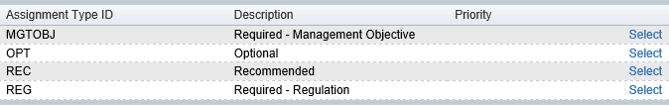

* + - 1. Select the program type.

*Note: You and can select from Scheduled, which has a fixed start and end date; Duration-based, which has a fixed duration, but learners can start at different times; or Open-ended, which has no fixed duration.*

* + - 1. The Status Active checkbox is checked by default. If the Status Active checkbox is not checked, the program will not be accessible from the catalog or assignable to the user.
      2. Select a Completion Status from the drop-down menu.
      3. To enable Progress Restrictions, check the By completion checkbox.
      4. For scheduled Programs, the By schedule checkbox may also be selected.
      5. Click Create Program when finished entering new program information.

*Note: Details of the Program are displayed.*

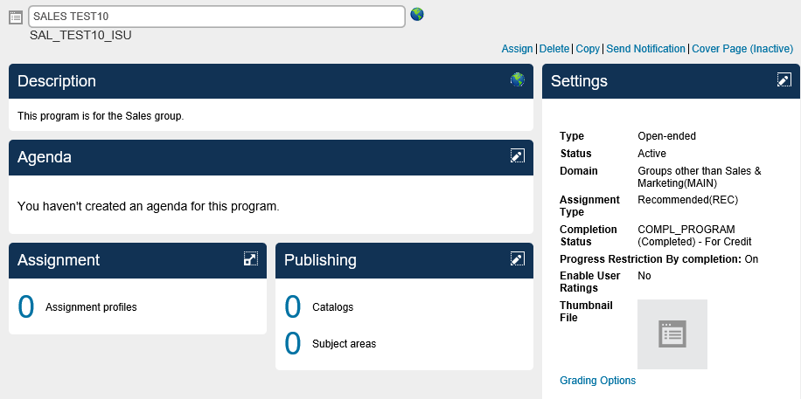

Optional Fields:

* + - 1. Click the Edit  icon next to Settings.
      2. Click on the Edit link next to Thumbnail File in Settings display.
      3. Upload a picture (.png, .jpg, .jpeg, etc.) file that is not more than 100 KB.

*Note: Picture files can be uploaded for Users to view.*

### Changing a Program

1. Navigate to Learning >Programs.
2. Enter the **Program ID** or other search parameters and click on **Search**.
3. Select the Program by clicking on the **Program ID**.
4. Click on the Edit icon  to edit the Agenda title.
5. Add Activities.
6. Click the Save button to save your changes.
7. Click the Done button to close the Agenda tile.

### Removing a Program from Users

1. Expand Manage User Learning > Manage Assignments.
2. Select the Remove Programs button and click Next
3. Enter the User ID or click add one or more from list.
4. Click Next and enter in the Program ID or click add one or more from the list.
5. Select Add and then select Run Job Now.
6. The Program has been removed from the specified users.

### Deleting a Program

*Note: You can delete a program only if there are no users assigned to the program.*

* + - 1. Navigate to Learning Activities > Programs.

1. Enter the **Program ID** or other search parameters and click on **Search**.
2. Select the Program by clicking on the **Program ID**.
3. Click on the **Delete** link above the Settings section.
4. Select **Yes** when asked “Are you sure you want to delete this Program?”

### Creating a Direct Link for Users to Access Program Assigned

* + - 1. Expand System Administration > Tools > Generate Direct Link

*Note: Link Output Format is set to URL.*

* + - 1. Click drop down for the Direct Link Type field and select Program Details.
      2. Click on the search icon  to find the program for which you want to create a link.
      3. Enter the program ID or other search parameters and click on Search
      4. Select the program and click Display Link.

*Note: The direct link for the target you selected is displayed. This can be launched by Users directly.*

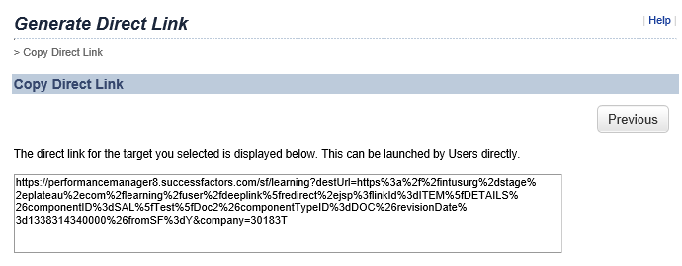

## Email Notifications

### Sending Email Notifications to Users

1. Expand Manage User Learning > Send Email Notifications.
2. Step 1: Identify a record type (**Class, Item, Curriculum,** or **Program)** to base your group of users on.

*Note: Cohort is not being used by LMS Admins.*

1. Click on **Next**.
2. Step 2: After identifying a record type to base your group of users on, you must narrow the group of users you send a message to by identifying one or more specific records.
3. Step 3: You can filter the group of users you send a message to by selecting a status that returns all users who are associated with that status.
4. Step 4: You can review the group of users you identified and add or remove other users. After you identify all the users who you want to receive your message, you can move to Step 5 in which you can select a premade message template or create your own message.
5. Click on **Next**.
6. Step 5: You can select a notification template that contains a prewritten message or write your own. When you select a notification template, the system automatically populates the **Subject** and **Body** boxes. If you want to allow recipients to reply to or copy your message, you can select or enter e-mail addresses for one or more administrators in the **Reply To** and **Send Copies To** boxes, respectively. You must select or enter e-mail addresses for one or more administrators in the **From** box to indicate who sent the message. Finally, you can attach a file to send with your message.

*Note: Recipients that you include in the* ***Reply To****,* ***Send Copies To****, and* ***From*** *boxes will receive one e-mail for each user who receives the message.*

## Record Learning Event

When an employee completes training outside of Intuitive or ISU, the event can be recorded in the LMS. If the employee received a certificate of completion or other documentation that should be retained, the LMS Admin will scan the document and create an LCR in Agile, attaching the scanned documentation. Reference the LCR process 859165 for actions to complete prior to recording external quality system related training in the LMS.

Users completing Substitute items will get credit for the original learning item as Completed.

### Recording One Learning Event Type for Multiple Users

1. Expand Manage **User Learning > Add Learning History with Finance.**
2. In step 1, select a learning event type (**Item, External Event,** or **Class** to give users credit for completing.
3. Click on **Next.**
4. In step 2, identify the learning event to record. That is, select an **Item** or **Class**, or create a description for an **External Event**. Click on the search icon to locate and select an **Item** or **Class** and the system will automatically populate the Item Type, Item ID, Revision Date, and Title for items and the Class ID for classes.
5. Click on **Next**.
6. In step 3, the system prepopulates any fields with data from the item or class record, and can be changed in a later step. This information is default data and applies to the users selected in step 4.
   1. **Instructor ID**: Click the Search button to locate and select an instructor ID to associate with this record. If the person who led the learning event does not have an instructor record, then type a name in the **Instructor Name** box.
   2. **Instructor Name**: If an **Instructor ID** is selected then the system automatically populates the **Instructor Name** box otherwise type a name.
   3. **Default Grade:** Enter the Default Grade when most of the users have the same grade as step 5 will allow modification to the grade by user. Valid Default Grade are a letter, a number, a number with decimal places and a percentage sign after it, and so on.
   4. **Default Completion Status**: Select a default completion status from the Default Completion Status list so that the users will have the same completion status and step 5 will allow modification to the completion status by user.
   5. **Completion Date/Completion Time**: For an item or external event, enter a completion date and time that is in the past. For a class the system automatically provides the completion date and time for the event.
   6. **Time Zone:** Defaults to your time zone. Select from drop-down list to change it.
   7. **Default Price**: Not used.
   8. **Currency ID**: Not used.
   9. **Total Hours**: Enter the total number of hours a user is engaged in completing a learning event. If recording a learning event for an item and the item has agendas then the system adds the duration values for each agenda and places that in the **Total Hours** box. If recording a learning event for a class and the class has agendas then the system calculates the difference between the start and end times of each agenda, adds those values, and places that in the **Total Hours** box.
   10. **Credit Hours**: Enter the number of hours that a user earns for completing a learning event.
   11. **Contact Hours**: Enter the total number of hours that a user is in an instructor-led agenda.
   12. **CPE**: CPE is an abbreviation for "Continuing Professional Education" and refers to learning activities that users perform to maintain and expand the skills that their profession demands. Therefore, CPE hours are very much like credit hours.
7. Click on **Next**.
8. In step 4, select users to record the learning event by entering a user's ID or by clicking **add one or more from list**. To remove a user from the list, select the **Remove** check box next to the user's name and click on **Apply Changes**.
9. In step 5, edit event information for each user added to the list in step 4. Enter a comment, select a different default grade, and change the completion status for each user. For external event, enter in the comment section, “Documents located in LCR ####” referencing the LCR ID.
10. In step 6, not used therefore skip by clicking on **Next**.
11. In step 7, review details entered for the learning event.
12. Click **Finish** to record the event, then click **OK**.
13. If step 8 appears, then enter your electronic signature to verify your identity before you can record the event.
    1. **Admin ID:** Enter your network User ID.
    2. **PIN:** Enter your network password.
    3. **Meaning Code:** Select from drop-down list.
    4. **Comments:** Not used.
14. Click **Apply Changes**.
15. The Status page will appear with the status of the action. To record another learning event, click **Start Over**. It is recommended not to use the **Print** or **Email** feature to send or print certificates of completion.

*Notes:*

*1) See Section 7.12.6 for how to create a Certificate of Completion.*

*2) You may attach a certificate of completion or other documentation for your external event by using the Learning Event Editor.*

### Recording Multiple Learning Event Type for Multiple Users

1. Expand **Manage User Learning > Add Learning History for Multiple Courses**.
2. In step 1:
   1. Select the type of learning event or events ([**Item**](javascript:toggleInline('30035')) An item is a container for a unit of learning that you can assign to a user and track its completion., [**Class**](javascript:toggleInline('29918')) A scheduled offering is an item or learning event with a scheduled date and time., or [**External Event**](javascript:toggleInline('33362')) An external event is a learning event outside the system.) to record. Enter an **Item Type ID**, **Item ID**, or **Class ID**, or click on the search icon to add one or more items or classes to the list. For an external event, create a description.

*Note: The system will not allow you to record two different learning event* types *at the same time.*

* 1. Select users for whom to record the event. Enter a user's ID or click the search icon to add one or more users to the list of selected users.

1. Click on **Next.**
2. In step 2, edit the default details for each event added in step 1. If the events selected do not already include the following information, then select a default completion date and time, time zone, grade, and completion status. Also, enter total hours, credit hours, contact hours, and CPE for each event. These details apply to all the users selected in step 1; however, click the **Expand** Expand buttonbutton to customize these details for individual users. Click **Apply Changes** for each learning event. Please refer to section 7.12.1 for further description on each field.
3. Click on **Next.**
4. In step 3, review a summary of the learning event or events to be recorded. Select **Do Not Assess** as this is not used.
5. Click on **Submit.**
6. If step 4 appears, then enter your electronic signature to verify your identity before you can record the event.
   1. **Admin ID:** Enter your network User ID.
   2. **PIN:** Enter your network password.
   3. **Meaning Code:** Select from drop-down list.
   4. **Comments:** Not used.
7. Click **Finish.**
8. The Status page will appear with the status of the action. To record another learning event, click **Start Over**. It is recommended not to use the **Print** or **Email** feature to send or print certificates of completion.

*Notes:*

*1) See Section 7.12.6 for how to create a Certificate of Completion.*

*2) You may attach a certificate of completion or other documentation for your external event by using the Learning Event Editor.*

### Editing Learning History

1. Expand Manage **User Learning > Edit Learning History**.
2. Enter a **User ID** and/or other search parameters and click on **Search.**

*Note: By default, Items is selected for Type of Learning Events. Change selection as appropriate. By selecting Program, Users who completed a program can be edited.*

1. Select a Learning Event to edit by clicking on the corresponding **Edit** icon.
2. Update appropriate fields and click on **Apply Changes**.
3. If e-signature verification page appears, then enter your electronic signature to verify your identity before you can record the event.
   1. **Admin ID:** Enter your network User ID.
   2. **PIN:** Enter your network password.
   3. **Meaning Code:** Select from drop-down list.
   4. **Comments:** Not used.

### Attaching Document to a Learning History

1. Expand **Manage User Learning > Edit Learning History**.
2. Enter a **User ID** and/or other search parameters and click on **Search.**

*Note: By default, Items is selected for Type of Learning Event. Change selection as appropriate.*

1. Select a Learning Event to edit by clicking on the corresponding **Edit** icon.
2. Click on **File Attachments.**
3. Click on **Browse** to select file to attach.
4. Enter **File Description**. (Optional)
5. Click on **Upload.** *(Note: File size cannot exceed 1MB)*
6. Close the window.
7. Click on **Apply Changes**.
8. If e-signature verification page appears, then enter your electronic signature to verify your identity before you can record the event.
   1. **Admin ID:** Enter your network User ID.
   2. **PIN:** Enter your network password.
   3. **Meaning Code:** Select from drop-down list.
   4. **Comments:** Not used.

### Removing Attached Document from a Learning History

1. Expand **Manage User Learning > Edit Learning History**.
2. Enter a **User ID** and/or other search parameters and click on **Search.**

*Note: By default, Items is selected for Type of Learning Event. Change selection as appropriate.*

1. Select a Learning Event to edit by clicking on the corresponding **Edit** icon.
2. Click on **File Attachments.**
3. Click on **Remove** for selected file, then select **OK**.
4. Close the window.
5. Click on **Apply Changes**.
6. If e-signature verification page appears, then enter your electronic signature to verify your identity before you can record the event.
   1. **Admin ID:** Enter your network User ID.
   2. **PIN:** Enter your network password.
   3. **Meaning Code:** Select from drop-down list.
   4. **Comments:** Not used.

### Printing Out Certificates of Completion

1. Navigate to **Reports.**
2. Locate the **ISU Certificate of Completion Report**.

*Note: The report can be found under the* ***User Management*** *category in the* ***Reports*** *section.*

There are two options for printing certificates:

* 1. Select **ISUCertificateofCompletionbyItem** to print certificates of completion for an item (this can be for both online and instructor led items) or for an individual.
  2. Select **ISUCertificateofCompletionbyScheduledOffering** to print certificates of completion for a class (only available for instructor-led training).

1. To run the **ISUCertificateofCompletionbyItem** report, enter search parameters to locate the item.
   1. Required Fields:
      1. Enter the **Item Type** and **Item ID** or click the filter icon.
      2. The **Run Report for Completed History Records Only** check box is preselected.
   2. Optional Fields:
      1. Enter the name of the first person to sign the certificate in the **Signature Name for Primary Signer** field.
      2. Enter the details to be displayed below the first signature in the **Signature Text for Primary Signer** field.
      3. Enter the name of the second person to sign the certificate in the **Signature Name for Additional Signer** field.
      4. Enter the details to be displayed below the second signature in the **Signature Text for Additional Signer** field.
      5. Enter the **User ID**(s) in the **User** field or click the filter icon.
      6. Enter a **Completion Date** for the item.
      7. Enter a **From Date** and **To Date** to narrow the range of dates the item was completed.
   3. Click **Run Report**.

*Note: The extended description and the certification expiration date are populated by the item summary tab information (sections called* ***Certificate Description Text*** *and* ***Certificate Expiration Text****).*

1. For **ISUCertificateofCompletionbyScheduledOffering** report, enter search parameters to locate the item.
   1. Required Fields:
      1. Enter in the **Class ID** or click the filter icon.
      2. The **Run Report for Completed History Records Only** check box is preselected.
   2. Optional Fields:
      1. Enter the name of the first person to sign the certificate in the **Signature Name for Primary Signer** field.
      2. Enter the details to be displayed below the first signature in the **Signature Text for Primary Signer** field.
      3. Enter the name of the second person to sign the certificate in the **Signature Name for Additional Signer** field.
      4. Enter the details to be displayed below the second signature in the **Signature Text for Additional Signer** field.
      5. Enter a **Completion Date** of the item.
   3. Click **Run Report**.

*Note: The extended description and the certification expiration date are populated from the Class summary tab information (fields called* ***Certificate Description Text*** *and* ***Certificate Expiration Text****).*

## Editing Required Dates

1. Expand **Manage User Learning > Edit Required Dates**.
2. Enter a User ID then click on Add and/or click on “add one or more from list” to search for users then click on Add check box then Add
3. Click on **Next**
4. If changing required dates for a curriculum assigned item, please enter Curriculum ID then click on Add and/or click on “add one or more from list” to search for curriculum then click on Add check box then Add otherwise click on Next
5. If changing required dates for a directly assigned item, please select Item Type and enter Item ID then click on Add and/or click on “add one or more from list” to search for item then click on Add check box then Add otherwise click on Next
6. Enter new Required Date then click on **Finish**

*Note: If job is affecting a large # of users or records, click on* ***Schedule Job*** *then* ***Finish****.*

## Reports

LMS Admins use a searchable dashboard to locate, schedule, run and export reports viewable by LMS Admins. The dashboard allows LMS Admins to filter reports by Category, Publication Status, and LMS Admin/User side reports.

*Note: Click on the Reports tab to return to the reports section after accessing a report.*

To access the Reports section, navigate to the **Reports** tab.

### Searching for a Report

1. Navigate to **Reports.**

*Note: Click on* ***Reports****.*

1. Type keyword(s) into the **Search** field.
2. Select the **Categories** to search.
3. Select “Admin” in the **Application** section.

Note: Admin application reports are only available for LMS Admins to run.

1. Click **Submit.**

### Running a Report

1. Navigate to **Reports.**
2. Click the name of the desired report to open a parameters page or click the plus icon to select a specific report.

*Note: Delimiters other than comma can be selected (I,;, ^, or ~) when running reports in CSV format.*

1. Enter report-filtering parameters.

*Note: The parameters vary based on the report.*

1. Click **Run Report** to run the report immediately or click **Schedule Job** to run the report on a specific day and time.

*Note: Use* ***Schedule Job*** *for reports that are larger than 50 records.*

### Scheduling a Report to run

1. Navigate to **Reports.**
2. Click the name of the desired report to open a parameters page or click the plus icon to select a specific report.
3. Input in report filtering parameters.

*Note: The parameters vary based on the report.*

1. Click **Schedule Job**.
2. Click **Schedule this job to be executed on** to schedule a single job.
   1. Click **View Available Time Slots** for allowable dates/times for background jobs.
   2. Required Fields:
      1. Enter the **Date** and **Time.**
      2. The **Time Zone** is prepopulated. Click the arrow to select another time zone from the drop down list.
3. Click **Schedule this job to recur as follows** to schedule a recurring job.
   1. Required Fields:
      1. Select the frequency of the report (**Daily**, **Weekly**, or **Monthly**) and the associated details.
      2. Enter the **Time of Day**.
      3. The **Time Zone** is prepopulated. Click the arrow to select another time zone from the drop down list.
   2. Optional Fields:
      1. Provide a **Job Description**.
      2. Enter an **Email** address if **Notify via email upon completion** is checked.
      3. Check the **Email the Report** check box to have the report emailed to the email address listed.
   3. Click **Finish.**
   4. A summary page will appear with the status of the job.
   5. Click **Finished** to return to the **Report** page.

Note: The scheduled job will display under the **Report Jobs** tab on the **Report** page.

## User Support

### Searching for a User Report

1. Navigate to **People > Users.**
2. Enter the **User ID** or other search parameters and click on **Search**.
3. Select the user by clicking on the **User ID**.

*Note:* *Access to edit user records is restricted therefore certain fields may be view only.*

### Previewing a User’s Libraries

1. Navigate to **People > Users**.
2. Enter the **User ID** or other search parameters and click on **Search**.
3. Select the user by clicking on the **User ID**.
4. Click on **Library Access** tab.
5. Click on link “Access all sections in view mode” to preview libraries.

## Managed Services Users

This section covers how to edit users who are conducting work for Intuitive’s and are required to undergo training administered and tracked by Intuitive but are not included in Intuitive’s HR system, SAP. Setup and inactivation of Managed Services users will be managed through AIMS and SAP.

* + 1. **Creating a Managed Services User**

*Initial Setup*

1. Managed Services user accounts are created by responsible Manager in the **System Account Management (SAM).**
   * 1. **Editing Managed Services User Data in SAP ECC**
2. Log in to SAP ECC Production.
3. Enter ZHR_ISU_LMS in the transaction field.
4. To update **Active**, check box for active status and uncheck box to inactivate user.
5. To update **Level**, enter INDV, MGR, DIR or EXEC.
6. To update **VP Name**, select from drop-down list for corresponding User ID.
7. Click on **Save.**

*Note: When a Managed Services User is added to SAP ECC table ZHR_LMS_NONEMP, an email will be sent to QS Compliance Training Team to update VP Name in SAP.*

* + 1. **Editing Managed Services User, Distributor Partner or Supplier/Vendor Data in Active Directory**

1. Functional Manager may modify user account attributes in SAM or submit an IT request with details including field(s) to update and update value(s).
   * 1. **Inactivating a Managed Services User or Suppler/Vendor or Distributor**
2. If a Managed Services User or Supplier/Vendor is to remain active in Active Directory, responsible LMS Admin must uncheck box for **Active** in SAP ECC table ZHR_NON_EMP. Please refer to section 7.17.1.

*Note: Updating SAP ECC will update LMS to inactive status and assignments will automatically be removed through the user interface.*

* 1. **ISI Distributor Partner Setup and Maintenance**
     1. **Creating a Distributor Partner User**

*Initial Setup*

1. Distributor user accounts are created or approved by the responsible LMS Admin (QS Compliance Training, Sales or Field Service/Customer Service) in **System Account Management (SAM).** Reference WI 1048297 to create RAQA Distributors.

Note: Prior to creating a new account, verify if user has an existing account.

1. ISU Admin to update Primary Supervisor as needed
   1. Add Primary Supervisor for Distributor as this is not populated by Active Directory. (Note: Active Directory supervisor manages Active Directory account and may differ from ISU therefore not sent to ISU)
      1. Log in to SAP ECC
      2. Go to transaction SM30
      3. Enter table name ZHR_LMS_NONEMP then click on Maintain
      4. Enter supervisor ID (all lowercase) in Manager column
      5. **Inactivating a Distributor Partner User**
2. Manager may deactivate the user account directly in System Account Management (SAM) or submit a IT request.
3. If Distributor has been disabled in Active Directory, the user interface will update both SAP ECC table ZHR_LMS_NONEMP and LMS to inactive status.

*Note: Assignments will automatically be removed through the user interface.*

* 1. **Supplier/Vendor Users**
     1. **Creating a Supplier/Vendor User**

*Initial Setup*

1. Supplier/Vendor user accounts are created as needed through **System Account Management (SAM).** Reference 1039082 WI Supplier Account Application Management.
   1. **Obsolete Document**

This section covers how to obsolete a document.

1. Verify that the Agile document is obsolete in Agile before proceeding with the next steps.
2. Expand **Learning Activities >Curricula** to search for the document.
3. Under the Actions icon, click **Deactivate.**
4. In the Deactivate window, check **Deactivate, Unassign and Remove relationships** button.
5. Check boxes for the following:
   1. Remove from active libraries
   2. Remove associated items from library
   3. Remove from active parent curricula
   4. Unassign from active users
6. Click **OK** button.
7. Expand **Learning Activities > Items** to search for the document.
8. Click on the Item and navigate to Item Details.
9. On Status field, change to inactive. Click **Save**.
10. Verify Curriculum is no longer assigned:
    1. Click on **Reports**.
    2. Search for User Curriculum Status (CSV) report.
    3. In Curriculum filter, enter Curriculum ID for obsolete document.
    4. Check box for “Indirect Assignments”.
    5. Select **Run Report.**
    6. Report should show no results.
    7. **Leave of Absence (LOA)**

This section covers Vacation (US only) and Leave of Absence (Global) processing.

1. Automated Vacation processing (US only) via Robotic Process Automation (RPA) Vacation bot will run once a day to update training required dates to add 1 day for each day the user is on vacation including weekends if vacation spans over the weekend.

*Note: If RPA Vacation bot cannot run, training required dates will not update until it is resolved and the bot is running again as there are no manual process to update required dates.*

1. Automated Leave of Absence processing via RPA LOA bot will run once a day and ad-hoc as needed to remove curricula assigned training when user is on LOA, Employee Status of inactive (1), and assign previously removed curricula when user returns from LOA, Employee Status of active (3).

Note: Should there be any issues with the RPA LOA bot, the import process can be run temporarily as follows until issue is resolved and LOA bot is running again:

1. QS Compliance Team will generate a report containing curricula assignments (*Curriculum Status CSV*) for users with employee status of inactive (or 1).
2. Information from the *Curriculum Status CSV* report will then be transferred to populate the corresponding column on the *Import Template*, making unique entries for each distinct parent curriculum
3. Values in the “Action” column will be set to “Assign” to add or “Remove” curricula accordingly.

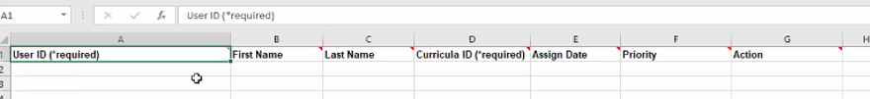

NOTE: For adding curricula with the use of the *Import Template*, an alert process will be required to confirm the user’s employee status is updated back to Active (or 3) in HCM.

1. Complete copies of both a dated *Curriculum Status CSV* report and the populated *Import Template* will be attached on an LCR, which will be submitted for approval by the QS Compliance Training Manager
2. Once the LCR has been approved, a task will be added for the ISU System Admin to upload the *Import Template* in ISU; therefore, executing the corresponding task indicated in the Action column to either add or remove curricula to the users listed.

# Process flow

N/A

# Attachments

N/A