Creating java script function with event hub trigger(Replacing steps 8-15):

1. Click on the + to create a new function

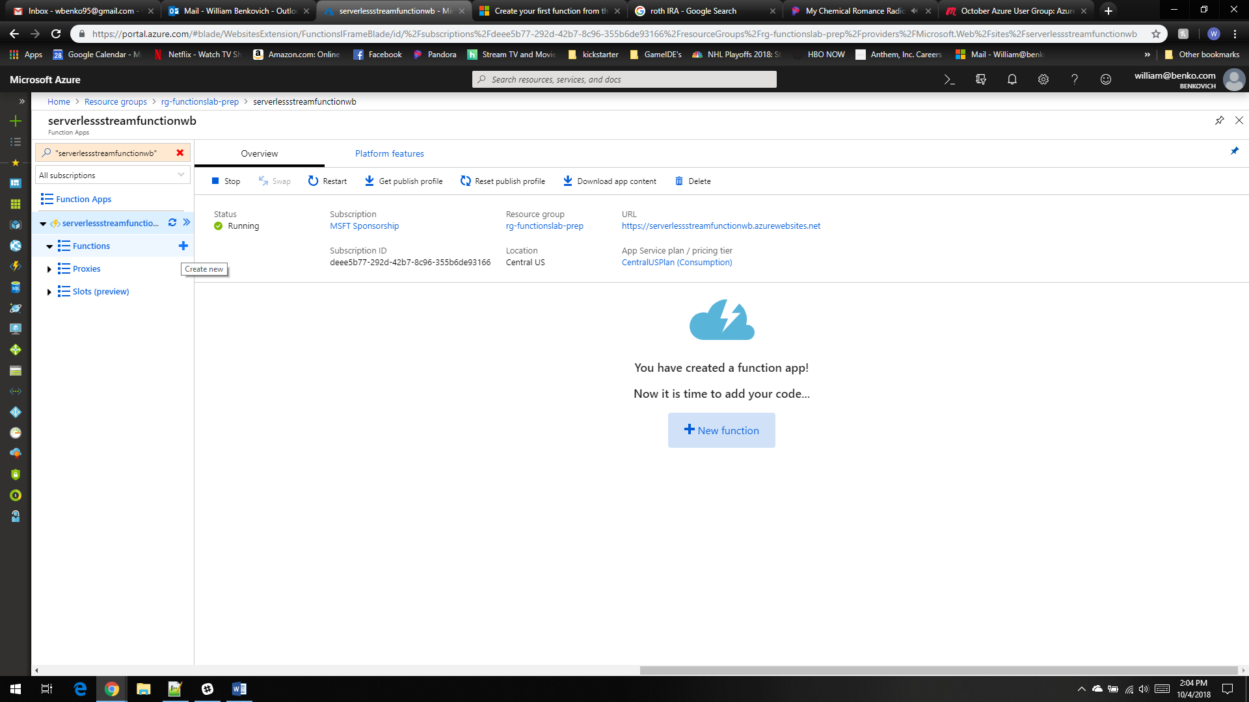

1. Select in portal and click continue

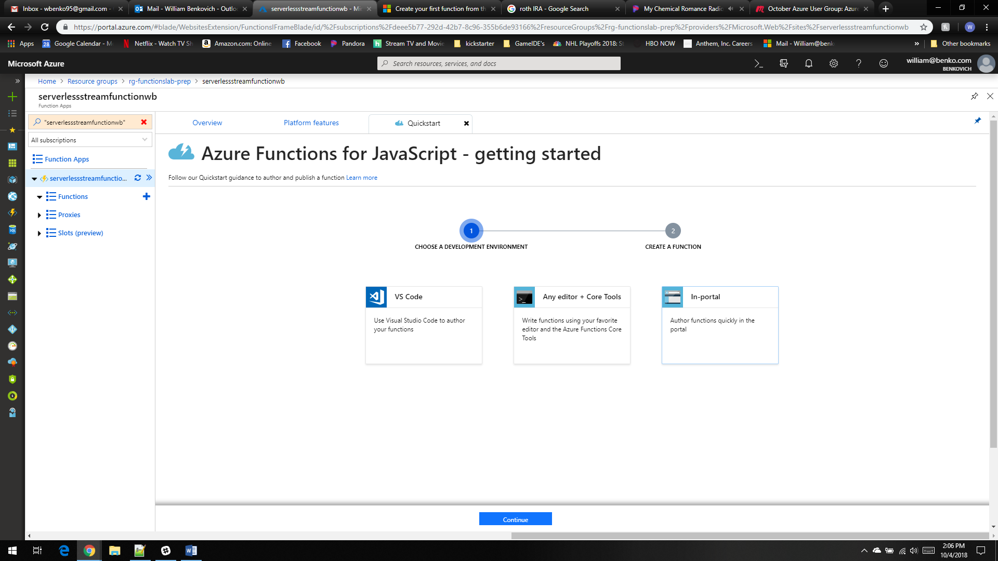

1. Select more templates and click finish and view templates

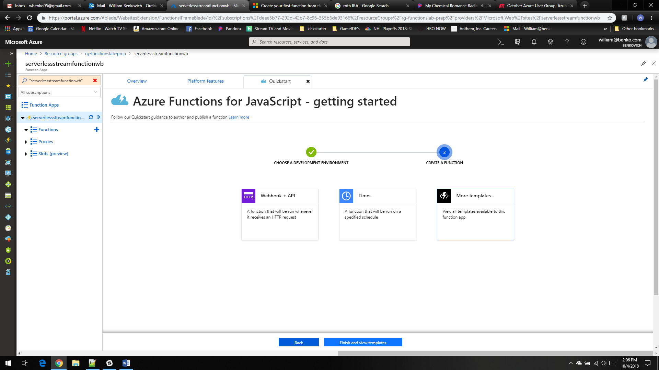

1. Select HTTP Trigger and change name of trigger to EventHubTriggerJS1. Then create

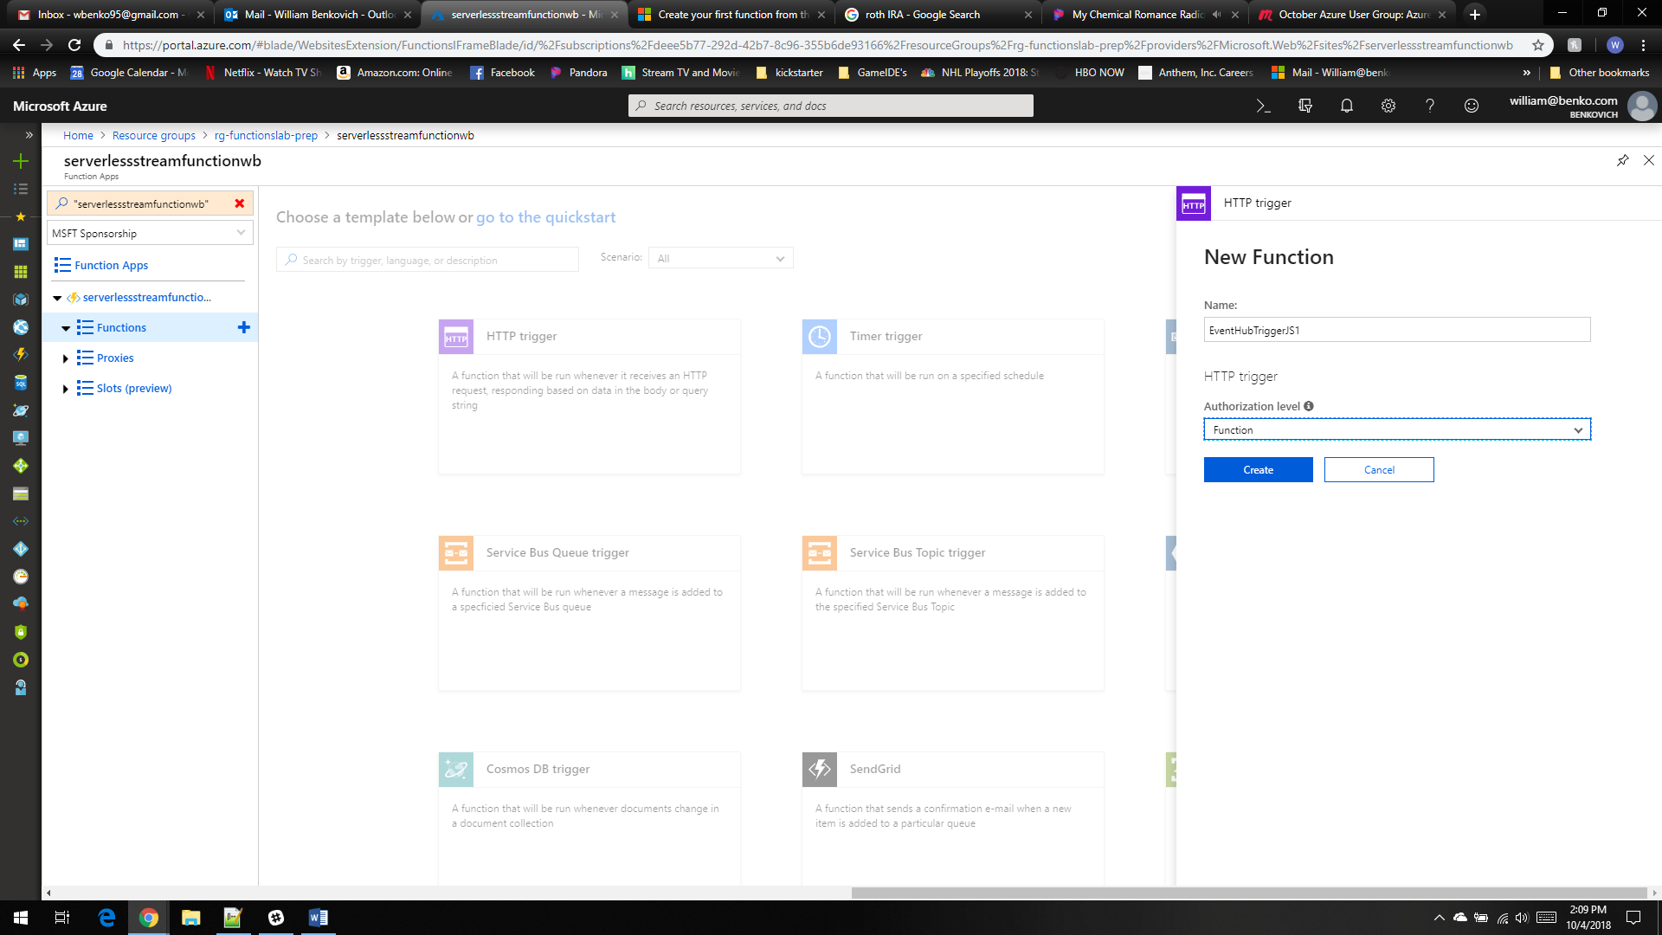

1. Select integrate

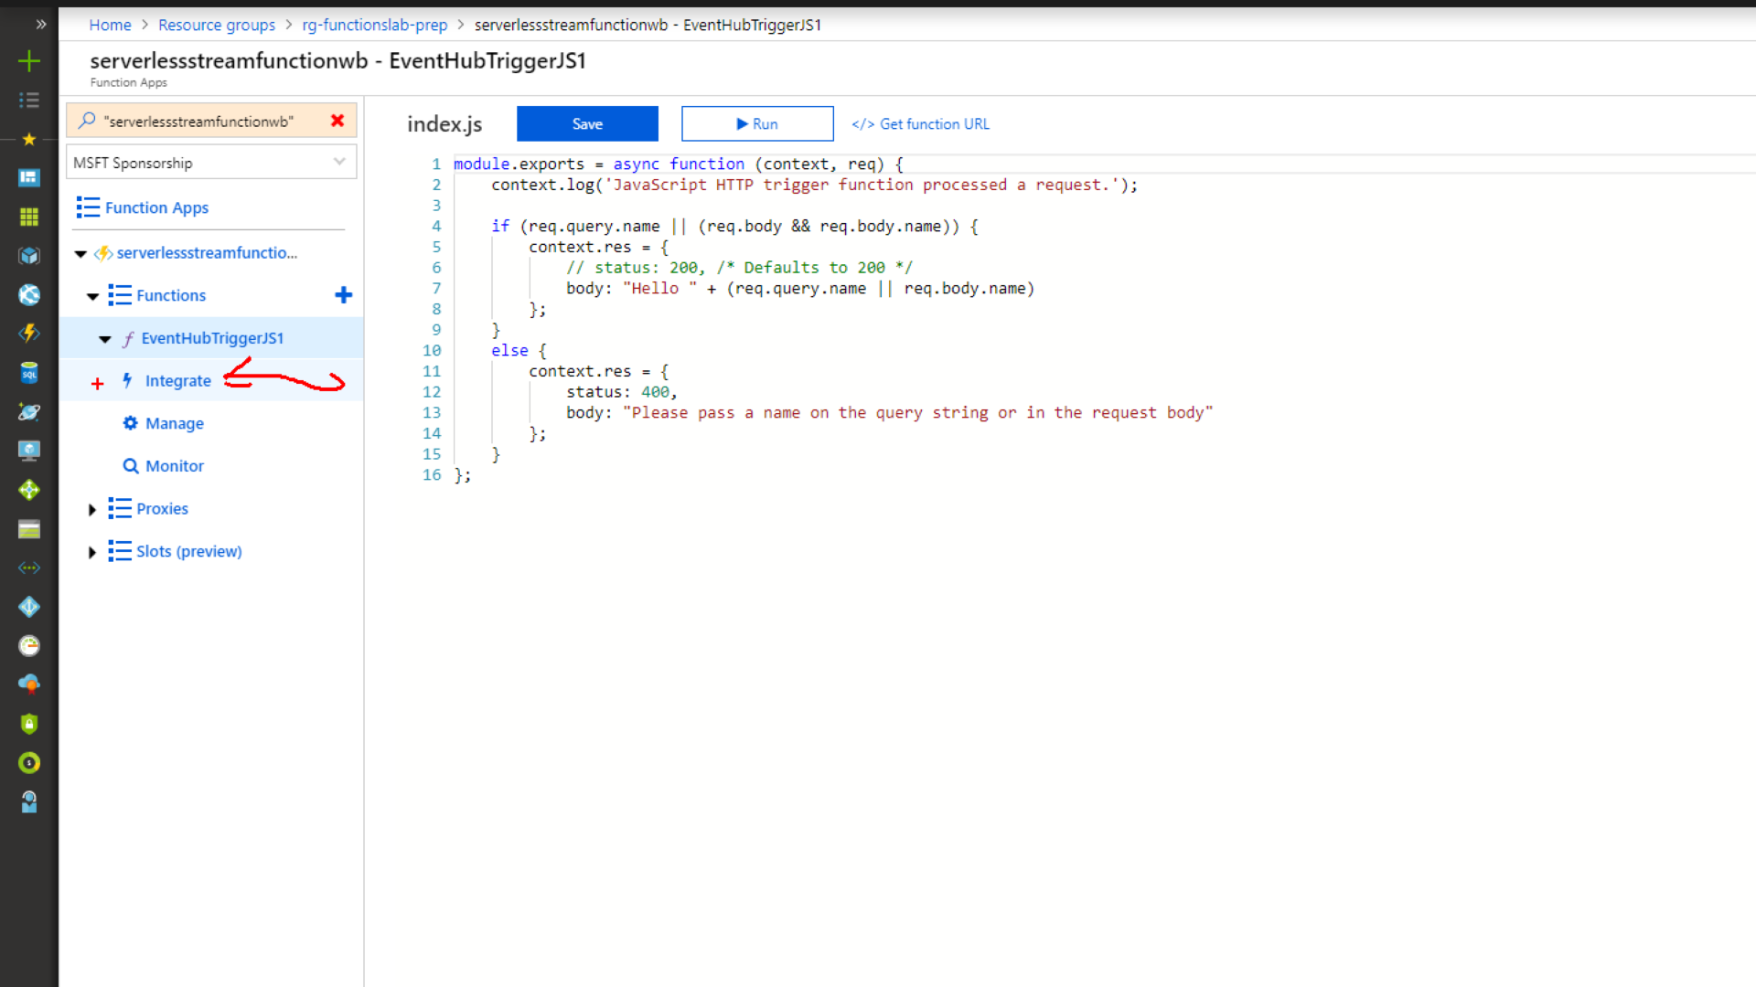

1. Select and delete the input and outputs set up

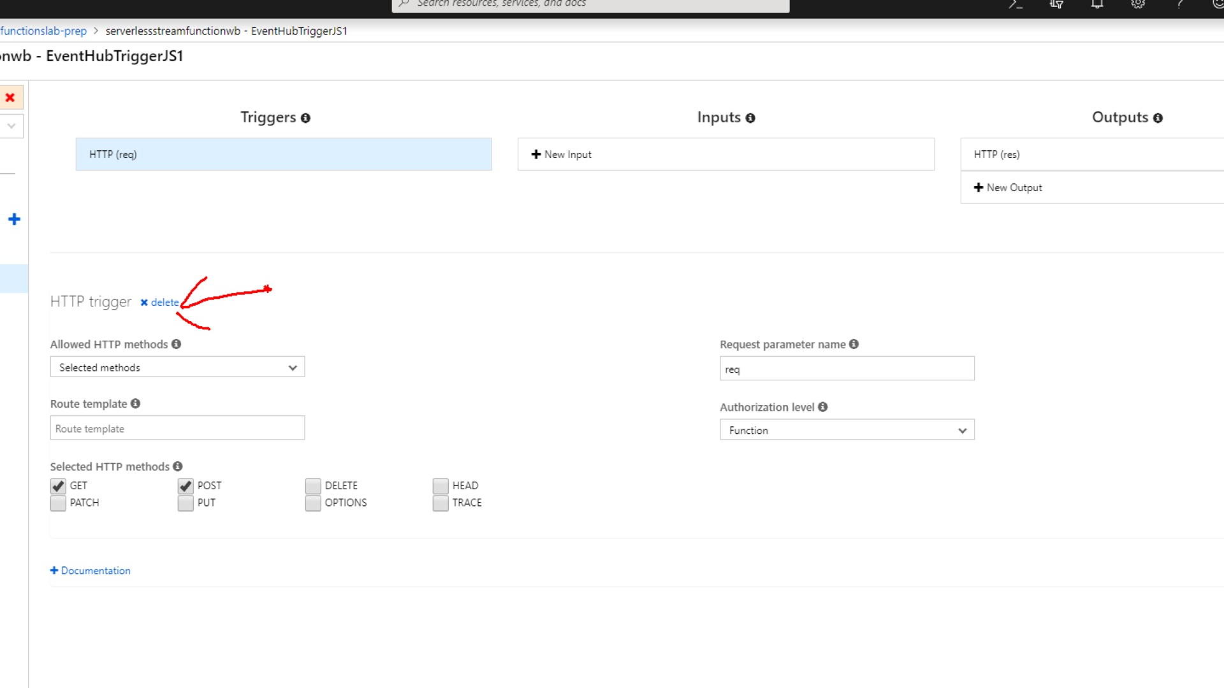

1. Click on inputs and select azure event hubs as the input

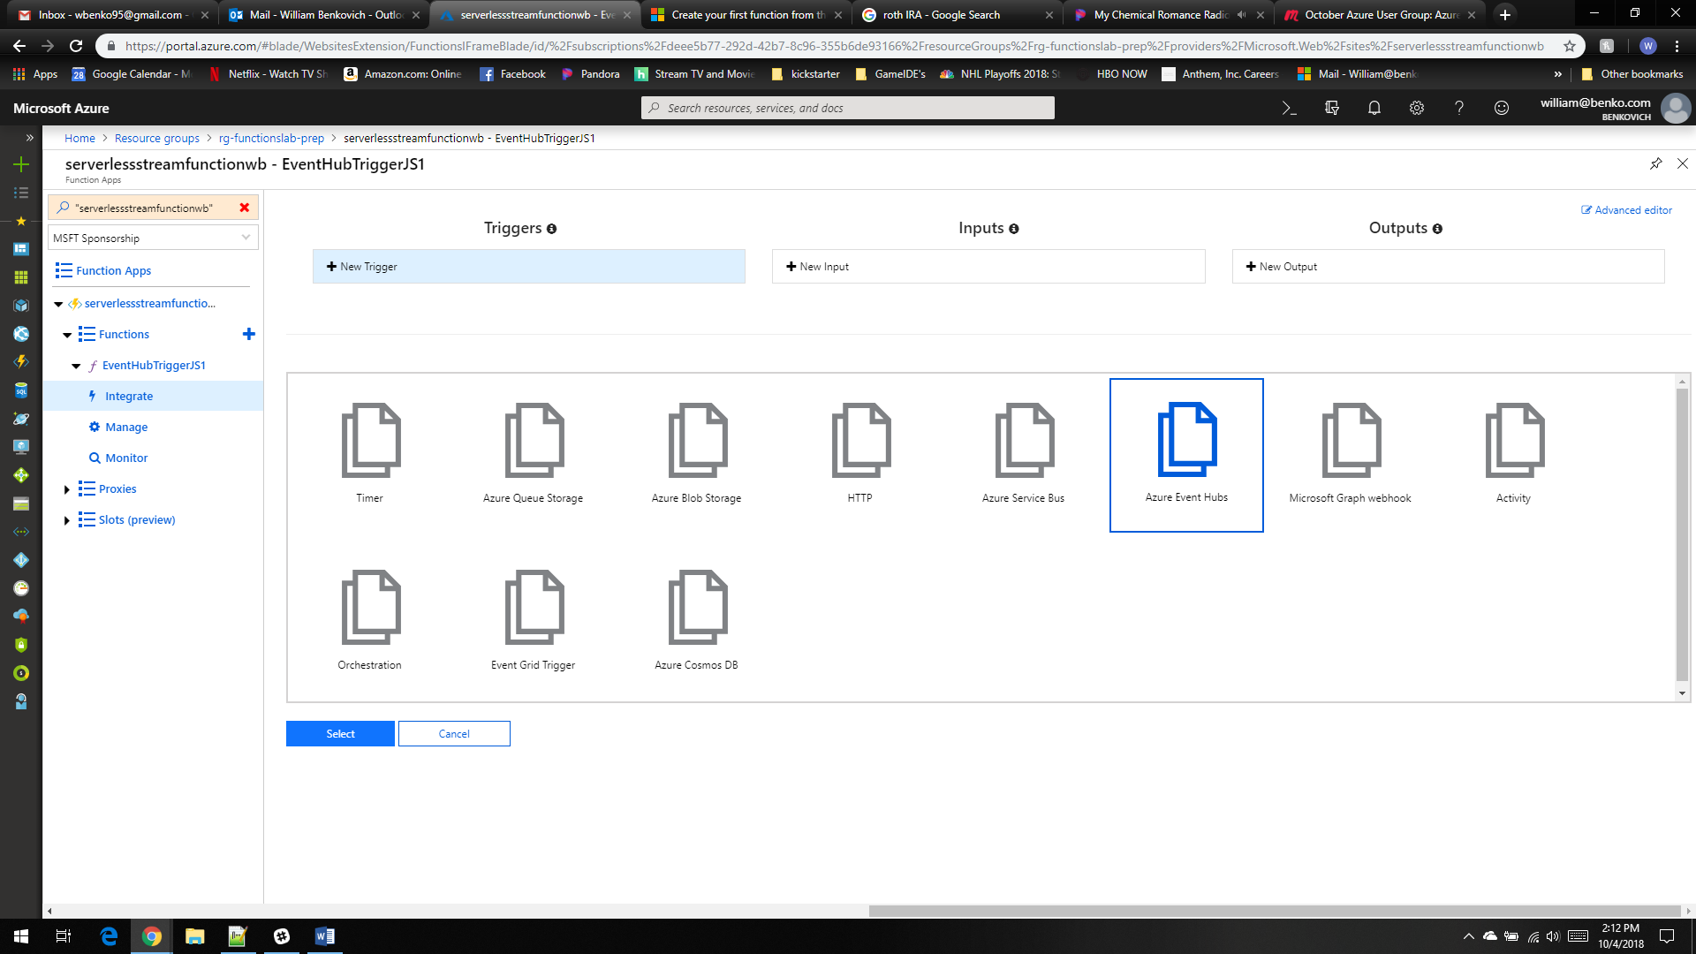

1. In the integrate panel select new event hub connection

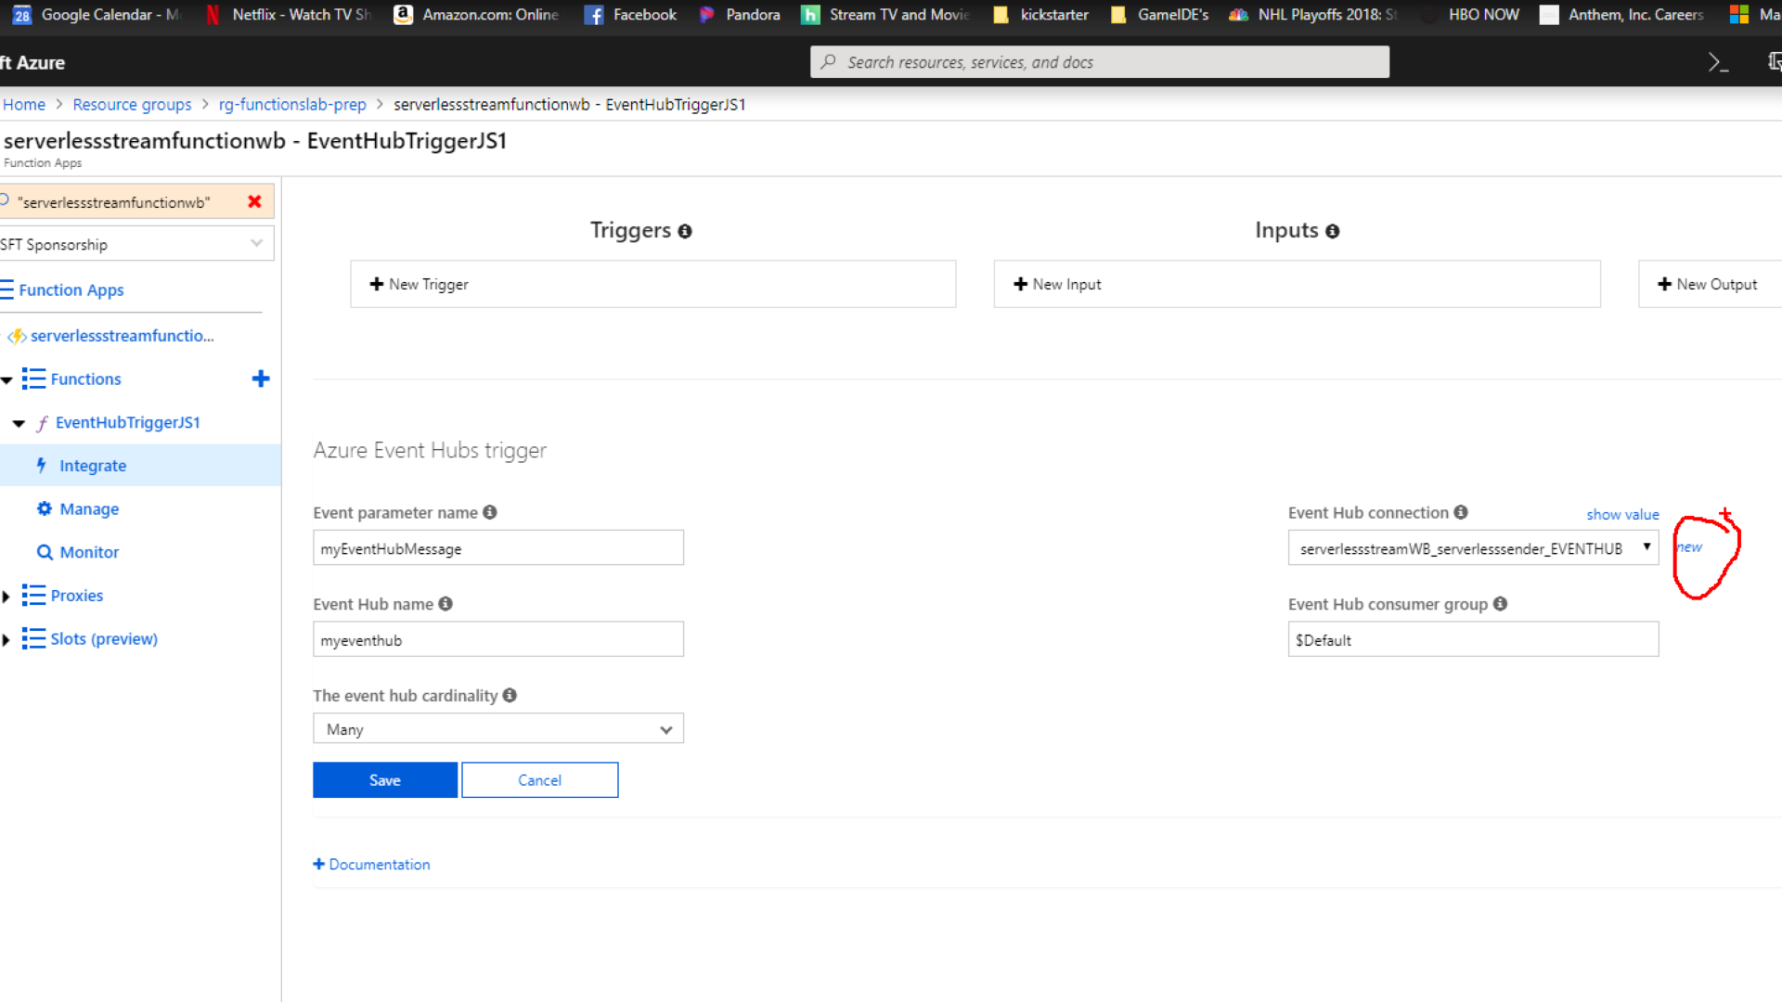

1. Make sure the event hub with the access policy we created earlier is selected

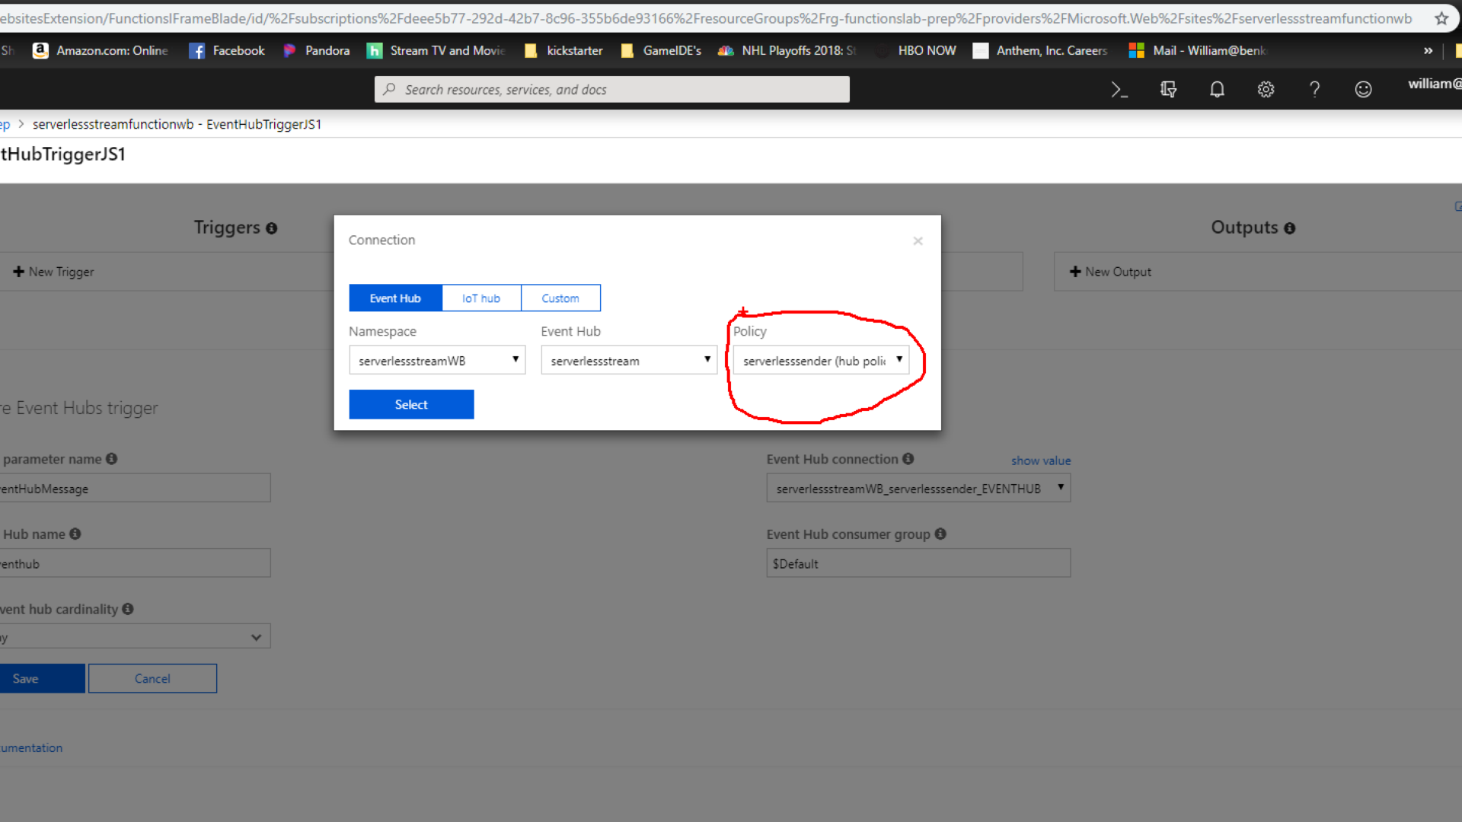

1. Update Event parameter name and Event hub name

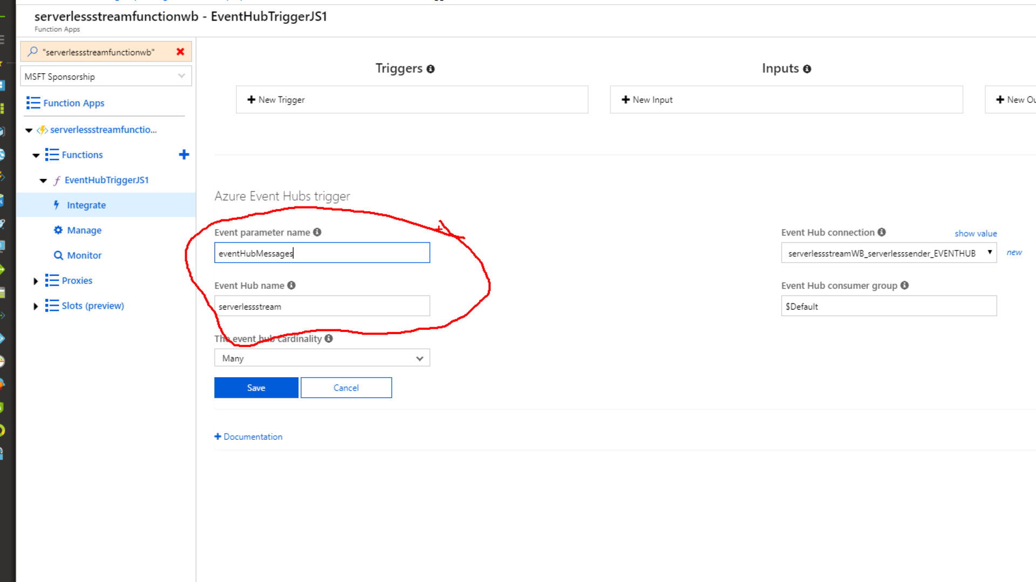

1. Save new input