Lissajous Wave Monitor
Will Jackson and Patrick Yukman
Engs 31: Digital Circuits
August 6, 2012

Functional Description
A Lissajous curve is a patterned, visual output that is a function of sinusoidal inputs. When drawn quickly enough, the functions will resolve into a shape; these shapes have been categorized, and many interesting observations can be made about the input function from their Lissajous figures. For example, Lissajous figures were used as early oscilloscopes, and modern audio technicians use them to determine if speakers are properly in phase.
The Lissajous Wave Monitor (LWM) is a device that takes two AC functions as input and outputs a figure to a VGA display. It is intended to be a modular tool, allowing any input that is centered at 0V and under 3V peak-to-peak. For testing, these inputs will come from function generators; the LWM could, however, be used for many purposes, including the ones mentioned above.

Block Diagram & Description

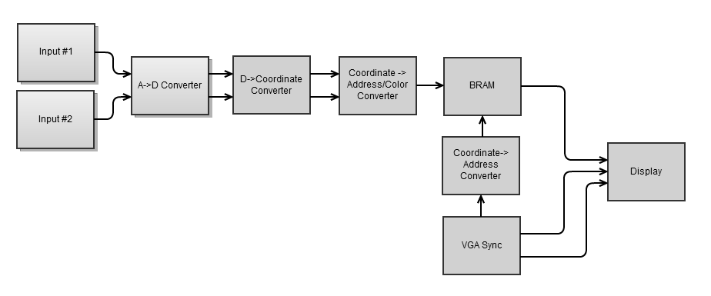
Specifications
- Level-shifted (0V center to 1.5V center) input terminals for the A-D converters to read.
- 20-pixel-long “comet” for better visualization of low-frequency input waves.
- Green-line output to VGA display, because hackers use green text.
- 640x480px VGA display.
- Shift-register comparators, preventing them from filling up with 20 instances of the same point
- (optional) Color-changer rotary switch.

Instructions for Use
Connect inputs, ensuing that V_{p-p} < 3V and signals are centered at 0V. Switch on, observe output.

Resolved Issues
- A->D converter reads values that are 0 to 3.3VAC, but the input should be a function centered at 0V. Solved by insisting user limit themselves to 3V_{p-p} and including an analog level-shifter.
- Low-frequency inputs not resolving to Lissajous figures. Solved by including “comet” shift-registers.
- Low video RAM available, can't output to screen fast enough to check every point. Solved by mapping VGA pixels to BRAM, which is updated from the A->D converter.

Unresolved Issues
- Dumping the comet: the VGA outputs slower than the comet is changing, won't dump a single line but a scattering of points.
- Need an efficient method for resetting a pixel to “black” in subsequent screen refreshes. Potential solution: resetting everything to black at every screen refresh.

