WARNING: Double/triple check the power and LED connections to the pinduino. If you put the plug the power into the LED header, you risk damaging the pinduino and LED strips (if they are plugged in).
Parts:
- Pinduino: 12-pin -- connects to J4 of AUX power driver board
  - Use 9-pin plug and 12-pin header
    - Plug into “top” 9 pins of J4
    - 12-pin header lets people connect additional inputs if customizing to unused inputs of the Pinduino
  - Note that only the left 9-pins of the board are used (and the one to the +20V isn’t used)
  - Power: J138 to Pinduino Power Board or with Z-connector pass through
- LEDs: Addressable Black PCB 60 LEDs/M tape on back
  - Ramps: 34 LEDs each
    - 2’ leads
    - 6’ LED wire with y-connector (connects to Pinduino)
- Power:
  - Pinduino Power Board (preferred)
  - Pass-thru
    - Pinduino4-pin 0.156 Molex plug
    - Z-connector needed for pass through
    - Plugs into J138 of the main power driver board (pin 1: key, 12V, GND, 5V)
      - 18” of wire
    - Plugs into Pinduino Power plug
Code: https://github.com/elyons/professor_pinball_pinduino_sketches/tree/master/NoGoodGofers
Installation: (Pictures are below!)
- LEDs:
  - Cut zip ties hold wires to ramps
  - Remove spots from ramps
  - Run LED wires along ramps and to the back
    - There are holes at the back of each ramp through which the LED harness runs down
  - Remove tape from LEDs
  - Apply LEDs to ramps starting from the front of the game and running to the back
  - Use zip ties to reattach wires to ramps
  - Reattach spot lights
- LED wiring harness
  - Plug LEDs into y-connector of LED wiring harness
  - Plug LED wiring harness into pinduino LED-1
- Pinduino:
  - Plug into J4 of AUX power driver board
- Plug power from J138 into Power port of pinduino
- Plug LEDs into LED-1 of pinduino
Finished!

WARNING: Double/triple check the power and LED connections to the pinduino. If you put the plug the power into the LED header, you risk damaging the pinduino and LED strips (if they are plugged in).

Free plug on AUX board
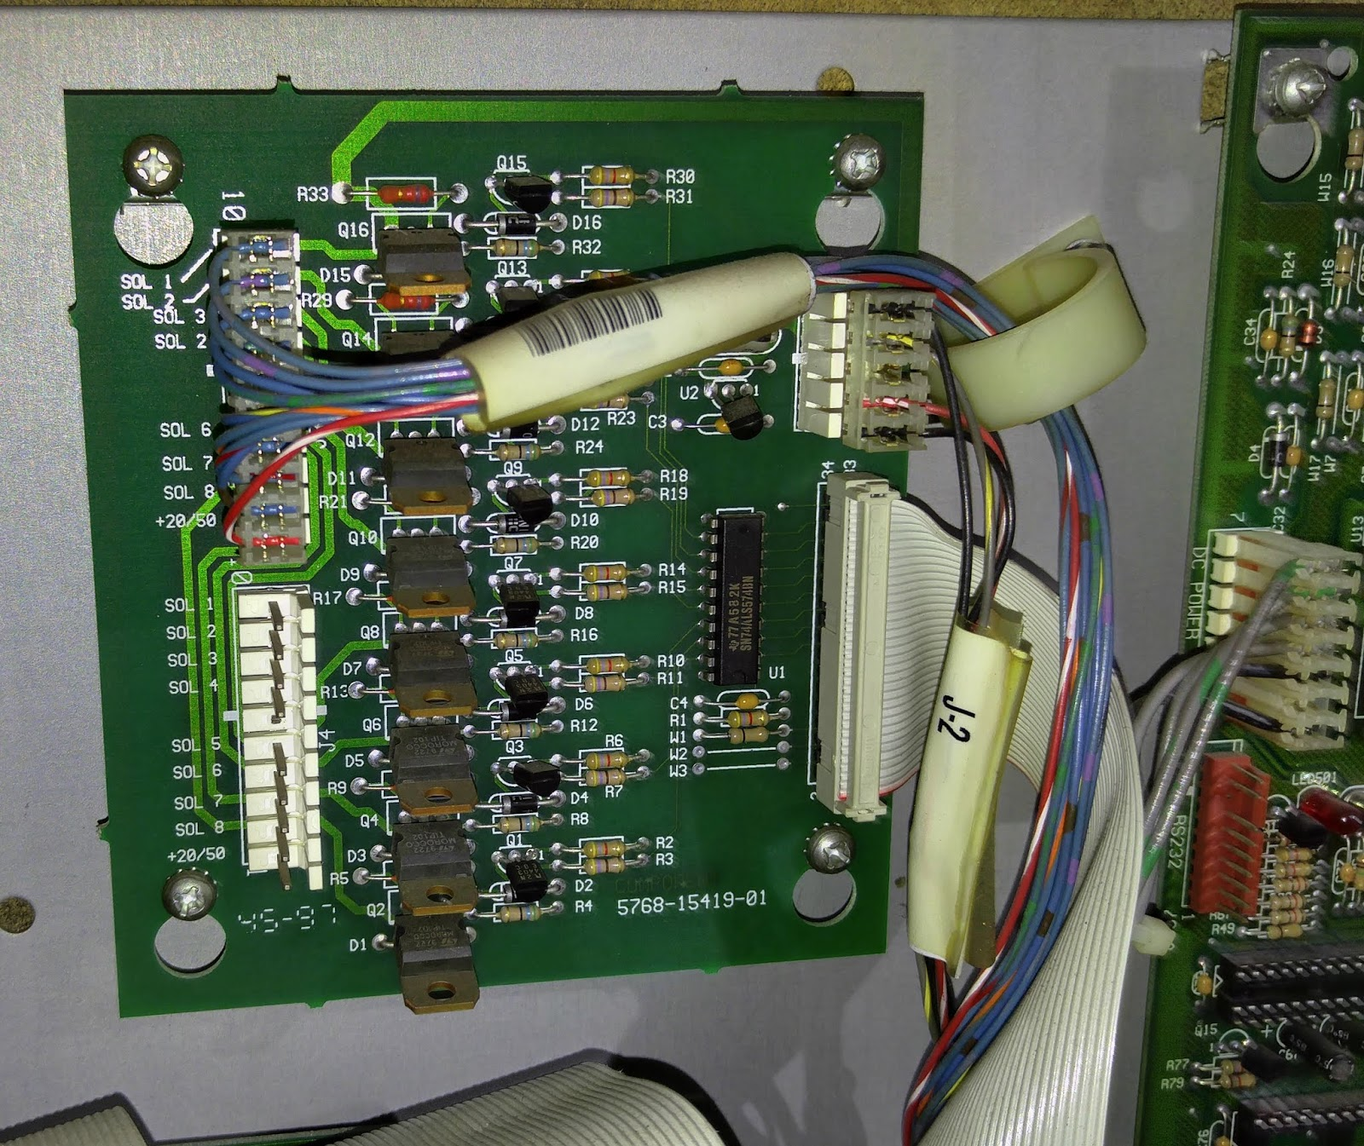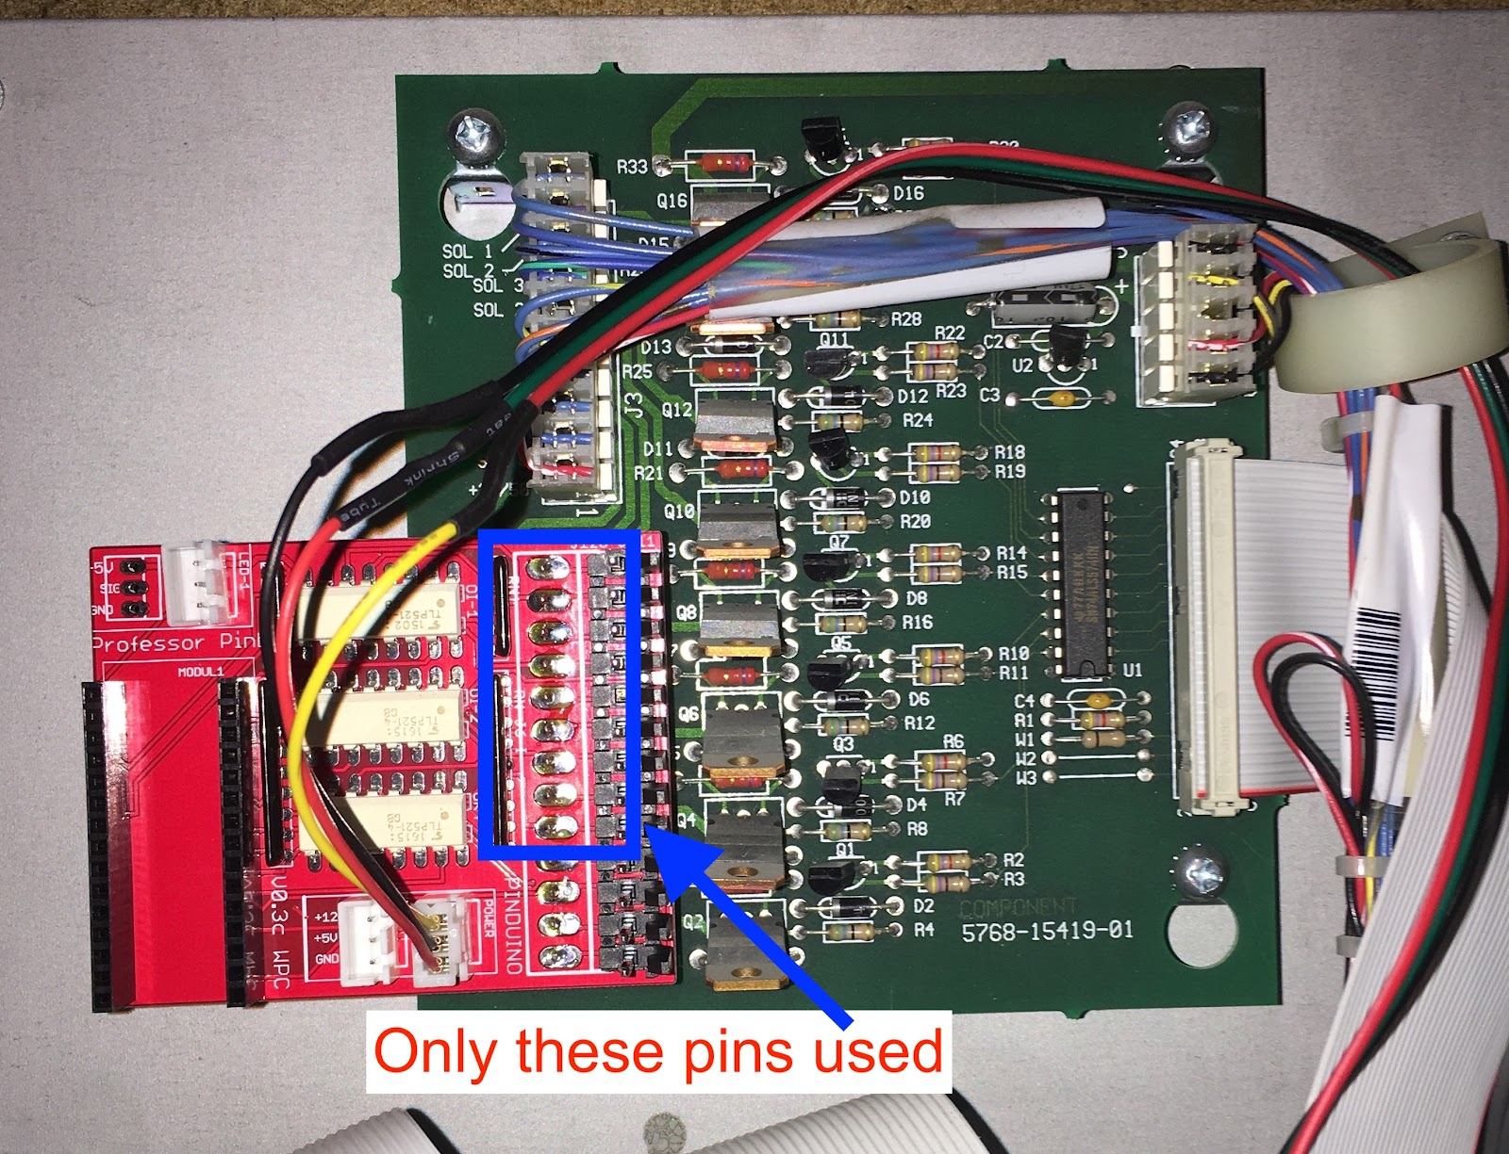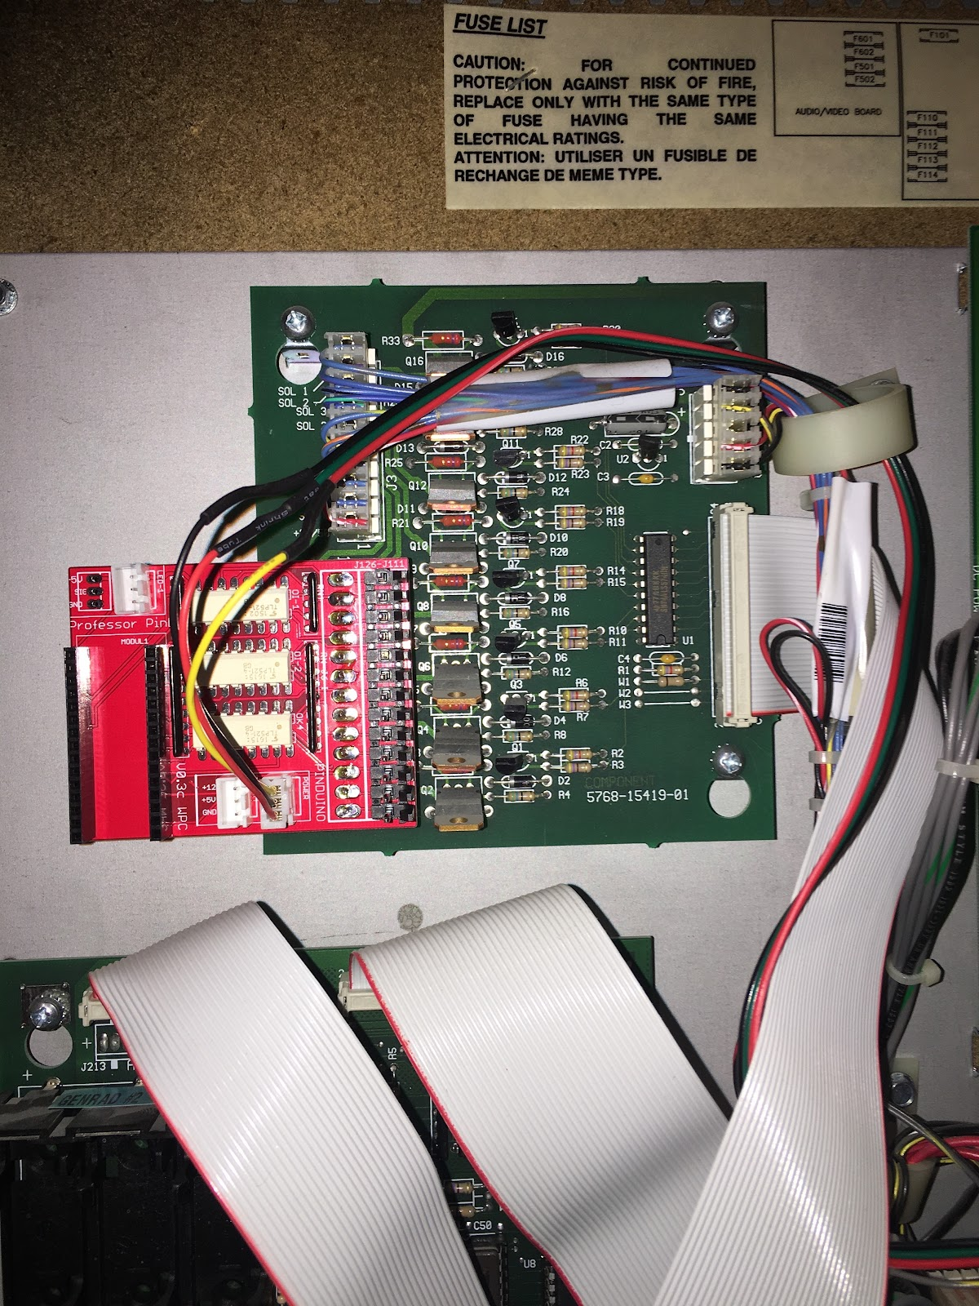
Removing existing wire harness for attaching LEDs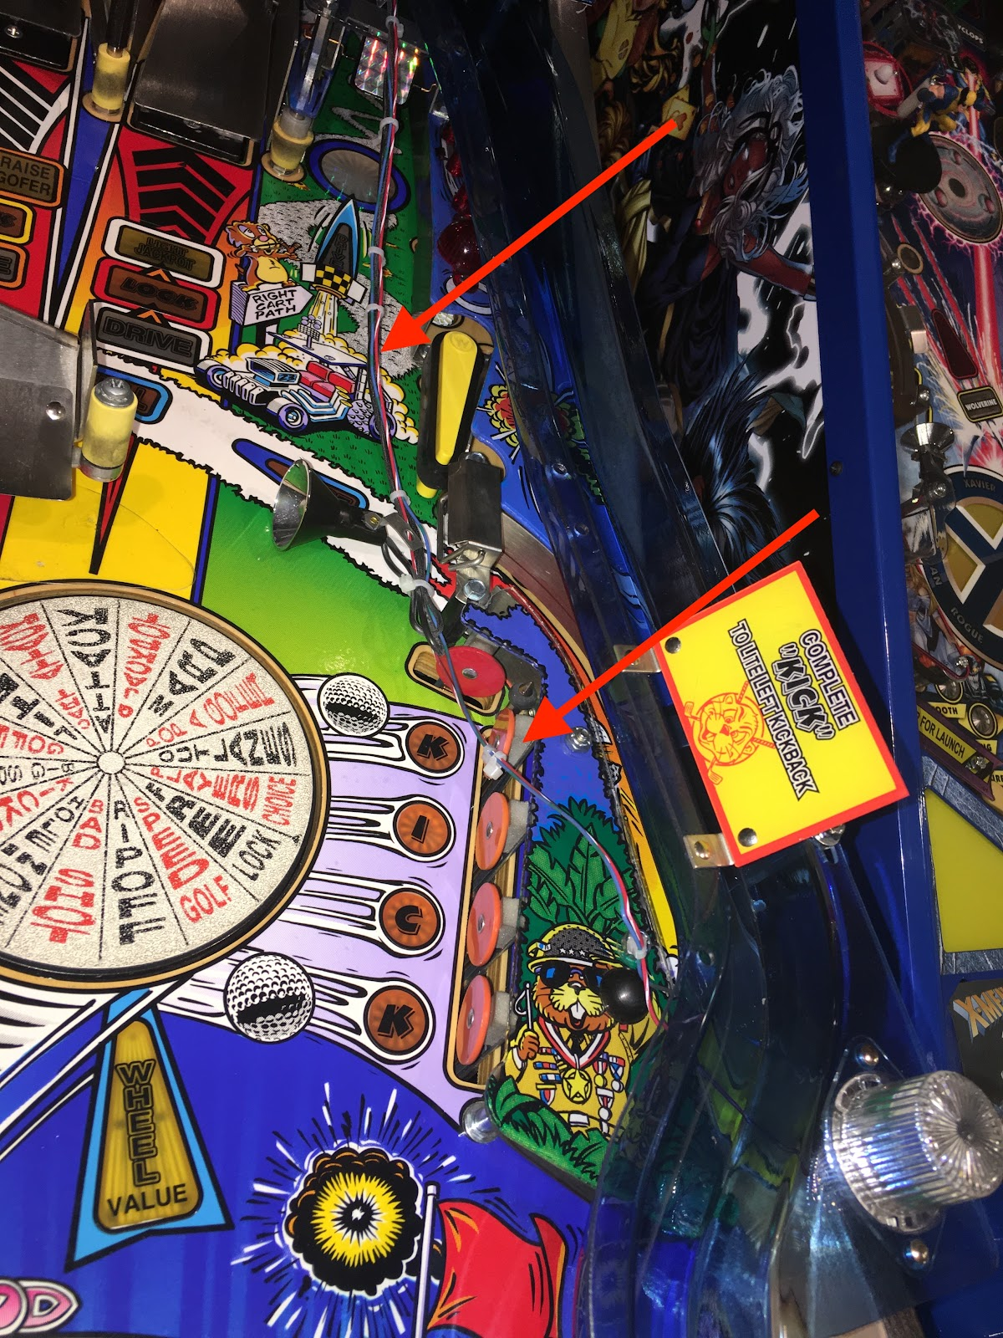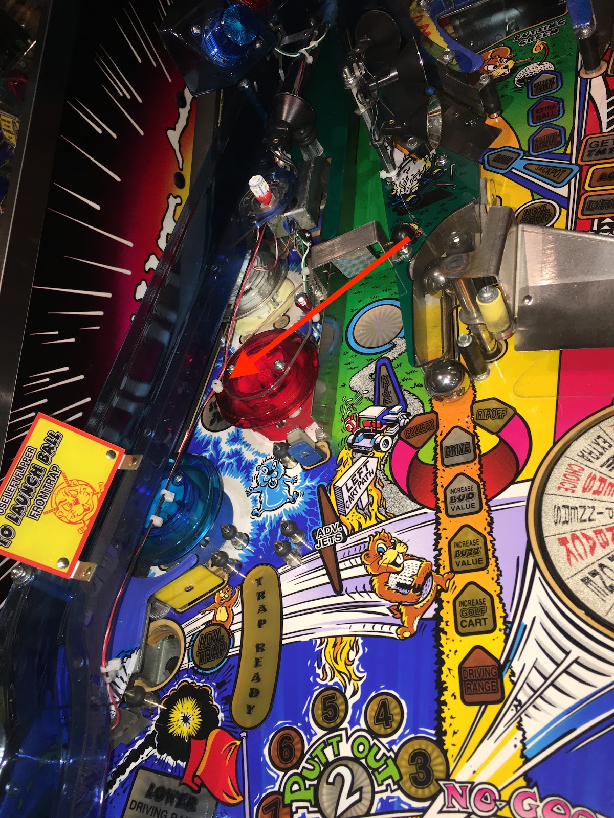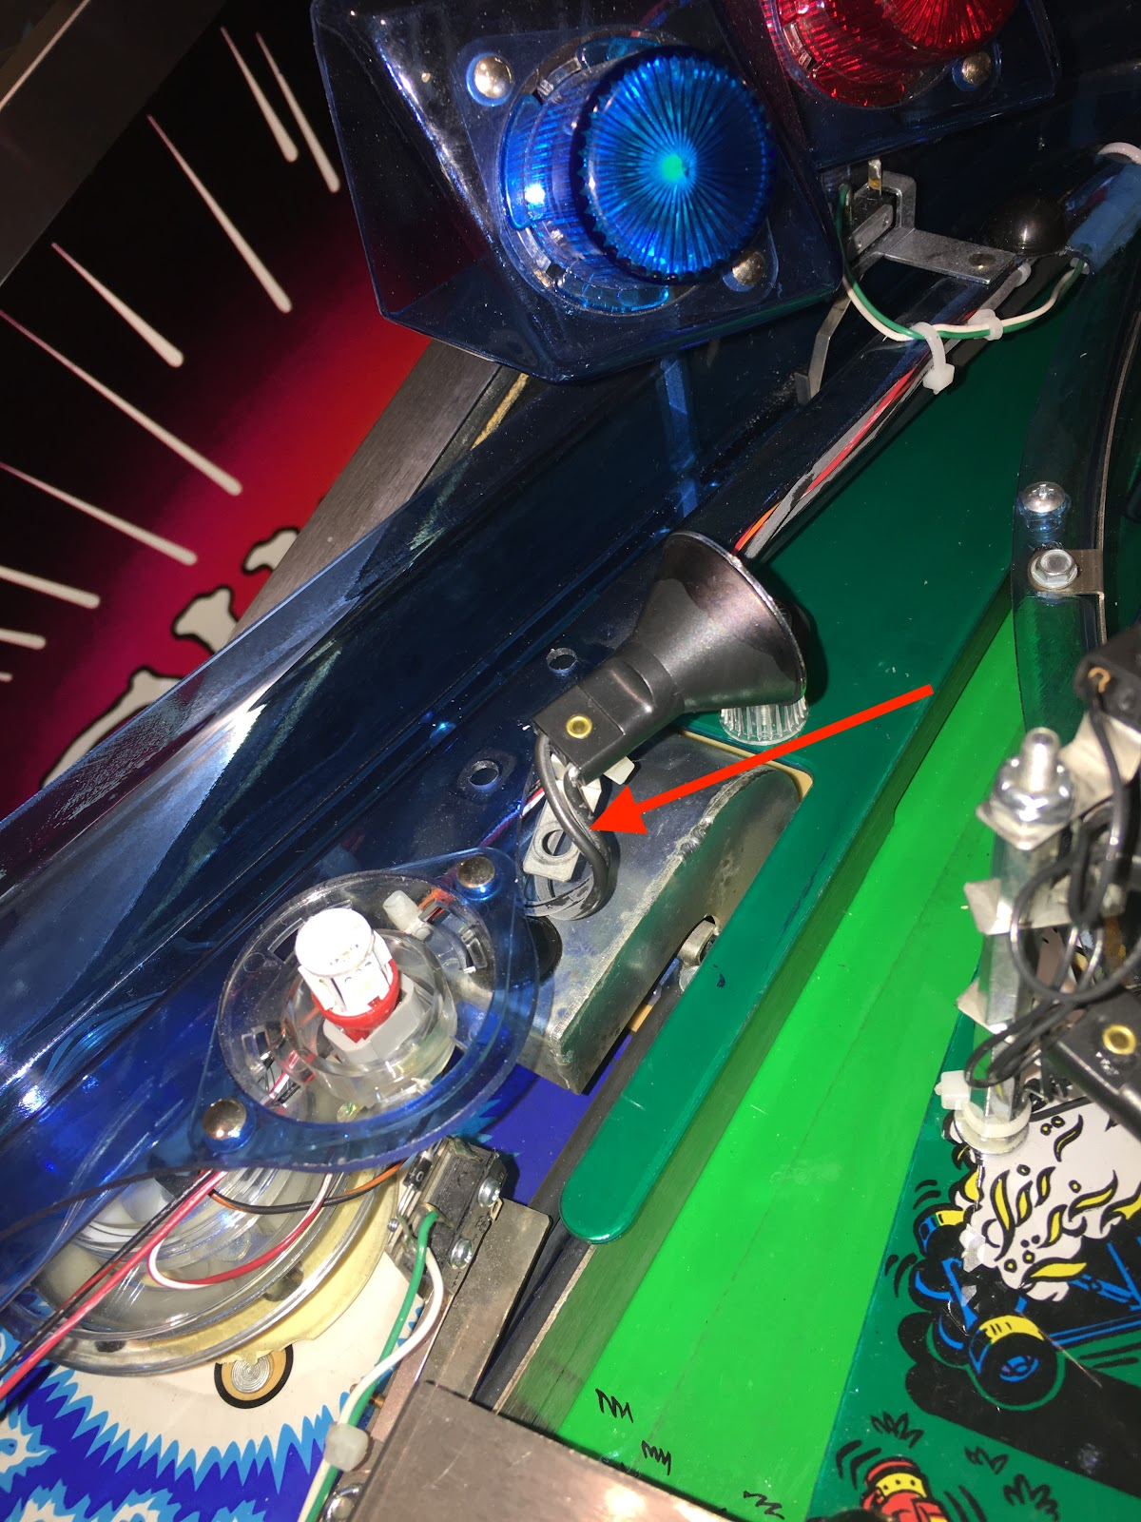
Route for LED wire harness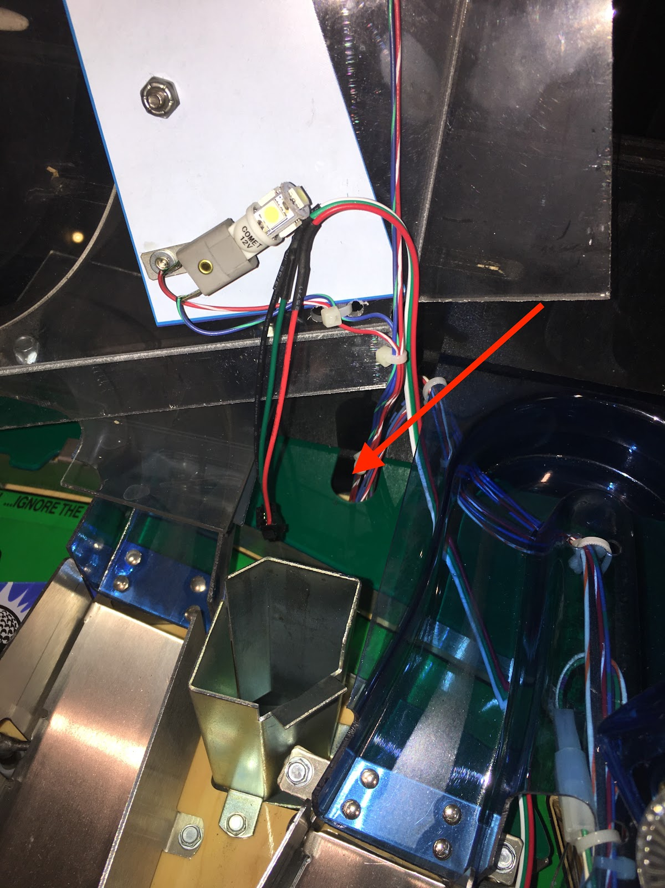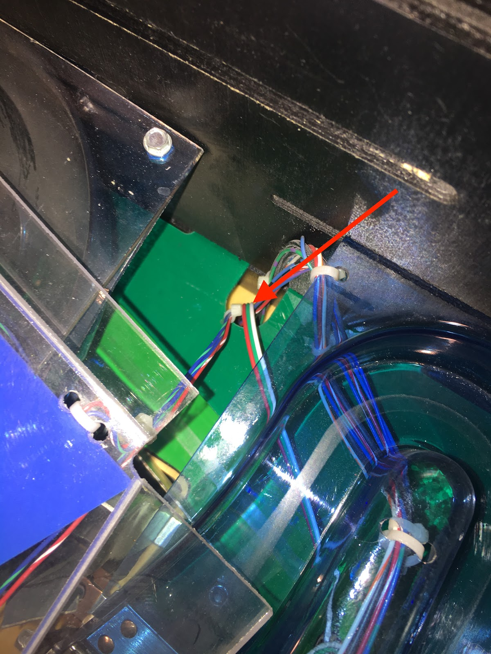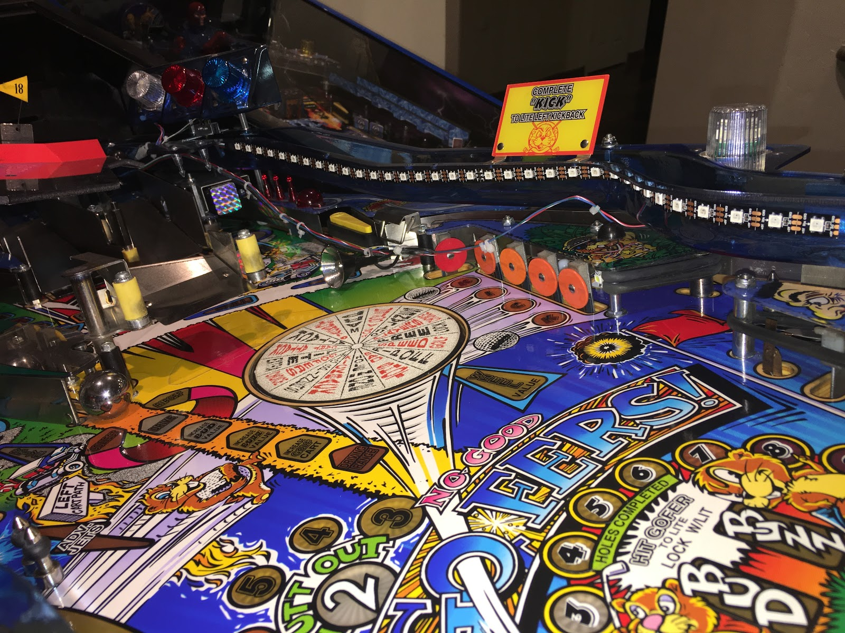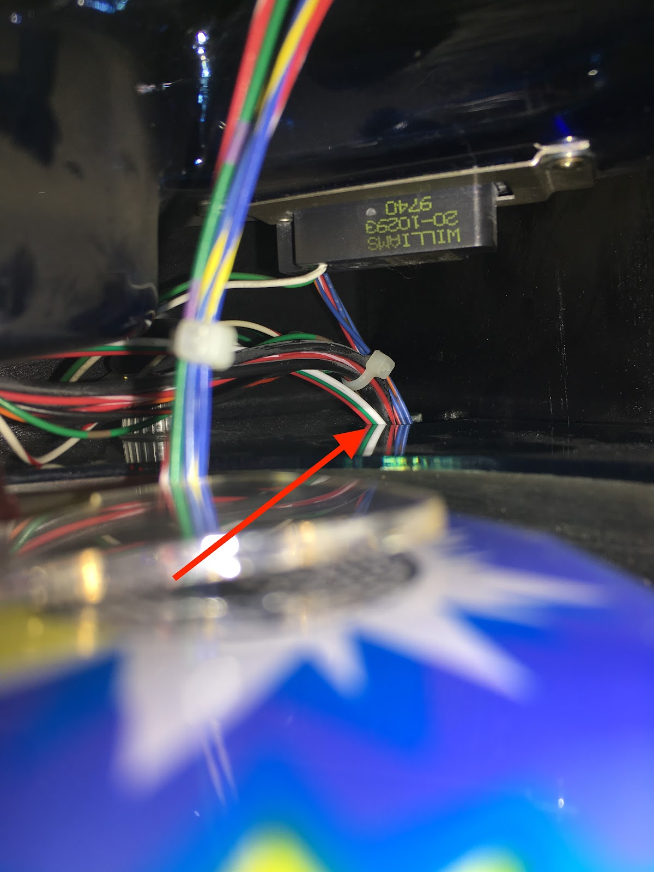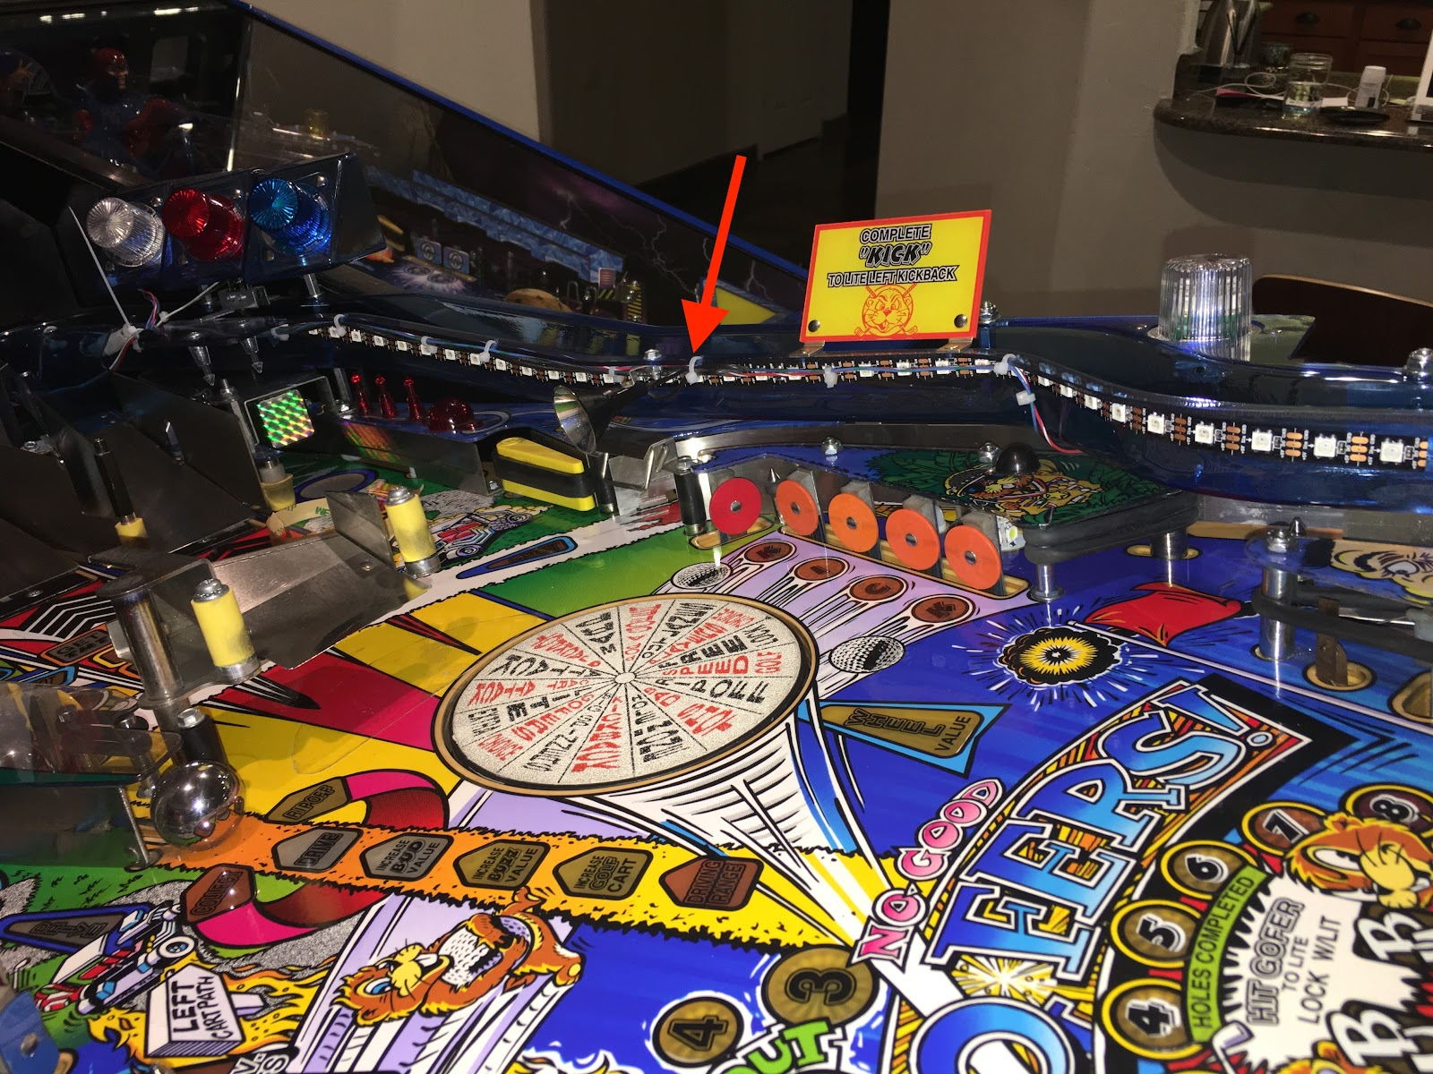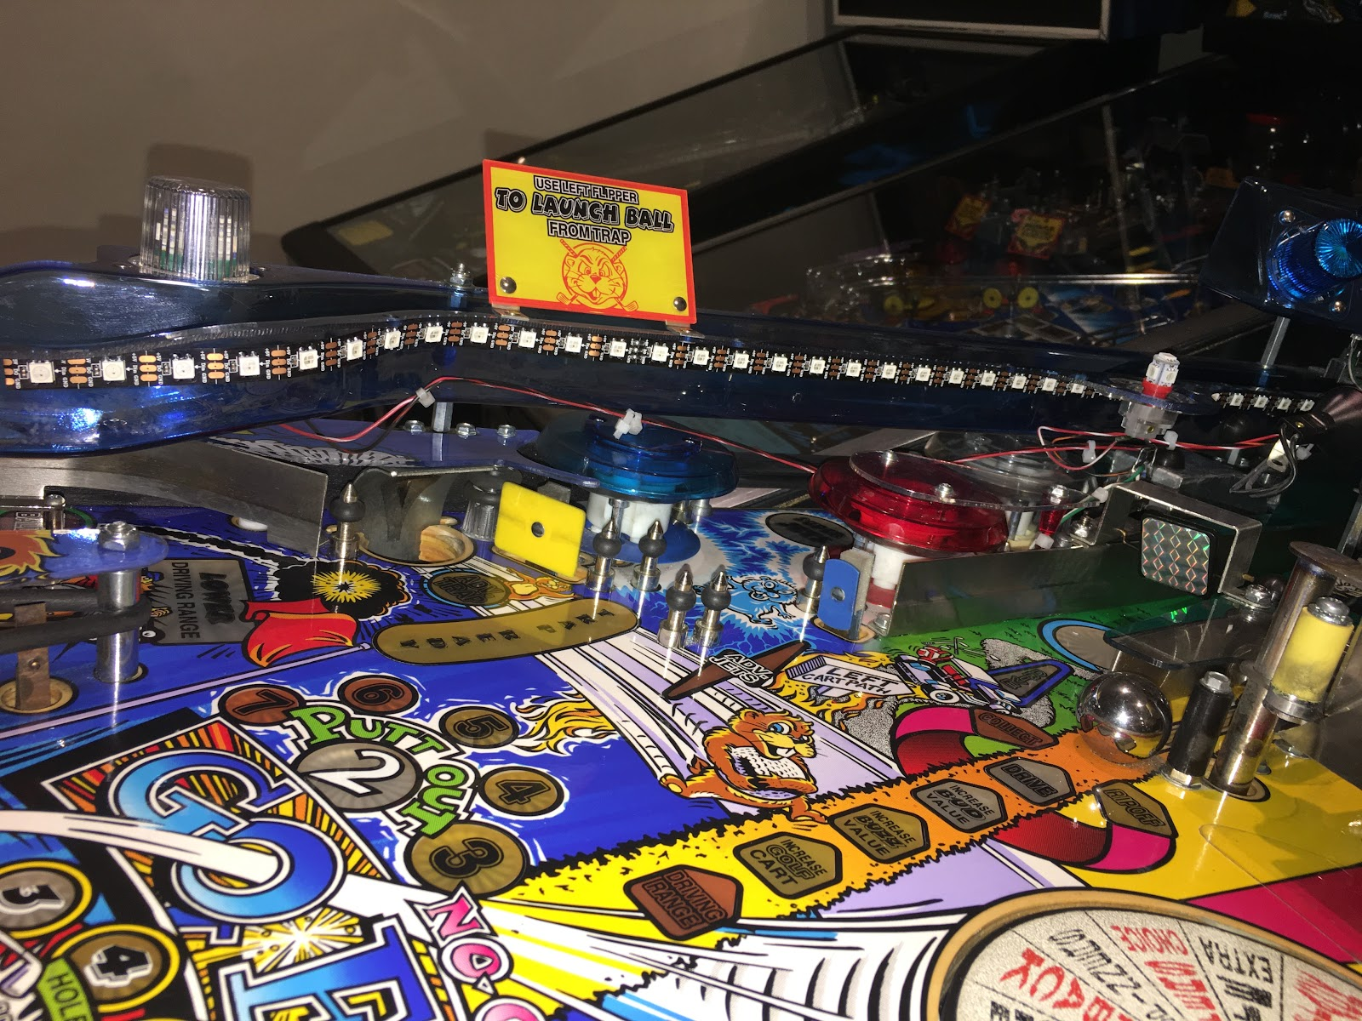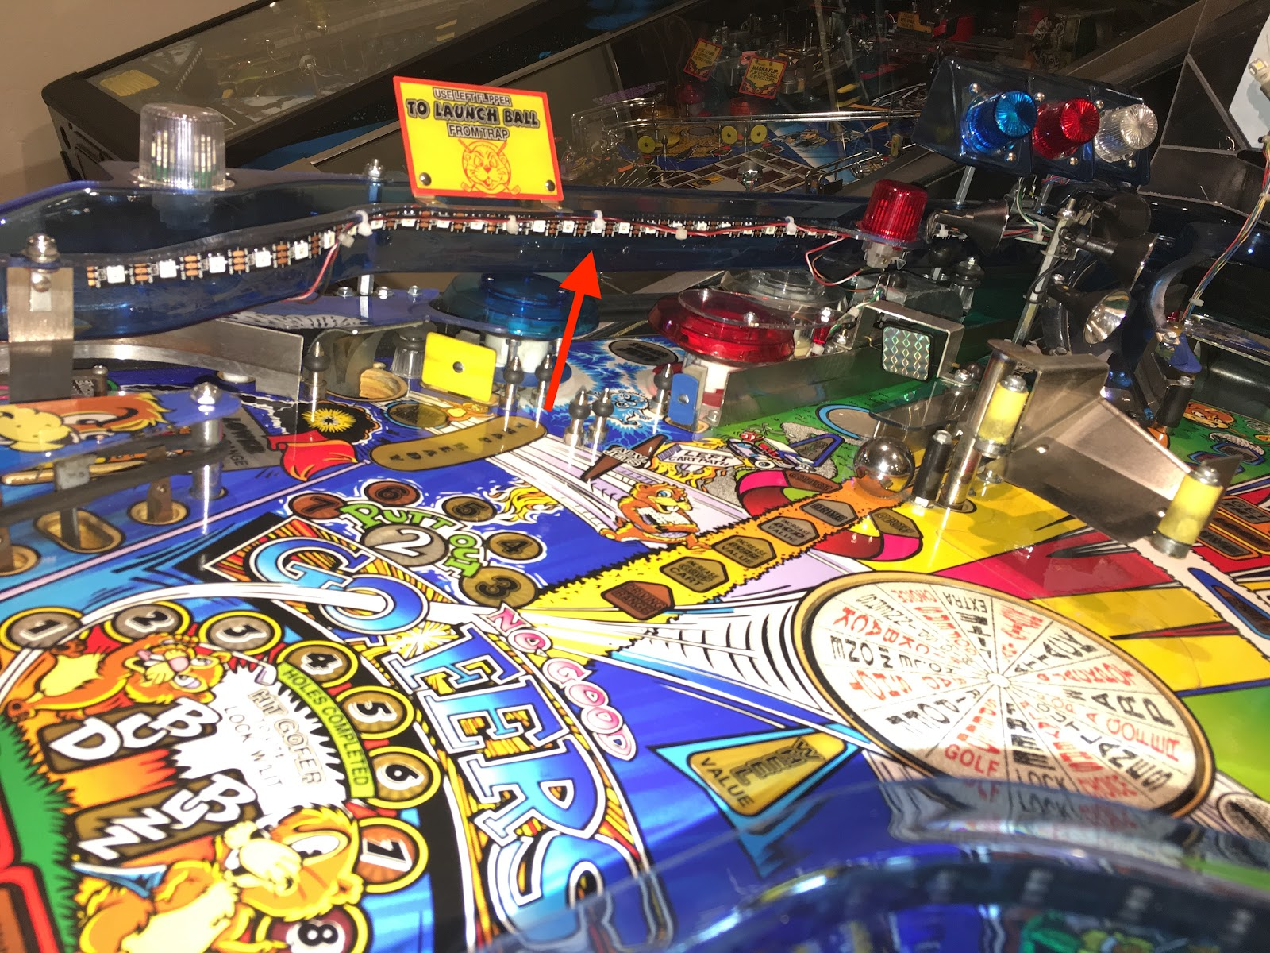
Power: J138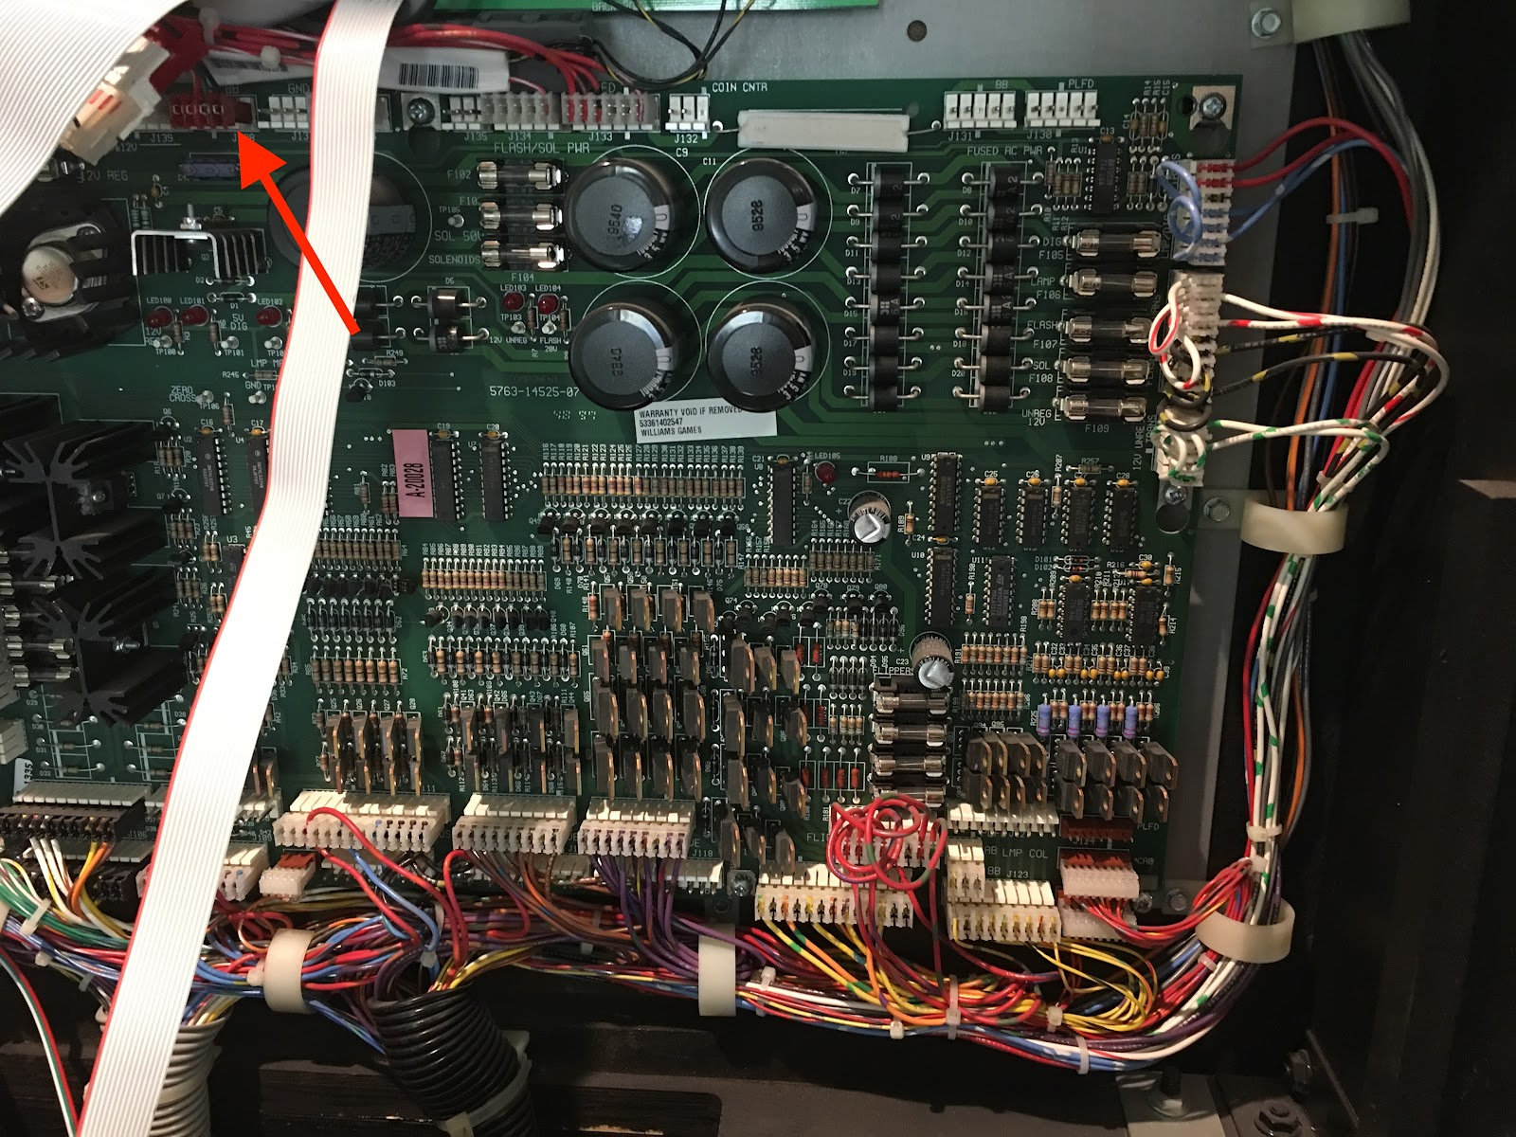
Example using pass-through wire harness. The Pinduino Board Board will plug here. For pictures of Pinduino power board installation: Click Here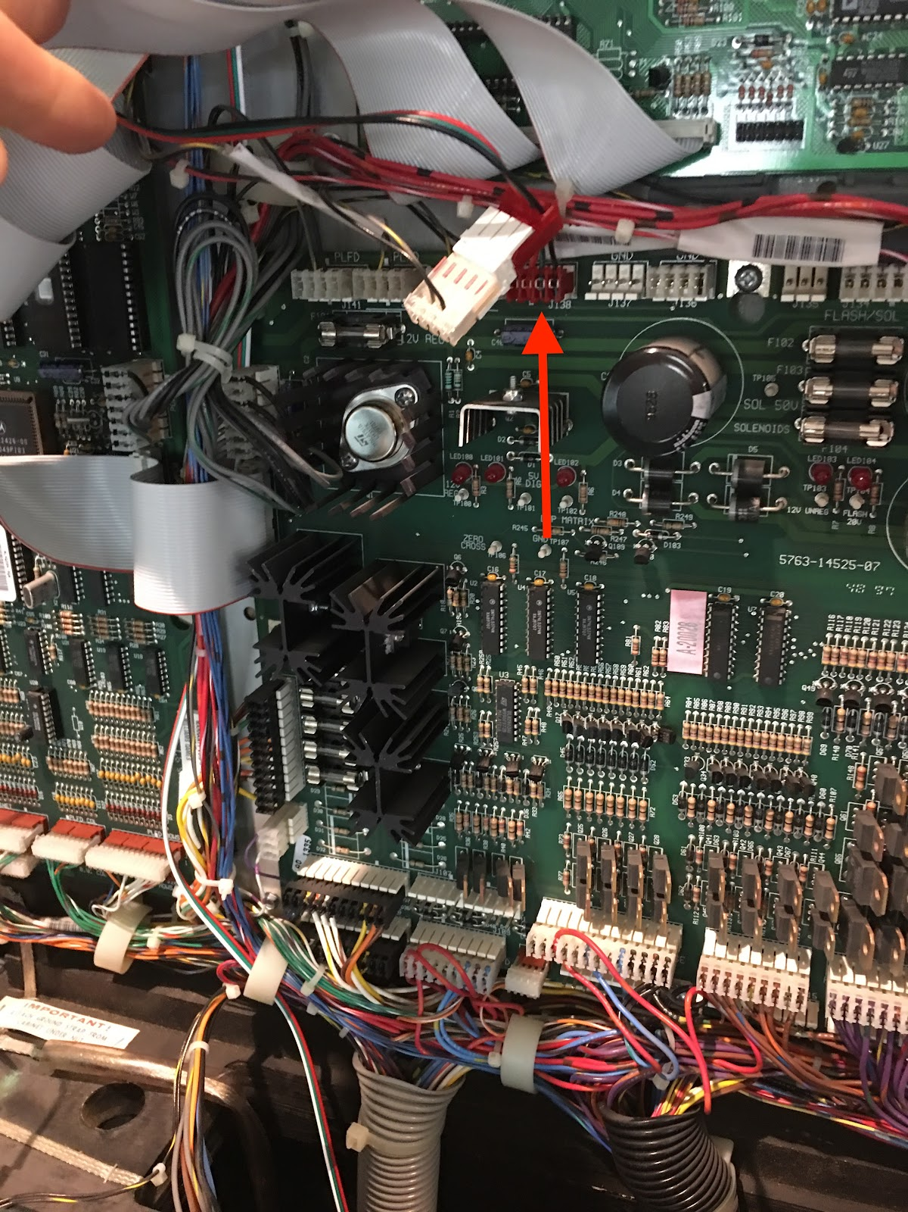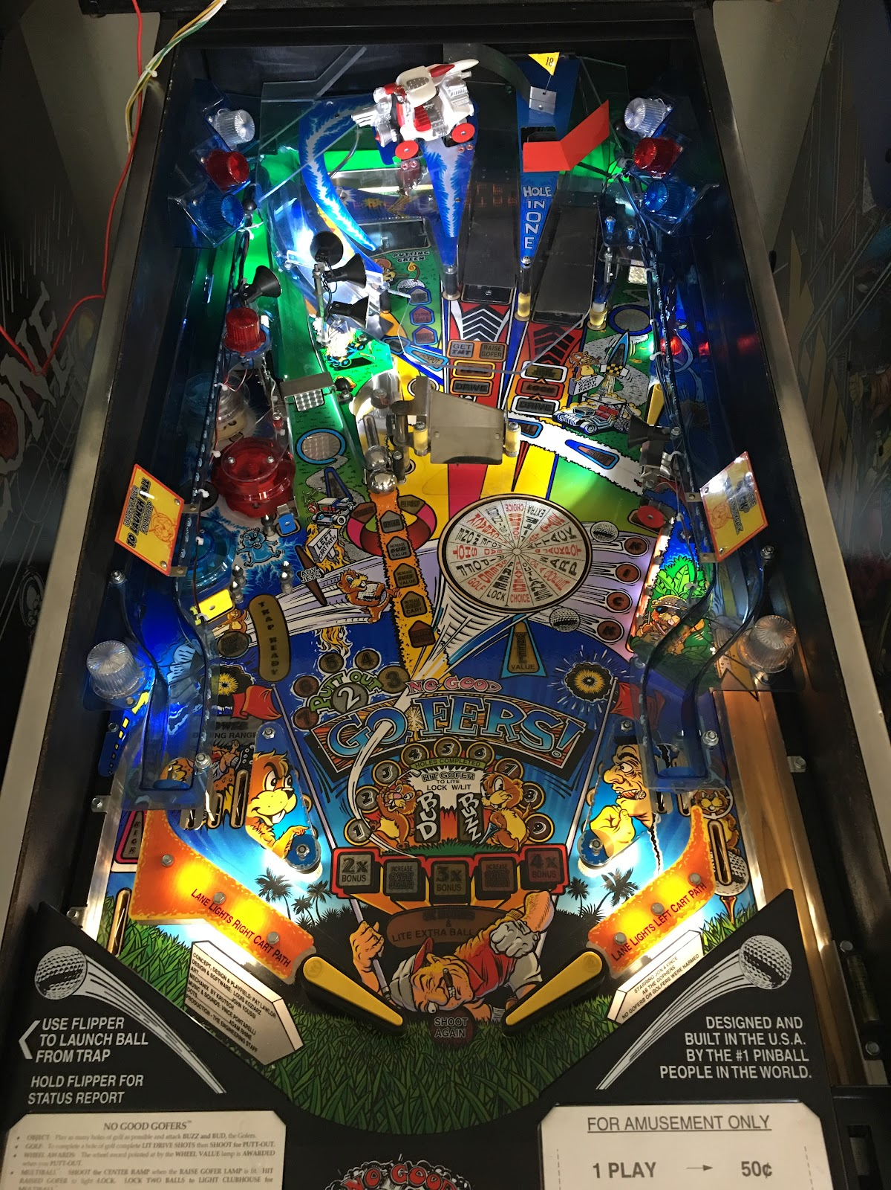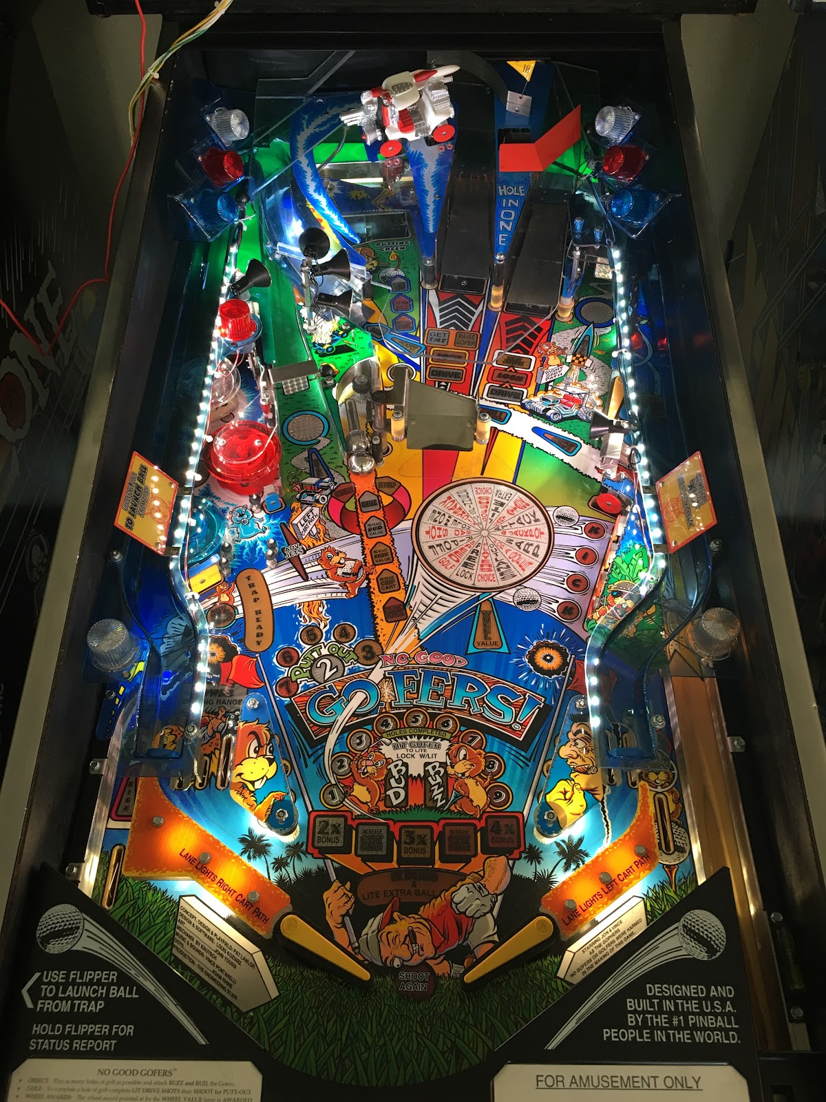

Pinball J4 Pin | Index | Position in Array |  | Value in Array | Arduino Pin | Notes
 | 0 | 1 |  | A1 | A1 | Analog input A1
 | 1 | 2 |  | A0 | A0 | Analog input A0
 | 2 | 3 |  | 13 | D13 | Onboard LED (can be read too)
2 | 3 | 4 |  | 12 | D12
3 | 4 | 5 |  | A2 | A2 | Analog input A2
4 | 5 | 6 |  | A3 | A3 | Analog input A3
5 | 6 | 7 |  | A4 | A4 | Also I2C SDA
 | 7 | 8 |  | A5 | A5 | Also I2C SCL
7 | 8 | 9 |  | 5 | D5
8 | 9 | 10 |  | 4 | D4
9 | 10 | 11 |  | 3 | D3
10 | 11 | 12 |  | 2 | D2
 | 12 | 13 |  | 9 | D9
 | 13 | 14 |  | 8 | D8
NONE | 14 | 15 |  | 7 | D7 | Blue Button
NONE | 15 | 16 |  | 6 | D6 | Red Button
Für LED Strip |  |  |  |  | D10 | LED Strip 1
Für LED Strip |  |  |  |  | D11 | LED Strip 2

- J4-2 → J126(4): Upper Right 1 Flasher
- J4-3 → J126(5): Upper Right 2 Flasher
- J4-4 → J126(6): Upper Right 3 Flasher
- J4-5 → J126(7): Upper Playfield Right
- J4-7 → J126(9): Upper Playfield Left
- J4-8 → J126(10): Upper Left 3 Flasher)
- J4-9 → J126(11): Upper Left 2 Flasher)
- J4-10 → J126(12): Upper Left 1 Flasher)

M5Stack Mini Dual Button Unit
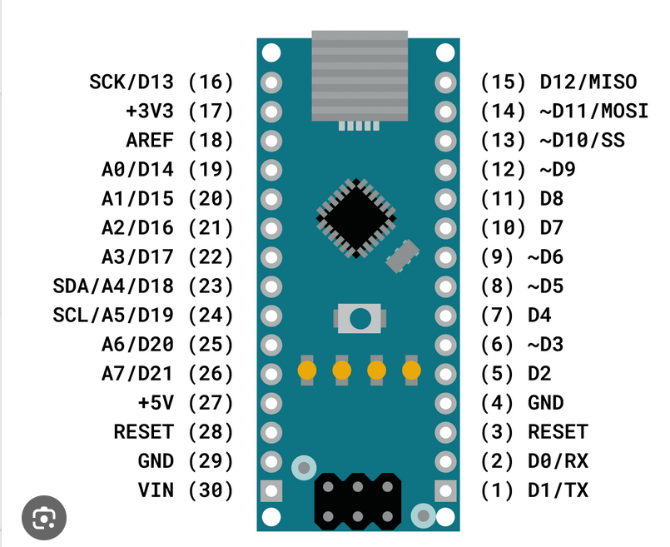
Red Button connected to D10->Yellow Wire
Blue Button connected to D11→White Wire

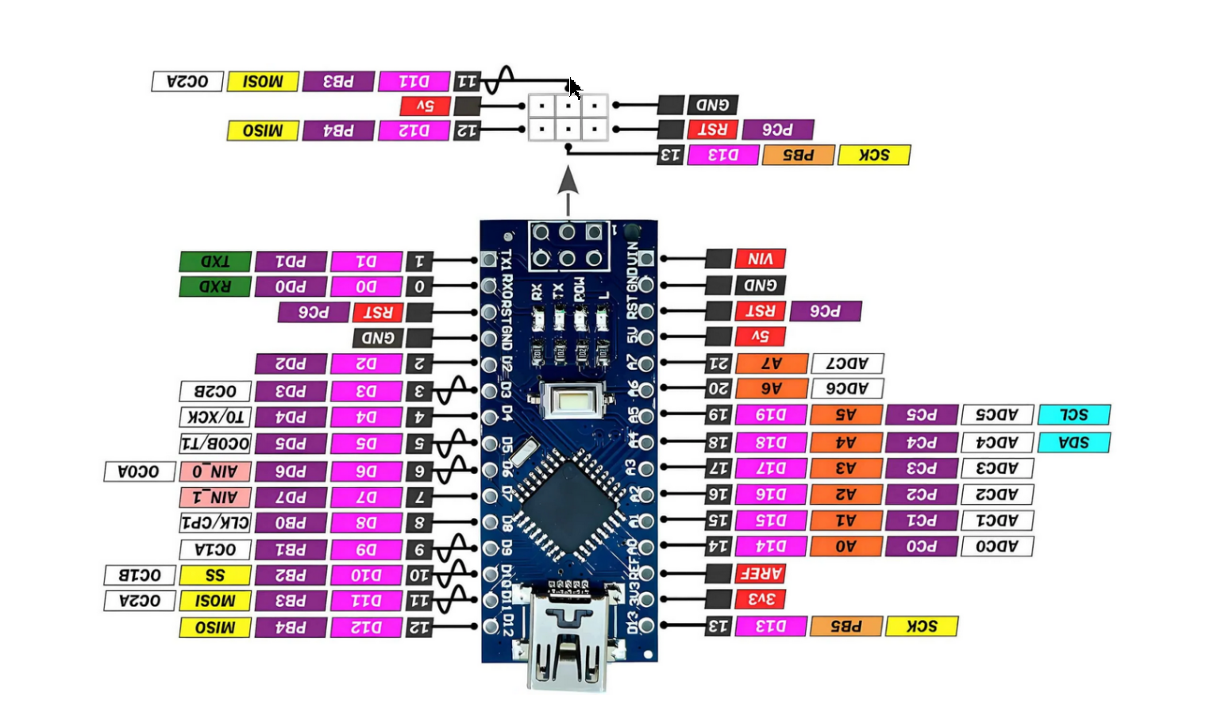

M5Stack Mini Dual Button Unit
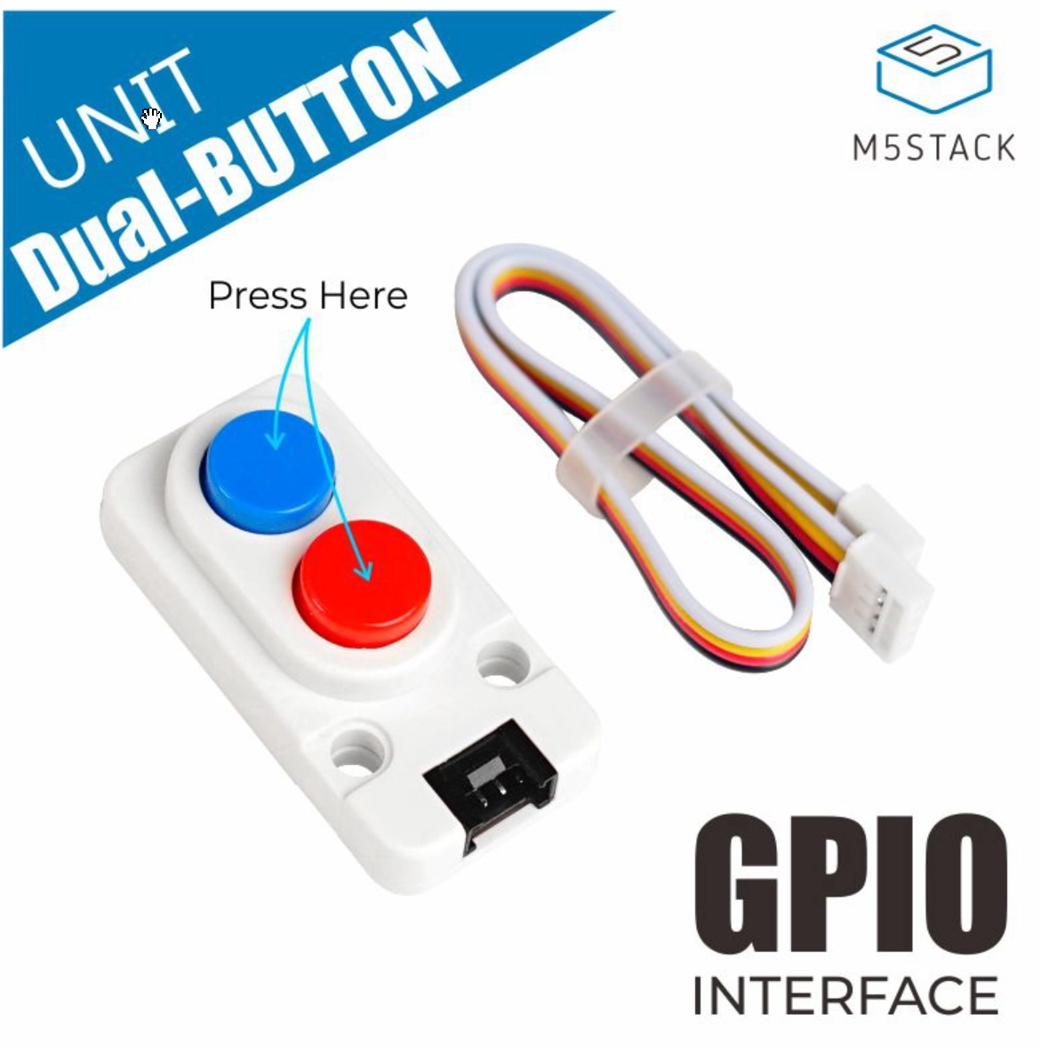
https://www.bastelgarage.ch/m5stack-mini-dual-button-unit?search=M5Stack%20Mini%20Dual%20Button%20Unit%20

Quelle | Pin | Ziel | Pin
Mean Well RD-65A | 12V | Pinduino | 12V
Mean Well RD-65A | 5V | Pinduino | 5V
Mean Well RD-65A | GND | Pinduino | GND
Mean Well RD-65A | GND | Pinball | GND
Mean Well RD-65A | GND | M5Stack Mini Dual Button Unit | GND
Mean Well RD-65A | 5V | M5Stack Mini Dual Button Unit | 5V
M5Stack Mini Dual Button Unit | Red Btn Input / Yellow Cable | Arduino Nano | D6
M5Stack Mini Dual Button Unit | Blue Btn Input / White Cable | Arduino Nano | D7
Arduino Nano | D10 | LED Strip 1 | D10
Arduino Nano | D11 | LED Strip 2 | D11

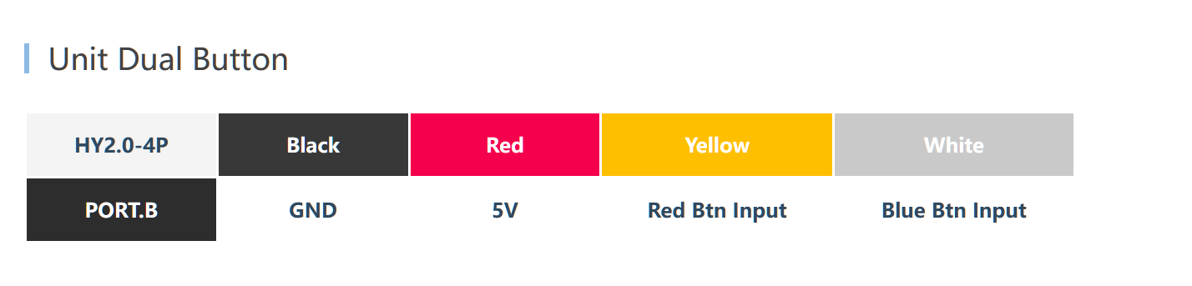

Software: https://github.com/wbkwbk/NoGoodGofers/tree/main

Knopf | Anzahl  Klicks | Funktion | Kommentar
Rot | 1 | - Ein  - Aus | Wenn nicht im Status  Auswahl der Spielfeldbeleuchtungsfarbe
Blau  Wenn LED an | 1 | - Nur Beleuchtung  - Volle Effekte | Nur wenn LED an sind
Rot | 2 | Volle Effekte und  Helligkeit auf Maximum  Statische Farbe gemäss Einstellung | Wenn nicht im Status  Auswahl der Spielfeldbeleuchtungsfarbe
Blau | Dauerhaft | Helligkeit einstellen | Geht nicht im Status  - LED aus  - Auswahl der Spielfeldbeleuchtungsfarbe
Blau  Wenn LED  aus | 1 | Wechselt in die Auswahl der Spielfeldbeleuchtungsfarbe | Nur wenn LED Aus
Status Auswahl der Spielfeldbeleuchtungsfarbe
Rot | 1 | Nächste Farbe
Rot | 2 | Setzt auf 1. Farbe zurück
Blau | 1 | Beendet Modus Auswahl der Spielfeldbeleuchtungsfarbe

