**一、SpringMVC基础入门，创建一个HelloWorld程序**

1.首先，导入SpringMVC需要的jar包。

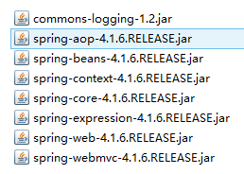

2.添加Web.xml配置文件中关于SpringMVC的配置

|  |  |
| --- | --- |
| 1  2  3  4  5  6  7  8  9  10  11  12  13  14  15 | <!--configure the setting of springmvcDispatcherServlet and configure the mapping-->    <servlet>        <servlet-name>springmvc</servlet-name>        <servlet-class>org.springframework.web.servlet.DispatcherServlet</servlet-class>        <init-param>              <param-name>contextConfigLocation</param-name>              <param-value>classpath:springmvc-servlet.xml</param-value>          </init-param>          <!-- <load-on-startup>1</load-on-startup> -->    </servlet>      <servlet-mapping>        <servlet-name>springmvc</servlet-name>        <url-pattern>/</url-pattern>    </servlet-mapping> |

3.在src下添加springmvc-servlet.xml配置文件

|  |  |
| --- | --- |
| 1  2  3  4  5  6  7  8  9  10  11  12  13  14  15  16  17  18  19  20  21  22  23  24  25  26  27 | <?xml version="1.0" encoding="UTF-8"?>  <beans xmlns="http://www.springframework.org/schema/beans"      xmlns:xsi="http://www.w3.org/2001/XMLSchema-instance"      xmlns:context="http://www.springframework.org/schema/context"      xmlns:mvc="http://www.springframework.org/schema/mvc"      xsi:schemaLocation="http://www.springframework.org/schema/beans http://www.springframework.org/schema/beans/spring-beans.xsd          http://www.springframework.org/schema/context http://www.springframework.org/schema/context/spring-context-4.1.xsd          http://www.springframework.org/schema/mvc http://www.springframework.org/schema/mvc/spring-mvc-4.1.xsd">        <!-- scan the package and the sub package -->      <context:component-scan base-package="test.SpringMVC"/>        <!-- don't handle the static resource -->      <mvc:default-servlet-handler />        <!-- if you use annotation you must configure following setting -->      <mvc:annotation-driven />        <!-- configure the InternalResourceViewResolver -->      <bean class="org.springframework.web.servlet.view.InternalResourceViewResolver"              id="internalResourceViewResolver">          <!-- 前缀 -->          <property name="prefix" value="/WEB-INF/jsp/" />          <!-- 后缀 -->          <property name="suffix" value=".jsp" />      </bean>  </beans> |

4.在WEB-INF文件夹下创建名为jsp的文件夹，用来存放jsp视图。创建一个hello.jsp，在body中添加“Hello World”。

5.建立包及Controller，如下所示

http://images0.cnblogs.com/blog2015/694841/201506/032227247897004.png

6.编写Controller代码

|  |  |
| --- | --- |
| 1  2  3  4  5  6  7  8  9 | @Controller  @RequestMapping("/mvc")  public class mvcController {        @RequestMapping("/hello")      public String hello(){          return "hello";      }  } |

7.启动服务器，键入 http://localhost:8080/项目名/mvc/hello

二、配置解析

1.Dispatcherservlet

DispatcherServlet是前置控制器，配置在web.xml文件中的。拦截匹配的请求，Servlet拦截匹配规则要自已定义，把拦截下来的请求，依据相应的规则分发到目标Controller来处理，是配置spring MVC的第一步。

2.InternalResourceViewResolver

视图名称解析器

3.以上出现的注解

@Controller 负责注册一个bean 到spring 上下文中

@RequestMapping 注解为控制器指定可以处理哪些 URL 请求

三、SpringMVC常用注解

@Controller

负责注册一个bean 到spring 上下文中

@RequestMapping

注解为控制器指定可以处理哪些 URL 请求

@RequestBody

该注解用于读取Request请求的body部分数据，使用系统默认配置的HttpMessageConverter进行解析，然后把相应的数据绑定到要返回的对象上 ,再把HttpMessageConverter返回的对象数据绑定到 controller中方法的参数上

@ResponseBody

该注解用于将Controller的方法返回的对象，通过适当的HttpMessageConverter转换为指定格式后，写入到Response对象的body数据区

@ModelAttribute

在方法定义上使用 @ModelAttribute 注解：Spring MVC 在调用目标处理方法前，会先逐个调用在方法级上标注了@ModelAttribute 的方法

在方法的入参前使用 @ModelAttribute 注解：可以从隐含对象中获取隐含的模型数据中获取对象，再将请求参数 –绑定到对象中，再传入入参将方法入参对象添加到模型中

@RequestParam

在处理方法入参处使用 @RequestParam 可以把请求参 数传递给请求方法

@PathVariable

绑定 URL 占位符到入参

@ExceptionHandler

注解到方法上，出现异常时会执行该方法

@ControllerAdvice

使一个Contoller成为全局的异常处理类，类中用@ExceptionHandler方法注解的方法可以处理所有Controller发生的异常

四、自动匹配参数

|  |  |
| --- | --- |
| 1  2  3  4  5  6 | //match automatically      @RequestMapping("/person")      public String toPerson(String name,double age){          System.out.println(name+" "+age);          return "hello";      } |

五、自动装箱

1.编写一个Person实体类

|  |  |
| --- | --- |
| 1  2  3  4  5  6  7  8  9  10  11  12  13  14  15  16  17  18  19 | package test.SpringMVC.model;    public class Person {      public String getName() {          return name;      }      public void setName(String name) {          this.name = name;      }      public int getAge() {          return age;      }      public void setAge(int age) {          this.age = age;      }      private String name;      private int age;    } |

2.在Controller里编写方法

|  |  |
| --- | --- |
| 1  2  3  4  5  6 | //boxing automatically      @RequestMapping("/person1")      public String toPerson(Person p){          System.out.println(p.getName()+" "+p.getAge());          return "hello";      } |

六、使用InitBinder来处理Date类型的参数

|  |  |
| --- | --- |
| 1  2  3  4  5  6  7  8  9  10  11  12  13 | //the parameter was converted in initBinder      @RequestMapping("/date")      public String date(Date date){          System.out.println(date);          return "hello";      }        //At the time of initialization,convert the type "String" to type "date"      @InitBinder      public void initBinder(ServletRequestDataBinder binder){          binder.registerCustomEditor(Date.class, new CustomDateEditor(new SimpleDateFormat("yyyy-MM-dd"),                  true));      } |

七、向前台传递参数

|  |  |
| --- | --- |
| 1  2  3  4  5  6  7  8  9 | //pass the parameters to front-end      @RequestMapping("/show")      public String showPerson(Map<String,Object> map){          Person p =new Person();          map.put("p", p);          p.setAge(20);          p.setName("jayjay");          return "show";      } |

前台可在Request域中取到”p”

八、使用Ajax调用

|  |  |
| --- | --- |
| 1  2  3  4  5  6  7  8  9 | //pass the parameters to front-end using ajax      @RequestMapping("/getPerson")      public void getPerson(String name,PrintWriter pw){          pw.write("hello,"+name);      }      @RequestMapping("/name")      public String sayHello(){          return "name";      } |

前台用下面的Jquery代码调用

|  |  |
| --- | --- |
| 1  2  3  4  5  6  7 | $(function(){                $("#btn").click(function(){                    $.post("mvc/getPerson",{name:$("#name").val()},function(data){                        alert(data);                    });                });            }); |

九、在Controller中使用redirect方式处理请求

|  |  |
| --- | --- |
| 1  2  3  4  5 | //redirect      @RequestMapping("/redirect")      public String redirect(){          return "redirect:hello";      } |

十、文件上传

1.需要导入两个jar包

http://images0.cnblogs.com/blog2015/694841/201506/052005184887879.png

2.在SpringMVC配置文件中加入

|  |  |
| --- | --- |
| 1  2  3  4 | <!-- upload settings -->      <bean id="multipartResolver"  class="org.springframework.web.multipart.commons.CommonsMultipartResolver">          <property name="maxUploadSize" value="102400000"></property>      </bean> |

3.方法代码

|  |  |
| --- | --- |
| 1  2  3  4  5  6  7  8  9  10  11  12  13  14 | @RequestMapping(value="/upload",method=RequestMethod.POST)      public String upload(HttpServletRequest req) throws Exception{          MultipartHttpServletRequest mreq = (MultipartHttpServletRequest)req;          MultipartFile file = mreq.getFile("file");          String fileName = file.getOriginalFilename();          SimpleDateFormat sdf = new SimpleDateFormat("yyyyMMddHHmmss");          FileOutputStream fos = new FileOutputStream(req.getSession().getServletContext().getRealPath("/")+                  "upload/"+sdf.format(new Date())+fileName.substring(fileName.lastIndexOf('.')));          fos.write(file.getBytes());          fos.flush();          fos.close();            return "hello";      } |

4.前台form表单

|  |  |
| --- | --- |
| 1  2  3  4 | <form action="mvc/upload" method="post" enctype="multipart/form-data">            <input type="file" name="file">            <input type="submit" value="submit">        </form> |

十一、使用@RequestParam注解指定参数的name

|  |  |
| --- | --- |
| 1  2  3  4  5  6  7  8  9  10 | @Controller  @RequestMapping("/test")  public class mvcController1 {      @RequestMapping(value="/param")      public String testRequestParam(@RequestParam(value="id") Integer id,              @RequestParam(value="name")String name){          System.out.println(id+" "+name);          return "/hello";      }  } |

十二、RESTFul风格的SringMVC

1.RestController

|  |  |
| --- | --- |
| 1  2  3  4  5  6  7  8  9  10  11  12  13  14  15  16  17  18  19  20  21  22  23  24  25  26  27  28 | @Controller  @RequestMapping("/rest")  public class RestController {      @RequestMapping(value="/user/{id}",method=RequestMethod.GET)      public String get(@PathVariable("id") Integer id){          System.out.println("get"+id);          return "/hello";      }        @RequestMapping(value="/user/{id}",method=RequestMethod.POST)      public String post(@PathVariable("id") Integer id){          System.out.println("post"+id);          return "/hello";      }        @RequestMapping(value="/user/{id}",method=RequestMethod.PUT)      public String put(@PathVariable("id") Integer id){          System.out.println("put"+id);          return "/hello";      }        @RequestMapping(value="/user/{id}",method=RequestMethod.DELETE)      public String delete(@PathVariable("id") Integer id){          System.out.println("delete"+id);          return "/hello";      }    } |

2.form表单发送put和delete请求

在web.xml中配置

|  |  |
| --- | --- |
| 1  2  3  4  5  6  7  8  9 | <!-- configure the HiddenHttpMethodFilter,convert the post method to put or delete -->    <filter>        <filter-name>HiddenHttpMethodFilter</filter-name>        <filter-class>org.springframework.web.filter.HiddenHttpMethodFilter</filter-class>    </filter>    <filter-mapping>        <filter-name>HiddenHttpMethodFilter</filter-name>        <url-pattern>/*</url-pattern>    </filter-mapping> |

在前台可以用以下代码产生请求

|  |  |
| --- | --- |
| 1  2  3  4  5  6  7  8  9  10  11  12  13  14  15  16  17 | <form action="rest/user/1" method="post">          <input type="hidden" name="_method" value="PUT">          <input type="submit" value="put">      </form>        <form action="rest/user/1" method="post">          <input type="submit" value="post">      </form>        <form action="rest/user/1" method="get">          <input type="submit" value="get">      </form>        <form action="rest/user/1" method="post">          <input type="hidden" name="_method" value="DELETE">          <input type="submit" value="delete">      </form> |

十三、返回json格式的字符串

1.导入以下jar包

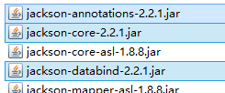

2.方法代码

|  |  |
| --- | --- |
| 1  2  3  4  5  6  7  8  9  10  11  12  13  14 | @Controller  @RequestMapping("/json")  public class jsonController {        @ResponseBody      @RequestMapping("/user")      public  User get(){          User u = new User();          u.setId(1);          u.setName("jayjay");          u.setBirth(new Date());          return u;      }  } |

十四、异常的处理

1.处理局部异常（Controller内）

|  |  |
| --- | --- |
| 1  2  3  4  5  6  7  8  9  10  11  12  13 | @ExceptionHandler      public ModelAndView exceptionHandler(Exception ex){          ModelAndView mv = new ModelAndView("error");          mv.addObject("exception", ex);          System.out.println("in testExceptionHandler");          return mv;      }        @RequestMapping("/error")      public String error(){          int i = 5/0;          return "hello";      } |

2.处理全局异常（所有Controller）

|  |  |
| --- | --- |
| 1  2  3  4  5  6  7  8  9  10 | @ControllerAdvice  public class testControllerAdvice {      @ExceptionHandler      public ModelAndView exceptionHandler(Exception ex){          ModelAndView mv = new ModelAndView("error");          mv.addObject("exception", ex);          System.out.println("in testControllerAdvice");          return mv;      }  } |

3.另一种处理全局异常的方法

在SpringMVC配置文件中配置

|  |  |
| --- | --- |
| 1  2  3  4  5  6  7  8 | <!-- configure SimpleMappingExceptionResolver -->      <bean class="org.springframework.web.servlet.handler.SimpleMappingExceptionResolver">          <property name="exceptionMappings">              <props>                  <prop key="java.lang.ArithmeticException">error</prop>              </props>          </property>      </bean> |

error是出错页面

十五、设置一个自定义拦截器

1.创建一个MyInterceptor类，并实现HandlerInterceptor接口

|  |  |
| --- | --- |
| 1  2  3  4  5  6  7  8  9  10  11  12  13  14  15  16  17  18  19  20  21  22  23 | public class MyInterceptor implements HandlerInterceptor {        @Override      public void afterCompletion(HttpServletRequest arg0,              HttpServletResponse arg1, Object arg2, Exception arg3)              throws Exception {          System.out.println("afterCompletion");      }        @Override      public void postHandle(HttpServletRequest arg0, HttpServletResponse arg1,              Object arg2, ModelAndView arg3) throws Exception {          System.out.println("postHandle");      }        @Override      public boolean preHandle(HttpServletRequest arg0, HttpServletResponse arg1,              Object arg2) throws Exception {          System.out.println("preHandle");          return true;      }    } |

2.在SpringMVC的配置文件中配置

|  |  |
| --- | --- |
| 1  2  3  4  5  6  7 | <!-- interceptor setting -->      <mvc:interceptors>          <mvc:interceptor>              <mvc:mapping path="/mvc/**"/>              <bean class="test.SpringMVC.Interceptor.MyInterceptor"></bean>          </mvc:interceptor>      </mvc:interceptors> |

3.拦截器执行顺序

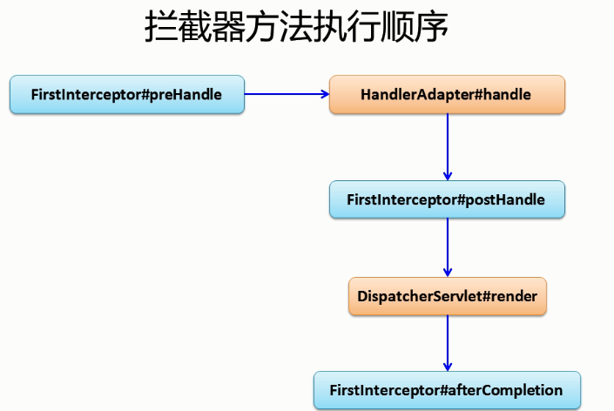

十六、表单的验证（使用Hibernate-validate）及国际化

1.导入Hibernate-validate需要的jar包

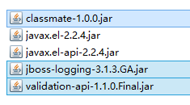(未选中不用导入)

http://images0.cnblogs.com/blog2015/694841/201506/052116407233893.png

2.编写实体类User并加上验证注解

|  |  |
| --- | --- |
| 1  2  3  4  5  6  7  8  9  10  11  12  13  14  15  16  17  18  19  20  21  22  23  24  25  26  27  28  29  30  31 | public class User {      public int getId() {          return id;      }      public void setId(int id) {          this.id = id;      }      public String getName() {          return name;      }      public void setName(String name) {          this.name = name;      }      public Date getBirth() {          return birth;      }      public void setBirth(Date birth) {          this.birth = birth;      }      @Override      public String toString() {          return "User [id=" + id + ", name=" + name + ", birth=" + birth + "]";      }      private int id;      @NotEmpty      private String name;        @Past      @DateTimeFormat(pattern="yyyy-MM-dd")      private Date birth;  } |

ps:@Past表示时间必须是一个过去值

3.在jsp中使用SpringMVC的form表单

|  |  |
| --- | --- |
| 1  2  3  4  5  6 | <form:form action="form/add" method="post" modelAttribute="user">         id:<form:input path="id"/><form:errors path="id"/>         name:<form:input path="name"/><form:errors path="name"/>         birth:<form:input path="birth"/><form:errors path="birth"/>         <input type="submit" value="submit">     </form:form> |

ps:path对应name

4.Controller中代码

|  |  |
| --- | --- |
| 1  2  3  4  5  6  7  8  9  10  11  12  13  14  15  16  17 | @Controller  @RequestMapping("/form")  public class formController {      @RequestMapping(value="/add",method=RequestMethod.POST)      public String add(@Valid User u,BindingResult br){          if(br.getErrorCount()>0){              return "addUser";          }          return "showUser";      }        @RequestMapping(value="/add",method=RequestMethod.GET)      public String add(Map<String,Object> map){          map.put("user",new User());          return "addUser";      }  } |

ps:

1.因为jsp中使用了modelAttribute属性，所以必须在request域中有一个”user”.

2.@Valid 表示按照在实体上标记的注解验证参数

3.返回到原页面错误信息回回显，表单也会回显

5.错误信息自定义

在src目录下添加locale.properties

|  |  |
| --- | --- |
| 1  2  3  4  5 | NotEmpty.user.name=name can't not be empty  Past.user.birth=birth should be a past value  DateTimeFormat.user.birth=the format of input is wrong  typeMismatch.user.birth=the format of input is wrong  typeMismatch.user.id=the format of input is wrong |

在SpringMVC配置文件中配置

|  |  |
| --- | --- |
| 1  2  3  4 | <!-- configure the locale resource -->      <bean id="messageSource" class="org.springframework.context.support.ResourceBundleMessageSource">          <property name="basename" value="locale"></property>      </bean> |

6.国际化显示

在src下添加locale_zh_CN.properties

|  |  |
| --- | --- |
| 1  2 | username=账号  password=密码 |

locale.properties中添加

|  |  |
| --- | --- |
| 1  2 | username=user name  password=password |

创建一个locale.jsp

|  |  |
| --- | --- |
| 1  2  3  4 | <body>      <fmt:message key="username"></fmt:message>      <fmt:message key="password"></fmt:message>    </body> |

在SpringMVC中配置

|  |  |
| --- | --- |
| 1  2 | <!-- make the jsp page can be visited -->     <mvc:view-controller path="/locale" view-name="locale"/> |

让locale.jsp在WEB-INF下也能直接访问

最后，访问locale.jsp，切换浏览器语言，能看到账号和密码的语言也切换了

十七、压轴大戏–整合SpringIOC和SpringMVC

1.创建一个test.SpringMVC.integrate的包用来演示整合，并创建各类

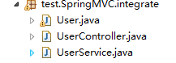

2.User实体类

|  |  |
| --- | --- |
| 1  2  3  4  5  6  7  8  9  10  11  12  13  14  15  16  17  18  19  20  21  22  23  24  25  26  27  28  29  30  31 | public class User {      public int getId() {          return id;      }      public void setId(int id) {          this.id = id;      }      public String getName() {          return name;      }      public void setName(String name) {          this.name = name;      }      public Date getBirth() {          return birth;      }      public void setBirth(Date birth) {          this.birth = birth;      }      @Override      public String toString() {          return "User [id=" + id + ", name=" + name + ", birth=" + birth + "]";      }      private int id;      @NotEmpty      private String name;        @Past      @DateTimeFormat(pattern="yyyy-MM-dd")      private Date birth;  } |

3.UserService类

|  |  |
| --- | --- |
| 1  2  3  4  5  6  7  8  9  10 | @Component  public class UserService {      public UserService(){          System.out.println("UserService Constructor...\n\n\n\n\n\n");      }        public void save(){          System.out.println("save");      }  } |

4.UserController

|  |  |
| --- | --- |
| 1  2  3  4  5  6  7  8  9  10  11  12  13 | @Controller  @RequestMapping("/integrate")  public class UserController {      @Autowired      private UserService userService;        @RequestMapping("/user")      public String saveUser(@RequestBody @ModelAttribute User u){          System.out.println(u);          userService.save();          return "hello";      }  } |

5.Spring配置文件

在src目录下创建SpringIOC的配置文件applicationContext.xml

|  |  |
| --- | --- |
| 1  2  3  4  5  6  7  8  9  10  11  12  13  14  15  16  17  18  19  20  21  22  23  24  25  26  27  28  29  30  31  32 | <?xml version="1.0" encoding="UTF-8"?>  <beans xmlns="http://www.springframework.org/schema/beans"      xmlns:xsi="http://www.w3.org/2001/XMLSchema-instance"      xsi:schemaLocation="http://www.springframework.org/schema/beans    http://www.springframework.org/schema/beans/spring-beans.xsd      http://www.springframework.org/schema/util      http://www.springframework.org/schema/util/spring-util-4.0.xsd      http://www.springframework.org/schema/context      http://www.springframework.org/schema/context/spring-context.xsd            "          xmlns:util="http://www.springframework.org/schema/util"          xmlns:p="http://www.springframework.org/schema/p"          xmlns:context="http://www.springframework.org/schema/context"          >      <context:component-scan base-package="test.SpringMVC.integrate">          <context:exclude-filter type="annotation"              expression="org.springframework.stereotype.Controller"/>          <context:exclude-filter type="annotation"              expression="org.springframework.web.bind.annotation.ControllerAdvice"/>      </context:component-scan>    </beans> |

在Web.xml中添加配置

|  |  |
| --- | --- |
| 1  2  3  4  5  6  7  8 | <!-- configure the springIOC -->    <listener>        <listener-class>org.springframework.web.context.ContextLoaderListener</listener-class>    </listener>    <context-param>      <param-name>contextConfigLocation</param-name>      <param-value>classpath:applicationContext.xml</param-value>    </context-param> |

6.在SpringMVC中进行一些配置，防止SpringMVC和SpringIOC对同一个对象的管理重合

|  |  |
| --- | --- |
| 1  2  3  4  5  6  7 | <!-- scan the package and the sub package -->      <context:component-scan base-package="test.SpringMVC.integrate">          <context:include-filter type="annotation"              expression="org.springframework.stereotype.Controller"/>          <context:include-filter type="annotation"              expression="org.springframework.web.bind.annotation.ControllerAdvice"/>      </context:component-scan> |

**十八、SpringMVC详细运行流程图**

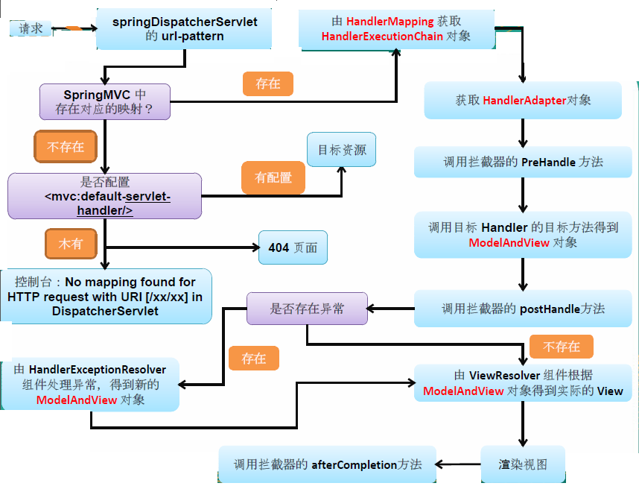

十九、SpringMVC与struts2的区别

1、springmvc基于方法开发的，struts2基于类开发的。springmvc将url和controller里的方法映射。映射成功后springmvc生成一个Handler对象，对象中只包括了一个method。方法执行结束，形参数据销毁。springmvc的controller开发类似web service开发。  
2、springmvc可以进行单例开发，并且建议使用单例开发，struts2通过类的成员变量接收参数，无法使用单例，只能使用多例。  
3、经过实际测试，struts2速度慢，在于使用struts标签，如果使用struts建议使用jstl。