Senior Seminar Group Project

Take a Hike!   
RAD Documentation

By Kyle Hartfield, Jordane Lawrence, Brady Winter, Wesley Olinger, Charlie Whelden

|  |
| --- |
| **1. Introduction**  **1.1 Purpose of this system** - This app will give a brief description of the trails in the area to allow new hikers to choose the most appropriate one. It will provide a distance and a difficulty rating of each trail so the user knows exactly what to expect. There will also be a safety feature that will alert the user’s contacts if a user does not indicate that they’re safe after the hike ought to have finished.  **1.2 Objectives and success criteria of the project** -This app will be used as an information and safety appliance. It will provide a brief description of hikable trials in the area. It will also log the start and finish time of a particular person's hike so others can see that they made it back safely. There will also be an alert system built into the app.  **Success Criteria**   * Must show the difficulty of the trail and location of a hike * Must be able to notify Users Contacts if things go wrong * Sends alert signal before a user goes out on a hike and again once the hiker returns. * Provides a brief description of the trails in the area along with a difficulty rating |
|  |

|  |  |
| --- | --- |
|  |  |
|  | |
| **2.1** **Overview**  The user will be able to choose the trail of where they are hiking. When they do so, the app will send a message to the contact provided alerting them when the hiker started. When the user is done with the hike they will have the ability to “cancel” the hike which will alert the same contact that they have made it back safely. A database will be used to store details about the trail such as length, difficulty, and a brief description. This information will be displayed to the user so they have a better idea of what to expect. |  |
|  | |
| **2.2 Functional requirements**   * Select a hike * End a hike upon completion * Look at hike trail details * Send alerts before and after a hike |  |
|  | |
| **2.3 Non-functional requirements**   * Display start and end time of hike * Store hike information in database * Keep track of hike duration |  |
|  | |
| **3.1 Use Cases**  **Name:** Starting a hike  **Description:** When a user wants to go for a hike they can select which trail they wish to hike, start time, est. finish time, and location.  **Actors**: End User  **Flow**: The user decides to hike a trail. They can select the trail they wish to hike. The user can also list the start time of the hike and what time they believe to be finished.  **Name:** Sending a message to a contact  **Description:** Once the user has decided on a trail they can begin a hike. By doing this the app will notify a contact of the location, est. return time, and when they left. Once the hiker has returned they can cancel the hike they were just on which send another message to the contact which alerts them the hiker has returned safely.  **Actors**: User’s contacts.  **Flow:** The user can begin their hike by selecting the hike and time they anticipate on finishing. Upon completion of the hike they may cancel it to alert their contact of their safety.  **Name**: Selecting a trail to hike  **Description:** The app will provide a list of trails in the area and rate them based on difficulty. This will allow hikers who are not familiar with the area choose the best trail for their skill level.  **Actors**: End User  **Flow:** Before beginning a hike the user must select a trail. The app will provide a list of trails which the user can pick from. It will also provide a rating of each trail so a hiker know the difficulty of the trail before getting started.  **Name**: Ending a Hike  **Description**: Once the hiker has completed the trail they may end the hike to show everyone they have gotten back safely.  **Actors:** End User  **Flow**: Upon completion of a hike the user may select to end the hike. This will show that hiker made it through the hike safely.  **3.5 Use case model**  Jakes.png |  |

**User Interface Model**

**Home Page**

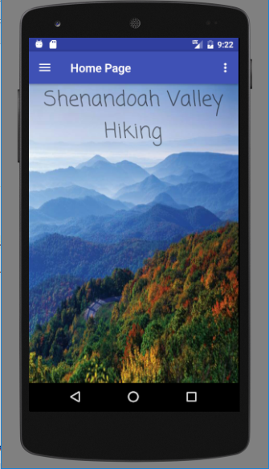

**Navigation Page**

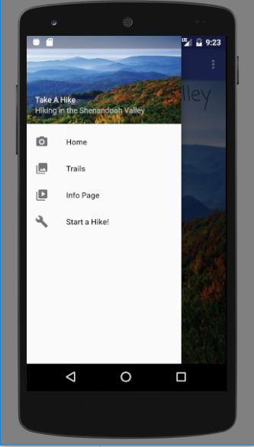

**Trail Page**

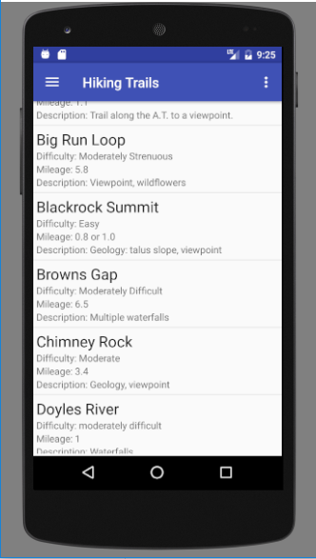

**Info Page**

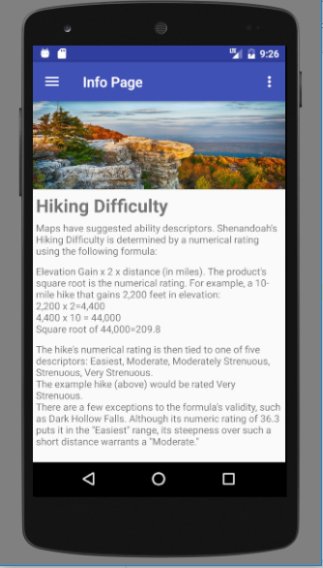

**Start A Hike**

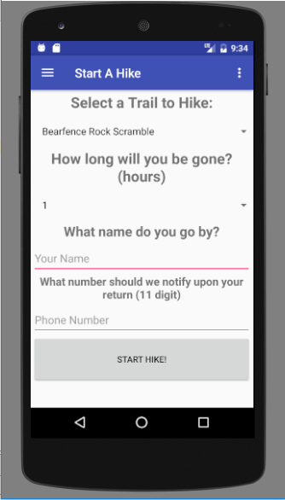

**Hike Started Page**

