Take-a-hike  
User Documentation  
By Charlie Whelden, Wesley Olinger, Jordaine Lawrence, Brady Winter, Kyle Hartfield

Congratulations! By downloading this app, you’ve taken your first step toward becoming a master-hiker in the Shenandoah valley. This user guide will tell you all about the app, it’s features, and what you can do with it. It’s written in Q & A format for quick reference, but can be read just like a standard user guide.   
  
  
  
  
**Q: Help! I can’t install your app.  
A:** The app only works with certain versions of Android. If you have a later version than 23, you can’t use the app.

(As a rule of thumb: it is preferable to install the penultimate build in a line of software.)

**Q: What is take-a-hike?**   
**A**: Take-A-Hike is an app for hikers that offers both safety and information. It rates trails based on difficulty so that you don’t attempt a hike that’s difficult, and so that you’re not wasting your time with a hike that’s too easy. It also notifies your friends when you’ve left, where you’ll be going, and when you should be back so that if anything goes awry, they can send for help.

**Q: How do I navigate your app?   
A:** 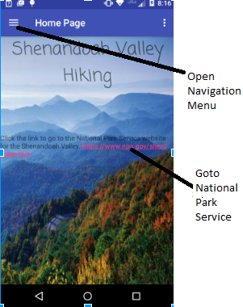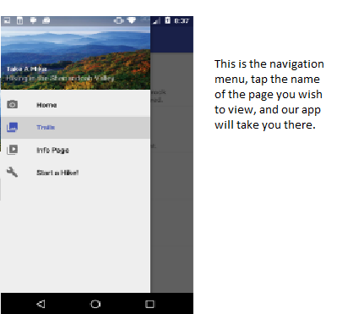

**Q: How do I see info about the trails?**  
**A**: In the top left hand corner of the app is a menu with lines on it. Tap it. Then tap the “trails,” option. Refer to the 2nd page for “how do I navigate this app.”

**Q: How do I start a hike?**  
**A:** In the top left hand corner of the app is a menu with lines on it. Tap it. Then tap the “start a hike” option.   
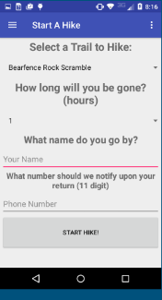

**Q: Why won’t your app let me start a hike?**  
**A:** You have to enter the required info before you start a hike. Enter the name your friends know you by and then their number.

**Q: Why do I need 11 digits?   
A:** Our SMS-API is based out Poland. You need a country code for the international call. Dial 1 first for the United States.

**Q:** **I pressed “Start a hike,” now I can’t do anything! Help!**   
**A:** Hit “end hike.” So the app will notify your friend you made it back safely from your hike and then you can navigate the app normally.   
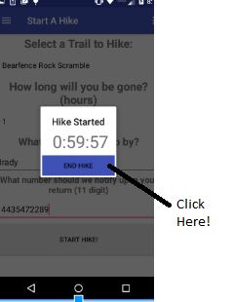

**Q: What if I don’t want your app to text my friends, can I just look at trails?  
A:** Yep. Just select the “trails,” page instead of “start-a-hike.”

**Q: My friend is a private person, is their number safe with you?  
A:** We have no idea. Our app uses SMS-API -- a text message service based out of poland. You’d have to ask them what they do with your friend’s info. We unchecked the little box on our user account that says, “allow your numbers to be used for marketing purposes.” But we don’t know if this means anything or if they’ll honor our wishes.

**Q:** **Can I start a hike without giving you a number?**   
**A:** No.   
  
**Q: Can I start a hike without giving you a name?**  
**A**: No.   
  
**Q: Can I customize the message I send to my friends?  
A:** No. The message will tell them you’re going on a hike. That’s the purpose of this feature. There are other apps that let you send custom SMSes.

**Q: Why can’t your app do (whatever?)   
A:** Email [wso003@eagles.bridgewater.edu](mailto:wso003@eagles.bridgewater.edu) to suggest a feature.   
  
**Q: How do you determine the difficulty ratings?   
A:** They are provided by the national park service. You can see them at this webpage: [https://www.nps.gov/shen/planyourvisit/how-to-determine-hiking-difficulty.hm](https://www.nps.gov/shen/planyourvisit/how-to-determine-hiking-difficulty.htm).