FE 513 Case Study

“About CDS Skew Notes”

Yongduk Kim

Question 1.

1. **What CDX skew?**

* The structured notes which repackage “the difference” between the spread of a CDS index and its constituent single-name CDS contracts. The difference is called the Skew.
* CDX buyer takes on the credit exposure to the loans or bonds, and exposed to defaults. It means buying index is equivalent to selling protection so that buying position receive a fixed coupon.

1. **How exactly is it calculated?**

* The (Negative or Positive) Skew = Composite Spread - Model Spread
* For example,
  + Composite Spread= a CDS index “commodity” listed on ICE named as MARKIT CDX.NA.IG.(“IG”)
  + Model Spread = 125 of the most liquid North American entities with investment grade credit ratings. (21st Century Fox America, Inc. AT&T Inc., CBS Corporation, HP Inc.)
  + The term “*Spread*” is price quotation and indicates basis point.
  + AND, the model spread is a result of converted price to quotation unit “spread”.
* There are two ways to calculate the theoretical value of an index based on the underlying instruments
* Simple valuation
  + Model Value(Intrinsic value)

= 100 – $\sum_{n=1}^{125}{\left(\left(CDS spread_{n}-CDS index fixed coupon\right)*Risky Duration\right)}$

* The more accurate and complex way is to use the hazard rate model for each underlying components of the index.

1. **What arbitrage trade is available to market participants in mid 2016?**

* In the middle of 2016, there was negative skew. It means the composite spread is smaller than the model spread. Namely, **Short the model spread(125 single-name CDS) and Long the composite spread(index)** because it might generate the positive yields(model spread – composite spread >0). So, the point is to issue a structured note which gives a fixed coupon.
  + *Can we see this trading as an arbitrage trading ? without risks?*

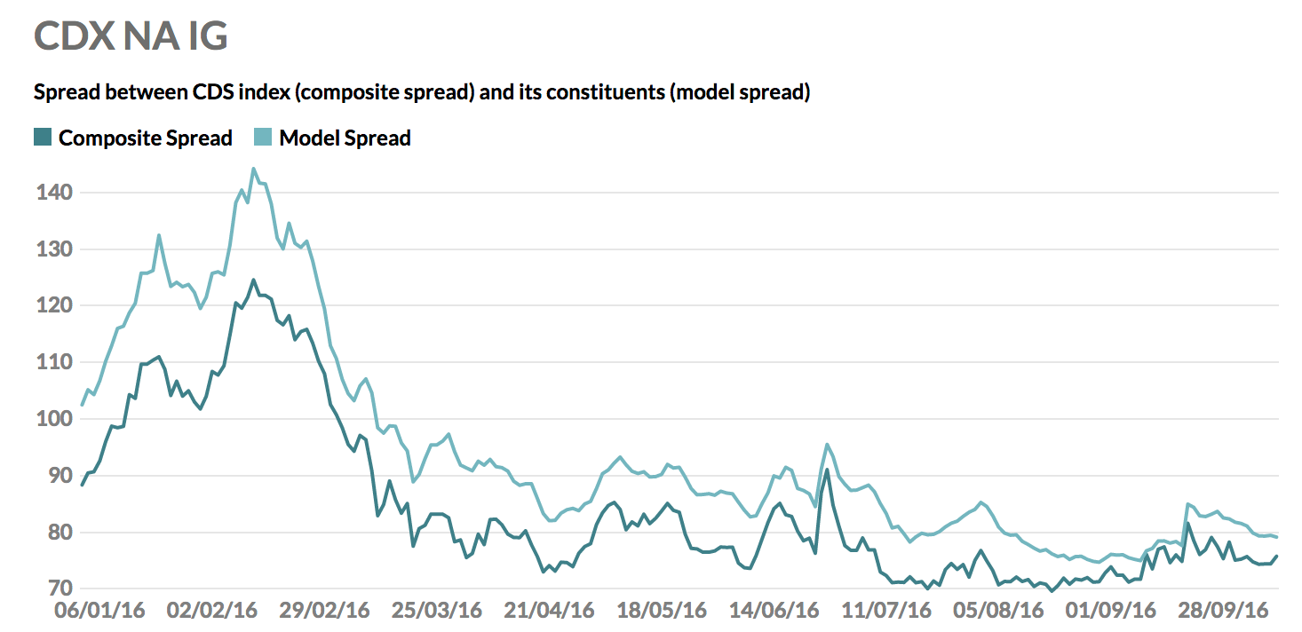

1. **who is taking the other side of this trade?**

* Consumers who seek regular cash flows(coupons) and the principal at the maturity. It acts like coupon bonds. According to the Risk.net, most of clients were insurance companies in European countries not only for positive yields, but also capital requirement, especially Solvency II. Furthermore, in the middle of 2016, European government bonds yields were negative!.

< Apr/01/2016, Euro Area Yield Curve[1]>

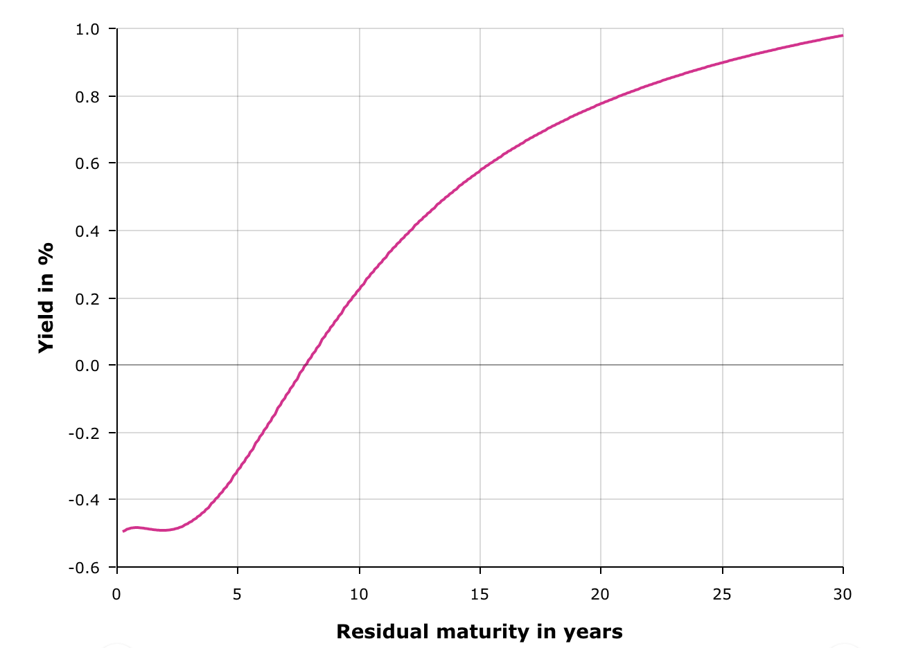

* To be specific, when constructing Skew notes, the issuer has both long and short position on CDS index and its constitutes. As a result, this product is only exposed to issuer CREDIT risk.(Solvency regulation 참고)
* As we can see below, the value of financial assets should be adjusted depending on their risk profile. However, the bond intended to hold-to-maturity have some incentives to mitigate its discount rate applied in the valuation of predictable liabilities.(Matching adjustment)
  + Matching adjustment[2]: a matching adjustment will adjust the discount rate applied in the valuation of predictable liabilities which are cash-flow matched using fixed income assets. The predictability of the portfolio means that matching assets can be *held to maturity* and that the insurer is consequently *not exposed to price movements,* only to the risk of default. The matching adjustment is symmetrical – it can be positive in times of high risk aversion in the markets and negative in times of low risk aversion.

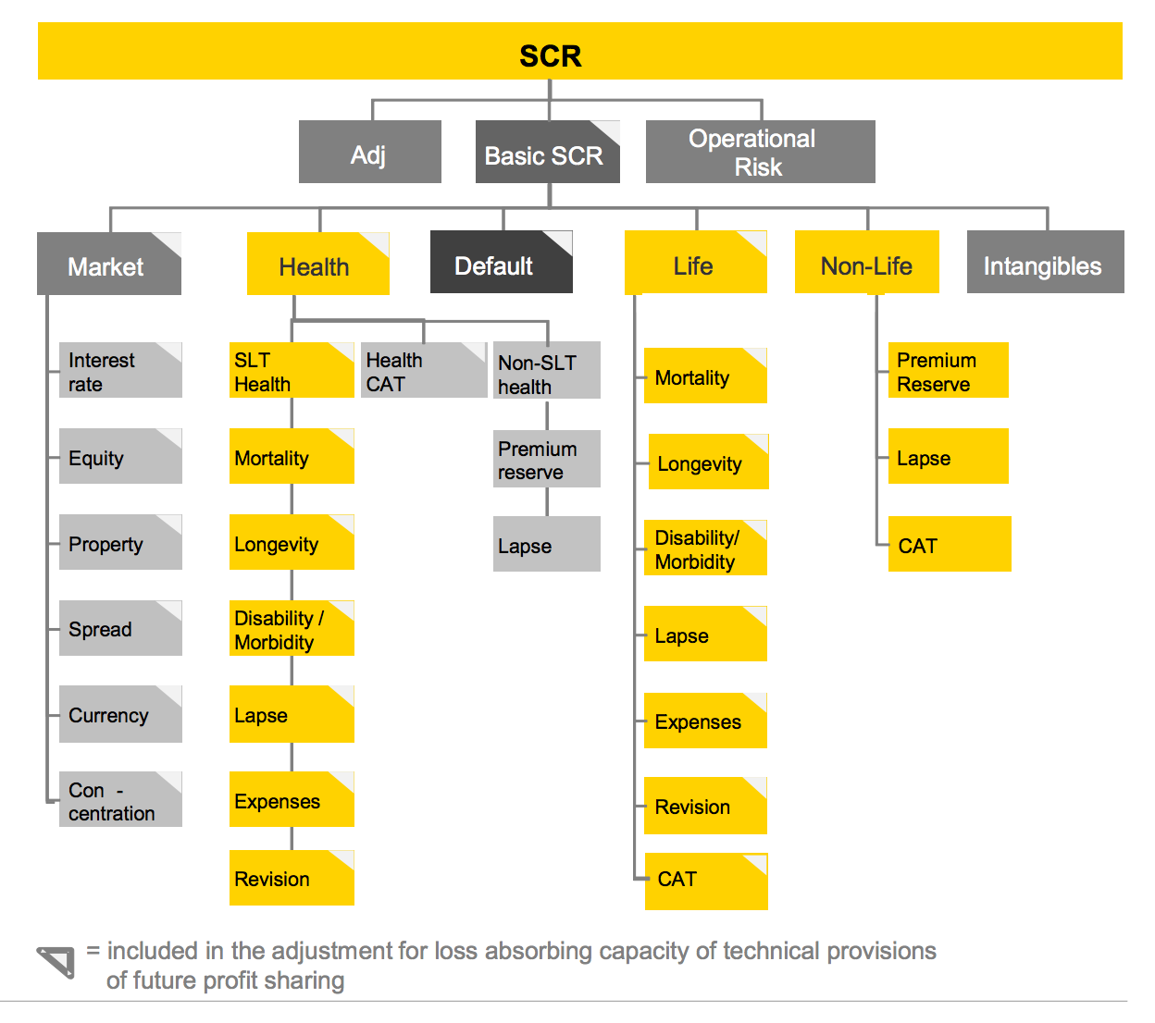

< CDS Skew Notes Diagram >

IRS

Initial Exchange Amount = Purchase price of Lloyd Bank’s Notes – CDX Skew NotesX

BUY Lloyd Bank’ Notes

SELL Skew note

Libor + 2.00% per annum

(quarterly)

Skew investor

BUY Skew note

Aggregate Interest Amount payable by Libretto Capital

(quarterly, Libor + 2.00% per annum)

)

Citibank London

(A)

Libretto Capital

(B)

USD 10,000,000

Aggregate Interest Amount receivable by Libretto Capital

(quarterly, 2.70% per annum)

Market

*BUY* CHEAP

CDX.NA.HY24

(Index)

Protection Seller

*SELL* HIGH

Reference Entity CDS

(Single Name)

Protection Seller

CDX.NA.HY24 Index Swap

Original Notional Amount: USE 150,000,000(15x)

Model Spread

(Intrinsic Price)

Composite Spread

(Market Price)

**CDX.NA.HY24 Spread = Composite Spread**

**CDS Skew**

5.00% per annum

(quarterly)

Multiple Single Name Swap

**Reference Entity Weighting * Original Nominal Amount**

**= Model Spread**

5.00% per annum

(quarterly)

SELL Lloyd Bank’s Notes

2.70%

per annum

(semi-annual)

USD 10,000,000

Lloyd Bank

: Swap Contracts

: Cash Flows

: Entities

: Transactions

Question 2.

1. **Suppose you work for a bank and want to take advantage of the opportunity to issue a skew bond. Assume the “skew” is -15 bp when the transaction is initiated. Design a transaction that can pay investors LIBOR + 200 bp with certainty.**

* As the above diagram, from Libretto Capital perspective,
  + Step 1. Sell Skew Notes paying LIBOR+200bp with nominal principal X.
  + Step 2. Buy X value of Fixed Notes with fixed rate y%.
  + Step 3. Make a Payer Fixed IRS(payer swap) with y% form Step 2 notes and Receive Floating(LIBOR + 2.00%)
  + Step 4. Make an Index Swap contract with fixed rates(5.00%) for CDX.NA.HY24 spread.
  + Step 5. Make a Multiple Single Name swap with the model spread for fixed rate(5.00%)
  + Step 6. Buy CDX.NA.HY24 index and Sell each reference entities single name CDS in the market.
* The Libretto Capital(or Citibank London) can earn positive skew, 15 bp.
* AND, at mid of 2016, LIBOR was at low level(about 0.4%) so that this transaction also generate positive swap value in Step 2 for Citibank London. ( I regard Libretto Capital and Citibank London are a same entity because whole earnings flowed to Citibank London.)

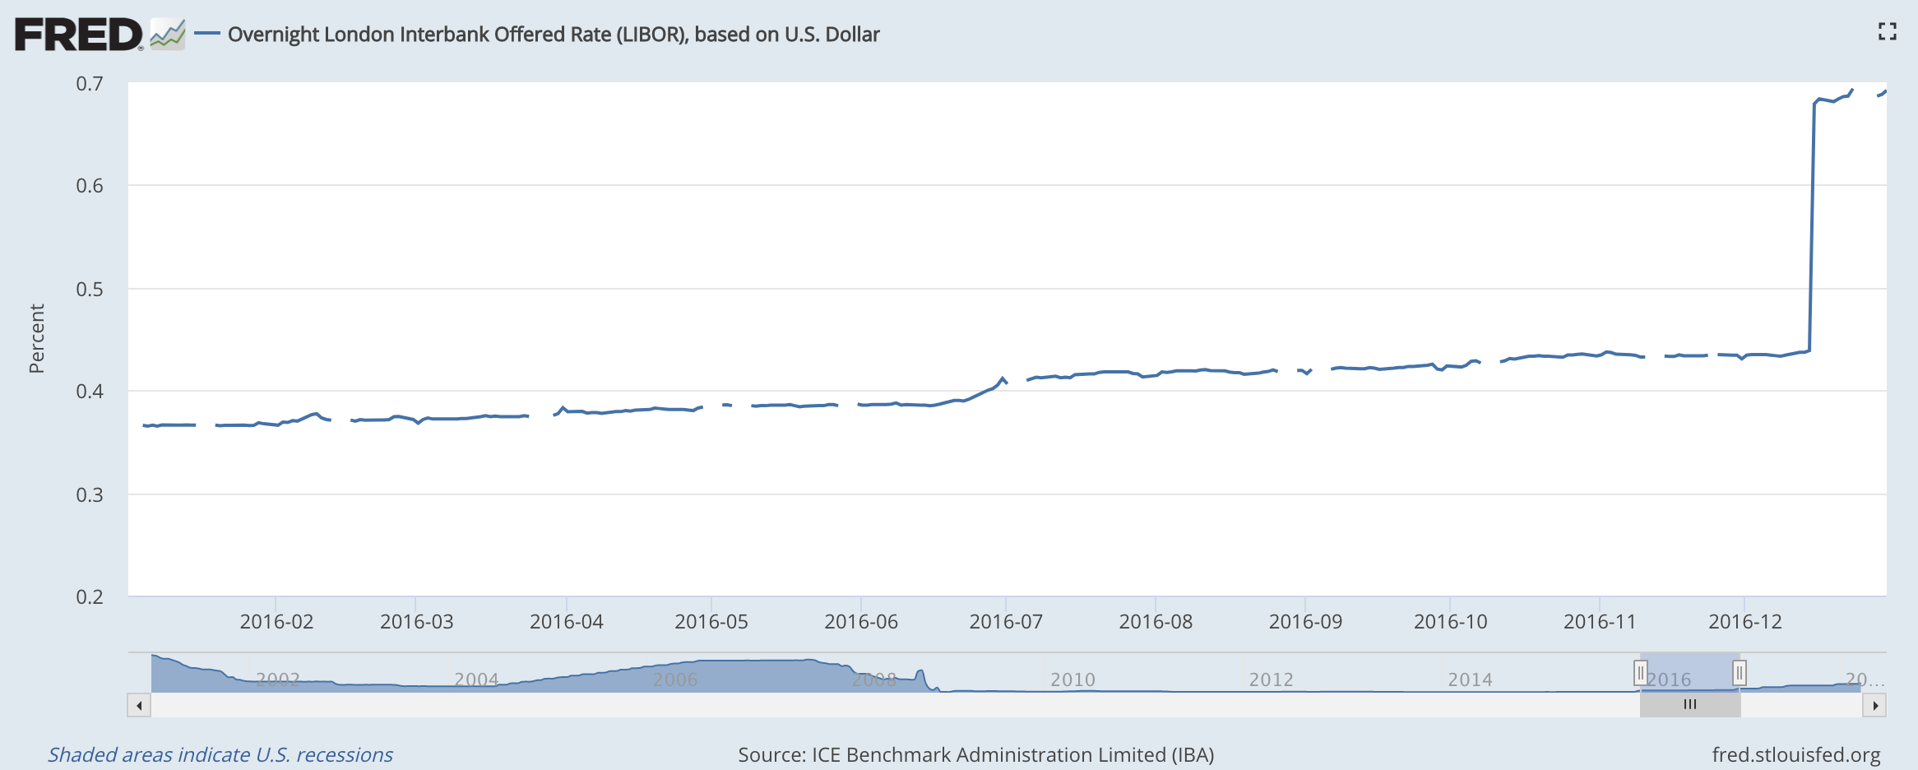

1. **Explain the terms of the deal and what trades your bank needs to undertake to set up the note and to *guarantee that investor’s principal is protected*.**

* To protect and guarantee investor’s principal, their principal should be invested to the riskless asset. In the above case, investor’s money was used to buy Lloyd’s notes, which had stable grades. To enforce investor’s principal to be protected, it is also available to buy Lloyd’s single name CDS.
* Long-term unsecured senior debt ratings of “A1” by Moody's, “A” by S&P and “A+” by Fitch.

1. **Show a diagram of where all the cash-flows go in your structure.**

* Shown above.

Question 3.

1. **Explain what happens in your transaction if, after the deal is sold, the skew gets more negative.**

* If the skew gets more negative, the capital gain from CDS arbitrage transaction will change by two possible paths
* Frist, $ΔModel spread>ΔComposite spread>0$
  + Model Spread(Short position) increase more than Composite spread(Long position)
  + Positive cash flow
* Second, 0 > $ΔModel spread>ΔComposite spread$
  + Composite Spread(Long position) decrease more than Model spread(Short position)
  + NEGATIVE CASHFLOW.

1. **Assume that positions in index CDS contracts are *marked to market* but that single-name CDS contracts are not. Does any party (either your bank or your investors) have to pay in additional cash?**

* Increasing skew means the Composite spread and the Model spread diverge. Therefore, Long-Short strategy, which CDS skew arbitrage is doing, may generate negative returns. However, if CDS index position is supposed to be marking-to-market, it is same meaning that only Long position value changes depending on CDS index market price. My bank should pay additional cash because the differential Long position value is not offset by Short position. If short position and long position move with a same direction, my Short position may also generate similar value changes, but, different sign, which is available to offset gain or loss from daily Long position marked-to-marking.
* BUT, if Short position do transactions similar to marked-to-marking, they can generate cash flows.

1. **If so, how does this affect the risk/reward characteristics of the transaction?**

* Obviously, marked-to-marking feature has considerable impacts on risk/reward characteristics of the transaction.
* It increases the CDS skew notes issuer’s credit risk because the issuer must be ready to fulfill margin. Cash flows are not matched between Long and Short position.
* If the demand to sell CDS index expand dramatically, Long position value decrease rapidly. In this case, CDS skew notes issuer should have sufficient funds to hold its long position. On the other hand, Short position does not execute marked-to-market so that no cash flow is expected from Short position.(Actually, Markit’s CDX series are classified as commodity and traded on OTC market)
* Therefore, the demand for CDS skew notes might decrease since its Long-Short position, which helps European insurance companies to sidestep Solvency II’s capital regulation, encourages the brisk demands in 2016.

Question 4.

1. **Explain what financial engineering problem skew bonds solve**

* The CDS skew notes helped European insurance company to meet Solvency II’s capital requirement, even though some banks were confused for interpreting IFRS 9's section on embedded derivatives.
* Except the accounting aspect, this product acted as a solution to overcome the negative yield circumstance in European countries. It generates positive yields that is big enough to be enticed.
* Volcker rule (regulation arbitrage)
* Tax arbitrage
* A very recent and similar example is *CoCos*! Contingent Convertible bonds (CoCos) are debt instruments that must transform into shares of equity or are written off upon a triggering event. CoCo triggers are designed so that conversion occurs when the bank is in crisis, as determined either by regulatory assessment or objective bank losses. For the issuer, CoCos serve two functions: 1) they enable the issuer to raise leveraged capital in a tax efficient manner while 2) qualifying for Tier 1 or Tier 2 capital treatment.

1. **Do you think their function is beneficial to financial markets overall?**

* These transactions to earn arbitrage profits make the market more efficient. Therefore, CDS index and single name CDS can reach to the fair (market) value. They act like market makers.
* The risk is if they should sell before the maturity? credit risk? default risk? How to solve it? 무시할 만큼 작은 수준인가? 만약 snowball swap처럼 발생사에 상당한 손실에 처한다면? 평균 자산들의 레버리지 비율과 특정 마켓에서 큰 손실이 날 가능성은? 계산할 방법은? Composite 구성할 수 있는 방법으로 PCA 등을 설명하는 건 어떤가? 인덱스 구성하는 것이니 복제 비용을 줄일 수 있겠다.

1. AAA-rated euro area central government bonds and all euro area central government bonds, ECB
2. <http://europa.eu/rapid/press-release_MEMO-15-3120_fr.htm#_ftn4>