**Problem Set 2**

Wanbae Park

**Digital Options**

1. The value of digital put option at t = 0 should be equal to , where if there is no arbitrage opportunities. (: continuously compounded dividend yield) Since digital put options pays if and otherwise pays nothing, the value of option should be equal to , where denotes risk-neutral probability. Because we already know that is equal to risk neutral probability such that is greater than or equal to strike price, is calculated as follows.

Therefore, the value of digital put option should be equal to .

1. Consider the following investment strategies.
2. Short a digital call option which pays dollars with strike price and maturity .
3. Invest on a riskless zero coupon bond with face value and maturity .

Then, at the maturity, the payoff structure of the portfolio above is as the following table.

|  |  |  |
| --- | --- | --- |
|  |  |  |
| Digital Call Option |  | 0 |
| Zero Coupon Bond |  |  |
| Total | 0 |  |

Since the payoff structure is identical to digital put option, the portfolio completely replicate payoff of digital put option.

1. The payoff of Dual Directional Trigger jump securities can be replicated by constructing the following portfolio.
2. Short 1/15 amount of put option with strike price 120.
3. Long a digital call option with strike price 120 with cash amount 4.
4. Long 1/15 amount of put option with strike price 150.
5. Short another 1/15 amount of put option with strike price 120.
6. Long a digital call option with strike price 150 with cash amount 3.75.
7. Invest on a zero coupon bond with face value 6.

All securities have the same maturity, May 30, 2020. If the portfolio is constructed by above, payoff structure of Dual Directional Trigger Jump securities can be exactly replicated. The following figure is payoff profile of replicating portfolio.

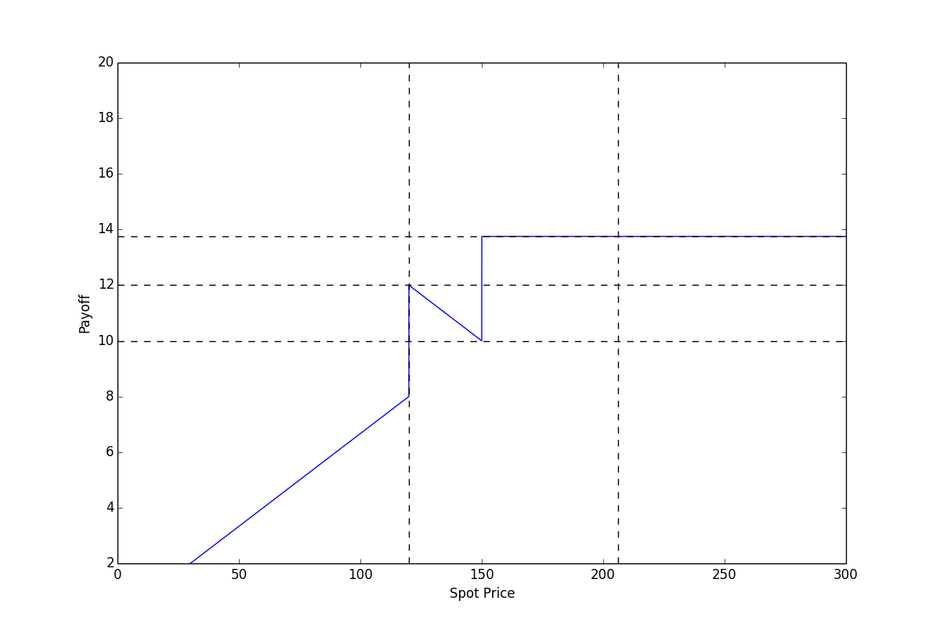

As shown above, it completely replicates payoff structure of the securities issued by J.P Morgan. Therefore, if there is no arbitrage opportunities in market, price of the securities should be equal to cost for constructing replicating portfolio.

**PRICE!!!!!**

1. It is reasonable to give information about price of digital put option with strike level 120. The note gives payoff less than the face value only if the underlying index at the maturity is less than 120. Therefore, since digital put option price with unit payoff represents probability of the state that underlying index level is less than strike level(times discount factor), it is reasonable to give information about price of digital put option whose strike is 120.

**Link between binomial model and Black-Scholes PDE**

Let , where . Using Taylor expansion to and at , we can obtain the following approximated value.

By binomial model, the value of derivative is equal to , where . Since and can be approximated as , the risk-neutral probability can be represented as . Combining the results, we can derive the equation follows.

By subtracting and dividing by to both sides and rearranging, we can obtain the desired result below.