**A1-2 Report**

Baorong Wei, 301401797

**Image reconstruction:**

Large.jpg



Least Square Error: 0.016263751325344137

Large1.jpg



Least Square Error: 0.03173398137360804

Target.jpg



Least Square Error: 0.08066741308843695

Target1.jpg



Least Square Error: 0.008017128033765924

**Poisson Blending:**

Source1



Total Least Squares Error: 1.686494009875726e-11

Source2

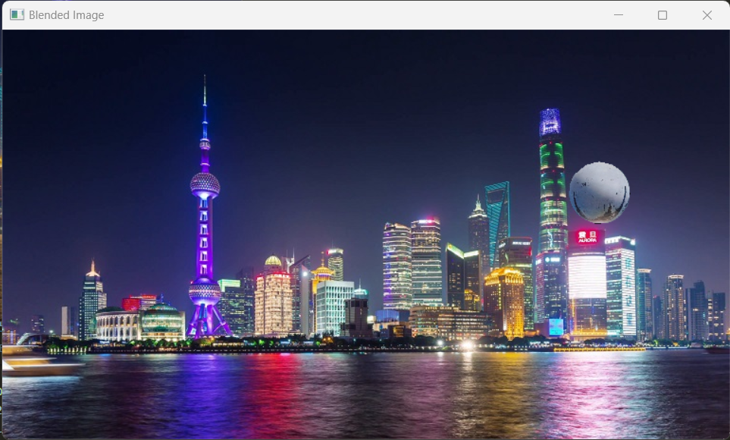

Total Least Squares Error: 1.457064187326508e-11