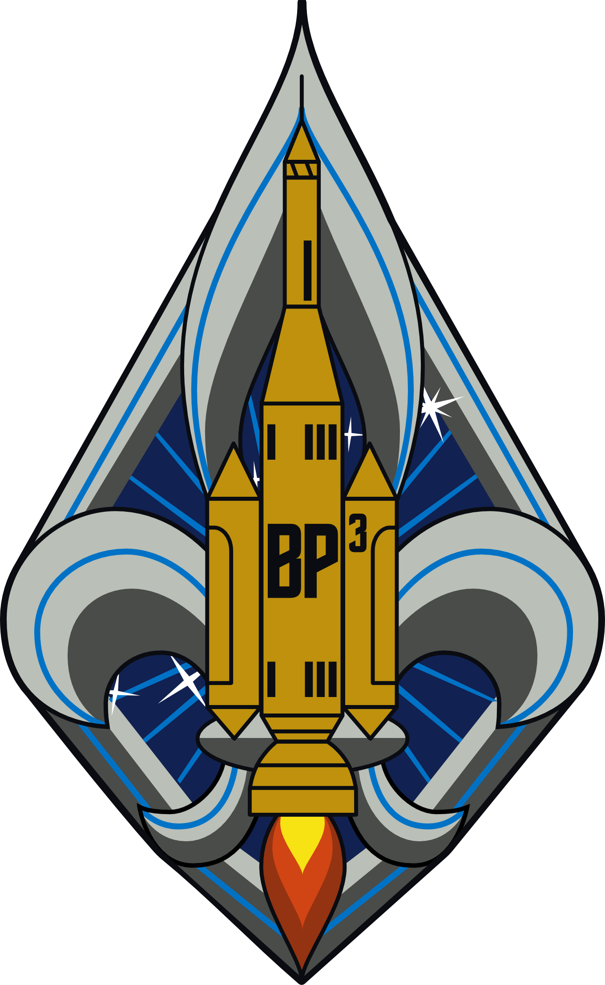

SPACE SCOUT MANUAL

Contents:

- Welcome To Space Scouting

- Ideals
- Ships, Crews, Watches
- Outer Space
- Advancement
- Starfleet Association
- Personal Growth
- Leadership Development
- Uniform

i. Welcome To Space Scouting

Congratulations! You are embarking on a life-long adventure which will, if properly executed, lead you into outer space as a representative of the human race. This journey is very exciting, but it will not be easy, so Be Prepared for many challenges, which you can overcome if you use teamwork and ingenuity. Apply yourself, and you WILL achieve a career as a Space Explorer.

This manual will serve as your primary written guide to the Space Scouting program, study it well. Memorize as much as you can, and check the bottom of the page to ensure you have the latest copy.

1. Ideals

Space Scout Motto: Baden-Powell says Be Prepared and Boldly Proceed (BP³)

Space Scout Mission: To train youth as Space Explorers and help humanity reach the stars.

Space Scout Oath:  As a Space Scout, I promise to do my best  To guard against space accidents;  To know the location and proper use of the  lifesaving devices on every vessel I board;  To be prepared to render aid to those in need; and  To boldly proceed as none have done before. | Scout Oath:  On my honor, I will do my best  To do my duty to God and my country,  and to obey the Scout Law;  To help other people at all times;  To keep myself physically strong,  mentally awake, and morally straight.

Scout Law: A Scout is Trustworthy, Loyal, Helpful, Friendly, Courteous, Kind,
Obedient, Cheerful, Thrifty, Brave, Clean, and Reverent.

BSA Mission Statement:  The mission of the Boy Scouts of America is  To prepare young people to make  ethical and moral choices over their lifetimes  By instilling in them the values of the Scout Oath and Law. | BSA Vision Statement:  The Boy Scouts of America will  Prepare every eligible youth in America  To become a responsible,  participating citizen and leader  Who is guided by the Scout Oath and Law.

2. Ships, Crews, Watches

As a Space Scout, you are a registered member of an Explorer Post unit through the Learning For Life company, a subsidiary of the Boy Scouts of America. Space Scouting styles our Explorer Post unit as a Space Scout Ship (SSS). The name of the Space Scout flagship unit is Explorer Post 1701, also known as SSS 1701 Enterprise. All founding Space Scouts are members of SSS Enterprise.

The Space Scout unit is a group of youth and adults who work together toward common goals related to space exploration. One of the primary goals of each unit is to acquire, utilize, and maintain a space flight vessel, also known as a space ship. The space vessel owned by a Space Scout unit is a Space Scout Ship Vessel (SSSV), so when SSS Enterprise acquires it's own space vessel, that space ship will be labeled the SSSV Enterprise.

In addition to the primary space vessel, a Space Scout unit may own additional vessels or sub-vessels such as shuttle craft. While in operation, each vessel is controlled by a group of people known as the crew. If a Space Scout Ship unit operates 1 or 0 vessels, then there is exactly 1 crew in the unit. If a Space Scout unit operates 2 or more vessels simultaneously, then there are 2 or more crews in the unit. A crew is a sub-group of a Space Scout Ship unit.

In a crew operating a space vessel overnight, there are a minimum of 2 watches, which are a group of people responsible for actively attending to the vessels needs. One watch works the vessel, while the remaining watches eat and rest. A watch is a sub-group of a crew.

Divisions

Space Scouting is organized into 8 divisions, signified by colored shoulder tabs (loops) on the Space Scout uniform:

- Operations: Red
- Security: Red
- Engineering: Green
- Science: Blue
- Medical: Blue
- Helm: Silver
- Communications: Silver
- Command: Silver, Gold, White

All Space Scouts start in the operations (ops) division, and may optionally choose to specialize in one of the other divisions upon attaining the rank of Cadet. Command division is open to youth having attained the rank of Astronaut.

The youth officers in a Space Scout unit are known as the Quarterdeck, and include the Bosun (also spelled Boatswain), Bosun's Mate of Admin, Bosun's Mate of Program, Yeoman, Purser, Storekeeper, and Crew Leader. The Bosun may assign additional youth officers as Quarterdeck members.

The direct-contact adult officers in a Space Scout unit are known as the Wardroom, and include the Skipper, First Mate, Skipper's Mates, Secretary, and Treasurer.

Chartered Organization

As with all Scouting units, the Space Explorer Post is a cooperative undertaking between Learning For Life (the charter provider) and a chartered organization, which in this case is a corporation named Auto-Parallel Technologies, Inc. (APTech for short). The Skipper and First Mate Johnson are the founders of APTech, which specializes in software, supercomputing, and astrophysics.

3. Outer Space

Vocabulary: Please write in the definitions for each word below
- Planet
- Moon
- Star
- Star System
- Oort Cloud
- Galaxy
- Universe
- Multiverse
- Nova
- Supernova
- Hypernova
- Quasar
- Pulsar
- Black Hole
- Big Bang
- Cosmology
- Red Shift
- Physics
- Matter
- Energy
- Atom
- Nucleus
- Proton
- Neutron
- Electron
- Quark
- Photon
- Boson
- Higgs Boson
- Particle Accelerator
- Quantum Mechanics
- Electromagnetism
- Weak Nuclear Force
- Strong Nuclear Force
- Gravity
- Artificial Gravity
- Artificial Intelligence
- Speed Of Light
- Warp Drive
- Impulse Drive
- Subspace Communications

Careers
- Astrophysics
- Aeronautics
- STEM

4. Advancement

There are 9 full Space Scout ranks, as well as the easy-to-attain Recruit rank for very new members.

5. Starfleet Association

Starfleet is the sister organization of Space Scouts. Youth are offer advancement through Space Scouting, and likewise adults are offered advancement through Starfleet. The Skipper of your Space Scout Ship should be a member, in good standing, of Starfleet. In 1964, Gene Rodenberry created Starfleet, which has been popularized through television and film since.

Space Scouts and Starfleet share the same vision and goals of peaceful space exploration for the benefit of all humanity. Space Scouts and Starfleet may sometimes share personnel or facilities, however they are 2 distinctly separate organizations. All members of Starfleet must be at least 21 years of age before joining. Space Scouts admits youth members 14 - 20 years old, as well as adults age 21 and older.

The United Federation of Planets (UFP) is open to all species and civilizations wishing to share in benevolent science and the peaceful exploration of outer space. Starfleet is the humanitarian and diplomatic space-faring component of UFP.


Symbols

Starfleet is represented by an upward-pointing asymmetrical arrowhead, inset with a tall 5-pointed star, optionally overlaid on an circle. The arrowhead is a symbol of the individual, the upward-reaching star stands for the internal drive toward excellence, and the circle or oval represents the unity of all Starfleet members. A number of different colors and styles are used, depending on the situation. The Starfleet crest is proudly worn by all Starfleet personnel, and displayed on all Starfleet vessels or property.


UFP is represented by a star map of the Sun, Proxima Centauri, and Alpha Centauri (a binary star system), inscribed in a mechanized gear, itself within a wreath consisting of crossed conventionalized branches of the olive tree. The olive branches are a symbol for peace, the gear stands for the science and engineering of space travel, and the star map represents all the species and planets of the universe. White and blue are the official colors of the United Federation of Planets.

Starfleet and Space Scouts alike proudly fly the UFP flag alongside their own planetary flags.

6. Personal Growth

- Community Service
- Education
- Pray
- Meditate
- Duty to God

7. Leadership Development

12 Leadership Qualities

8. Uniform

Insignia Guide

Space Scouting is represented by a rocket-powered space vessel labeled with BP³ surrounded by fleur-de-lis trails of smoke and Ursa Minor, overlaid upon a diamond field of rays.

CWU-73/P Guide

*To Be Added*

APPENDIX A. LEGAL DISCLAIMER

"Starfleet", "United Federation of Planets", the Starfleet arrowhead logo, the United Federation of Planets star field logo, and the Final Frontier font may be the property of Paramount Studios or the Rodenberry estate.

