Supplementary Table 1: Percent total watershed resistome by drug class.
Drug Class | Watershed | Blue River | Indian Creek | Indian Creek North | Tomahawk Creek
Aminoglycoside | 12.74 | 10.01 | 27.46 | 1.83 | 0
Beta-lactam | 19.91 | 20.16 | 14.37 | 42.91 | 2.13
Diaminopyrimidine | 0.322 | 0.31 | 0.17 | 5.14 | 0
Fluoroquinolone | 0.3996 | 0.2 | 1.24 | 0 | 0
Glycopeptide | 0.04839 | 0 | 0 | 0 | 0
Lincosamide | 3.381 | 3.89 | 1.18 | 0 | 0
LSa | 0.3854 | 0.55 | 0 | 0 | 0
Macrolide | 20.81 | 24.66 | 16.1 | 0 | 0
MLS | 2.752 | 3.44 | 1.72 | 0 | 0
MSb | 6.434 | 7.26 | 6.63 | 0 | 0
Multidrug | 1.12 | 0.13 | 0.92 | 43.86 | 0
Phenicol | 0.2465 | 0.35 | 0 | 0 | 0
Polypeptide | 0.07465 | 0.11 | 0 | 0 | 0
Rifamycin | 0.003097 | 0 | 0 | 0.23 | 0
Sulfone-Sulfonamide | 16.92 | 15.91 | 20.25 | 6.02 | 97.87
Tetracycline | 14.46 | 13.01 | 9.97 | 0 | 0

Supplementary Table 2: ARG-bearing contigs matching known mobile genetic elements.
Contig ID | MGE Type | MGE Components | ARG genes | Complete
gc_10 | ICE | None | tetQ | N
gc_12 | In | IntI, istAB | sul1, qacEG | Y
gc_15 | Plasmid | None | blaA | N
gc_22 | Tn916 | IntTn, xisTn | tetM | Y
gc_26 | Plasmid | IS66, res | tet, mph, msr | Y
gc_33 | ISCR | IS91 | sul2 | Y
gc_35 | Plasmid | Int, relaxase, trfA, mobC | qacL, blaOXA | Y
gc_52 | Plasmid | TnpA tnpR | blaA | Y
gc_58 | Plasmid | tnpR | blaA | Y
gc_59 | Plasmid | IS66 | sul1, qacE, aadA | N
gc_61 | ICE | None | tetM | N
gc_80 | ICE | None | tetM | N
gc_91 | Plasmid | None | blaTEM, bla2 | N
gc_92 | Plasmid | None | sul2 | N
gc_102 | Plasmid | None | blaTEM | N
gc_107 | ICE | None | ermB | N
gc_113 | Plasmid | None | aadA, blaOXA | N
gc_120 | Plasmid | SI91, res, intTn | sul2 | Y
gc_133 | Plasmid | None | aph3 | N
gc_162 | Plasmid | None | tetRC | N
gc_172 | Plasmid | None | aph3, aph6 | N
gc_181 | Plasmid | None | tetA | N
gc_184 | ICE | None | erm23 | N
gc_188 | Plasmid | None | tetG | N
gc_203 | Plasmid | None | tetR, aph6 | N
gc_216 | Plasmid | None | tetX | N
gc_235 | Plasmid | None | mph, mef | N
gc_242 | Plasmid | None | qnrS | N
gc_257 | Plasmid | None | lnuC | N
qc_156 | ISCR | IS91 | ermF | Y

Supplementary Table 3: Summary of the antibiotic susceptibility testing results.
Sample  Site | E. coli CFU | Beta-lactams | Sulfanomides | Trimethoprim | Gentamicin | Tetracycline
ICC | 33 | 0 | 0 | 0 | 0 | 0
DIB | 53 | 0 | 0 | 0 | 0 | 0
BRA | 55 | 0 | 0 | 0 | 0 | 0
BCT | 74 | 1 | 0 | 0 | 0 | 0
BRA2 | 1020 | 0 | 0 | 0 | 0 | 0
EBR | 500 | 1 | 0 | 0 | 0 | 0
KWW | 350 | 0 | 0 | 0 | 0 | 0
KRB | 150 | 0 | 0 | 0 | 0 | 0
MPB | 65 | 0 | 0 | 0 | 0 | 0
MLB | 6300 | 0 | 0 | 0 | 0 | 0
AHP | 1200 | 0 | 0 | 0 | 0 | 0
SVP | 1200 | 0 | 0 | 0 | 0 | 0
CWS | 6400 | 0 | 0 | 0 | 0 | 0
CWN | 1600 | 8 | 0 | 0 | 0 | 0
FCP | 580 | 0 | 0 | 0 | 0 | 0
FRP | 620 | 0 | 0 | 0 | 0 | 1
ILP | 460 | 1 | 0 | 0 | 0 | 0
TBP | 420 | 0 | 0 | 0 | 0 | 0
FSP | 650 | 3 | 0 | 0 | 0 | 0
LDP | 320 | 0 | 0 | 0 | 0 | 0
ICG | 340 | 0 | 0 | 0 | 0 | 0
BBB | 470 | 0 | 0 | 0 | 0 | 0
CPA | 500 | 0 | 0 | 0 | 0 | 0
MWW | 1300 | 0 | 0 | 0 | 0 | 0
UMC | 2500 | 1 | 0 | 0 | 0 | 0

Supplementary Table 4: Characteristics of the four WWTPs associated with the study.
Wastewater Treatment Plant | Coordinates | Secondary Treatment * | Capacity
Wastewater Treatment Plant | Coordinates | Secondary Treatment * | Flow Rate (MGD) | Load (P.E.) | Average Daily Flow (MGD)
Douglas L. Smith Middle Basin Plant (MBP) | 38.9240271, -94.7022235 | BNR | 14.5 | 145,000 | 10.9
Tomahawk Wastewater Treatment Plant (TC) | 38.9305624, -94.6247989 | TF | 4-7 | 40,000 | 6.5
Blue River Main (BRM) | 38.8493673, -94.6190643 | BNR | 10.5 | 105,000 | 5.9
Blue River Wastewater Plant (BR) | 39.1190071, -94.4976568 | TF/GC | 120 | 850,000 | 81 †
*AS=Activated Sludge; TF=Trickle Filter; TF/GC=Trickle Filter with Gravity Clarifiers BNR=Biological Nutrient Removal
† data from 2011 operation permit

Supplementary Table 5: Description of sites sampled within the Blue River Watershed.
Site Code | Association | Latitude | Longitude | Field Site
ICC | WWTP | 38.952958 | -94.563948 | Indian Creek
DIB | WWTP | 38.956451 | -94.560134 | Blue River
BRA | WWTP | 38.939143 | -94.561442 | Blue River
BCT | WWTP | 38.903159 | -94.578199 | Blue River
BRA2 | WWTP | 38.939143 | -94.561442 | Blue River
EBR | WWTP | 38.891412 | -94.583257 | Blue River
KWW | WWTP | 38.854923 | -94.615853 | Blue River
KRB | Reference | 38.842448 | -94.612554 | Blue River
MPB | Reference | 38.813318 | -94.670967 | Blue River
MLB | Rural | 38.818864 | -94.778833 | Coffee Creek
AHP | Reference | 38.857594 | -94.7882 | Indian Creek South
SVP | WWTP | 38.925804 | -94.697055 | Indian Creek South
CWS | Hospital | 38.92075 | -94.699529 | Indian Creek North
CWN | WWTP | 38.93288 | -94.69652 | Indian Creek
FCP | Reference | 38.900837 | -94.739828 | Indian Creek South
FRP | Reference | 38.942513 | -94.737143 | Indian Creek North
ILP | Reference | 38.9002091 | -94.6489961 | Tomahawk Creek
TBP | Reference | 38.922873 | -94.625833 | Tomahawk Creek
FSP | Reference | 38.93085 | -94.631627 | Indian Creek
LDP | WWTP | 38.932129 | -94.61322 | Indian Creek
ICG | WWTP | 38.943062 | -94.593613 | Indian Creek
BBB | WWTP | 39.017381 | -94.521087 | Blue River
CPA | Hospital | 39.087112 | -94.49946 | Blue River
MWW | WWTP | 39.119097 | -94.489562 | Blue River
UMC | DM * | 39.119258 | -94.476065 | Blue River
* Drug manufacturing plant
Supplementary Table 6: Physical and chemical parameters of sample site surface waters.
Site Code | DO (%) | SPC (uS/cm) | TDS (mg/L) | pH | ORP (mV) | Temperature (C) | Turbidity (NTv)
DIB | 47.4 | 869 | 565.5 | 8.57 | 124.3 | NA | 2.95
BRA | 52.7 | 690 | 448.5 | 8.62 | 67.9 | NA | 3.61
BCT | 68.1 | 667 | 435.5 | 8.92 | 52.2 | NA | 1.29
EBR | 69.4 | 648 | 422.5 | 8.77 | 130.8 | 28.4 | 1.74
KWW | 60.8 | 504 | 325 | 8.07 | 143.9 | 25.9 | 1.37
KRB | 69.2 | 600 | 390 | 8.36 | 96.6 | 27.4 | 5.19
MPB | 59.4 | 520 | 338 | 8.65 | 121.3 | 26.8 | 7.16
BBB | 59.2 | 505 | 331.5 | 8.18 | 124.3 | 33.4 | 7.22
CPA | 69.2 | 634 | 409.5 | 8.42 | 108.4 | 29.2 | 8.86
MWW | 59.6 | 633 | 409.5 | 8.45 | 131.3 | 25.9 | 10.94
UMC | 54.2 | 661 | 429 | 8.35 | 130.1 | 28.2 | 20.72
MLB | 57.3 | 404.6 | 263.25 | 8.26 | 146.4 | 22.8 | 69.33
ICC | 22.4 | 1063 | 689 | 8.52 | 126.1 | NA | 7.47
AHP | 65.3 | 291.5 | 189.8 | 8.91 | 126.4 | 28.6 | 1.69
SVP | 64.6 | 715 | 468 | 8.33 | 154.1 | 26.5 | 3.48
CWS | 65 | 436.6 | 280 | 8.32 | 68.5 | 30.7 | 15.05
CWN | 69.7 | 698 | 455 | 8.34 | 95.2 | 27.7 | 6.38
FCP | 68.3 | 439.6 | 286 | 8.34 | 97.7 | 25.9 | 2.15
FRP | 64.2 | 531 | 344.5 | 8.43 | 113.7 | 24.1 | 1.01
FSP | 62.1 | 653 | 422.5 | 8.36 | 154.5 | 25 | 8.27
LDP | 67.3 | 395.5 | 256.1 | 8.27 | 150.4 | 27.7 | 7.51
ICG | 62.9 | 681 | 442 | 8.22 | 139.7 | 29.8 | 4.9
ILP | 57.1 | 661 | 429 | 8.54 | 136.4 | 23.3 | 2.03
TBP | 69.1 | 565 | 364 | 8.44 | 150 | 24.8 | 4.69
Supplementary Table 7: Sequencing and assembly statistics.

Site Code | Sample ID | Raw reads * | QC reads * | Assembled reads * | Assembly size † | Longest contig † | N50 † | Predicted genes
ICC | 0WARd141 | 214.68 | 213.74 | 191.75 | 1773029.807 | 790.281 | 1.39 | 2805270
ICC | 0WARd143 | 165.12 | 164.87 | 147.82 | 1773029.807 | 790.281 | 1.39 | 2715470
ICC | 0WARd145 | 160.1 | 158.96 | 143.99 | 1773029.807 | 790.281 | 1.39 | 2649963
DIB | 0WARd147 | 164.51 | 163.47 | 140.17 | 2066497.786 | 886.934 | 1.31 | 3088504
DIB | 0WARd149 | 143 | 142.55 | 125.55 | 2066497.786 | 886.934 | 1.31 | 2784405
DIB | 0WARd151 | 132.48 | 131.7 | 103.25 | 2066497.786 | 886.934 | 1.31 | 2940173
BRA | 0WARd153 | 198.65 | 197.21 | 163.08 | 1627030.767 | 222.045 | 1.192 | 2726818
BRA | 0WARd155 | 156.08 | 154.84 | 133.58 | 1627030.767 | 222.045 | 1.192 | 2622683
BCT | 0WARd159 | 216.97 | 215.08 | 190.12 | 1909046.573 | 243.513 | 1.153 | 3213441
BCT | 0WARd161 | 140.26 | 139.41 | 124.54 | 1909046.573 | 243.513 | 1.153 | 3006743
BCT | 0WARd163 | 141.75 | 141.51 | 127.27 | 1909046.573 | 243.513 | 1.153 | 2968453
BRA2 | 0WARd165 | 125.91 | 124.83 | 106.54 | 1356668.341 | 368.517 | 1.247 | 2048307
BRA2 | 0WARd167 | 85.28 | 84.49 | 72.85 | 1356668.341 | 368.517 | 1.247 | 1947600
BRA2 | 0WARd169 | 137.17 | 136.98 | 116.25 | 1356668.341 | 368.517 | 1.247 | 2147761
EBR | 0WARd171 | 89.01 | 88.48 | 71.93 | 1707184.766 | 694.519 | 1.143 | 2473162
EBR | 0WARd175 | 134.65 | 133.64 | 116.78 | 1707184.766 | 694.519 | 1.143 | 2652366
EBR | 0WARd177 | 183.56 | 182.5 | 156.22 | 1707184.766 | 694.519 | 1.143 | 2831697
KWW | 0WARd179 | 175.22 | 174.73 | 155.8 | 1185504.272 | 1058.463 | 1.381 | 1865421
KWW | 0WARd181 | 160.66 | 159.41 | 143.18 | 1185504.272 | 1058.463 | 1.381 | 1770378
KWW | 0WARd183 | 135.67 | 134.86 | 119.73 | 1185504.272 | 1058.463 | 1.381 | 1761288
KRB | 0WARd185 | 173.6 | 171.44 | 124.76 | 2226793.91 | 380.215 | 1.293 | 3349704
KRB | 0WARd187 | 117.16 | 115.99 | 84.86 | 2226793.91 | 380.215 | 1.293 | 3130327
KRB | 0WARd189 | 123.18 | 122.57 | 73.64 | 2226793.91 | 380.215 | 1.293 | 3148582
MPB | 0WARd191 | 94.53 | 93.78 | 75.41 | 1541349.776 | 552.934 | 1.479 | 1937485
MPB | 0WARd193 | 126.38 | 125.36 | 99.65 | 1541349.776 | 552.934 | 1.479 | 2039725
MPB | 0WARd195 | 200.26 | 200.12 | 158.15 | 1541349.776 | 552.934 | 1.479 | 2422736
MLB | 0WARd197 | 158.21 | 156.83 | 65.36 | 1790892.087 | 641.849 | 0.958 | 2668606
MLB | 0WARd199 | 171.9 | 171.76 | 64.16 | 1790892.087 | 641.849 | 0.958 | 2718086
MLB | 0WARd201 | 89.17 | 87.47 | 35.36 | 1790892.087 | 641.849 | 0.958 | 2273581
AHP | 0WARd203 | 122.41 | 122.02 | 41.07 | 2083048.327 | 874.703 | 0.882 | 3506581
AHP | 0WARd205 | 140.5 | 139.32 | 49.2 | 2083048.327 | 874.703 | 0.882 | 3709573
AHP | 0WARd207 | 123.65 | 123.39 | 43.32 | 2083048.327 | 874.703 | 0.882 | 3553086
SVP | 0WARd209 | 181.31 | 180.23 | 132.19 | 1952078.806 | 601.753 | 1.287 | 3075726
SVP | 0WARd211 | 176.91 | 175.9 | 132.3 | 1952078.806 | 601.753 | 1.287 | 3106407
SVP | 0WARd213 | 130.34 | 129.09 | 94.56 | 1952078.806 | 601.753 | 1.287 | 2846919
CWS | 0WARd215 | 180.93 | 180.68 | 84.05 | 1983953.61 | 324.478 | 0.924 | 3232833
CWS | 0WARd217 | 153.62 | 152.08 | 74.68 | 1983953.61 | 324.478 | 0.924 | 2986842
CWS | 0WARd219 | 153.9 | 153.48 | 77.25 | 1983953.61 | 324.478 | 0.924 | 3028946
CWN | 0WARd221 | 156.23 | 154.97 | 102.81 | 1788982.017 | 1023.981 | 1.181 | 2837817
CWN | 0WARd223 | 118.45 | 115.95 | 77.01 | 1788982.017 | 1023.981 | 1.181 | 2656357
CWN | 0WARd225 | 143.89 | 141.32 | 97.53 | 1788982.017 | 1023.981 | 1.181 | 2737209
FCP | 0WARd227 | 143.14 | 141.4 | 105.69 | 1317236.377 | 785.472 | 1.294 | 1937184
FCP | 0WARd229 | 155.94 | 150.27 | 100.68 | 1317236.377 | 785.472 | 1.294 | 2008218
FCP | 0WARd231 | 88.16 | 87.01 | 61.12 | 1317236.377 | 785.472 | 1.294 | 1817423
FRP | 0WARd233 | 107.24 | 106.83 | 57.8 | 1093447.802 | 778.023 | 1.046 | 1438672
FRP | 0WARd235 | 145.11 | 144.53 | 77.28 | 1093447.802 | 778.023 | 1.046 | 1542757
FRP | 0WARd237 | 102.09 | 101.34 | 47.86 | 1093447.802 | 778.023 | 1.046 | 1437178
ILP | 0WARd239 | 144.86 | 143.86 | 107.42 | 1991509.103 | 679.187 | 1.353 | 3008241
ILP | 0WARd241 | 155.22 | 154.72 | 108.64 | 1991509.103 | 679.187 | 1.353 | 3101276
ILP | 0WARd243 | 107.28 | 106.39 | 77.91 | 1991509.103 | 679.187 | 1.353 | 2870618
TBP | 0WARd245 | 128.8 | 128.66 | 88.01 | 1825724.526 | 559.277 | 1.397 | 2721418
TBP | 0WARd247 | 122.24 | 119.69 | 87.71 | 1825724.526 | 559.277 | 1.397 | 2610847
TBP | 0WARd249 | 119.6 | 118.41 | 84.09 | 1825724.526 | 559.277 | 1.397 | 2648541
FSP | 0WARd251 | 135.61 | 134.75 | 97.31 | 1421333.367 | 480.591 | 1.351 | 2125328
FSP | 0WARd253 | 100.77 | 98.61 | 65.4 | 1421333.367 | 480.591 | 1.351 | 2019532
FSP | 0WARd255 | 129.5 | 129.32 | 99.07 | 1421333.367 | 480.591 | 1.351 | 2111103
LDP | 0WARd257 | 130.9 | 130.28 | 97.85 | 1858935.237 | 1046.936 | 1.17 | 2690783
LDP | 0WARd259 | 149.2 | 149.04 | 111.6 | 1858935.237 | 1046.936 | 1.17 | 2880390
LDP | 0WARd261 | 184.26 | 182.84 | 132.64 | 1858935.237 | 1046.936 | 1.17 | 2980981
ICG | 0WARd263 | 203.02 | 202.11 | 139.94 | 2249366.77 | 506.848 | 1.131 | 3601002
ICG | 0WARd265 | 85.41 | 83.53 | 60.09 | 2249366.77 | 506.848 | 1.131 | 2876908
ICG | 0WARd267 | 179.38 | 177.54 | 131.17 | 2249366.77 | 506.848 | 1.131 | 3550160
BBB | 0WARd269 | 114.04 | 112.27 | 83.86 | 1942089.993 | 318.27 | 1.202 | 2926643
BBB | 0WARd271 | 166.58 | 164.96 | 126.41 | 1942089.993 | 318.27 | 1.202 | 3081325
BBB | 0WARd273 | 114.47 | 114.09 | 87.02 | 1942089.993 | 318.27 | 1.202 | 2859632
CPA | 0WARd275 | 222.68 | 219.05 | 145.65 | 2757479.071 | 458.349 | 1.038 | 4448272
CPA | 0WARd277 | 126.58 | 126.17 | 77.36 | 2757479.071 | 458.349 | 1.038 | 3831727
CPA | 0WARd279 | 145.71 | 144.71 | 111.74 | 2757479.071 | 458.349 | 1.038 | 3510064
MWW | 0WARd281 | 162.49 | 160.64 | 128.17 | 2223033.81 | 325.827 | 1.224 | 3479168
MWW | 0WARd283 | 157.29 | 156.73 | 125.54 | 2223033.81 | 325.827 | 1.224 | 3432362
MWW | 0WARd285 | 145.1 | 144.24 | 117.73 | 2223033.81 | 325.827 | 1.224 | 3429777
UMC | 0WARd287 | 173.4 | 173.25 | 91.91 | 2297663.705 | 361.295 | 0.979 | 3517234
UMC | 0WARd289 | 98.42 | 98.21 | 62 | 2297663.705 | 361.295 | 0.979 | 2834563
UMC | 0WARd291 | 153.57 | 153.15 | 108 | 2297663.705 | 361.295 | 0.979 | 3332918
* per million
† thousand bps (kbp)
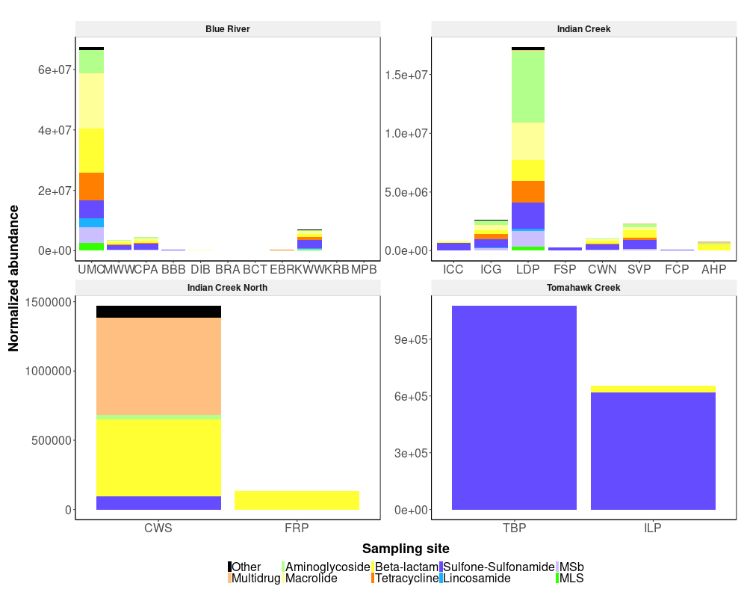Supplementary Figure 1: Total normalized ARG abundance by sampling site. The Other category represents ARGs that together compose less than 5% of the total watershed resistome. Note that site DIB is the first site sampled downstream of the confluence of the Blue River and Indian Creek.

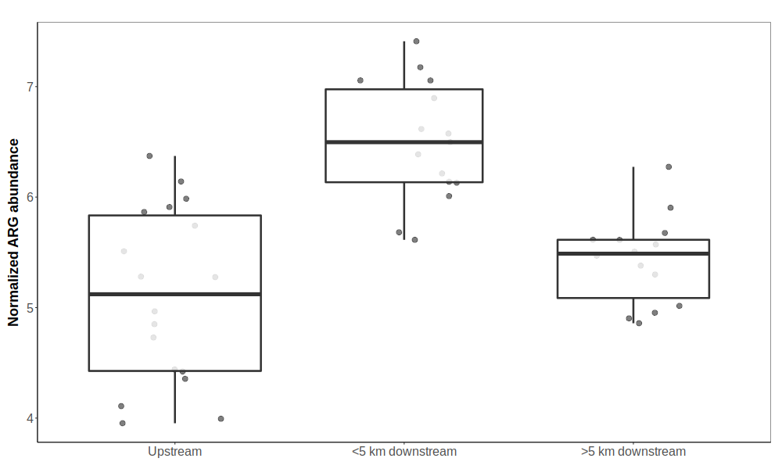Supplementary Figure 2: Total ARG abundance at varying distances from WWTP. Samples are grouped based on where they were collected relative to the nearest WWTP (Upstream = surface waters with no impact from a WWTP; <5 km downstream = within 5 km downstream the nearest WWTP; >5 km downstream = more than 5 km downstream the nearest WWTP). The area between the lower and upper hinge represents the inter-quartile range (IQR), or difference between the first and third quartiles.

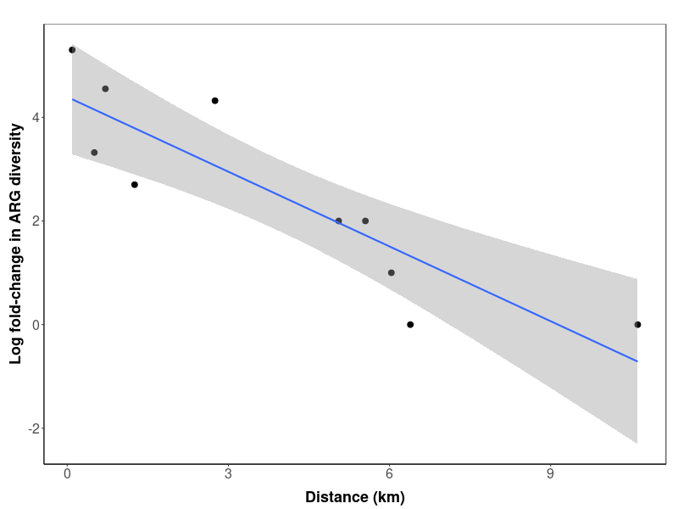
Supplementary Figure 3: ARG richness with increasing distance downstream a WWTP. The change in ARG richness was calculated as the log2 fold-change in the number of unique ARG types detected between a downstream WWTP site and its closest upstream site. A smoothing curve based on linear regression (blue line) is shown along with 95% confidence intervals (shaded region).

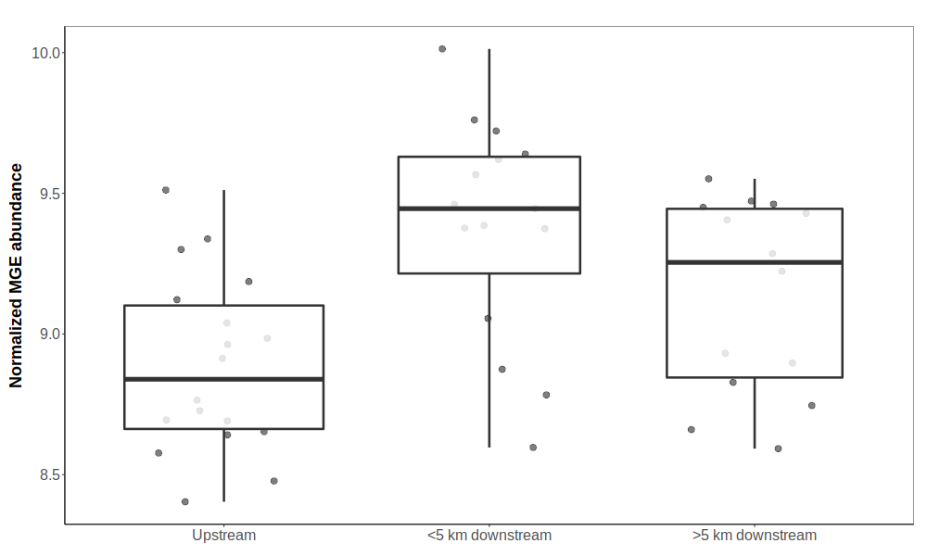Supplementary Figure 4: Total MGE abundance at varying distances from WWTP. Samples are grouped based on where they were collected relative to the nearest WWTP (Upstream = surface waters with no impact from a WWTP; <5 km downstream = within 5 km downstream the nearest WWTP; >5 km downstream = more than 5 km downstream the nearest WWTP). The area between the lower and upper hinge represents the inter-quartile range (IQR), or difference between the first and third quartiles. Notches approximate 95\% confidence intervals around median abundance (center lines), and extend from the median ± 1.58 * IQR / sqrt(n).

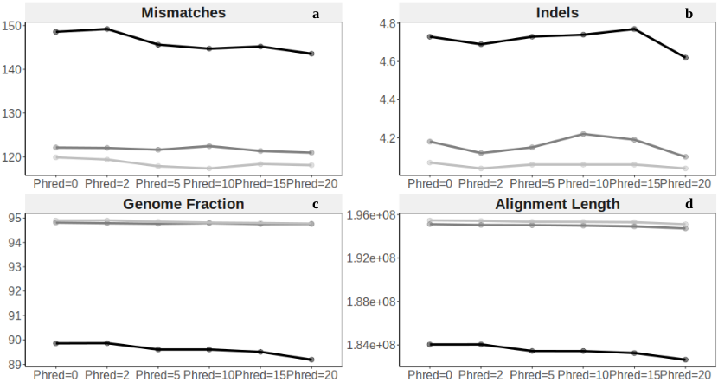

Supplementary Figure 5: Association between assembly quality and quality score threshold at varying sequencing depths. Top panels represent two of the most common types of assembly error – number of mismatches (a) and indels (b). Bottom panels represent standard metrics of assembly performance – fraction of the genome covered by reads (c) and total alignment length (d).

