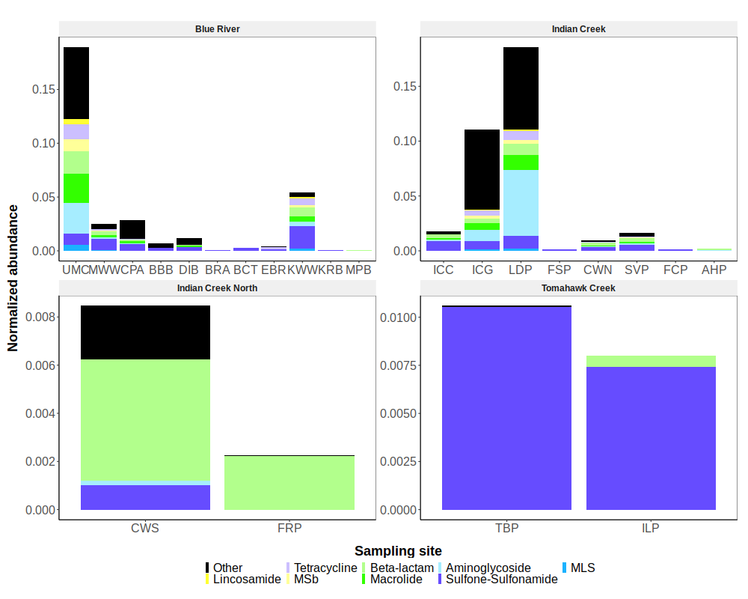Figure A.S1: Total normalized ARG abundance by sampling site. ARG abundances were normalized to the abundance of the rpoB gene by dividing the FP of each ARG to the FP of the rpoB gene. The Other category represents ARGs that together compose less than 5% of the total watershed resistome. Note that site DIB is the first site sampled downstream of the confluence of the Blue River and Indian Creek.

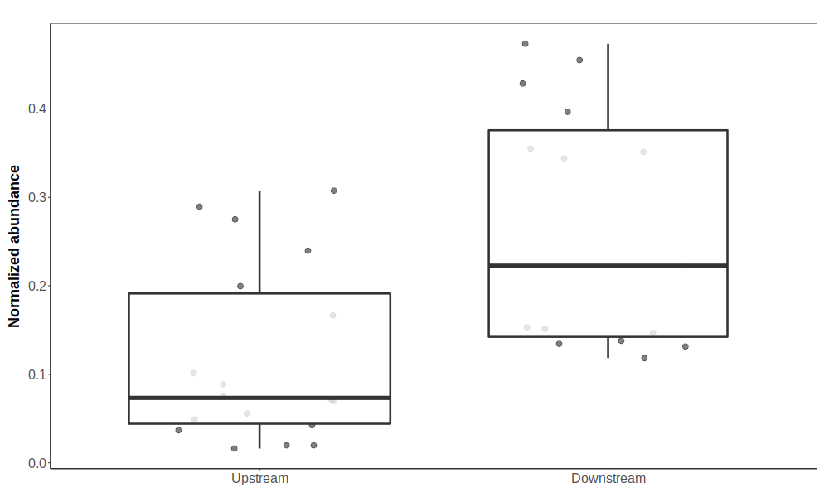Figure A.1: Total abundance of ARGs was significantly higher in river waters sampled immediately downstream from WWTP discharge (ANOVA, p-adjusted = 0.00051). ARG abundances were normalized to the abundance of the rpoB gene by dividing the FP of each ARG to the FP of the rpoB gene, and then root-transformed for analysis. Samples are grouped based on where they were collected relative to the nearest WWTP (Upstream = surface waters with no impact from a WWTP; Downstream = within 5 km downstream the nearest WWTP). The area between the lower and upper hinge represents the inter-quartile range (IQR), or difference between the first and third quartiles.

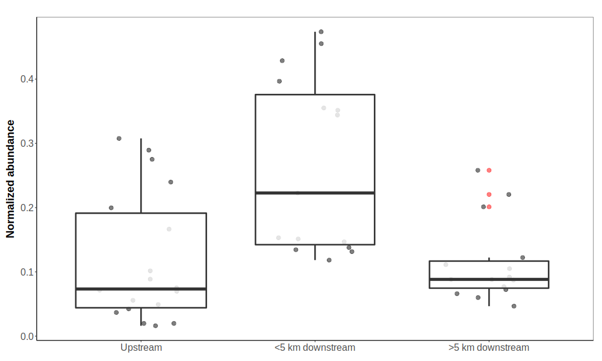Figure A.S2: Total ARG abundance decreased substantially at sites located more than 5 km downstream from WWTPs compared to sites within 5 km (ANOVA, p-adjusted = 0.00058). ARG abundances were normalized to the abundance of the rpoB gene by dividing the FP of each ARG to the FP of the rpoB gene, and then root-transformed for analysis. Samples are grouped based on where they were collected relative to the nearest WWTP (Upstream = surface waters with no impact from a WWTP; <5 km downstream = within 5 km downstream the nearest WWTP; >5 km downstream = more than 5 km downstream the nearest WWTP). The area between the lower and upper hinge represents the inter-quartile range (IQR), or difference between the first and third quartiles.

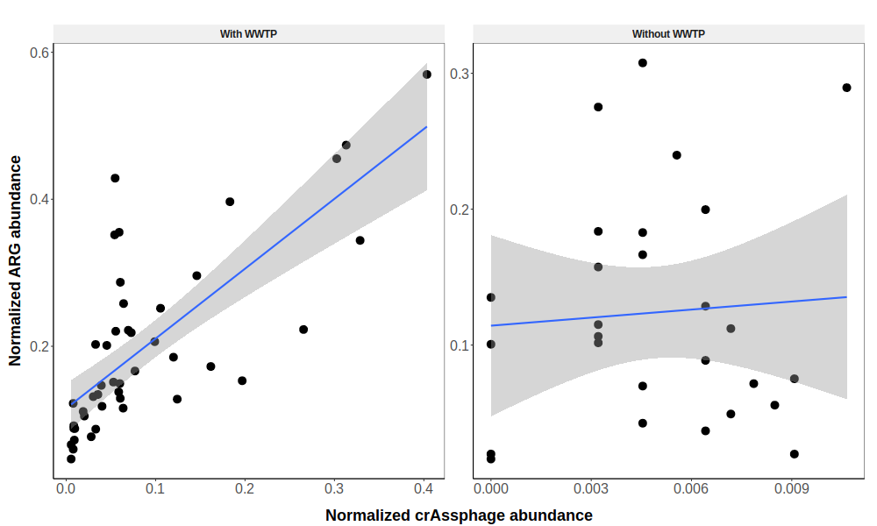Figure A.2: The abundances of ARGs and crAssphage were highly correlated with each other in river samples downstream from WWTPs (linear regression, adjusted R² = 0.54, p = 5.196e-09), while no correlation was found between crAssphage and ARG abundances in samples collected from sites without an upstream WWTP (linear regression, adjusted R² = -0.03, p = 0.73). ARG abundances were normalized to the abundance of the rpoB gene by dividing the FP of each ARG to the FP of the rpoB gene, and then root-transformed for analysis. Sites are grouped according to whether one or more WWTP is located upstream the sample site (left) or not (right). Smoothing curves based on linear regression (blue line) are shown along with 95% confidence intervals (shaded regions). Note the smaller range of crAssphage abundances in samples without upstream WWTPs.

