Willie Breaux
ITAI 2372
2/13/2026
PayPal Fraud Use Case
PayPal Holdings, Inc. is an American multinational financial technology company operating an online payments system in many countries that supports online money transfers. PayPal processes millions of transactions hourly and faces evolving fraud tactics from cybercriminals, including sophisticated methods such as account takeovers, synthetic identities, and real-time attacks. Traditional rules-based systems struggle with false positives and fail to adapt quickly, leading to financial losses exceeding billions of dollars annually and eroding customer trust when legitimate payments are blocked (IBM, 2023; PayPal Holdings, Inc., 2024). Given the high volume of transactions, fraud detection is critical to protecting users and preventing financial losses. By leveraging machine learning, deep learning, and advanced analytics, A.I. can analyze large volumes of transactional data in real time, identify suspicious patterns, and predict potentially fraudulent activity before it occurs (IBM, 2023; SAS Institute Inc., 2022).
PayPal uses A.I. technologies, including machine learning algorithms, to analyze user behavior in real time, such as transaction patterns, login locations, and device information (Andrew & Philips, 2025). PayPal leverages machine learning to score transactions in milliseconds by processing over 500 signals, including user behavior, IP geolocation, device fingerprinting, and transaction velocity (Reruption, n.d.). In unsupervised models, machine learning algorithms process and analyze untagged data to identify patterns of normal buying activity and detect potentially fraudulent anomalies (PayPal Editorial Staff, 2024). Core models include recurrent neural networks (RNNs) for sequential transaction analysis and autoencoders for unsupervised anomaly detection, processing 250+ features like velocity checks, graph-based entity resolution, and biometric signals (Reruption, n.d.). By combining A.I. with behavioral analytics, PayPal can detect unusual patterns in user behavior that indicate potential fraud (Andrew & Philips, 2025).
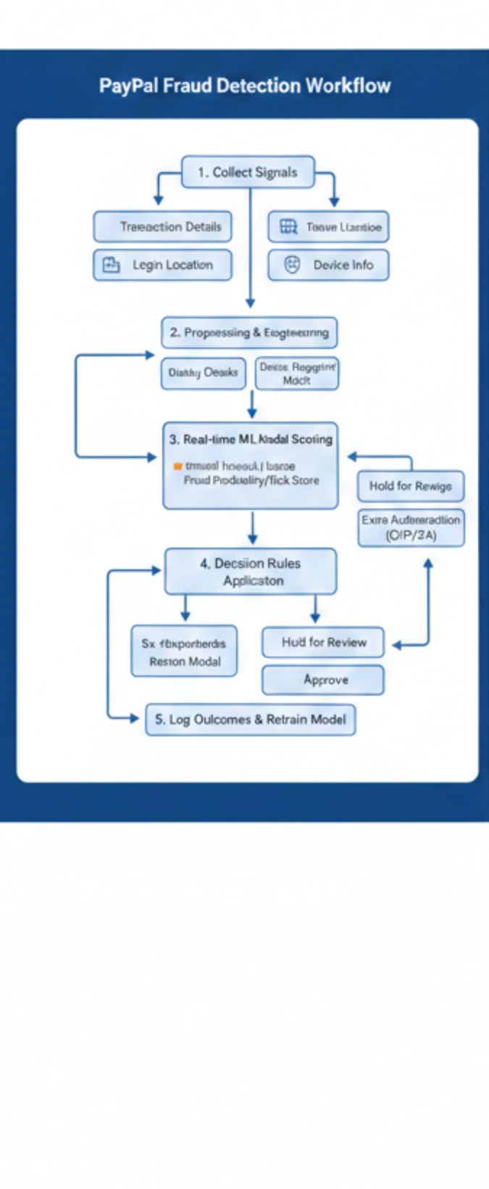
Figure 1. PayPal Fraud Detection Workflow
Note. Diagram generated using NanoBanana AI, 2026, based on publicly available fraud detection concepts
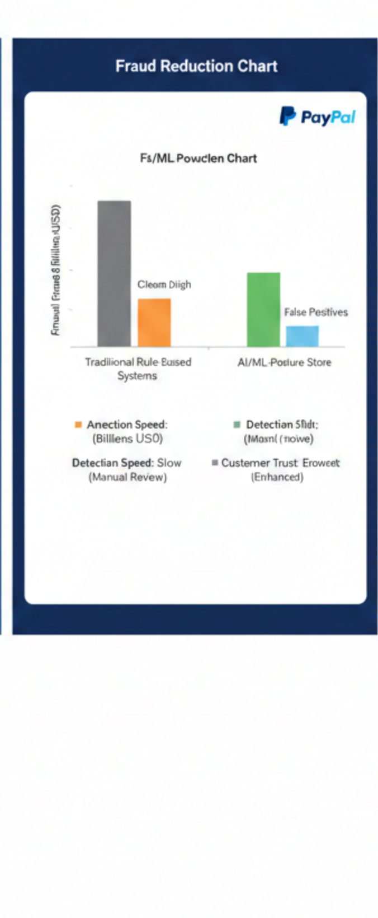
Figure 2. Fraud Reduction Using AI-Based Detection
Note. Diagram generated using NanoBanana AI, 2026.

The fraud detection works in this order as follows: Collect signal from each event (transaction details + login location + device info), next preprocessing and feature engineering (clean data, convert signal into model features like velocity, risk flags, device fingerprint match), then the model score the event in real time using an ML model (outputs a fraud probability/risk score), followed by applying decision rule based on the score (approve, decline, hold for review, or require extra authentication like OTP/2FA). The final step is to log the model's outcomes and feedback (confirmed fraud vs. legitimate) to retrain and improve the model over time.
The benefits that A.I. models bring to fraud detection for financial institutions are as follows: Machine learning models can analyze large volumes of transactional data in real time, enabling the quick detection and prevention of suspicious activity (PayPal, n.d.). These systems also improve detection speed by scoring transactions instantly using behavioral and device data, which enables faster responses to threats (Reruption, n.d.). In addition, A.I. reduces false positives by learning normal customer behavior patterns, improving accuracy, and minimizing disruptions to legitimate transactions (Andrew & Philips, 2025). These benefits ultimately lower companies' operating costs, reduce the need for manual investigation, and enhance customer trust. PayPal uses machine learning models to analyze transaction behavior and detect fraud in real time (PayPal, n.d.). Research on fraud detection systems shows that machine learning models can significantly improve accuracy and reduce false positives compared with traditional methods (Andrew & Philips, 2025).

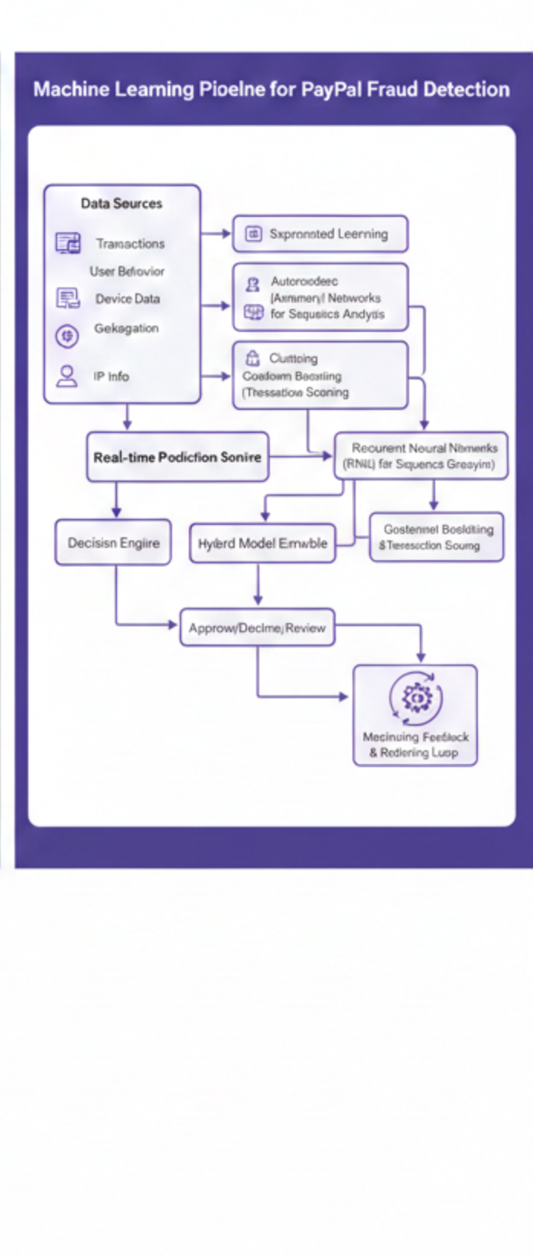
Figure 3. Machine Learning Pipeline for Fraud Detection
Note. Diagram generated using NanoBanana AI, 2026

There are still challenges and limitations that A.I. fraud detection systems face, as follows: Tech-wise, these systems must process large volumes of transactions in real time while fraudsters continuously adapt their tactics, sometimes using generative A.I. to create convincing fraudulent content that can bypass detection methods. Data challenges also persist because accurate fraud detection depends on high-quality, up-to-date data, and fraud patterns change frequently, requiring constant model retraining. Ethical and privacy concerns arise because fraud detection often involves analyzing sensitive customer data, and privacy regulations can limit how this data is collected and used. Operationally, implementing and maintaining A.I. systems can be costly and complex, and excessive false positives may slow operations and increase investigation costs. In turn, it negatively affects customer experience. A.I. is improving significantly with fraud detection; it is not perfect and still requires a human in the loop aspect to remain effective (IBM, n.d.).
Artificial Intelligence has become essential for modern fraud detection at PayPal and financial institutions alike, which process massive numbers of transactions every second. Machine learning and Behavioral analytics enable the identification of suspicious activity in real time, reducing fraud losses, improving detection speed, and lowering false positives compared with traditional rule-based systems. The use of A.I. in fraud detection demonstrates how advanced analytics can significantly strengthen financial security while also introducing new technical and ethical obstacles. Fraud methods will continue to evolve and transform, and organizations like PayPal and many new financial institutions with Crypto on the rise will need to keep improving their models to maintain effective and responsible fraud prevention.

.

References
Andrew, F., & Philips, S. (2025). Case studies: Successful implementations of AI in fraud detection. ResearchGate.
https://www.researchgate.net/publication/391657875_Case_Studies_Successful_Implementations_of_AI_in_Fraud_Detection
IBM. (2023). What is fraud detection?
https://www.ibm.com/think/topics/fraud-detection
PayPal Editorial Staff. (2024, November 5). Harnessing machine learning fraud detection technologies. PayPal Business Resource Center.
https://www.paypal.com/us/brc/article/payment-fraud-detection-machine-learning
PayPal Holdings, Inc. (2024). Form 10-K annual report.
https://investor.pypl.com
Reruption. (n.d.). PayPal’s deep learning fraud shield blocks billions.
https://reruption.com/en/knowledge/industry-cases/paypals-deep-learning-fraud-shield-blocks-billions
SAS Institute Inc. (2022). Fraud detection and prevention.
https://www.sas.com/en_us/insights/fraud/fraud-detection.html

