Technical Reports
Lab Journal
Name: Willie Breaux
Journal Entry: L06 Object Detection
Date: 10/15/2025
ITAI 1378
Image classification assigns an object/image to a category (e.g., “horse” or “car”). In contrast, object detection classifies and positions the object by drawing a bounding box around it. We use fractions (0 to 1) because it is consistently proportional, and coordinates are rescaled to fit across any image size/resolution. IoU measures how well a predicted bounding box overlaps the ground truth box.
IoU = (Area of Overlap) / (Area of Union)
The reason 0.5 is commonly used as the threshold is that it overlaps 50 percent with the image, which is considered and accepted as a “correct” detection.
If I had to choose between display_example and plot_detection to determine which was more challenging, I would say it was bits and pieces from both functions. In display_example, brand new techniques are being implemented before one's eyes. Things are coming together because following the steps and reading the text helped me understand what was happening. After reviewing the text, I noticed that in the function calculate_iou, there is a line (“max(0, inter_xmax – inter_xmin) and max(0, inter_ymax – inter_ymin)”), which results in the width or height being negative, which is not ideal for visualizing precision. I did not encounter any errors or error messages.
When looking at the bounding boxes for threshold 0.3 vs threshold 0.7, the lowest threshold had 12 boxes, while the higher threshold had only two. When deciding which threshold is better, I honestly do not know. With the lower threshold, you get a wider range of detectors, most of which are incorrect. However, with the higher threshold, you get fewer bounding boxes, and they are detected more accurately. I would say the higher threshold with more training and a higher validation percentage. When I experimented with the threshold hold data, I realized that the precision and hit percentage were not affected. This could be because the number of true/face positives didn’t change. Here are two examples of false positive and false negative Bounding boxes with labels. In the false positive image, one can see how the boxes are detecting the object, but the labels/categories are wrong. Moreover, in the false negative image, one can see that a pottery plant was detected on the side, but there is no pottery plant in the image.

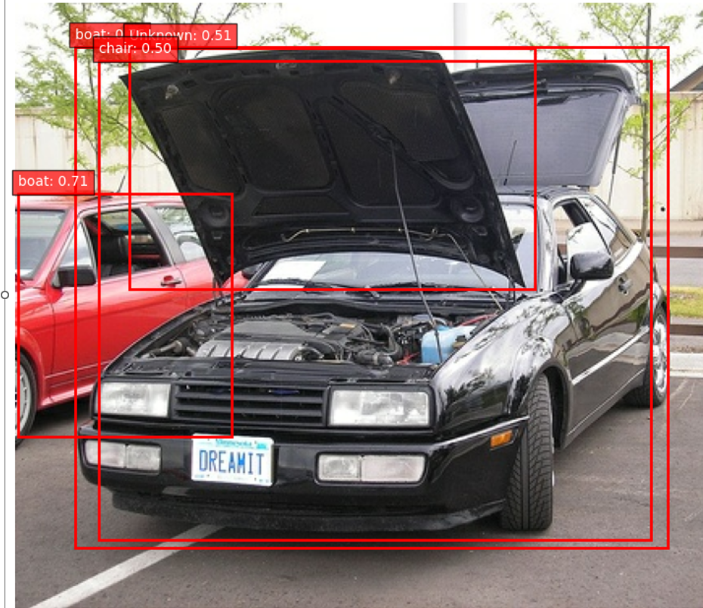
Figure 1False positive
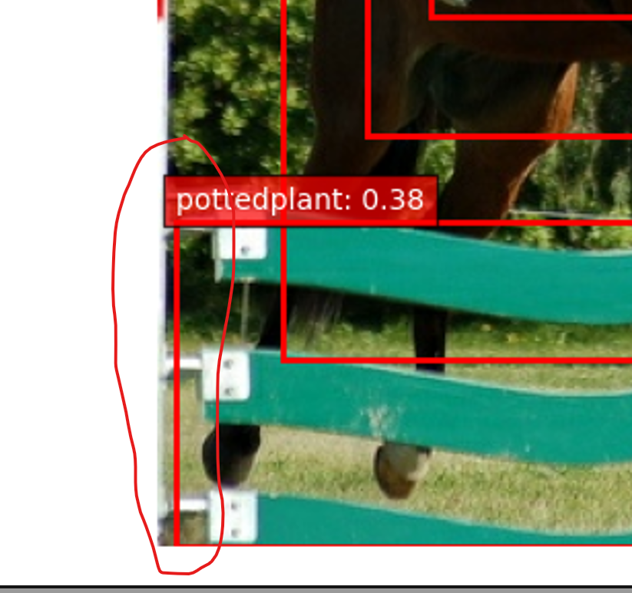
Figure 2False negative

For a self driving car detecting pedestrians, I would prioritize high precision, because I need the vehicle to detect accurately, which would be a human or animal, and be precise. I believe that a recall system would force the car to be more aware of the objects that surround it. For a photo app, I would prioritize high recall because if I were a photographer aiming to detect details in all aspects of an image, I would need recall to capture more than necessary. The advantages of using a pretrained model include saving time and allowing us to start working on it right away. I guess a disadvantage of a pre-trained model is that I didn’t train it myself, so I am not sure how accurate it may be. Three real-world applications would be, for example, how the military is using vision detection to detect drug boats in the ocean and destroy them before they touch US soil. If this equipment didn’t detect accurate information, then the military could accidentally mistake a civilian for a trafficker. Another real-world application would be a baseball speed radar, which detects how fast a ball is being thrown. This is necessary to help players and coaches improve performance. The last aspect is crash prevention in a vehicle, which is necessary because a driver might not pay attention for a split second. Instead, 20 years ago, if you rammed into the driver in front of you, the car would detect that the driver was not slowing down. The car ahead is getting closer, so the vehicle detects it and administers automatic braking to prevent a crash.

