Converter App

Use Cases

1. A user wants to know what Celsius is in Fahrenheit or vice versa.

* User selects the Celsius/Fahrenheit box

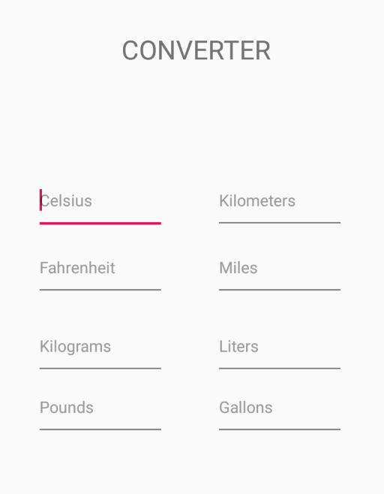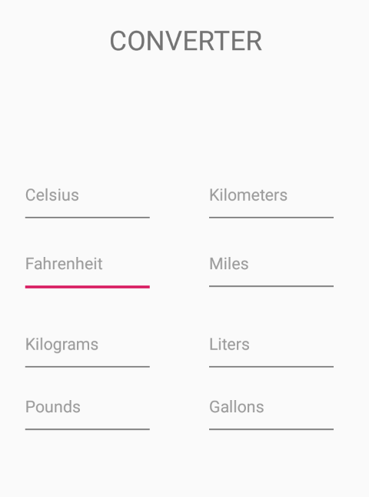

* A user types in the number they desire and sees the conversion to Fº/Cº

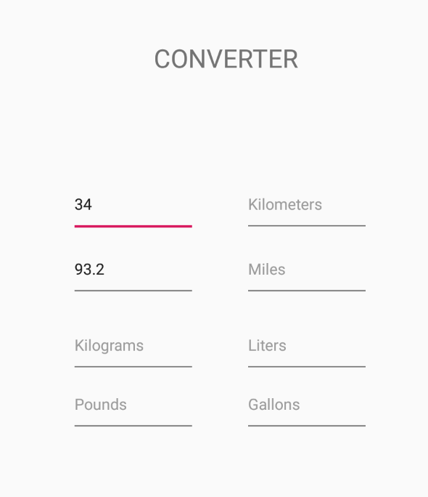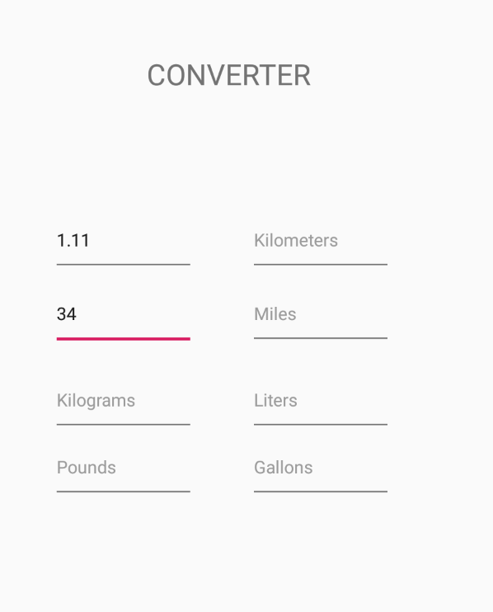

1. A user wants to know what Kilometers is in Miles or vice versa.

* A user selects the Kilometers/Miles box

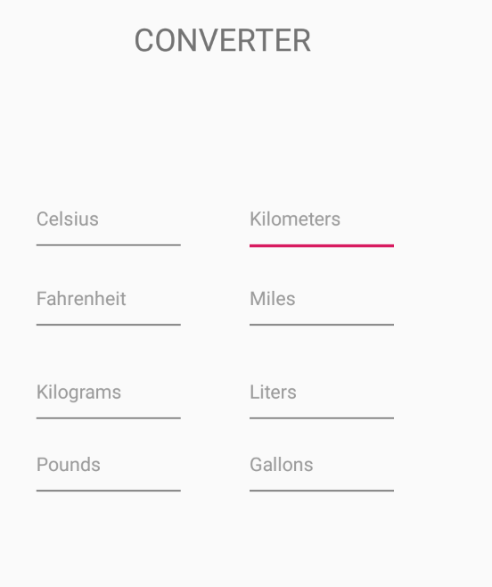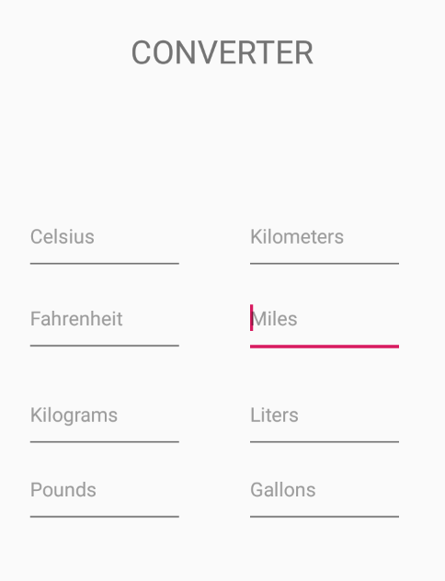

* A user types in the number they desire and sees the conversion to km/mi

­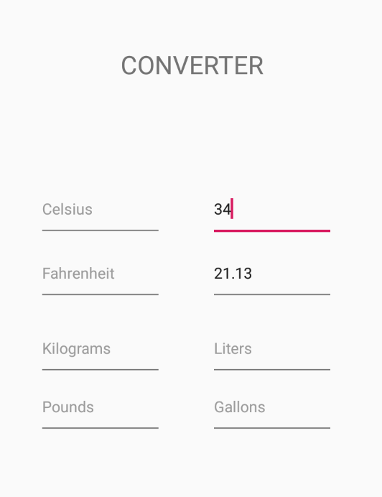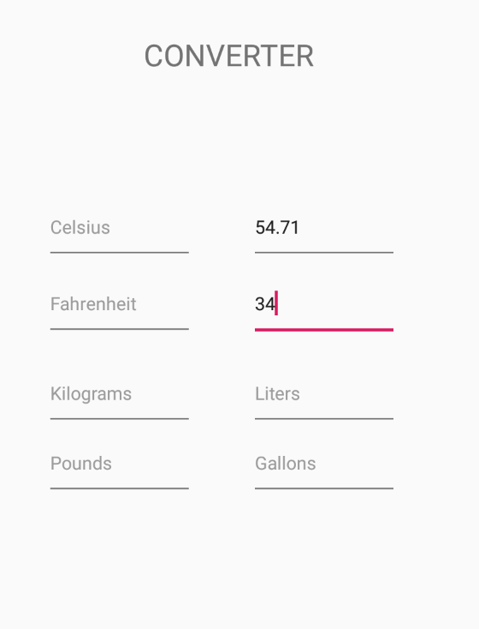

1. A user wants to know what Kilograms is in Pounds or vice versa.

* A user selects the Kilograms or pounds box

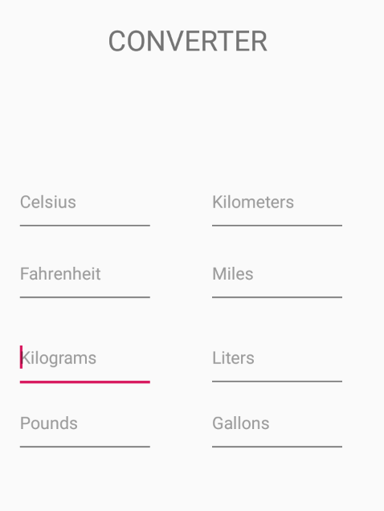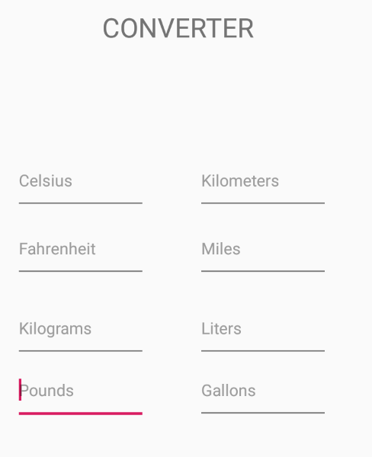

* A user types in the number they desire and sees the conversion to kg/lbs

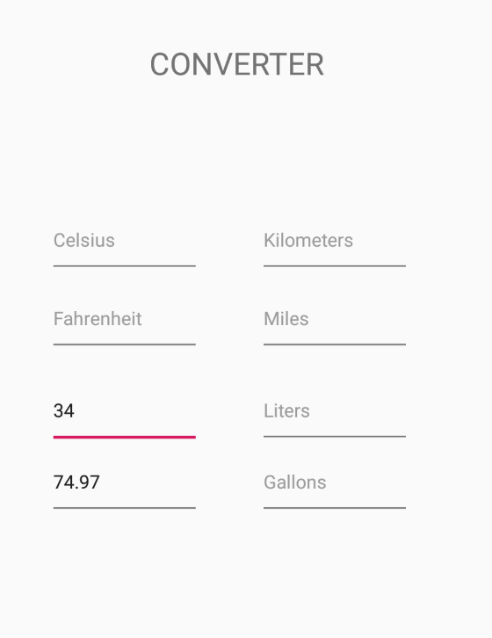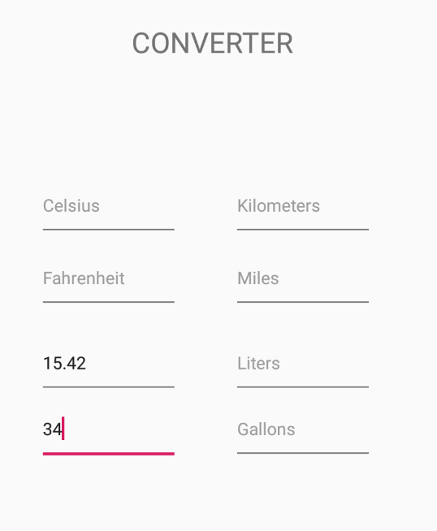

1. A user wants to know what Liters is in Gallons or vice versa.

* A user selects the liters or gallons box

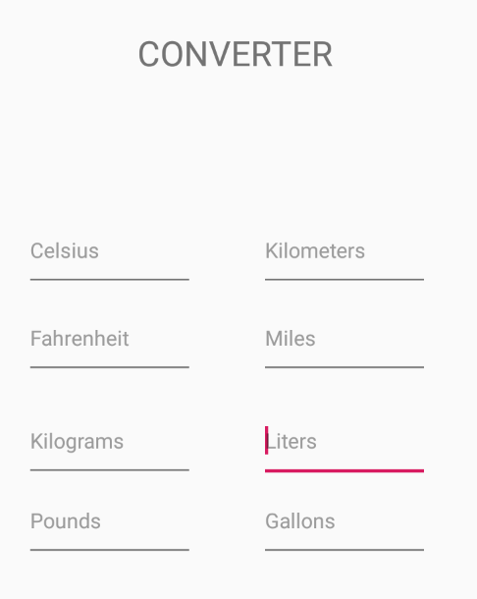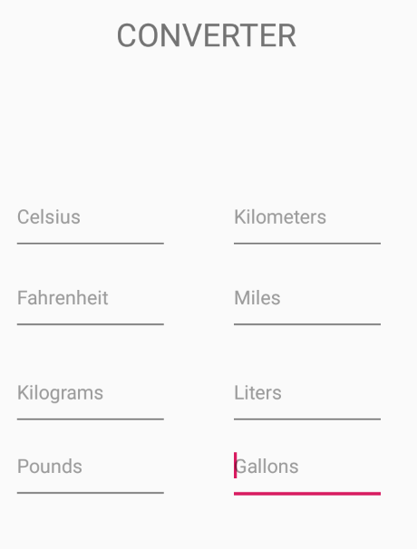

* A user types in the number they desire and sees the conversion to ltr/gal

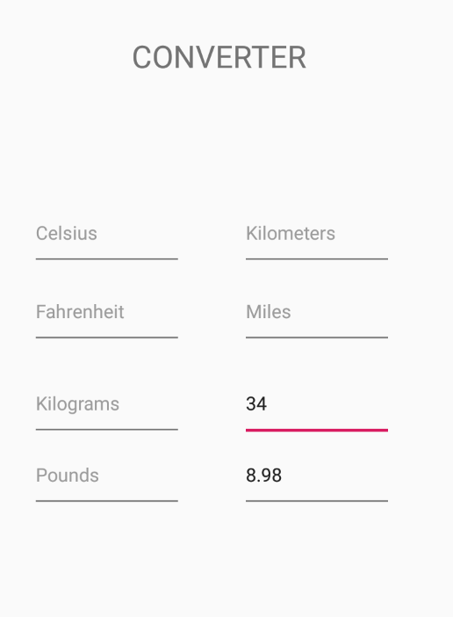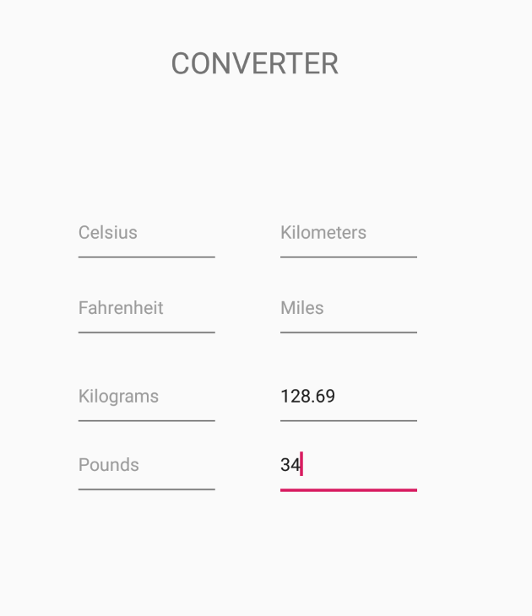

Test Cases

1. 45 C°/F°
2. 200 KM/Mi
3. 75 kg/lb
4. 20 ltr/gal

**