# 架构设计：

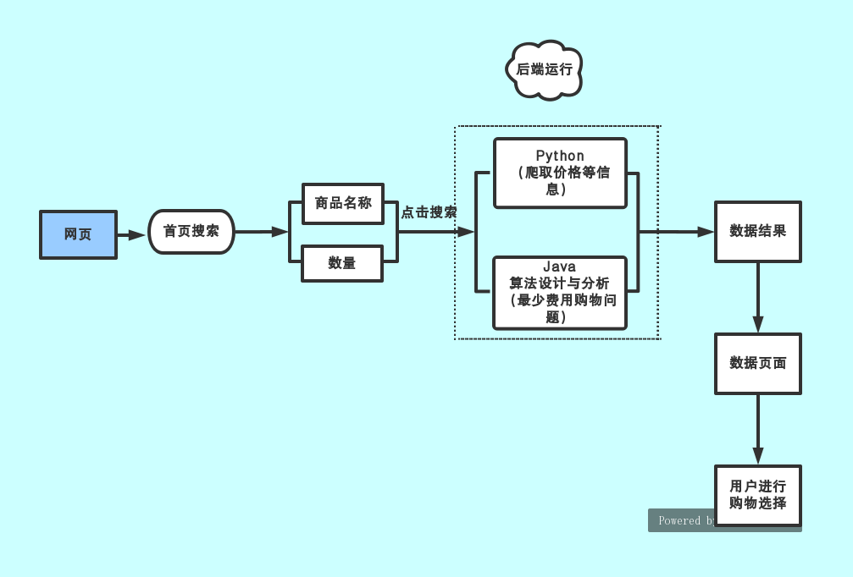

## 1.前端设计：

1. 使用工具：Adobe Dreamweaver CC 2018。
2. 网页总体设计。首页输入搜索条件，点击搜索后跳转到数据结果页面。
3. 首页设计。首页设置两个文本框，一个要求数据商品名称， 另一个要求输入所需数量，再设置一个搜索按钮，实现下一个数据结果页面的跳转。

首页界面如下：



首页编辑代码：

<!DOCTYPE html>

<html>

<head>

<meta charset="UTF-8">

<title>宇宙超省搜索</title>

<style type="text/css">

body,ul,li{

margin: 0;

padding: 0;

}

#wrap{

width: 612px;

margin: 50px 300px;

position: relative;

}

input{

width: 460px;

height: 42px;

border: 5px solid red;

float: left;

outline: none;

border-radius: 25px 0 0 25px;

font-size: 18px;

padding: 0 20px;

}

a{

color: darkmagenta;

text-decoration: none;

}

#list{

width: 480px;

position: relative;

left: 25px;

border: 1px solid #CECECE;

display: none;

/*z-index: -1;*/

}

#list>li{

/*height: 40px;*/

padding: 0 10px;

border-bottom: 1px solid #CECECE;

list-style: none;

line-height: 40px;

cursor: pointer;

}

#list>li:last-child{

border-bottom: none;

}

#list>li:hover{

background: chartreuse;

}

#btn{

float: left;

height: 52px;

width: 610px;

background: red;

color: white;

border: none;

text-align: center;

border-radius:25px 25px 25px 25px;

cursor: pointer;

outline: none;

font-size: 20px;

}

#btn1{

float: left;

height: 52px;

width: 100px;

background: red;

color: white;

border: none;

text-align: center;

border-radius:0 25px 25px 0;

cursor: pointer;

outline: none;

font-size: 20px;

}

.ul2{

width: 250px;

height:100%;

position: absolute;

right: 0;

top: 0;

/*z-index: 10;*/

background: #F6F9FC;

box-sizing: border-box;

padding-top: 20px;

display: none;

}

#list>li:hover .ul2{

display: block;

}

.ul2 .li2{

margin: 5px;

float: left;

/*box-sizing: border-box;*/

list-style: none;

/*background: red;*/

border: 1px solid #cecece;

}

.ul2 .li2 a{

display: block;

line-height: 30px;

width: 60px;

height: 30px;

text-align: center;

}

.ul2 .li2:hover {

background: red;

}

.ul2 .li2:hover a{

color: white;

}

.hover{

color: red;

}

</style>

</head>

<body background="../image/b1.jpg">

<div id="wrap">

<div style="overflow: hidden;">

<input type="text" name="txt" id="txt" value=""/>

<input type="button" name="btn" id="btn1" value="商品名称"/>

<input type="text" name="txt" id="txt" value=""/>

<input type="button" name="btn" id="btn1" value="数量" />

<input type="button" name="btn" id="btn" value="搜 索" onclick="window.location.href='2.html'"/>

</div>

<ul id="list"></ul>

</div>

</body>

</html>

1. 数据结果页面设计。结果页面设置两个文本框，第一个文本框显示筛选后得到的最省的店铺的名称，第二个文本框显示与其对应的商品价格。

数据结果页面如下：



数据结果页面编辑代码：

<!doctype html>

<html>

<head>

<meta charset="utf-8">

<title>宇宙最优选择</title>

<style>

.item1{

height: 100px;

width: 100px;

background-color: wheat;

text-align: center;

line-height: 30px;

margin: 100px auto;

}

</style>

</head>

<body background="../image/b4.jpg">

<div class="outer">

<div class="item1"><form>

最省店铺：

<input type="text" name="firstname" style="width: 200px;height: 25px">

<br />

最优价格：

<input type="text" name="lastname" style="width: 200px;height: 25px">

</form></div>

</div>

</body>

</html>

## 2.后端设计：

①编写Python，利用Python设计爬虫爬取淘宝、天猫、京东等各大网络消费品牌的商品名称、价格等有关信息。当用户从搜索网页输入商品名称及所需的数量后，点击搜索按钮，爬虫将在后台进行运行操作。

Python爬虫代码如下：

#!coding=utf-8

import requests

import re

import random

import time

import json

from requests.packages.urllib3.exceptions import InsecureRequestWarning

import pandas as pd

requests.packages.urllib3.disable_warnings(InsecureRequestWarning) ###禁止提醒SSL警告

class tm(object):####手机端

def __init__(self,path): ###保存数据路径

self.path=path

def goodsid(self,url): ###通过店铺URL获取店铺所有ID

shopname = re.search('https://(.*?).tmall', url).group(1)

searchurl = 'https://{}.m.tmall.com/shop/shop_auction_search.do?spm=a1z60.7754813.0.0.301755f0pZ1GjU&sort=defaul'.format(

shopname)

s=requests.session()

headers = {'Accept': '*/*',

'Accept-Language': 'zh-CN',

'User-Agent': 'Mozilla/5.0 (iPhone; CPU iPhone OS 10_3_3 like Mac OS X) AppleWebKit/603.3.8 (KHTML, like Gecko) FxiOS/10.6b8836 Mobile/14G60 Safari/603.3.8',

'Referer':'https://{}.m.tmall.com/shop/shop_auction_search.htm?spm=a1z60.7754813.0.0.301755f0pZ1GjU&sort=default'.format(shopname)

}

s.headers.update(headers)

page1=s.get(url=searchurl,verify=False).text

print(page1)

js=json.loads(page1)

total_page=int(js['total_page'])

shop_id=js['shop_id']

shop_title = js['shop_title']

shop_id_list = []

shop_title_list = []

item_id=re.findall('"item_id":(.*?),"',page1)

title=re.findall('"title":"(.*?)","',page1)

sold=re.findall('"sold":"(.*?)","',page1)

totalSoldQuantity=re.findall('"totalSoldQuantity":(.*?),"',page1)

skuurl=re.findall('"url":"(.*?)","',page1)

price=re.findall('"price":"(.*?)","',page1)

item_id_l=len(item_id)

shop_id_list.append(shop_id)

shop_id_list.extend(shop_id_list*(int(item_id_l)-1))

shop_title_list.append(shop_title)

shop_title_list.extend(shop_title_list*(int(item_id_l)-1))

# print(js)

# print(len(shop_id_list))

# print(len(shop_title_list))

# print(len(item_id))

# print(len(title))

# print(len(sold))

# print(len(totalSoldQuantity))

# print(len(skuurl))

# print(len(price))

data = {'shop_id': shop_id_list,'shop_title': shop_title_list,'item_id': item_id, 'title': title, 'sold':sold, 'totalSoldQuantity':totalSoldQuantity, 'skuurl':skuurl, 'price':price}

df = pd.DataFrame(data=data)

#print(df)

savepath=self.path + r'\tmgoodsid{}.csv'.format(shopname)

print(savepath)

df.to_csv(savepath, mode='a', index=False, encoding="GB18030")

time.sleep(random.random() * 2)

if total_page!=1:

for i in range(2,total_page+1):

time.sleep(random.random() * 2)

htmlurl=searchurl+'&p={}'.format(i)

html=s.get(url=htmlurl,verify=False).text

shop_id_list = []

shop_title_list = []

print(html)

item_id = re.findall('"item_id":(.*?),"',html)

title = re.findall('"title":"(.*?)","', html)

sold = re.findall('"sold":"(.*?)","', html)

totalSoldQuantity = re.findall('"totalSoldQuantity":(.*?),"', html)

skuurl = re.findall('"url":"(.*?)","', html)

price = re.findall('"price":"(.*?)","',html)

item_id_l = len(item_id)

shop_id_list.append(shop_id)

shop_id_list.extend(shop_id_list * (int(item_id_l) - 1))

shop_title_list.append(shop_title)

shop_title_list.extend(shop_title_list * (int(item_id_l) - 1))

data = {'shop_id': shop_id_list, 'shop_title': shop_title_list, 'item_id': item_id, 'title': title,

'sold': sold, 'totalSoldQuantity': totalSoldQuantity, 'skuurl': skuurl, 'price': price}

df = pd.DataFrame(data=data)

df.to_csv(self.path + r'\tmgoodsid{}.csv'.format(shopname),mode='a', index=False,header=0 ,encoding="GB18030")

df1 = pd.read_csv(self.path + r'\tmgoodsid{}.csv'.format(shopname), encoding='GB18030')

s.close()

return df1

def getiddata(self,id): ###获取ID数据

time.sleep(random.random() * 1 + 1)

s = requests.session()

t=int(time.time()*1000)

url='https://h5api.m.taobao.com/h5/mtop.taobao.detail.getdetail/6.0/' \

'?jsv=2.4.8&appKey=12574478&t={}' \

'&sign=7c9e1dedaa295fdb175d22c99746493b&api=mtop.taobao.detail.getdetail' \

'&v=6.0&dataType=jsonp&ttid=2017%40taobao_h5_6.6.0&AntiCreep=true&type=jsonp&callback=mtopjsonp2&' \

'data=%7B%22itemNumId%22%3A%22{}%22%7D'.format(t,id)

headers = {'Accept': '*/*',

'Accept-Language': 'zh-CN',

'User-Agent': 'Mozilla/5.0 (iPhone; CPU iPhone OS 10_3_3 like Mac OS X) AppleWebKit/603.3.8 (KHTML, like Gecko) FxiOS/10.6b8836 Mobile/14G60 Safari/603.3.8',

'Referer': 'https://detail.m.tmall.com/item.htm?spm=a220m.6910245.0.0.55b17434eiwv4f&id={}'.format(id)

}

print(url)

s.headers.update(headers)

html = s.get(url=url, verify=False).text

html=html.replace('\\','')

time.sleep(0.5)

info=re.search('skuBase":(.*?),"skuCore',html)

if info!=None:

skuBase=re.search('skuBase":(.*?),"skuCore',html).group(1) ##SKU+颜色

skuId = re.findall('"skuId":"(.*?)","', skuBase)

propPath=re.findall('"propPath":"(.*?)"}',skuBase)

skuBase=json.loads(skuBase)

prop_list=[]

for i in propPath:

prop = ''

prop1=i.split(';')

for j in prop1:

prop2=j.split(':')

for pid in skuBase['props']:

if pid['pid']==prop2[0]:

#prop=prop+pid['name']

for vid in pid['values']:

if vid['vid']==prop2[1]:

prop=prop+vid['name']

prop_list.append(str(prop))

sku2info = re.search('"sku2info":(.*?)},"s', html).group(1) ##价格

sku2info = json.loads(sku2info)

price = []

for i in skuId:

p = sku2info[str(i)]['price']['priceText']

price.append(p)

else:

skuId=[' ']

prop_list=[' ']

price=[' ']

data = {'skuid': skuId, 'prop': prop_list,'price':price}

df = pd.DataFrame(data=data)

return df

def iddata(self,id_df):

df_l=id_df.iloc[:,0].size

df=pd.DataFrame()

df.loc[0, "shop_id"] = ''

df.loc[:, "shop_title"] = ''

df.loc[:, "item_id"] = ''

df.loc[:, "title"] = ''

df.loc[:, "sold"] = ''

df.loc[:, "totalSoldQuantity"] = ''

df.loc[:, "skuurl"] = ''

df.loc[:, "price"] = ''

df.loc[:, "skuid"] = ''

df.loc[:, "prop"] = ''

df.loc[:, "skuprice"] = ''

shopid=id_df['shop_id'][1]

y=0

for i in range(0,df_l):

time.sleep(random.random() * 2.56)

pid=id_df['item_id'][i]

data=self.getiddata(pid)

data_l=data.iloc[:,0].size

for j in range(0,data_l):

df.at[y, "shop_id"] = id_df['shop_id'][i]

df.at[y, "shop_title"] = id_df['shop_title'][i]

df.at[y, "item_id"] = id_df['item_id'][i]

df.at[y, "title"] = id_df['title'][i]

df.at[y, "sold"] = id_df['sold'][i]

df.at[y, "totalSoldQuantity"] = id_df['totalSoldQuantity'][i]

df.at[y, "skuurl"] = id_df['skuurl'][i]

df.at[y, "price"] = id_df['price'][i]

df.at[y, "skuid"] = data['skuid'][j]

df.at[y, "prop"] = data['prop'][j]

df.at[y, "skuprice"] = data['price'][j]

y +=1

df.to_csv(self.path + r'\tm{}.csv'.format(shopid), index=False, encoding="GB18030")

return df

def urlitem(self,url,*args): ##通过目录获取 只适合部分

s = requests.session()

headers = {'Accept': '*/*',

'Accept-Language': 'zh-CN',

'User-Agent': 'Mozilla/5.0 (Windows NT 10.0; WOW64) AppleWebKit/537.36 (KHTML, like Gecko) Chrome/68.0.3440.15 Safari/537.36'

}

s.headers.update(headers)

itemhtml = s.get(url=url, verify=False).text

#print(itemhtml)

shopid = re.search('class="J_TModule"(.*?)"搜索列表"', itemhtml).group(1)

shopid=re.search('data-widgetid="(.*?)" id',shopid).group(1)

#print(shopid)

id=re.search('category-(.*?).htm',url).group(1)

nm=re.search('https://(.*?).tmall.com/',url).group(1)

t=int(time.time()*1000)

pageurl='https://{}.tmall.com/i/asynSearch.htm?_ksTS={}_888&callback=jsonp289&mid=w-{}-0&wid={}&path=/category-{}.htm'.format(nm,t,shopid,shopid,id)

print(pageurl)

time.sleep(random.random() * 1 + 1)

html = s.get(url=pageurl, verify=False).text

html = html.replace('\\', '')

html=re.sub('\n','',html)

page=re.search('ui-page-s-len">1/(.*?)</b>',html).group(1)

print(page)

nm_list=[]

idurl_list=[]

price_list=[]

sale_list=[]

for p in range(1,int(page)+1):

time.sleep(random.random())

pageurl = 'https://{}.tmall.com/i/asynSearch.htm?_ksTS={}_888&callback=jsonp289&mid=w-{}-0&wid={}&path=/category-{}.htm'.format(

nm, t, shopid, shopid, id)

html = s.get(url=pageurl, verify=False).text

html = html.replace('\\', '')

html = re.sub('\n', '', html)

print(html)

nm=re.findall('<img alt="(.*?)" data',html)[:-8]

print(nm)

id=re.findall('<a href="//detail.(.*?)&rn',html)

idurl=[]

for i in id:

idurl.append('https://detail.'+i)

price=re.findall('class="c-price">(.*?) ',html)[:-8]

sale=re.findall('sale-num">(.*?)</span>',html)[:-8]

nm_list.extend(nm)

idurl_list.extend(idurl)

price_list.extend(price)

sale_list.extend(sale)

print(len(nm_list))

print(len(idurl_list))

print(len(price_list))

print(len(sale_list))

data={'nm':nm_list,'idurl':idurl_list,'price':price_list,'sale':sale_list}

df=pd.DataFrame(data)

l=len(args)

for j in range(0,l):

df.loc[:, "col"+str(j)] = args[j]

print(df)

s.close()

return df

# 例子：

# tm = tm()

# url = 'https://shoushanggeshi.tmall.com/category-1310604910.htm'

# # url = 'https://shoushanggeshi.tmall.com/category-674950482.htm'

# tm.urlitem(url, '电脑', 'cpu')

if __name__=='__main__':

path=r'E:\tm'

tm=tm(path)

df=tm.goodsid('https://intel.tmall.com')

tm.iddata(df)

②使用Java编写解决最少费用购物问题的代码，即将Python爬虫爬取到的价格信息进行对比和筛选，得到商品最优的价格以及店铺名称，最终将数据呈现在数据结果页面，为用户提供最好的消费选择。

Java代码如下：

package fczx;

import java.util.Scanner;

class Commodity{

int piece;//购买数量

int price;//购买价格

}

public class MinmShopping {

private static int MAXCODE = 100;//商品编码的最大值

private static int SALECOMB = 50;//优惠商品组合数

private static int KIND = 10; //商品种类

private static int QUANTITY = 10; //购买某种商品数量的最大值

private static int b;//购买商品种类数

private static int s;//当前优惠组合数

private static int[] num = new int[MAXCODE+1];//记录商品编码与商品种类的对应关系

private static int[] product = new int[KIND+1];//记录不同种类商品的购买数量

private static int[][] offer = new int[SALECOMB+1][KIND+1];//offer[i][j]: 商品组合的优惠价(j=0)；某种优惠组合中某种商品需要购买的数量

private static Commodity[] purch = new Commodity[KIND+1];//记录不同商品的购买数量和购买价格

private static int[][][][][] cost = new int[QUANTITY+1][QUANTITY+1][QUANTITY+1][QUANTITY+1][QUANTITY+1];//记录本次购买的总花费

public static void main(String[] args){ init(); comp(1); out();

}

private static void minicost(){

int i,j,k,m,n,p,minm; minm = 0;

for(i=1; i<=b; i++)

minm += product[i]*purch[i].price;

for(p=1; p<=s; p++){

i = product[1] - offer[p][1];

j = product[2] - offer[p][2];

k = product[3] - offer[p][3];

m = product[4] - offer[p][4];

n = product[5] - offer[p][5];

if(i>=0 && j>=0 && k>=0 && m>=0 && n>=0 && cost[i][j][k][m][n]+offer[p][0] < minm)

minm = cost[i][j][k][m][n] + offer[p][0];

}

cost[product[1]][product[2]][product[3]][product[4]][product[5]] = minm;

}

private static void init(){

Scanner input = new Scanner(System.in);

int i,j,n,p,t,code;

for(i=0; i<51; i++) for(j=0; j<11; j++) offer[i][j] = 0;

for(i=0; i<11; i++){

purch[i] = new Commodity(); purch[i].piece = 0;

purch[i].price = 0; product[i] = 0;

}

b = input.nextInt();

for(i=1; i<=b; i++){

code = input.nextInt();

purch[i].piece = input.nextInt();

purch[i].price = input.nextInt();

num[code] = i;

}

s = input.nextInt();

for(i=1; i<=s; i++){

t = input.nextInt();

for(j=1; j<=t; j++){

n = input.nextInt();

p = input.nextInt();

offer[i][num[n]] = p;

}

offer[i][0] = input.nextInt();

}

}

private static void comp(int i){

if(i > b){ minicost();

return;

}

for(int j=0; j<=purch[i].piece; j++)

{

product[i] = j; comp(i+1);

}

}

private static void out(){

System.out.println(cost[product[1]][product[2]][product[3]][product[4]][product[5]]);

}

}

## 3.测试结果：

①利用Python设计爬虫爬取淘宝价格的代码运行成功。

②利用Java编写进行价格对比，解决最少费用购物问题的代码

运行成功。

③网页的总体设计完成。

④缺少服务器的搭建，无法将Python和Java代码调用到网页

上，故整体项目实施失败。