Modelling Socio-Economic Dynamics: The Impact of Environmental and Agent Variables on Inequality, Child Poverty, and Wealth Distribution in Sugarscape Simulations

# Introduction

Economic inequality has emerged as a critical issue of contemporary socioeconomic analysis, revealing persistent disparities in wealth accumulation and distribution. Epstein and Axtell's (1996) Sugarscape model provides an essential theoretical framework for understanding these disparities through agent-based simulations of resource acquisition, consumption, and wealth accumulation. By illustrating how simple interactions can lead to pronounced wealth inequalities, Sugarscape simulations resonate with modern empirical findings, particularly those presented by Piketty (2014), who documented substantial economic concentration within a small elite. Such inequalities have profound social consequences, notably manifesting in child poverty. McLoyd (1990) highlight that widespread economic disparities have tangible and adverse impacts on vulnerable populations, particularly children, who frequently suffer intergenerational cycles of deprivation. Thus, connecting theoretical insights from agent-based modeling with empirical realities underscores the systemic nature of inequality and its detrimental effects on societal welfare.

# Background (literature review)

The theoretical foundation for this investigation is significantly grounded in the seminal work of Epstein and Axtell (1996), whose Sugarscape model demonstrates that structural inequality can spontaneously emerge from minimal initial differences, profoundly influencing long-term wealth distribution. This simulation-based perspective aligns closely with the methodological advancements outlined by Wilensky and Rand (2015), who have extensively elaborated on the adaptability of agent-based models in examining social phenomena, including economic disparities and resource distribution.

Empirically, the importance of examining economic inequality through the lens of real-world socioeconomic outcomes has been reinforced by Piketty (2014), whose rigorous analysis of historical data elucidates patterns of wealth concentration and the systemic perpetuation of elite control over economic resources. Additionally, McLoyd (1990) provides critical empirical evidence on the impacts of economic inequality at the micro-level, particularly its influence on child poverty and intergenerational deprivation. Their research emphasizes how structural inequalities, initiated through unequal initial endowments, significantly restrict social mobility, perpetuating poverty cycles and exacerbating vulnerabilities.

Further research by Wilkinson (2020) expands this discussion by illustrating how pronounced economic inequalities correlate strongly with various adverse social outcomes, including reduced health, educational accomplishment, and overall societal cohesion. Their findings lend additional empirical weight to the theoretical arguments, reinforcing the urgency of addressing systemic inequalities as a matter of policy and social well-being.

In summary, while not all literature directly informs the methodological aspects of this study, key theoretical and practical sources significantly contribute to developing, calibrating, and contextualizing agent-based simulations like Sugarscape. This research critically underscores that addressing economic inequality is imperative, as simulations clearly demonstrate how minor initial disparities amplify over time, significantly impacting vulnerable groups, especially children, and threatening long-term socioeconomic stability.

# Research Question(s)

Will changes in the economic environment and agent exacerbate inequality between social groups?

Do changes in the agent's own conditions affect the proportion of children poverty?

Will changes in the environment affect the accumulation of wealth?

# Parameters and Variables

There are several parameters across these three models, particularly in the Sugarscape Wealth Distribution model (Sugar 3). The table below highlights the key parameters featured in the models.

**Table 1** Key parameters

|  |  |  |
| --- | --- | --- |
| **Parameters** | **Range (Values)** | **Description** |
| Population | Initial_population | Number of initial population of turtles (agents). |
| Initial Sugar | 0-25 | Number of units of sugar each turtle initially owns. |
| Grow Back Rate | Growback_rate | Number of sugar unites growth in each time interval of sugar regrowth |
| Run Length (step) | 1000 | Number of iterations in a single experiment execution. |
| Metabolism | 1-max_metabolism | Amount of sugar turtle consumes per time tick. |
| Vision | 1-max_vision | Number of patches the turtle can observe in the four cardinal directions (up, down, left, right) |
| Max Age (death age) | Min_death_age-100 | When a turtle's age exceeds its maximum age, it dies. |

* Initial Sugars, Metabolisms, Visions and Max Ages are randomly distributed within a given range across agents.

**Table 2** Variables that change in the behaviour space

|  |  |  |
| --- | --- | --- |
| **Variables** | **Range (Values)** | **The Value in the Original Model** |
| Initial_population | [400, 1000] | 400 |
| Growback_rate | [1, 3] | 1 |
| Min_death_age | [1, 60] | 60 |
| Max_metabolism | [4, 10] | 4 |
| Max_vision | [6, 10] | 6 |

# Scope and Methodology

The initial section of this report will comparatively analyse three variations of the Sugarscape model (immediate growback, constant growback, and wealth distribution) using identical initial conditions as outlined in the original parameters of **Table 2**. To enable a fair and meaningful comparison across these models, particularly regarding outcomes such as mean vision, mean metabolism, mean sugar (wealth), and the Gini index, the immediate and constant growback models have been adjusted to maintain a stable total population size (like Sugarscape3).

The second part of the analysis will focus exclusively on the wealth distribution model, exploring how varying initialization parameters, such as agents' initial population, vision range, and metabolism rates, affect wealth accumulation and economic inequality. By examining these variables systematically, the analysis aims to deepen the understanding of underlying factors that drive and perpetuate economic disparities within the modelled society. In order to examine the accumulation of wealth and number of children’s assets (sugar), new variables are proposed and calculated (**percentage_of_child_poverty** and **percentage_of_sugar_controlled_by_rich, see appendix)**, which are inspired by the description of World Bank's classification of countries by income introduced by Fantom and Serajuddin (2016).

.

# Result

## 6.1. Comparison of Three Sugarscape Models

Since the comparison in the first part is based on three models, thus, we used one-way ANOVA test. We could find that the F-statistic are extremely large and the p-value are all **0** (very close to 0), which indicates that there are statistically significant differences among the three models.

**Table 4** ANOVA Result for the three models



S3_wealth_distribution shows dramatic fluctuations in inequality (Gini_index), initially spiking and then dropping below the levels of other models before gradually increasing and then stabilizing at a lower level.

**Figure 1** Visualization of important variables of the three models

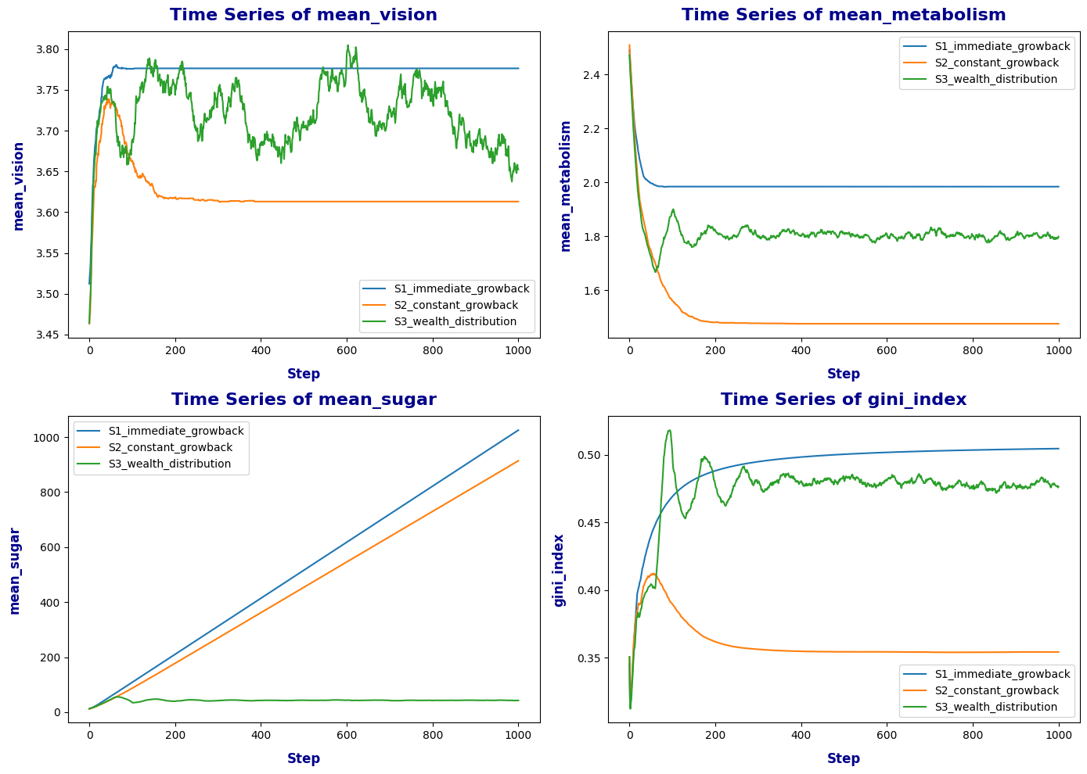

**Table 5** General Factors for Comparison



## 6.2. Comparison of Five Variables in Wealth Distribution Model

In the in-depth analysis of the Sugarscape 3 model, there are five groups of variables in the experiment, which correspond to each other to form 32 different combination experiments. **Table 6** shows all the result after data cleaning and processing.

**Table 6** Behaviour-space Experiment Summary



**Initial Population**:

The model was run with populations of **400** and **1000**. The Gini Index, which measures inequality, is slightly lower in a population of **1000**, suggesting that a larger population might lead to a more equal distribution of resources.

**Figure 2**

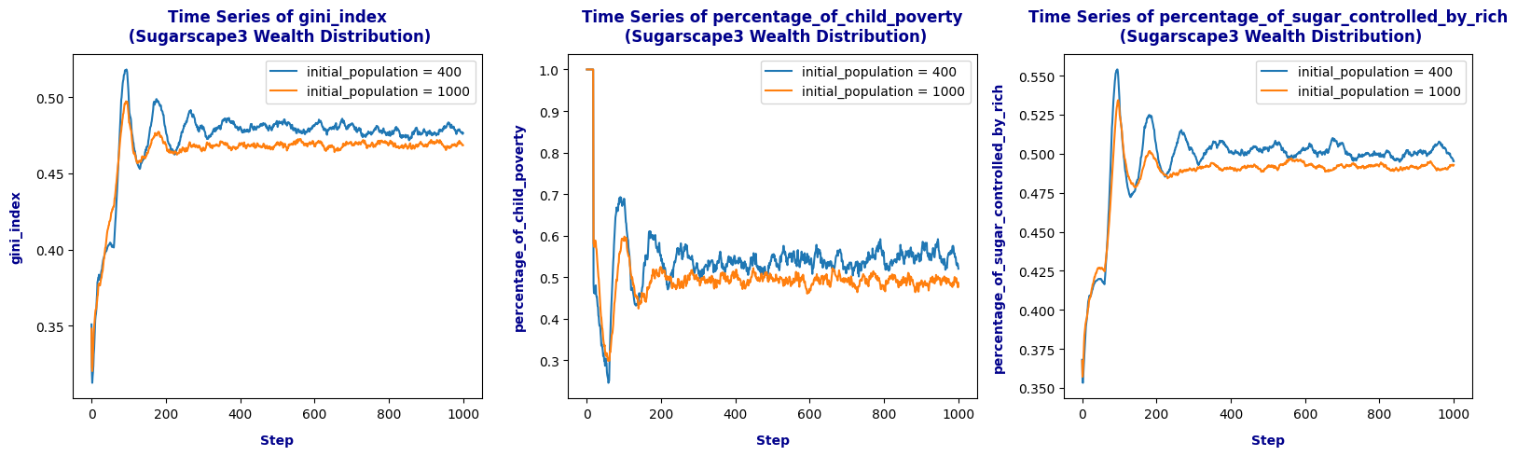

**Growback Rate**:

At a higher growback rate (**3**), the Gini Index is higher (**0.502**) and more than **52%** of the wealth is held by the top 20 percent rich, indicating more inequality possibly due to faster accumulation of resources by the wealthy.

**Figure 3**

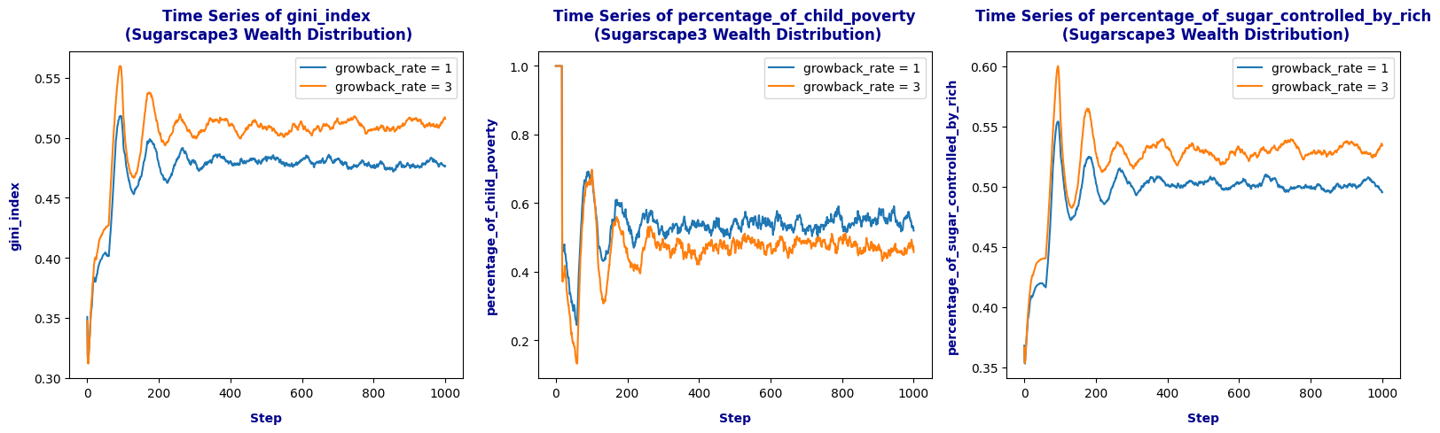

**Death Age**:

The **Table** **6** indicates significant differences in child poverty when death ages are varied, with a mean of **0.639** in child poverty for the **1-100** age range, which is considerably higher than other scenarios. This suggests that longer lifespans could be associated with higher child poverty, perhaps due to generational wealth disparities.

**Figure 4**

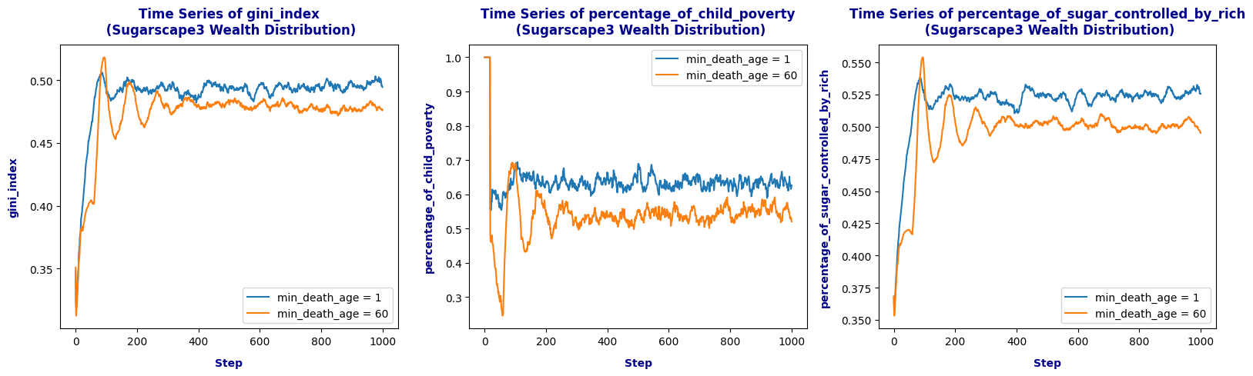

**Vision**:

The model shows more stable Gini Index and poverty rates when vision is limited **1-6**).

**Figure 5**

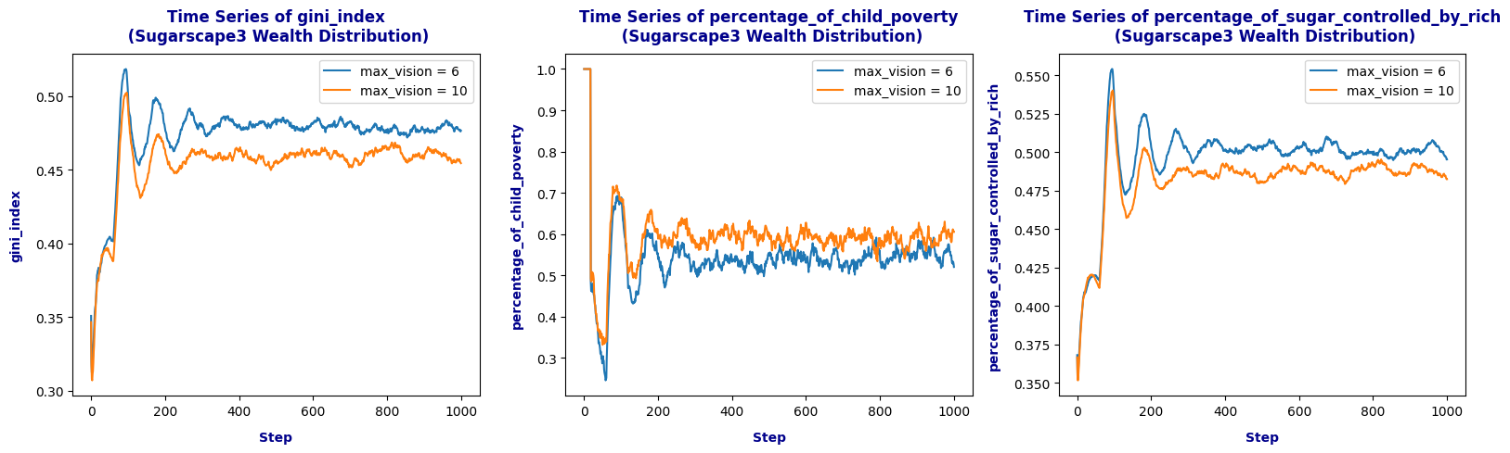

**Metabolism**:

Varied from **1-4** to **1-10**, impacting wealth distribution and poverty. Higher metabolism rates might indicate faster resource consumption or energy use, which impacts wealth distribution, seen in higher poverty rates when metabolism rates are high.

**Figure 6**

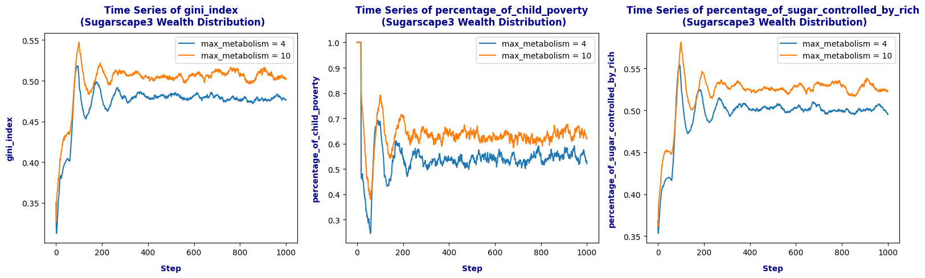

# Discussion

## 7.1. Impact of Economic Environment and Agent Characteristics on Inequality

**Economic Environment:** The variations in the Gini index across different initial population sizes, growback rates, minimum death ages, maximum vision, and metabolism levels illustrate how changes in economic parameters and resource availability affect inequality. For example, higher growback rates generally lead to a lower Gini index, suggesting that faster resource regeneration contributes to more equitable distribution. Similarly, extending the minimum death age tends to reduce inequality, possibly by stabilizing the population and extending the earning potential of agents.

**Agent Characteristics:** Adjustments in maximum vision and metabolism show varied effects. Higher vision capabilities generally correlate with lower inequality initially, as Teece (2007) proposed, as more capable agents can better locate and exploit resources, but this advantage might diminish over time as resources become scarce or competition intensifies.

## 7.2 Agent Conditions Affecting Child Poverty

As discussed by Minujin et.al. (2006), the percentage of child poverty fluctuates significantly across different scenarios, indicating that both the environment and agent-specific traits affect child poverty levels. High metabolism rates and lower vision capabilities increase child poverty rates, suggesting that more needy agents (higher metabolism) and those with less ability to access resources (lower vision) are more vulnerable. These simulations highlight how intrinsic capabilities and environmental richness interact to impact vulnerable populations.

## 7.3 Environmental Changes Affecting Wealth Accumulation

Changes in the environmental factors like growback rate significantly impact the accumulation of wealth, as seen in the percentage of sugar controlled by the rich. Rahman and Shamsaei (2009) posit that faster resource regeneration allows wealthier agents to capitalize on available resources more effectively, thereby enhancing their wealth accumulation. This is evident from the initial sharp increase in the percentage of sugar controlled by the rich when the growback rate is high.

The impact of agent traits such as maximum metabolism and vision also plays a crucial role. Agents with higher metabolism require more resources to sustain themselves, which could either lead to greater resource acquisition skills or greater vulnerability to poverty, depending on other environmental or personal traits.

# Conclusion

Overall, the simulations suggest that economic environments, resource availability, and individual agent characteristics profoundly influence social inequalities, vulnerability of children to poverty, and the overall distribution and accumulation of wealth within these model societies. These results underscore the complex interplay between policy, individual capabilities, and social outcomes like inequality and child poverty.

**Word Cout: 1410 (excludes tables)**

Reference

Epstein, J. M., & Axtell, R. L. (1996). Growing Artificial Societies: Social Science from the Bottom Up. Brookings Institution Press.

Fantom, N.J. and Serajuddin, U., (2016). The World Bank's classification of countries by income. World Bank Policy Research Working Paper, (7528).

McLoyd, V.C., (1990). The impact of economic hardship on Black families and children: Psychological distress, parenting, and socioemotional development. *Child development*, *61*(2), pp.311-346.

Minujin, A., Delamonica, E., Davidziuk, A. and Gonzalez, E.D., (2006). The definition of child poverty: a discussion of concepts and measurements. *Environment and urbanization*, *18*(2), pp.481-500.

Park, D., Hong, J. and Ryu, D., 2024. Heterogeneous expectations in the housing market: a sugarscape agent-based model. *Journal of Housing and the Built Environment*, *39*(3), pp.1465-1489.

Piketty, T. (2014). Capital in the Twenty-First Century. Cambridge, MA: Harvard University Press.

Rahman, A., Setayeshi, S. and SHAMSAEI, Z.M., (2007). An analysis to wealth distribution based on sugarscape model in an artificial society.

RAHMAN, A., SETAYESHI, S. and SHAMSAEI, Z.M., (2009). Wealth adjustment in an artificial society, based on a sugarscape model using one fifth of the wealth variable.

Teece, D.J., 2007. Explicating dynamic capabilities: the nature and microfoundations of (sustainable) enterprise performance. *Strategic management journal*, *28*(13), pp.1319-1350.

Wilensky, U. and Rand, W. (2015). An Introduction to Agent-Based Modeling: Modeling Natural, Social, and Engineered Complex Systems with NetLogo. Cambridge, MA: MIT Press.

Wilkinson, R.G., (2020). Income inequality, social cohesion, and health: clarifying the theory—a reply to Muntaner and Lynch. In The political economy of social inequalities (pp. 347-365). Routledge.

# Appendix

The code list below generated two new to-report function to observe **percentage_of_child_poverty** and **percentage_of_sugar_controlled_by_rich**.

