**堂食预订填写预订信息页**

1. 填写预订信息页面：选择填写预订信息，点击确定跳转到提交订单页面
2. 用餐人数上限30人；

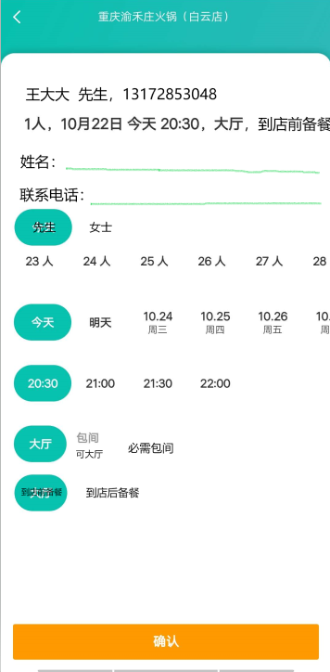

请求参数

|  |  |  |  |
| --- | --- | --- | --- |
| **参数** | **必选** | **类型** | **说明** |
|  |  |  |  |
|  |  |  |  |
|  |  |  |  |
|  |  |  |  |

返回字段

|  |  |  |
| --- | --- | --- |
| **返回字段** | **必选** | **说明** |
|  |  |  |
|  |  |  |
|  |  |  |
|  |  |  |