FREE Specialist Camp
All punters, snappers, kichker’s
All Skill Levels Welcome!
Whether you're new or experienced, come sharpen your skills and get quality reps.
🏆 Led by Luis Zendejas
ASU graduate and longtime NFL kicker
🔥 What We’ll Work On:
- Kicking technique & consistency
- Punt mechanics & hang time
- Long snapping accuracy & speed
- Returners welcome! (Focus on catching, tracking, and ball security)
📅 Date: April 17th
⏰ Time: 6:00 PM – 8:00 PM
📍 Location: Willow Canyon High School
💪 Why Attend?
- Position-specific coaching
- Game-like reps
- Improve fundamentals & confidence
- Compete and get better!
💥 This camp is FREE!
🎯 Bring:
Cleats, water, gloves (returners), and a great attitude
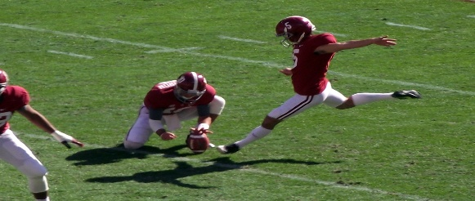
This Photo by Unknown Author is licensed under CC BY-SA

