Stay up-to-date with WCHS Booster Announcements!!



WCHS Boosters uses Stack TeamApp to communicate with parents about WCHS Football. Install Stack TeamApp by following the instructions below.

1. Download Stack Team App from the Apple or Google Play app store.

2. Sign up for your account with Team App. You will be sent an email to confirm your registration.

3. Log into the App and search for “WCHS Football Boosters”.

4. Choose your applicable access group(s).

5. If you do not have a smartphone, go to www.teamapp.com/clubs/546048 to sign up and view this app online.
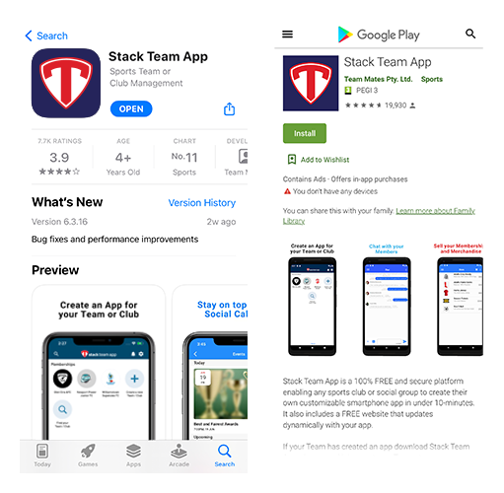

Need help?
Contact: Starr Harlander
Email: wchs.football.sec@gmail.com
Phone: 480.372.1950

