Homework 5

William Cohen

3/6/2021

library(tidyverse)

## -- Attaching packages --------------------------------------- tidyverse 1.3.0 --

## v ggplot2 3.3.2 v purrr 0.3.4  
## v tibble 3.0.4 v dplyr 1.0.2  
## v tidyr 1.1.2 v stringr 1.4.0  
## v readr 1.4.0 v forcats 0.5.0

## Warning: package 'tibble' was built under R version 4.0.3

## -- Conflicts ------------------------------------------ tidyverse_conflicts() --  
## x dplyr::filter() masks stats::filter()  
## x dplyr::lag() masks stats::lag()

Stockreturns <- c(-8.36, 1.63, -2.27, -2.93, -2.70,   
 -2.93, -9.14, -2.64, 6.82, -2.35,   
 -3.58, 6.13, 7.00, -15.25, -8.66,  
 -1.03, -9.16, -1.25, -1.22, -10.27,  
 -5.11, -0.80, -1.44, 1.28, -0.65,  
 4.34, 12.22, -7.21, -0.09, 7.34,   
 5.04, -7.24, -2.14, -1.01, -1.41,   
 12.03, -2.53, 4.33, 1.35)  
Stockreturns

## [1] -8.36 1.63 -2.27 -2.93 -2.70 -2.93 -9.14 -2.64 6.82 -2.35  
## [11] -3.58 6.13 7.00 -15.25 -8.66 -1.03 -9.16 -1.25 -1.22 -10.27  
## [21] -5.11 -0.80 -1.44 1.28 -0.65 4.34 12.22 -7.21 -0.09 7.34  
## [31] 5.04 -7.24 -2.14 -1.01 -1.41 12.03 -2.53 4.33 1.35

#1.  
stockMean <- mean(Stockreturns)  
stockMean

## [1] -1.124615

#2.  
stockSD <- sd(Stockreturns)  
stockSD

## [1] 5.977673

#3.  
pnorm(q = -1.5, mean = stockMean, sd = stockSD)

## [1] 0.4749638

#4.  
qnorm(p = 0.7, mean = stockMean, sd = stockSD)

## [1] 2.01008

#5.  
#Q1:  
#All between  
  
min(Stockreturns)

## [1] -15.25

#and  
  
qnorm(p = 0.25, mean = stockMean, sd = stockSD)

## [1] -5.156495

#6.  
boxplot(Stockreturns)

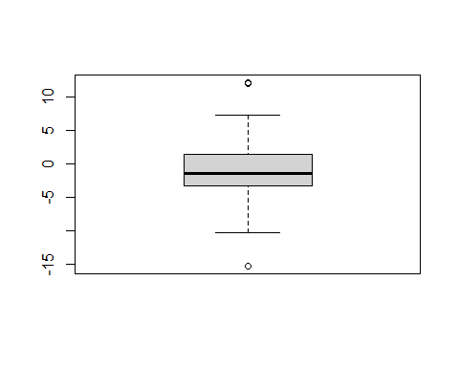

#The return data is not normal as the box plot is not symmetric.  
qqnorm(Stockreturns)  
qqline(Stockreturns)

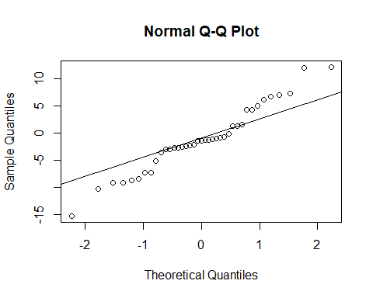

#7.  
# H(0) : Stock return mean is greater than or equal to 0.95, the average return of the S&P 500  
# H(A) : The mean is less than 0.95  
  
#8.  
StockT <- t.test(Stockreturns,mu=0.95, alternative = "less", conf.level = .95)  
StockT

##   
## One Sample t-test  
##   
## data: Stockreturns  
## t = -2.1674, df = 38, p-value = 0.01827  
## alternative hypothesis: true mean is less than 0.95  
## 95 percent confidence interval:  
## -Inf 0.4891698  
## sample estimates:  
## mean of x   
## -1.124615

#9.  
#As the p-value of the t-test,  
StockT$p.value

## [1] 0.01826898

#is less than 0.05, we reject the null hypothesis and conclude there is significant evidence to say the broker performs worse than average.