**VoIP Part 2 (Gantt and PERT Charts)**

Kiflom Semereab

CIS 517 - IT Project Management

Dr. David Verret

Strayer University

August 12, 2018

**Introduction**

There is a full application of Gantt chart together with PERT (Project Estimation Report Techniques) in project management in showing the fundamental tasks which are within a project. The primary task which has been assigned to the project manager is a breakdown of the workload into the manageable task to guarantee that the project will be finished within the time scheduled to complete. The two methods are both considered as more significant tools which are being applied in project management in analyzing the project through visualization, breaking down available work into small parts which are easily manageable to deal with, by doing this there is assurance that the deadline will be fitted in accordance with the original project plan.

**Gantt chart versus PERT diagram**

There are significant differences which exist between the two methods which are frequently applied to project management. The use of PERT together with Gantt chart is the favorite way of how information is being presented. The task which has been scheduled to be completed will be displayed with PERT and Gantt chart. However, the use of chart has emphasized on different pieces. When it comes to the Gantt chart, there is more focus on the percentage completion of the available task; this is without demonstrating the connection that the two task has in common. Whereas on the other hand, the application of PERT does not indicate the percentage completed and showing the work which depends on the other task (Misra and Chakraborty 2018).

The task which are placed in PERT charts usually present themselves having three representative time structure, this includes the following: optimistic, most likely and pessimistic. Through performing an average of time, a manager which has the responsibility of predicting the amount of each task will take before completion, this must be more realistically than the single time that Gantt charts gives. Finally, other significant different which exist between the two method is that Gantt charts are considered to be simpler to reading them. On the other hand, PERT are seen to extend an element of detail in the process of project scheduling through both the network models ability to the display dependence and the PERT exceptional aptitude to do in advance actual time that jobs will take to accomplishment.

**Advantages of Using a Gantt Chart over a PERT Chart and Vice Versa**

There is availability of strength together with the weaknesses that the two tools have. Typically, there is more application of Gantt chart in project management and is considered as one of popular and useful ways of displaying activities which are shown against time. Commonly Gantt chart are mostly applied for tracking schedules of a project which in turn present information in a format of a bar chart. The bar length has a clear indication on when the tasks begins and when they end.

The use of Gantt chart is considered more ideal to those project which are straightforward and have few interlinking jobs. The main idea behind Gantt chart is presenting project tasks and time allocation as the only two variable piece of data. Whereas this is taken as a limitation, there are interconnecting tasks that depend on one another, for more simple job it is at ease to interpret the information which has been presented on the Gantt chart.

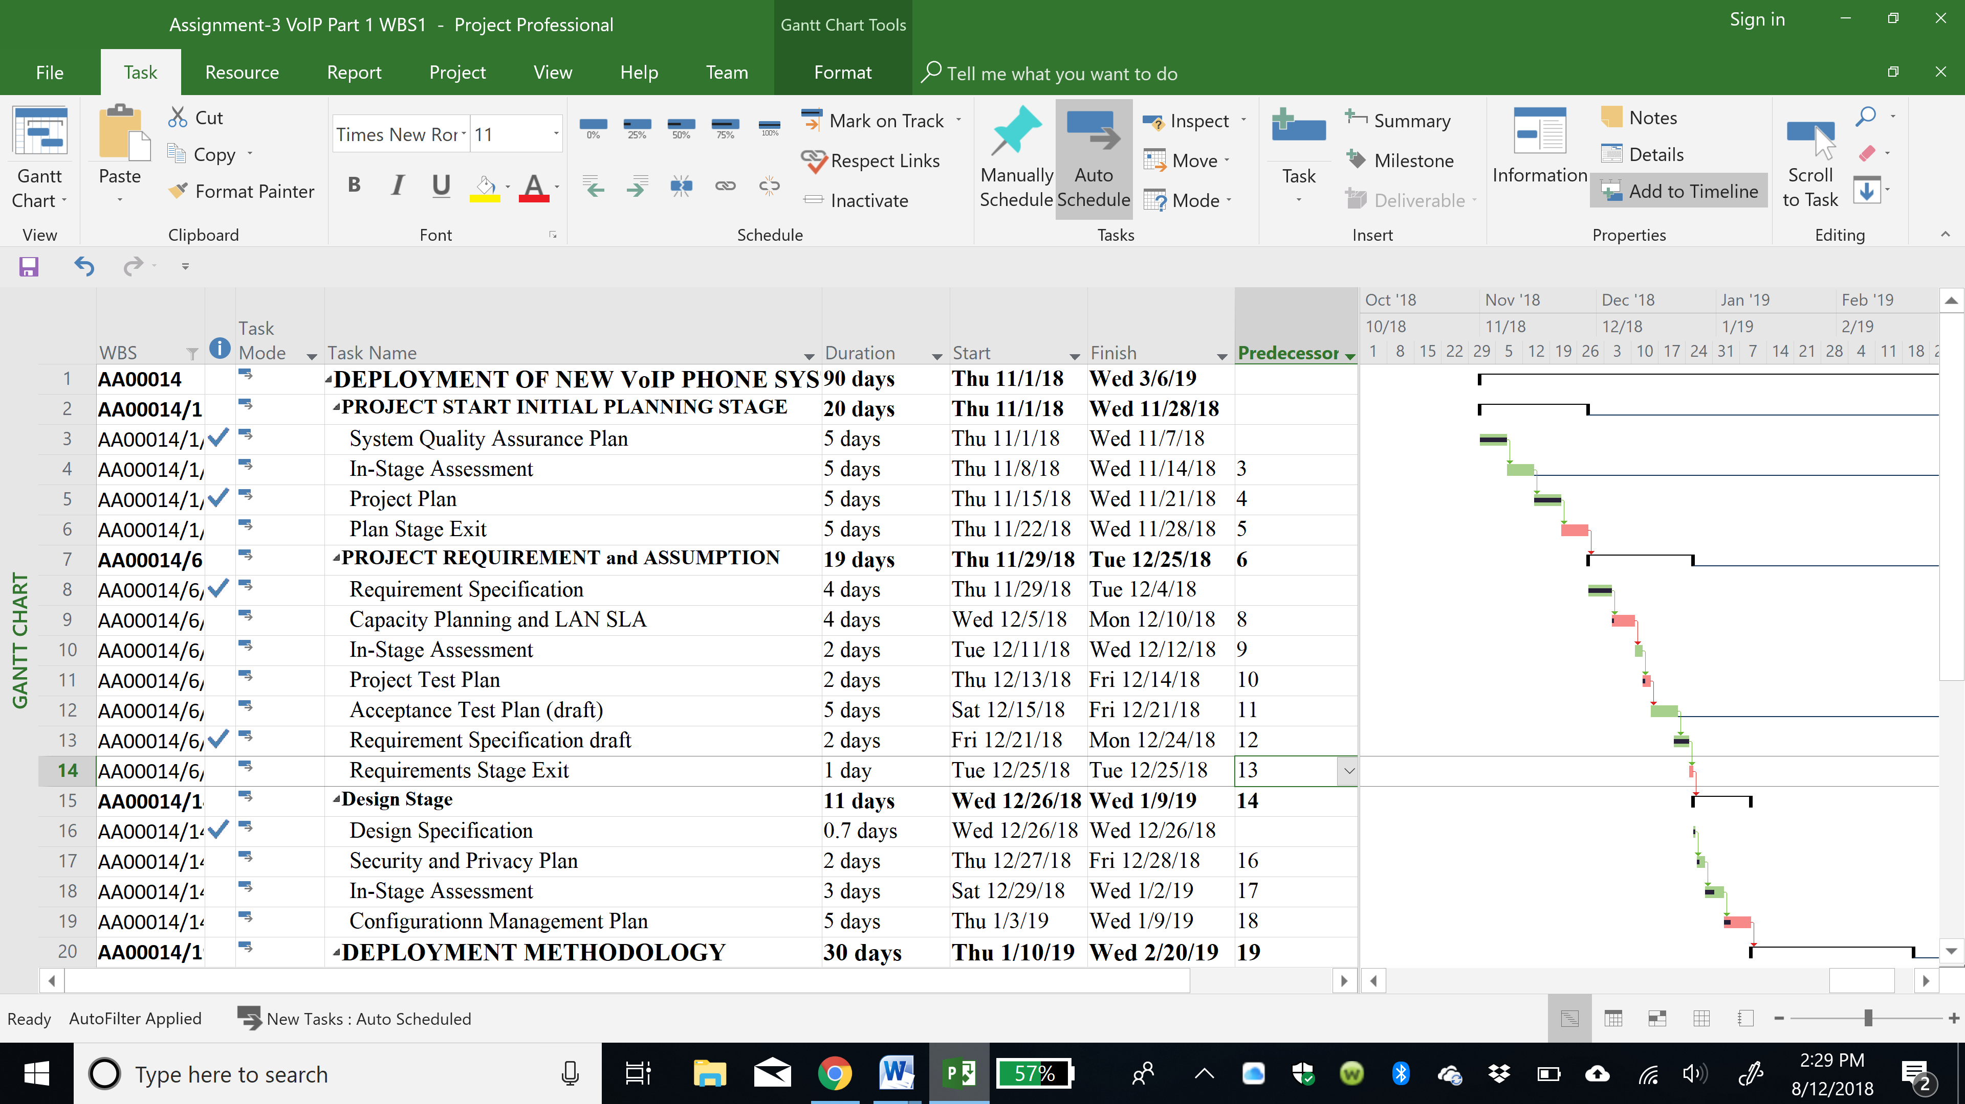

Program Evaluation and Review Technique (PERT) on the other hand is used to displaying information in form of a network model. This assist the project managers in visualizing the sequence of jobs, as you cannot begin on the activity which is coming next until the activity preceding is completed. In addition, PERT chart are used to display dependency nevertheless, Gantt chart are easier to change as a tasks moves along and it comes closer to completion.

Dependent upon the period or complexity of the project under study, there can be breakdown of the effort into phases or reiteration, and those then broken down into errands inside for each phase. There is similar manner on how Gantt chart together with PERT are broken down, potentially by use of a new chart for each phase, or combining the together in order to convey the all of the effort Hartpence B.(2013).



There is a milestone that Gantt chart go at completion of the key deliverable, whereas PERT chart employs appraisals tasks events at the end of each stage, at this time the deliverable of that stage would authenticate as placeholders specifying a communication of subtasks into one deliverable (Madani and Ahmed 2010).

**Importance of the Critical Path in Project Management**

Critical path is a very important to any project being executed and thus it is a must-have in order to stay on track and on the budget. Diagrammatically the critical path is representation of the sequential activities from beginning to the ending of the project of what requires to be completed and when. The critical path is considered as one of the longest categorization of events found in a project that must be accomplished on time for the whole project to end on plan. This events are seen to have direct impact on the date when the project is supposed to be finished. The plan of the project together with the time which has been predicted for completion of the project maybe inaccurate if the critical path is not accurate.

The critical path is considered to be an integral constituent of project management and is more significant in the control of any given project.

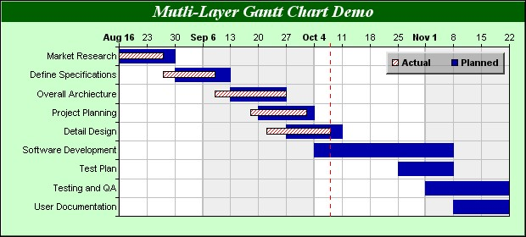

According to Petit J. and Hersent O.(2005) et al, when there has been the identification of the critical path, it can be indicated where effort cannot be realized. When there is a change in any activity present in the dangerous way, the timely completion of the project will be affected. Through determination the duration of the project, in addition to the categorization of the critical project jobs, there should be a focus by project manager on completing the critical path, while on the other hand allowing other tasks to slide their plan if essential, deprived of put at risk the time limit of the project. When a delay happens, many times the acceleration of the project or re-sequencing is accomplished to achieve time limit. “Critical Path Method (CPM) is a technique which is used in the determination of what time limit a project will take. Likewise, for any job which has been scheduled on the project, it will account for the initial beginning time and the slack” Hartpence B.(2013).

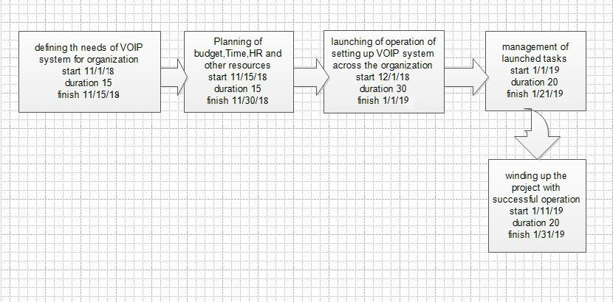

Reference:

Hartpence B.(2013) Packet Guide to Voice over IP: A system administrator's guide to VoIP technologies

Madani H. and Ahmed A.(2010) VoIP Performance Management and Optimization (Networking Technology: Ip Communications)

Misra S. and Chakraborty T.(2018) VoIP Technology: Applications and Challenges (Springer Series in Wireless Technology)

Petit J. and Hersent O.(2005) Beyond VoIP Protocols: Understanding Voice Technology and Networking Techniques for IP Telephony