Fast Food Availability & Adult Obesity in the United States
Digital Story Project Report
December 1, 2025
Wendy Calderon
ITEC 4210 Information Analytics

Dataset Source and Justification
For this project, I used 2 data sets to explore whether fast food availability relates to adult obesity rates in the Unites States.

Dataset 1: Datafiniti Fast-Food Restaurants
This dataset included thousands of listings across the U.S. Key fields used were state and a unique restaurant ID. This dataset allowed the counting of fast-food restaurants per state as the measure of availability.

Dataset 2: CDC Nutrition, Physical Activity, and Obesity
This dataset provided adult obesity percentages for each U.S. state. The data was filtered to 2023 to match the best and most relevant time frame. Key fields included: state abbreviation, state name, obesity percentage. These data sets align because both use state-level data and were joined using state abbreviations.

Project Objective
The main project objective was to test a thesis I had about the correlation between just how much the increasing obesity rates in the United States are caused by the availability of fast-food restaurants. By comparing restaurant counts with obesity prevalence on the state level, the project evaluates whether states with more fast-food restaurants actually show higher obesity rates.

Data Wrangling Process
The process it took to clean the data and filter it to relevant fields included many steps. First was removing irrelevant fields like addresses or phone numbers. Fields that were kept included state, unique restaurant ID, and obesity values. I also made sure that state abbreviations were consistent across datasets. I converted obesity values to numerical values. Curated fields included RestaurantsByState, a summarized table with restaurant counts per state and ObesityCategory grouping states into Low, Medium, or High obesity rate tiers.

Facts and Dimensions
Fact Tables:
- RestaurantByState – RestaurantCount per state.
- ObesityByState2023 – ObesityRate and ObesityCategory.
Dimension is a state field connecting both fact tables.

Visualizations and Interpretations
Visualization 1 – Bar Chart: Fast-Food Restaurants by State
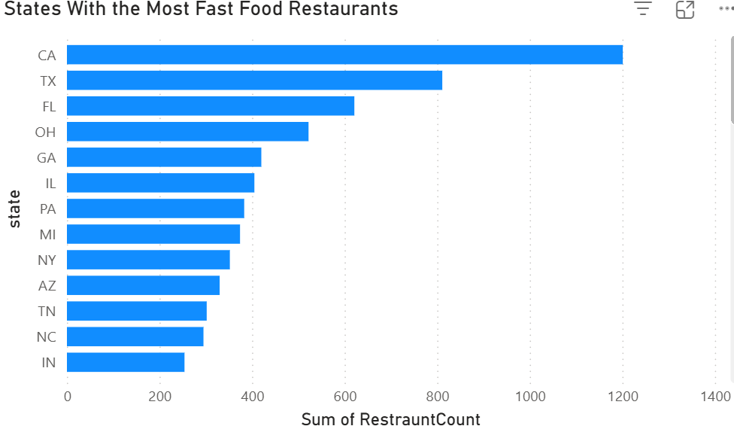
This Bar Chart highlights which states dominate fast-food availability. It shows meaningful gaps between high and low states. This chart sets the stage for comparing availability to obesity outcomes.

Visualization 2 – Bubble Map: Geographic Restaurant Distribution
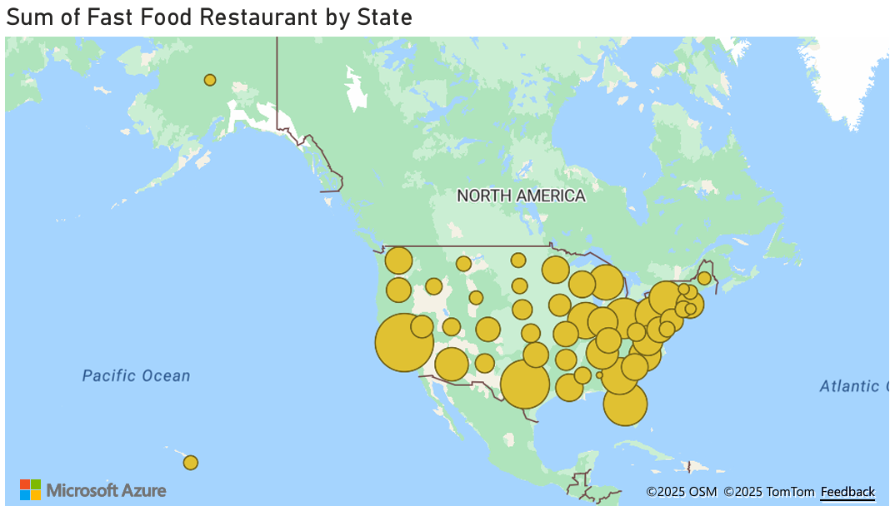
This Bubble Map visualizes the biggest clusters on a map. These include CA, TX, and FL. Smaller states have much fewer restaurants. It shows geographic distribution quickly which makes it effective.

Visualization 3 – Scatter Plot: Restaurant Count vs Obesity Rate
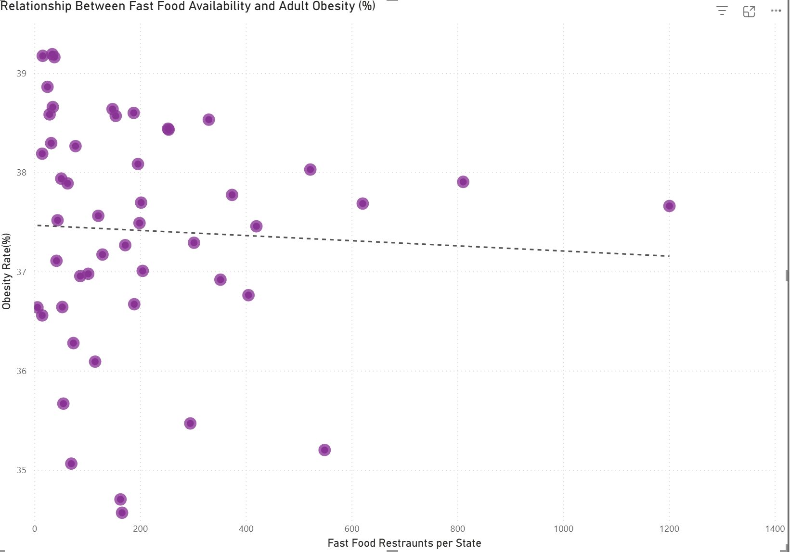
This Scatter Plot was my main analysis for my thesis. The trendline is almost completely flat showing no strong linear relationship. My conclusion came down to this; If fast-food caused obesity I’d see a strong upward trend. However, since the line is basically flat, that means there is no strong correlation between restaurant count and obesity rates. Some states with high counts are mid-range in obesity, and some with low counts are still very high.
Visualization 4 – Treemap: Obesity Categories by State
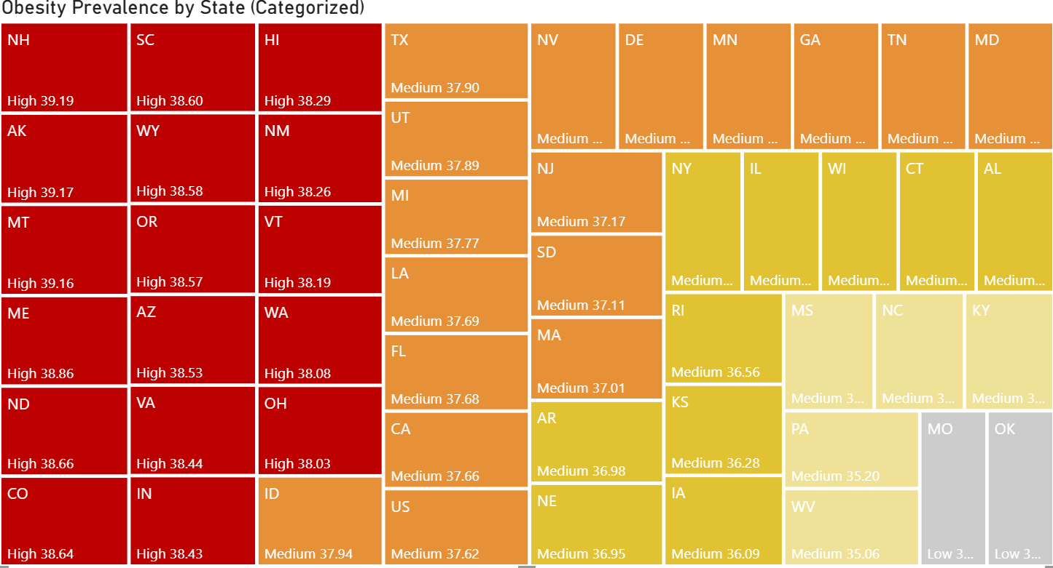
This Tree Map groups states into obesity categories. Low is categorized as Less than 35%. Medium is 35%-38%. High is over 38%. Most states are in the medium range. The high category mostly includes southern states, which lines up with CDC patterns This chart helped summarize obesity levels without mixing them with restaurant counts.

KPIs Used in the Dashboard
- RestaurantCount – number of fast-food restaurants per state
- ObesityRate (%) – adult obesity prevalence
- ObesityCategory – risk tier (Low, Medium, High)
- Overall comparison between RestaurantCount and ObesityRate

Dashboard Overview
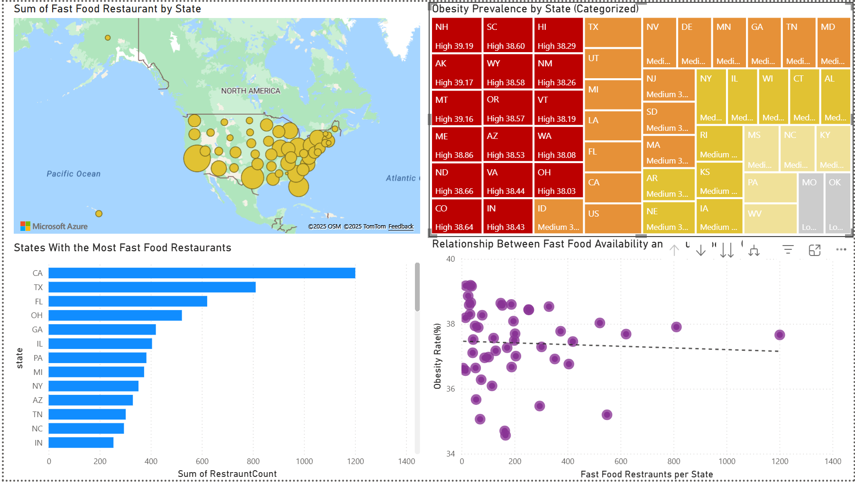
Dashboard contains:
• Bar chart ranking states by restaurant count
• Bubble map of restaurant distribution
• Scatter plot testing relationship between fast food and obesity
• Treemap showing obesity risk categories

Conclusion
The findings show that high fast-food availability does not always match high obesity rates. The weak correlation challenged my assumption that fast food access alone is what drives obesity. Other factors like income, lifestyle, physical activity are likely bigger influences on obesity than I previously thought. My analysis shows how data can help evaluate common assumptions and provide a more accurate picture of public health trends.
In the future, I would add factors like income, physical activity or social influence and compare them over multiple years. I believe additional factors would show a stronger correlation than just fast-food availability.

Contributions
This was an individual project.

For additional information on APA Style formatting, please consult the APA Style Manual, 7th Edition.

