A Two-Level Alphabet for Protein Sequence Generation
A proposal for improving how our model writes protein sequences
Oct 30, 2026 · @Yan

Summary
Let the model decide what kind of amino acid belongs at each position before it commits to the exact one.
Today a position is either finished or blank. There is no way to hold a half-made decision like "this one points into the core, so it should be greasy — which greasy one can wait." That is where folding constraints live. So: group the 20 residues into six chemical families, and have the model write the family pattern first and the identities second. Same model, same size, near-zero added cost.

How the model writes a sequence today
The model is a fill-in-the-blanks machine. We hide a random fraction of a real protein's residues and train it to guess what was hidden, over millions of proteins at every hiding rate.
To write a new protein we run that backwards: start from a blank sequence, ask the model to guess every position, keep only its most confident guesses, and repeat until nothing is blank. A 300-residue protein takes 50 to 200 rounds.
Two features matter later. There is no fixed direction — it can fill the middle first, which is why it is good at scaffolding. And a residue, once written, is never revised.
This family of models is called masked diffusion. DPLM, EvoDiff and the generation mode of ESM3 all work roughly this way.

The problem
Every position is either a specific amino acid or blank, with nothing in between. That bites hardest in the early rounds, when almost everything is blank and the model judges every position separately, sampling each one independently of the others.
Separate choices are the wrong kind of choice for a protein. A greasy residue only works if its spatial neighbours are greasy too; a buried charge needs a partner; two cysteines must both be present. Sampling one at a time gives residues that are each defensible and collectively impossible. Hence the pattern we see: sequences written from scratch fold badly, while sequences written into an existing scaffold are fine, because the surrounding residues hand over the relationships for free.
The one dial we have does not help. Lower temperature collapses every sample onto the same average sequence; higher temperature destroys foldability. What is missing is a way to say this position is buried and hydrophobic; which hydrophobic can wait. The greasy/polar pattern is what sets the fold. Choosing between leucine and isoleucine is a later, much more local question.

The proposed change
Give every position two slots instead of one: a family slot and an identity slot. The model fills in families first and identities second.
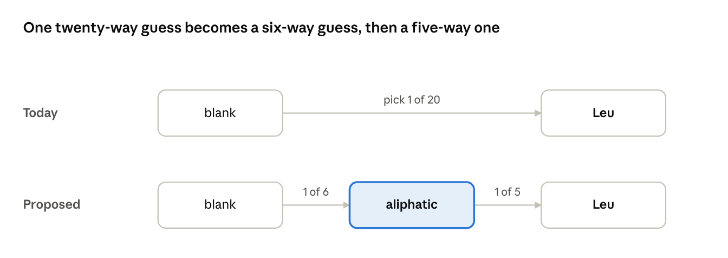
the two-stage reveal · before and after
The journey is the same length; we have added a stop halfway along it. In place of a single twenty-way guess, the model makes a six-way guess and then a five-way one.
The six families group residues by the chemistry that governs how they behave inside a fold.
Family | Residues | What it does in a structure
Aliphatic | A V L I M | Packs the core; the main driver of folding
Aromatic | F W Y | Core packing plus ring stacking, common at interfaces
Polar | S T N Q H | Surface, hydrogen bonding, active sites
Positive | K R | Salt bridges, contacts with nucleic acid
Negative | D E | Salt bridges, metal coordination
Special | G P C | Flexibility (G), rigid kinks (P), disulfides (C)
Every residue belongs to exactly one family, so the label is computed from the sequence itself. Nothing is annotated by hand and no structures are needed.
Two rules keep the family slot meaningful. Families are hidden less often than identities during training, so the pattern comes out first at generation time. And a written family is binding — the identity stage may only pick inside it, enforced in the code rather than left to the model's discretion.
Everything else stays put: same network, same size, same training objective. The additions are one lookup table on the way in and one output layer on the way out.

Why we expect it to help
- The coordination problem shrinks. The relationships that wreck a design — core packing, salt bridges, helix propensity, disulfides — are family-level, not identity-level. Six options are easier to coordinate than twenty. And once families are settled, picking which aliphatic goes where really is a local decision, which is the one case where the model's one-at-a-time habit is harmless.
- Two dials instead of one. Sample families cold to protect the fold and identities hot for variety. Available at generation time, with no retraining.
- Mistakes become graded. Leucine-for-isoleucine becomes a cheap within-family slip, while leucine-for-aspartate requires a family error. Today they are equally wrong.
- A control knob we actually want. We can write the family pattern ourselves and let the model fill identities: transmembrane segments, amphipathic helices, coiled-coil registers, surface charge.

How we will know if it worked
The decisive test is one you can read off a hydropathy plot, and I would run it first.
- Hydropathy periodicity. Fourier-transform the hydrophobicity trace of each generated sequence. Real proteins show sharp power near 3.6 residues per cycle for helices and 2 for strands. The current model has no mechanism for organising patterning at that scale and should look flat by comparison.
- Quality against variety. Sweep both temperatures and plot foldability against diversity as a curve. The claim is that the whole curve moves outward, not that one number improves.
- Controllability. Hand the model a family pattern taken from a real protein, then measure how often it complies and whether the result still folds.
Controls: match parameter count and compute against the current model, and try two-family and ten-family versions to check the benefit tracks the hierarchy. Also worth watching is the fraction of buried positions that come out hydrophobic, against the natural distribution. Tests 1 and 2 both coming out positive would convince me; 2 without 1 is probably an incidental regularising effect rather than the mechanism.

Risks
- The family split is a judgement call. Six is my guess at the right granularity, not a derived number. Too coarse and the families do not constrain the fold; too fine and we have relabelled the original problem. This is where I most want your opinion.
- Function may not benefit. The argument is about folding. Active sites care about exact identity, so expect gains in foldability and little or nothing in catalytic plausibility.
- The second stage could go dead. At strongly conserved positions the family may already fix the identity, leaving the identity stage little to learn.
- The model might ignore its own plan. The binding rule should prevent this, but it is worth confirming rather than assuming.
We should drop the idea if the periodicity test shows nothing after a fair training budget, or if the advantage vanishes once compute is matched.

