Study of Crystalline Water Ice in the Kuiper Belt
[name redacted]

I. Introduction
The spectrum of a Kuiper Belt Object (KBO) provides clues about its composition, particularly about the type of ice on its surface. In this study, ice is broken down into two categories based on molecular structure: crystalline and amorphous. Crystalline ice has molecules that are organized in a geometric pattern. In contrast, the molecules of amorphous ice are randomly arranged. An object’s surface ice composition indicates the physical processes in effect on that object.
To determine the type of ice on an object, a spectrum of the object is required. From spectral features, an analysis is made of the object’s composition. In particular, the 1.65 micron feature observed on some KBOs indicates the presence of crystalline water ice. Crystalline water ice features have already been identified on some KBOs, including Charon (Cook et al. 2007) and Quaoar (Jewitt & Luu, 2004). Ice on a KBO should be amorphized on time scale much less than the age of the solar system, less than 30 Myr according to Cook et al. (2007). So why do spectral signatures for crystalline water ice appear for KBOs?
Several theories have been put forth, including that of Cook et al. (2007), which says that the existence of crystalline water ice on the surface of a Kuiper Belt Object indicates possible cryovolcanic activity. The primary objective of this study is to identify which objects in the collisional family of the KBO 2003 EL₆₁ have crystalline water ice and determine if cryovolcanism is a plausible mechanism for the resurfacing of these objects.
Spectral data for the 2003 EL₆₁ collisional family are taken from the Supplementary Material of Brown et al. (2007). The Brown et al. data are discussed in Section 2 of this paper. The approach used to determine whether ice is crystalline or amorphous is based on the study of Mastrapa and Brown (2006), where the area of the 1.65 micron spectral feature is employed. This method and the results of the area ratio analysis are discussed in Section 3. A theoretical model showing the plausibility of cryovolcanism on KBOs is discussed in Section 4. Finally, Section V contains a discussion of how Hapke modeling can be applied to the problem at hand to make future progress on this work.

II. Data
The KBO 2003 EL₆₁ has a rapid rotation rate and a “family” of other KBOs with similar orbit characteristics (inclination, eccentricity, etc.) Objects in the 2003 EL₆₁ collisional family are the primary focus of this study. Brown et al. (2007) presented infrared spectra of six objects which will be discussed. These are 1995 SM₅₅, 2005 RR₄₃, 2002 TX₃₀₀, 2003 OP₃₂, and 2003 EL₆₁ and its satellite. The spectra, which come from the Supplemental Figure of Brown et al. (2007), were taken between 1.4 and 2.4 microns with a spectral resolution of λ/∆λ~160 using NIRC, the near-infrared imaging spectrograph on the W.M. Keck Telescope (see Fig. 1.)
Due to inability to access the original data used to create the spectra seen in Fig. 1, data points had to be extracted from the literature using a program called GraphClick. This method introduced new sources of error into the calculations for which the spectra are used. First, the errors for individual data points are unknown. Second, some of the points had to be selected by hand, so the location of each data point is not exact. These uncertainties did not affect qualitative deductions made from the data, but made it difficult to quantitatively assess errors in numerical results.
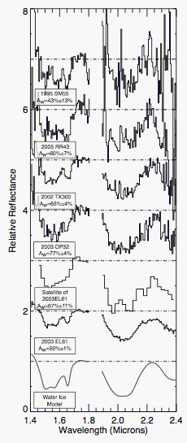
Fig. 1. Supplemental Figure from Brown et al. (2007) showing the spectra and water ice model for the collisional family of 2003 EL₆₁.

III. Observational Results
The molecules in crystalline ice are arranged in a repeating pattern, while the molecules in amorphous ice are randomly arranged. In addition to their difference in molecular arrangement, crystalline and amorphous ice differ spectroscopically. Both types of ice have features at 1.5 microns and 2 microns, but the 1.65 micron feature is different for crystalline and amorphous ice. By measuring the band ratio of the 1.65 micron feature to the 1.5 micron feature, it is possible to determine the degree of crystallinity. This method, described by Fink and Larson (1975), involves measuring the area of the 1.65 micron band and comparing it to the full 1.5 micron band, which extends from 1.4 to 1.8 microns. A sample of the band areas used in this method are shown in Figure 9 of Grundy and Schmitt (1998).
A similar method is used by Mastrapa and Brown (2006). To perform the method, a baseline is drawn from 1.4 to 1.8 microns on the spectrum. A second baseline is drawn from 1.6 to 1.8 microns. The ratio of the area under the second baseline to the area under the first is used to determine whether or not an object has crystalline water ice. The resulting area ratio is offset by 0.1 from the ratios found by Grundy and Schmitt (1998). In either case, the ratio of band areas can be used to determine the temperature of ice. Figures 6 and 7 of Mastrapa and Brown (2006) illustrate the dependence of the band area ratio on temperature. The result is that amorphous ice has a band area ratio of about 0.03, whereas crystalline ice at a temperature of 50 K has a ratio of about 0.10.
To measure the band ratios, a routine written in IDL was used to compute the area ratios for each object. The results are presented in Table 1 below.
Table 1 – 2003 EL₆₁ collisional family band ratios
Object | Ratio
1995 SM₅₅ | 0.1410
2005 RR₄₃ | 0.0537
2002 TX₃₀₀ | 0.0898
2003 OP₃₂ | 0.0829
Satellite of 2003 EL₆₁ | 0.1053
2003 EL₆₁ | 0.0936

The data clearly indicate that crystalline water ice is present on each of the objects. The only object which is uncertain is 2005 RR₄₃, but a qualitative look at the spectrum verifies the presence of a 1.65 micron feature. The same routine was run using a range of baselines for each object, producing a range of values of about ±0.02 in the areas.

IV. Model Results
A theoretical model was developed by Desch (publication in progress) to determine the size limit above which KBOs can harbor a sub-surface ocean due to radiogenic heating. Inputs into the one-dimensional, time-evolving internal modeling code are radius and density. The code was run for a range of radius values from 200 to 1000 km and density values from 1.1 to 2.5 g cm⁻³. Calculated freeze-out times are shown as a function of radius and density in Fig. 2 below.
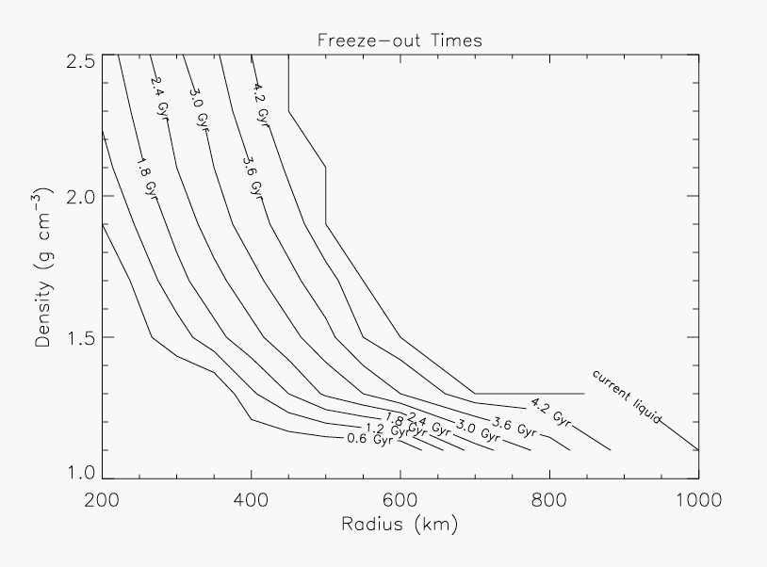
Fig. 2. Contour plot of freeze-out times as a function of radius and density. Anything to the right of the “current liquid” line should currently harbor sub-surface liquid.

The model results indicate that KBOs with a radius greater than ~500 km will have sub-surface liquid if their densities are greater than ~2.0 g cm⁻³. They will therefore show the spectral signature for crystalline water ice if the sub-surface liquid is able to spill out onto the surface through fissures in the icy surface layer. Ultimately, this means that using the technique described in Section 3 on KBOs above 500 km should result in the determination that crystalline water ice is present.

V. Proposal of Future Work
Although the analysis presented in Section 3 allows a determination of whether or not crystalline water ice is present on a KBO, a more rigorous approach is required to determine a quantitative crystallinity fraction. Hapke modeling provides a better quantitative understanding of the problem at hand. In particular, the Hapke model (Hapke 1981) analysis will yield a crystallinity fraction rather than a simple “crystalline” or “amorphous” diagnosis. In this technique, data is analyzed by fitting spectra using models for a mix of crystalline and amorphous water ices. The Hapke model parameters are: 1. ω_{o} (single scattering albedo), h (the width of the opposition surge), S_{o} (the strength of the opposition surge), P_{o} (the particle phase function parameter) and θ (the effective surface tilt). The output is the most likely fraction of crystalline to amorphous water ices. By adding a Gaussian noise term to the data, a range of likely crystallinity fractions can be determined.
In order to have an understanding of the role of crystalline water ice in the Kuiper Belt, an extensive study of KBO spectra is required. The proposed study would involve acquisition of data using an infrared spectrometer, combined with existing data available in literature. Hapke parameters for each object and models for crystalline and amorphous water ices at appropriate temperatures will be determined from existing sources in the literature. The resulting Hapke model fit will provide insight into the prevalence of crystalline water ice and the mechanism by which it is produced in the Kuiper Belt.
References Cited
Brown, M.E., Barkume, K.M., Ragozzine, D., Schaller, E.L. 2007. A collisional family of icy objects in the Kuiper belt. Nature 446, 294-296.

Cook, J.C., Desch, S.J., Roush, T.L., Trujillo, C.A., Geballe, T.R. 2007. Near-Infrared Spectroscopy of Charon: Possible Evidence for Cryovolcanism on Kuiper Belt Objects. Astrophysical Journal 663, 1406-1419.

Fink, U., Larson, H.P. 1975. Temperature dependence of the water-ice spectrum between 1 and 4 microns - Application to Europa, Ganymede and Saturn's rings. Icarus 24, 411-420.

Grundy, W.M., Schmitt, B. 1998. The temperature-dependent near-infrared absorption spectrum of hexagonal H2O ice. Journal of Geophysical Research 103, 25809-25822.

Hapke, B. 1981. Bidirectional reflectance spectroscopy. I - Theory. Journal of Geophysical Research 86, 3039-3054.

Jewitt, D.C., Luu, J. 2004. Crystalline water ice on the Kuiper belt object (50000) Quaoar. Nature 432, 731-733.

Mastrapa, R.M.E., Brown, R.H. 2006. Ion irradiation of crystalline H2O ice: Effect on the 1.65-micron band. Icarus 183, 207-214.

