**Table of Contents**

**System Request Pg. 2**

**Narrative Pg. 3**

**Agile Stories Pg. 6**

**Process Models Pg. 8**

**Vision Document Pg. 10**

**Team Charter Pg. 16**

**The Glen Group**

**William Brown, Chris Isherwood, Ken Ballard,**

**Brendan MacNamara, Patrick Baker**

**System Request** --- University of Louisville School of Nursing

**Project Sponsor:**     Dr. Barker

University of Louisville School of Nursing

Trish Hart, Assistant Dean of the School of Nursing

**Business Need:**

The School of Nursing has requested a solution for their need of a new website that is easily managed, as well as a collaborative database that contains all the student information in a centralized location.

**Business Requirements:**

Student Tracking/Management

Reduction of Manual Entry/Redundant Data

Include Student Record Queries

        Generate Reports

       Data Security

       Increased Productivity by Automating Processes

       Data Consolidating

       Streamlining Application Process

**Business Value:**Increase productivity by automating processes

Increased Grant Funding

By implementing automated student application submission forms for potential students and current students applying for upper division status, the School of Nursing can focus more on tracking students to decrease attrition rates. Creating an automated process can help the School of Nursing to focus more time than they currently spend on obtaining grants. Each grant proposal takes roughly 5 hours to complete. Through this automated process we can reduce the completion time on grants by a conservative estimated time of 1 hour, to 4 hours, and with a 40-hour work week and assuming a 40% success rate on $5,000 we could potentially increase their revenue:

       Old Grant Revenue Estimate: ((40/5).4) *$5,000 = $16,000

       New Grant Revenue Estimate: ((40/4).4) *$5,000 = $20,000

This reduction in grant completion time amounts to a potential estimated grant revenue increase of $4,000.

Decreased Attrition Rates

By implementing a better system to track students through automated processes we can help to reduce the attrition rate in the School of Nursing. The automated processes free up time for advisors to work with students. These advisors could potentially retain a conservative estimate of two students per year with an estimated $6,000 in tuition and fees;

Retained students: (2*$6,000) *2 semesters = $24,000 increase to tuition revenue per year.

**Narrative**

**Problem Statement:**

The client, the School of Nursing, requires contemporary IT solutions so that they accomplish their goal of acquiring a fully operational and interactive web site and centralized database. After implementation of these two entities, we are confident that the College of Nursing, as an institution, will be able to focus on the most significant aspects of the organization.

Our group plans to implement high quality solutions in resolving the college’s most significant technological issues. These solutions will create value for the School of Nursing by increasing student retention, consequently creating revenue and a reduction in costs.

**Business Case:**

As the School of Nursing continues to compete to be one of the top 100 nursing school in the nation, it is apparent that data consolidation and management as well as student tracking is of the utmost importance in a competitive environment. As more students choose their choice of college each year, and they apply and are granted acceptance at UofL, their concerns over their lack of IT automation will only continue to heighten. By planning and designing potential solutions now, the School of Nursing will be better positioned to focus on organizational goals: retaining their students and graduating the best and brightest nurses from the University of Louisville.

    Our group will focus on identifying and solving key problems addressed. In addition to data consolidation, other problems exist such as labor intensive application forms, student tracking and enrollment, an interactive website, and a lack of query-able databases. Finding solutions to these problems could allow the School of Nursing to retain more students from freshman to senior year, increasing their revenue while also decreasing labor intensive manual processes.

    Data consolidation remains as one of the key problems for the School of Nursing, and will be considered high priority in order to eliminate data redundancies as well as data errors that may exist in their current system. With the current Excel and Access database combination, the School of Nursing could increase productivity as well as data accuracy but implementing a new system with one centralized database, containing pertinent student information accessible by authorized personnel at any location necessary. Doing this will allow data to be accessed through queries, saving time and allowing focus to shift even more to the tracking and graduation of students making their way through the nursing program.

**Technical Feasibility**

This portion of the Feasibility Study encompasses several questions:

* Can the client’s problems be solved with current technology?
* Will the new information system be compatible with some parts of the system being replaced?
* How much training should be expected for employees to learn the new system?

In addressing the aforementioned problems, the current technology for the creation and implementation of the system does exist. As it pertains to compatibility, any existing system features that must be included will be integrated without fail.

Given the extensive efforts the admins of the College of Nursing using Microsoft Excel, Access, SharePoint, and the current web interface, we are confident that the users at the SoN will quickly acclimate, and become familiar with the new system, fairly quickly.

**Organizational Feasibility**

In the organizational feasibility, it is vital to note the key stakeholders and their relationship with the College of Nursing. These are:

·        Admin (Champion)– The admin helps to initiate the project to address the problem. They provide the resources necessary to find possible solutions. They help provide the project guidelines and see the project to completion.

·        Advisors (Management) – The advisors know the project and how the project will benefit them. They will be able to determine how the project is doing and if it helps to reduce the total workload that they currently are experiencing. They are a primary end-user in the project.

·        Students (System user) – The students, like the advisors, will be a determinate in if the project is successful or not. The students will also be a primary end-user for this project.

**Economic Feasibility**

Judging the economic feasibility of implementing a new system, there are many factors to consider. The economic viability of the project requires determining if increased revenue will outweigh any potential costs.

|  |  |
| --- | --- |
| **Development Costs** | **Operational Costs** |
| Hardware and software | Hardware upgrades |
| Add-ons for software | Software upgrades |
|  | Hardware Repairs |
|  | Software Licensing Fees |

|  |  |
| --- | --- |
| **Tangible Benefits** | **Intangible Benefits** |
| Revenue Increase | Student Happiness |
| Increase in efficiency | Increased advisor/student relationship |
| Decreased attrition rates | Increased interest for SoN |
|  |  |

|  |  |
| --- | --- |
| **Benefits** | **$ Amount** |
| Reduced attrition ($6,000 per semester per student) | $24,000 |
| Student acquisition ($6,000 per semester per student) | $60,000 |
| SoN has more time to apply for grants | $4,000 |
| Decrease in work load hours per year | 80/year |
| Total potential benefits | $88,000 |

**Agile Stories**

Judging by what the client has desired to be incorporated in their new proposed system and based on what the user’s needs will be, we have developed agile stories. These stories will be useful in determining how the proposed system needs to be used and what features need to be considered into its design and implementation.

|  |  |  |  |
| --- | --- | --- | --- |
| **Title** | Data Management | | |
| **As...** | Admissions/Advisors | | |
| **I want to.** | Be able to access student information from one centralized database | | |
| **So that...** | Data redundancy, data error, and manual labor is reduced or eliminated due to automatic processes from application input and input student information. | | |
|  | 4 | GLEN Development Group | 4 |
| ID: 1 | **Value** (On a 1-4 Scale, 4 Being Highest) | **Author** | **Effort Estimate** (On a 1-4 Scale, 4 Being Highest) |

|  |  |  |  |
| --- | --- | --- | --- |
| **Title** | Online Application Management | | |
| **As...** | Aspiring/Current Nursing students | | |
| **I want to...** | Apply online through a streamlined application process that submits electronically to the School of Nursing | | |
| **So that...** | feedback regarding acceptance and rejection based on their application is received in a timely manner via email. | | |
|  | 3 | GLEN Development Group | 3 |
| ID: 2 | **Value** (On a 1-4 Scale, 4 Being Highest) | **Author** | **Effort Estimate** (On a 1-4 Scale, 4 Being Highest) |

|  |  |  |  |
| --- | --- | --- | --- |
| **Title** | Run Queries/Generate Reports | | |
| **As...** | Admissions/Advisors | | |
| **I want to...** | Be able to run queries and generate reports based on a consolidated worksheet that contains all student information | | |
| **So that...** | The School of Nursing can better track their students and easily track GPA, clinicals, certification compliance, and graduation requirements. | | |
|  | 4 | GLEN Development Group | 3 |
| ID: 3 | **Value** (On a 1-4 Scale, 4 Being Highest) | **Author** | **Effort Estimate** (On a 1-4 Scale, 4 Being Highest) |

|  |  |  |  |
| --- | --- | --- | --- |
| **Title** | Receive Online Application Forms | | |
| **As...** | Admissions/Advisors | | |
| **I want to...** | Receive online application submissions from undergraduate, postgraduate, Master’s, and doctoral programs | | |
| **So that...** | Submitted application forms could be automatically input into a centralized database and automated emails could be sent to students verifying acceptance or rejection. | | |
|  | 2 | GLEN Development Group | 2 |
| ID: 4 | **Value** (On a 1-4 Scale, 4 Being Highest) | **Author** | **Effort Estimate** (On a 1-4 Scale, 4 Being Highest) |

**As-Is Process Model**

This model describes the current system that the School of Nursing uses, describing the different steps they take for their students to enroll and eventually graduate.

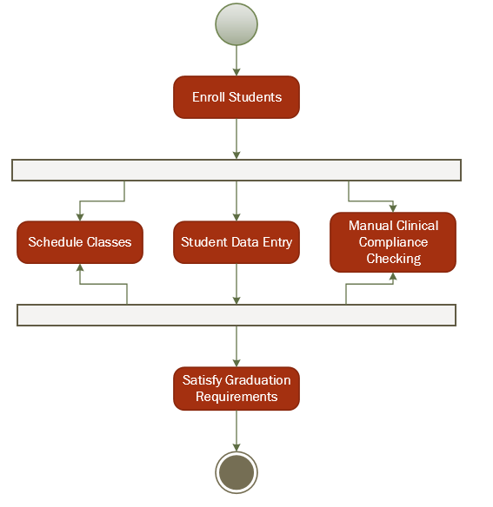

**To-Be Process Model**

This model describes what the School of Nursing’s business processes could look like if a new system is implemented, allowing new steps and more in depth business processes to take place.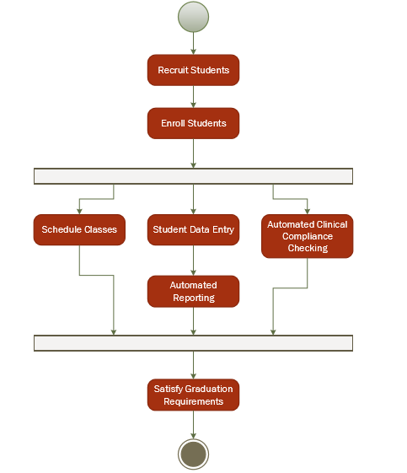

**Vision**

# Introduction

Trish Hart of the University of Louisville's School of Nursing approached Dr. Barker's CIS 320 class with a series of technical problems and limitations their organization is currently facing. These include a need for database querying, report generating, and reduction of manual entries. Glen Development Group intends to conduct research into, and eventually design, a solution that will resolve the issues and limitations that the School of Nursing department currently faces.

## References

While working on this project, Glen Development Group has utilized the following resources to gather pertinent information.

* Client-based discussions.
* Recommendations made by Dr. Barker.
* National League of Nursing website.

# Positioning

## Problem Statement

The School of Nursing does not presently have a dedicated database which allows them to make streamlined queries, generate reports, and adding new entries requires extensive manual processing. The primary goal is to create a system solution that would reduce data redundancy, allow for streamlined data queries and reports, allow for multiple users, and be relatively user-friendly. The secondary goal is to create the system which would integrate the proposed solution within the School of Nursing department, allowing the staff better data access and data interpolation, allowing new student data entries to occur without excessive labor, and reducing erroneous data.

|  |  |
| --- | --- |
| The problem of | generating streamlined queries and reports, data redundancy, and multiple user access |
| affects | School of Nursing staff and students |
| the impact of which is | repetitive data processing, time-loss, inefficient data accessibility |
| a successful solution would be | one that is FERPA and HIPAA compliant while also consolidating the School of Nursing database into a system which allows for streamlined queries, generating reports, is accessible to multiple users, and feasible for the department's budget. |

## Product Position Statement

|  |  |
| --- | --- |
| For | Admission Staff, Potential Students, and Returning Students |
| Who | need access to the School of Nursing student database, require generated reports, |
| The (product name) | consolidated database |
| That | will allow for easier data manipulation and streamlined database interpolation |
| Unlike | the current system of Excel spreadsheets and Microsoft Access databases |
| Our product | could allow for a more efficient and effective data entry and  retrieval process. |

# Stakeholder and User Descriptions

## Stakeholder Summary

|  |  |  |
| --- | --- | --- |
| Name | Description | Responsibilities |
| Students | Individuals attending the College of Nursing to gain accreditation. | Students are the entire purpose of the Nursing program and they require:   * Ability to view their academic progression and standing |
| University of Louisville | Parent organization that supports the School of Nursing department. | U of L provides the Nursing department with funding and they require:   * Student retention reports * Student graduate reports * Student progression reports |
| Hospitals | Organizations who intend to hire and employ the U of L Nursing students. | Hospitals are the organizations who hire potential graduates, they also provide on-site training for the students and they require:   * Student graduate data * Student admission data |

## User Summary

|  |  |  |
| --- | --- | --- |
| Name | Description | Responsibilities |
| Admission Staff | The employees running and maintaining the admissions and retention of students in the School of Nursing | School of Nursing Admission staff are the primary workforce in the admissions office and are responsible for:   * Enrolling Students into lower and upper divisions * Seek grants and donors for continued funding * Financial reporting * Student Progress Reporting |
| Students | Individuals attending the College of Nursing to gain accreditation. | * Access all online applications and forms for upper division programs * Online Form Submission |

## User Environment

* Centralized Database System with the ability to:
  + Consolidate Data
  + Query Abilities
  + Generate Reports
  + Record Keeping for Current and Previous:
    - Students
    - Donors
* Website with the ability to:
  + Application Retrieval
  + Application Submission
  + Donation Form Retrieval
  + Donation Form Submission
  + Integration of the Centralized Database
  + News Feed
  + Calendar of Scheduled Events

## Summary of Key Stakeholder or User Needs

|  |  |  |  |  |
| --- | --- | --- | --- | --- |
| **Need** | **Priority** | **Concerns** | **Current Solution** | **Proposed Solutions** |
| Data Consolidation | High | Data loss, data integrity, redundancies, accuracy | Excel Spreadsheets, Access Database | A consolidated database storage solution that could allow for a database that contains all necessary information that could be used to run queries and generate reports from. |
| Web Browser | High | Online submission forms | Webpage | An interactive webpage that allows automated database entries and responses based on applications and student input |
| New Student/Continuing to Upper Division Students | High | Data redundancy, student tracking, data integrity | Webpage, Excel Spreadsheets, Access Database | Application submission forms that automate information into a consolidated database to eliminate data redundancy and excess manual labor |
|  |  |  |  |  |

## Alternatives and Competition

* Microsoft SharePoint in conjunction with Office 365 contains the tools capable to accomplish some needs of the School of Nursing. While it has options for offering Office 365 for non-profit organizations SharePoint charges by the user. This means that as the School of Nursing grows, the monthly costs of SharePoint would also grow.
* Microsoft Azure would be a sufficient alternative to the problems proposed by the School of Nursing. This program has the ability to manage the web content, the integrated consolidated database structure, as well as the back ends of both entities. A major drawback of this approach is the limited security provided by the Azure cloud.
* The current data management system and web site lack options and expandability. It also lacks data consolidation and access to current data. It is, however, inexpensive.

**Product Overview**

## Product Perspective

The product could consist of three major components: The first being a consolidated database system to store student information to readily generate reports and queries based on the needs of the School of Nursing. The second component could be an improved system of online application submission forms that could allow information to be automatically entered into a consolidated database once submitted, along with automated emails describing deadlines and important information relevant to individual students. The final component could be an improved user experience, with more access to information relevant to their needs and a better process through which to apply to upper division status from, as well as for authorized personnel to be able access better and more accurate data.

## Assumptions and Dependencies

The School of Nursing relies heavily on Microsoft Office 365 and its Excel and Access programs. These are used mainly for the keeping of student records. There are open source products that allow you to consolidate data into one centralized database, however; enterprise solutions such as Microsoft’s SQL server are a more viable option for the School of Nursing’s business needs.

# Product Features

* A consolidated database solution could allow massive amounts of data to be stored in one centralized location, allowing the use of meaningful queries to be run and meaningful reports to be printed off. Consolidating data would allow a reduction in data redundancy, as well as a more accurate representation of information stored within the database. This system could also be backed up in a secure manner to limit data loss in the case of a natural disaster or system failure.
* A website that allows for online submission forms that are automated to populate a database without the use of outside labor. This creates a system that could allow for automated emails to be sent to students based on current standings as well as important information relevant to individual students.
* A new user experience that could allow authorized personnel to quickly and efficiently query relevant information from the consolidated data. This removes the necessity of manually transferring data into various Excel sheets and their Access database, eliminating possible redundancies as well as human entry error as well as allowing for the generation of reports. This new system could also allow the tracking of students to be more streamlined and so could potentially help retain more students by getting them the help they need before it is too late.

# Other Product Requirements

* The final product must be compliant with all governing regulations, including OSHA, HIPAA, and laws that oversee the collection and sharing of student information.
* The application must be accessible from different user computers with a range of specifications, such as end user computer hardware configurations, operating systems, and browser types.
* The platform in which the system is designed and hosted must be able to handle the usage requirement of the users, including multiple concurrent users, several thousand and more database entries, and frequent querying.
* The system should have built in backup capabilities in order to protect against the loss of data in the event of a hardware or software failure.
* Documentation for the operation of the system by the end users should be readily available. Maintenance documentation should also be available if and when the application needs updating or patching.
* Primary attributes of the system’s operation should include compatibility with user computers, system stability, and ease of use.

**Team Charter**

**Team Goals:**

As a team, we would like to actively and effectively attack each assignment. We aim to be very thorough and efficient in achieving the School of Nursing’s goals as well as our own team goals that we have set forth which include:

* Completing assignments in a timely manner so reviewing and then revising is possible before each iteration presentation is due.
* Give everyone equally distributed work as well as listening to each individual’s ideas on which direction they believe the project should take. This allows everyone’s voice to be heard and each member of the team is clear on what is expected from them and from our team as we work through project steps.
* Work together as a team to ensure fluidity in work, as well as camaraderie in the group so we are proactively working together. This is important due to the long duration of the project.
* Any disagreements will be resolved through thorough mediation between parties and in the case of a disagreement that is unsettled then popular vote will decide the matter so we can continue to work in an efficient manner.

**Team Communication:**

Communication will primarily be through group text as well as email’s, with document sharing being used through Google Drive. We found texting is the most reliable and useful way of communication in order to allow everyone to receive information in a timely manner.

**Team Decisions:**

Disagreements will be met with mediation, and unresolved issues will be handled through voting and majority rules. This allows the team to vote for the way they feel would be best in the direction of the project, and for the team to have a continuation of fair, productive working relationship with each other. Compromises will have to be made and they will have to be made in a timely manner so we can effectively meet our goals and stay productive on our task at hand.

**Team Meetings:**

The team will as many times a week as needed, with a minimum of two in class periods and one out of class period. The library as well as the College of Business provide study rooms we will take full advantage of and these meetings are where decisions will be made and discussions had. These meetings are also the time for splitting up work load, as well as discussing any relevant topics at hand.

**Project Repository:**   
Our team will maintain our project documentation mainly through Google Drive so each team member will have equal access to the project documents. This also allows the documents to be saved into a safe location where if a computer crashes we won’t lose all the work. Email will be used sparingly to share documents, used only when Google Drive is deemed inappropriate due to file type, etc. This centralization of documentation is important to ensure each team member can stay up to date and on task with upcoming assignments.