Airline Seating

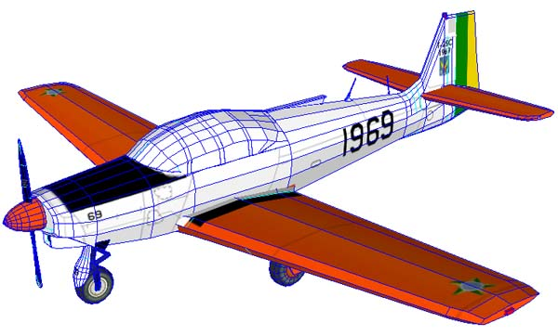

OBJECTIVE:
The objective of the assignment is to use object-oriented design techniques to design an application.

DESCRIPTION:
You have been hired to design an airline seating application for the FBN (Fly-By-Night) Airlines. In this portion of the assignment, the task is to do the object oriented design for the application. This system will be used only by the company and its employees. Customers will not interact with the system.
REQUIREMENTS:
Design an application that assigns seats on an airplane. The airplane has 20 seats in first class (five rows of 4 seats each, separated by an aisle) and 90 seats in economy class (15 rows of 6 seats each, separated by an aisle). Your app should take three commands: add passengers, show seating and quit. When passengers are added, ask for the class (first or economy), the number of passengers traveling together (1 to 2 in first class, 1 to 3 in economy), and the seating preferences (aisle or window in first class, center or window in economy). Then try to find a match and assign seats. If no match exists, display a message. Your design should include a class named airplane that is not coupled with the scanner or print classes. Follow the design process that is described in the presentation for this topic.
Once you have a conceptual model for your application, you should identify the classes you will need to implement your model. Once the classes have been identified you need to identify their responsibilities and relationships to the other classes
SUBMIT:
Please do this work in electronic format so that it can be uploaded into Moodle. I have posted a tool named UMLet. You may download it for use if you wish. You can also use Word to complete the work. If using UMLet, export the work to PDF format before submitting it.
1. A UML class diagram showing all your classes and the relationships between them.
2. A sequence diagram of one particular interaction between objects in your application. Label the diagram with the name of the scenario you are modeling.
Requirements:
- Submit program through the assignment tool in Moodle 2.
- Work should be in electronic format.

NOTE: Be sure to adhere to the University’s Policy on Academic Integrity as discussed in the syllabus. Programming assignments are to be written individually and submitted programs must be the result of your own efforts.

